Command networks

Ping

Verifies IP-level connectivity to another TCP/IP computer by sending Internet Control Message Protocol (ICMP) Echo Request messages. The receipt of corresponding Echo Reply messages are displayed, along with round-trip times. Ping is the primary TCP/IP command used to troubleshoot connectivity, reachability, and name resolution.



You can use ping to test both the computer name and the IP address of the computer. If pinging the IP address is successful, but pinging the computer name is not, you might have a name resolution problem.

Arp

Displays and modifies entries in the Address Resolution Protocol (ARP) cache, which contains one or more tables that are used to store IP addresses and their resolved Ethernet or Token Ring physical addresses. There is a separate table for each Ethernet or Token Ring network adapter installed on your computer.

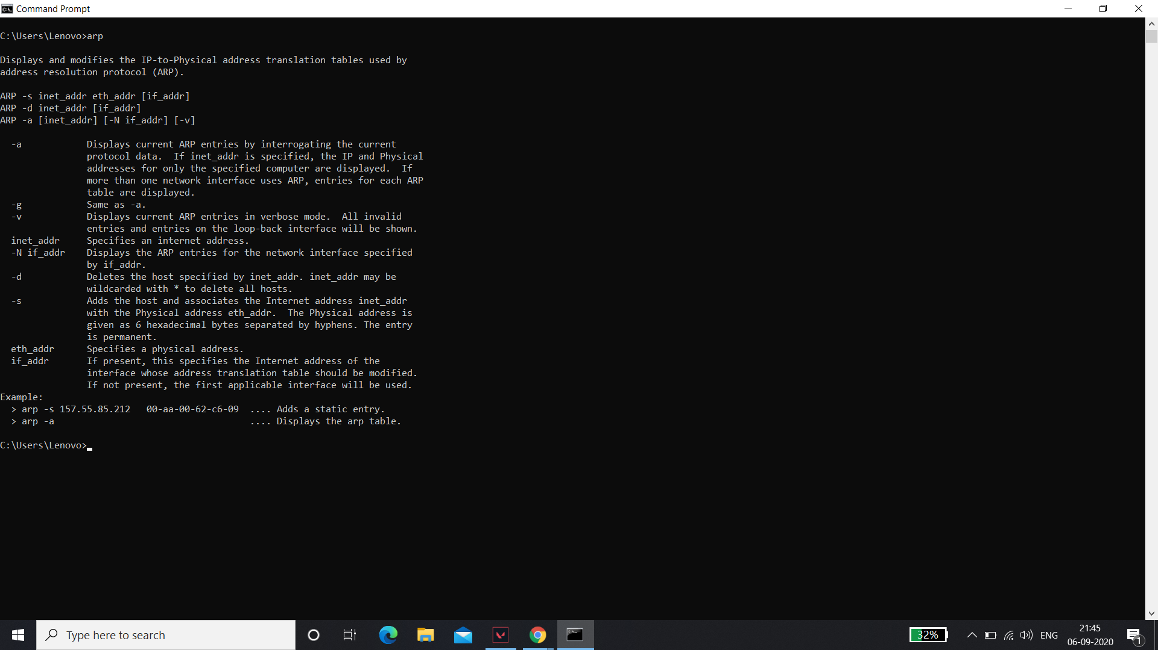

### Netstat

Displays active TCP connections, ports on which the computer is listening, Ethernet statistics, the IP routing table, IPv4 statistics (for the IP, ICMP, TCP, and UDP protocols), and IPv6 statistics (for the IPv6, ICMPv6, TCP over IPv6, and UDP over IPv6 protocols)

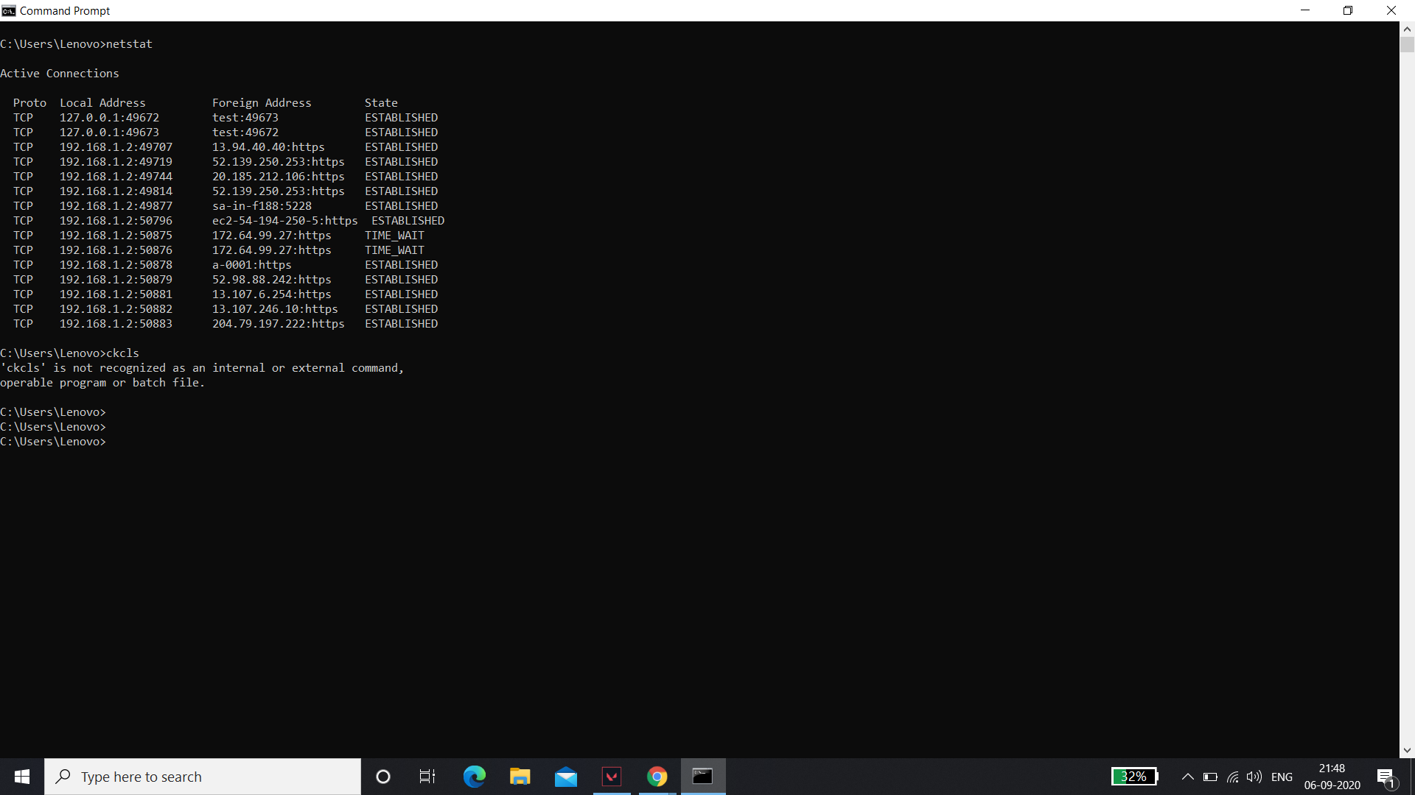

**Netstat provides statistics for the following:**

* Proto - The name of the protocol (TCP or UDP).
* Local Address - The IP address of the local computer and the port number being used. The name of the local computer that corresponds to the IP address and the name of the port is shown unless the -n parameter is specified. If the port is not yet established, the port number is shown as an asterisk (*).

### Nbtstat

Displays NetBIOS over TCP/IP (NetBT) protocol statistics

NetBIOS name tables for both the local computer and remote computers, and the NetBIOS name cache. Nbtstat allows a refresh of the NetBIOS name cache and the names registered with Windows Internet Name Service (WINS).

Nbtstat command-line parameters are case-sensitive.



Ipconfig

Displays all current TCP/IP network configuration values and refreshes Dynamic Host Configuration Protocol (DHCP) and Domain Name System (DNS) settings. This command is most useful on computers that are configured to obtain an IP address automatically. This enables users to determine which TCP/IP configuration values have been configured by DHCP, Automatic Private IP Addressing (APIPA), or an alternate configuration.

* If the Adapter name contains any spaces, use quotation marks around the adapter name (that is, "Adapter Name").
* For adapter names, ipconfig supports the use of the asterisk (*) wildcard character to specify either adapters with names that begin with a specified string or adapters with names that contain a specified string.

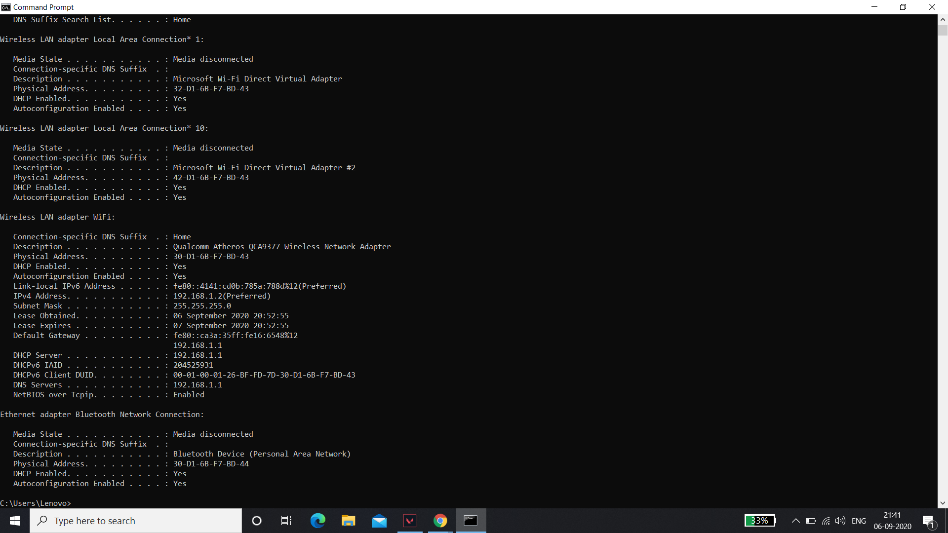

Hostname

The hostname command is the simplest of all the TCP/IP commands presented in this tutorial. It simply displays the computer's host name. For example:

C:\>hostname

doug

C:\>

Here, the host name for the computer is doug. The Windows version of the hostname command has no parameters.



Getmac

We can find mac address (physical address) of a computer using the command ‘getmac‘. This can be used to get mac address for remote computers also. Below are few examples on how to use this command.



# nslookup

nslookup is the name of a program that lets an Internet server administrator or any computer user enter a host name (for example, "whatis.com") and find out the corresponding IP address or domain name system record. The user can also enter a command for it to do a reverse DNS lookup and find the host name for an IP address that is specified.



Taskkill

The **taskkill** command allows a user running any version of Microsoft Windows from XP on to "kill" a task from a Windows command line by [PID](https://www.computerhope.com/jargon/p/pid.htm) (process id) or image name. This command is similar to [end tasking](https://www.computerhope.com/jargon/e/endtask.htm) a program in Windows.

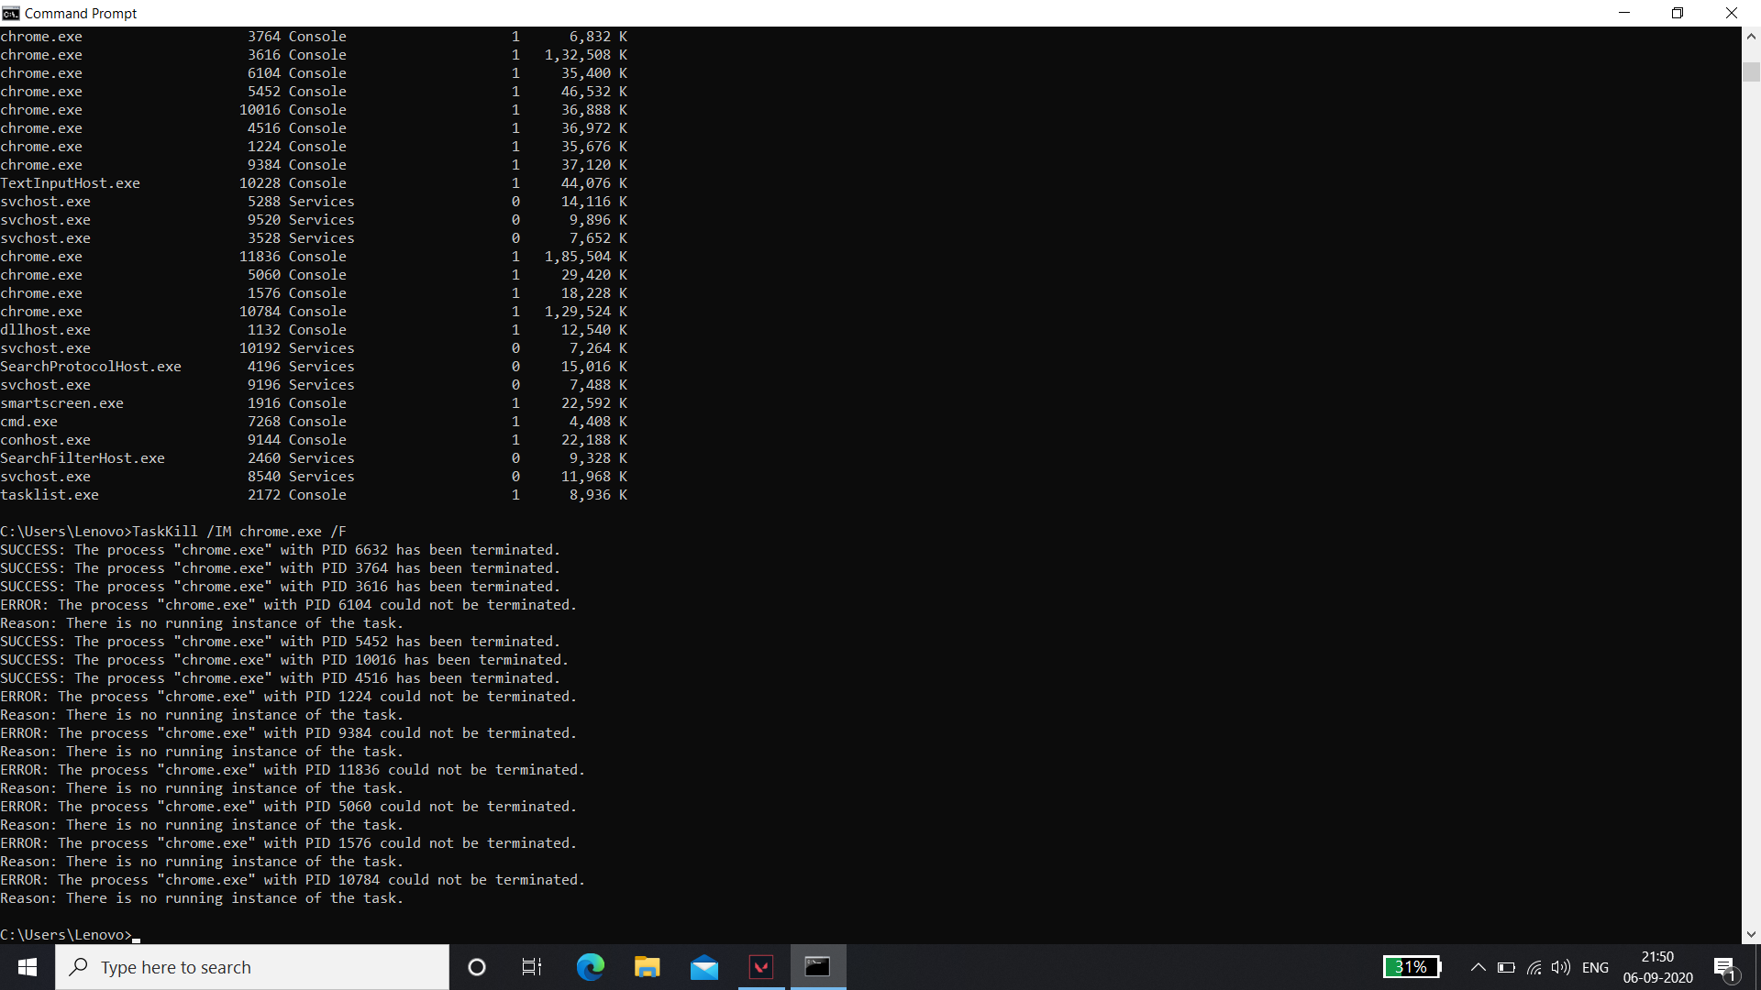

# tasklist

Displays a list of currently running processes on the local computer or on a remote computer. **Tasklist** replaces the **tlist** tool.

