Docker task 2:  
  
Create a dockerfile, docker-compose file which when executed must display your basic details in the website.

Index.html file:

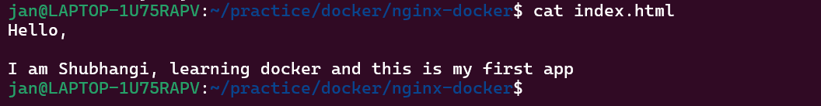

Docker file:

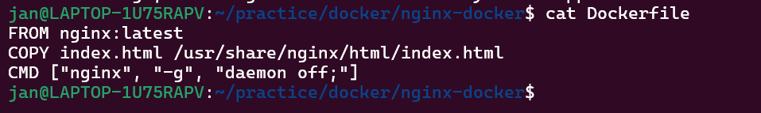

docker-compose file :

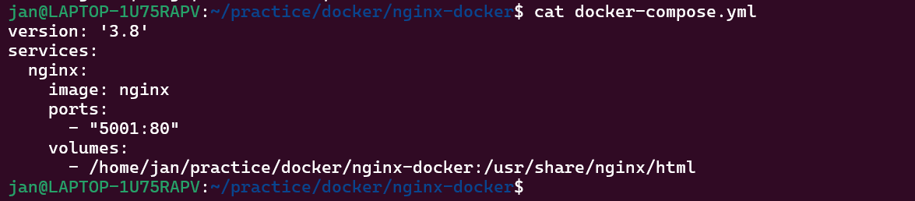

Docker-compose up:

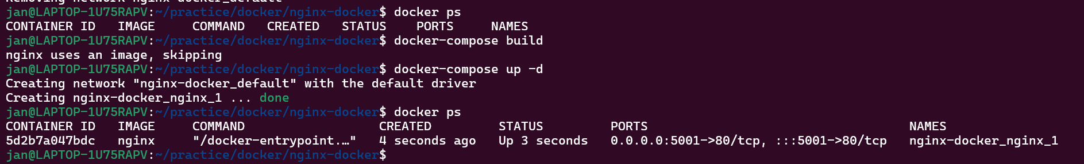

display the contents from index.html file in the website:

