Docker Task 3:

Create a Custom NGINX Docker Image

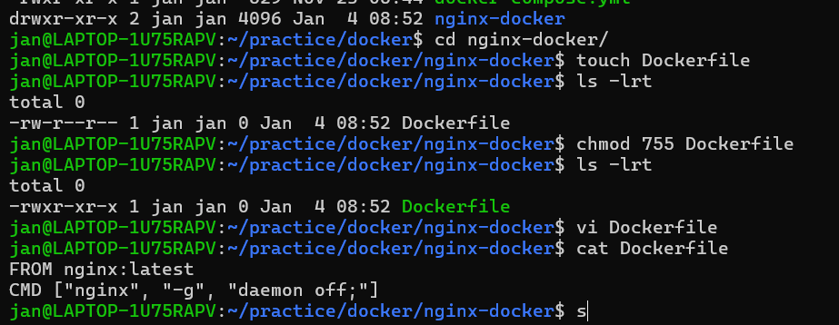

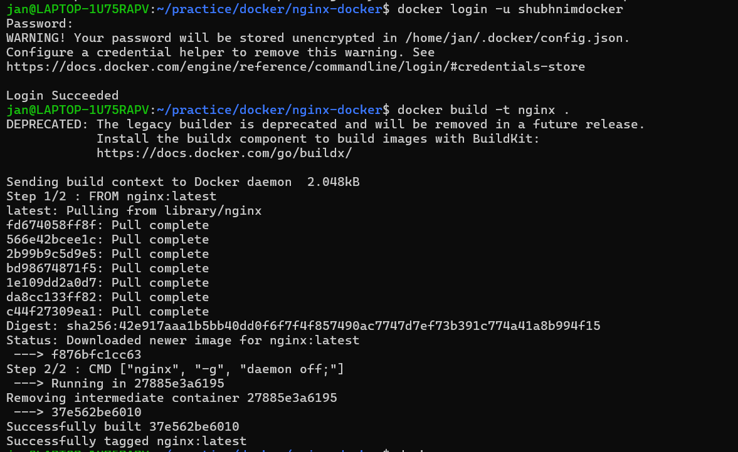

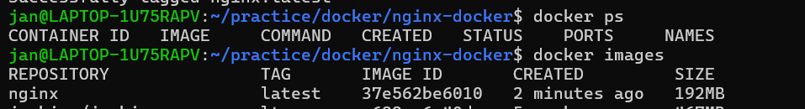

deploy it using docker compose, where the volume bind mount should be at /var/opt/nginx location.

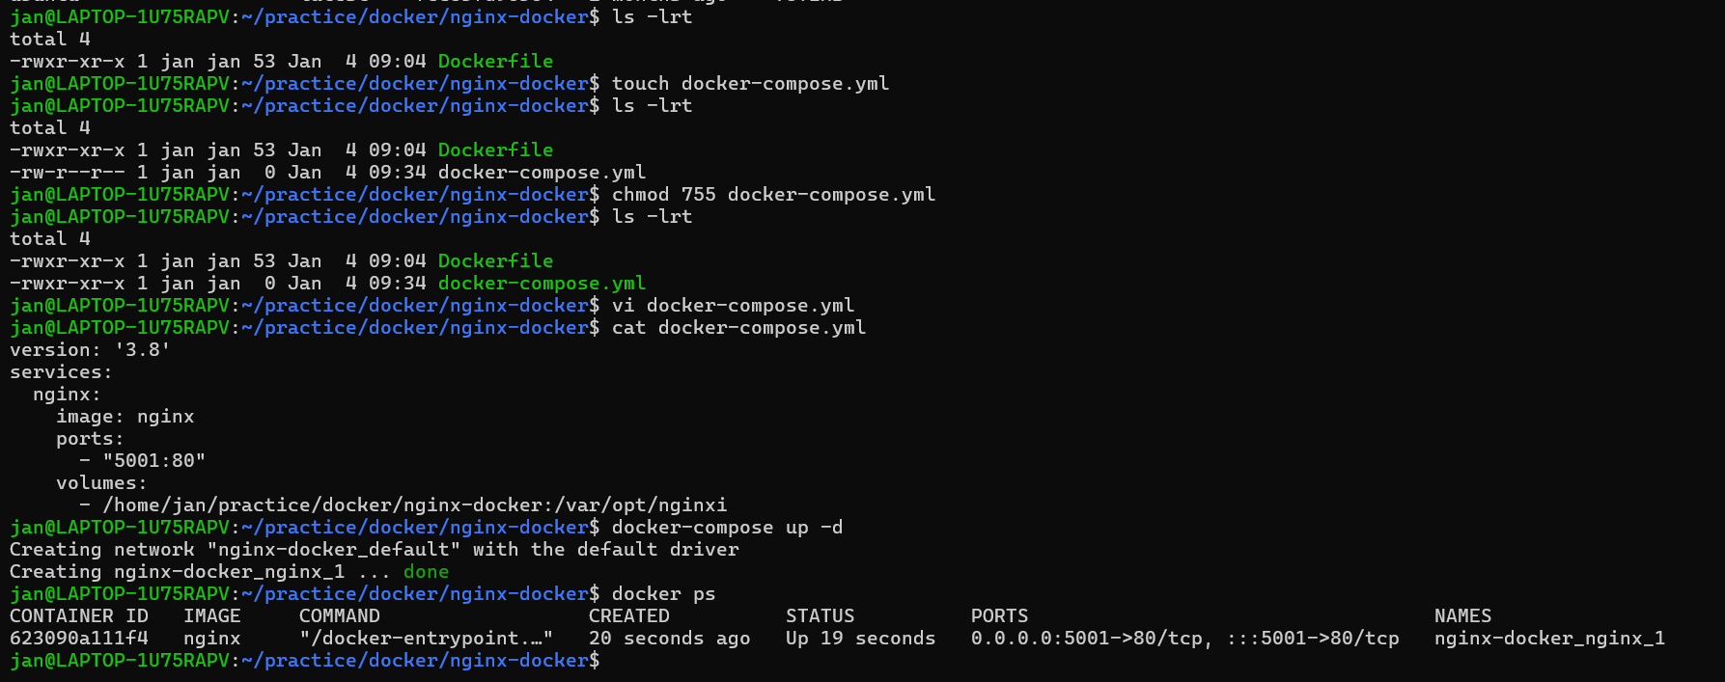

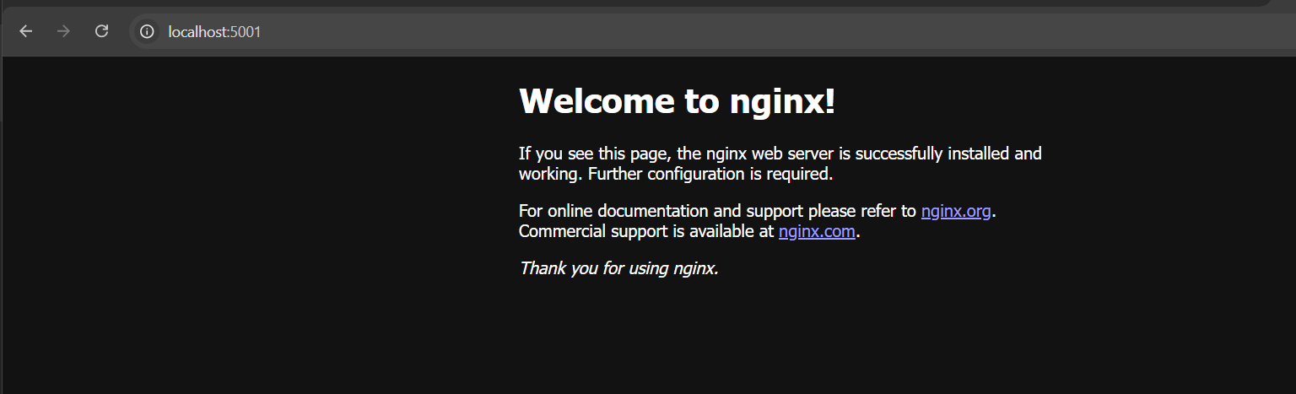

Push the custom image to Docker Hub

