Install docker on EC2 and explore the docker commands (docker images, containers, volumes, network)

EC2 instance creation:

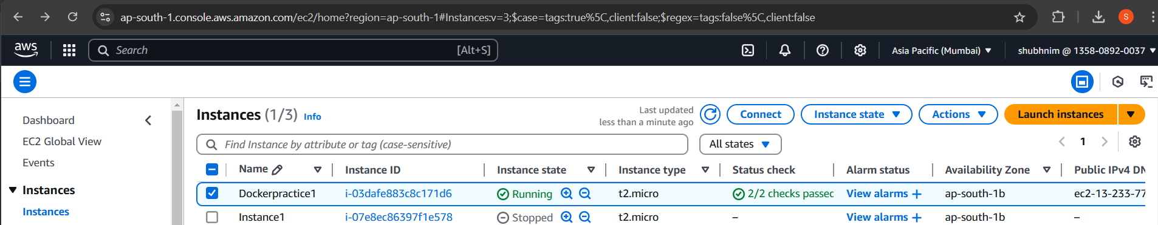

Connecting to EC2 instance:

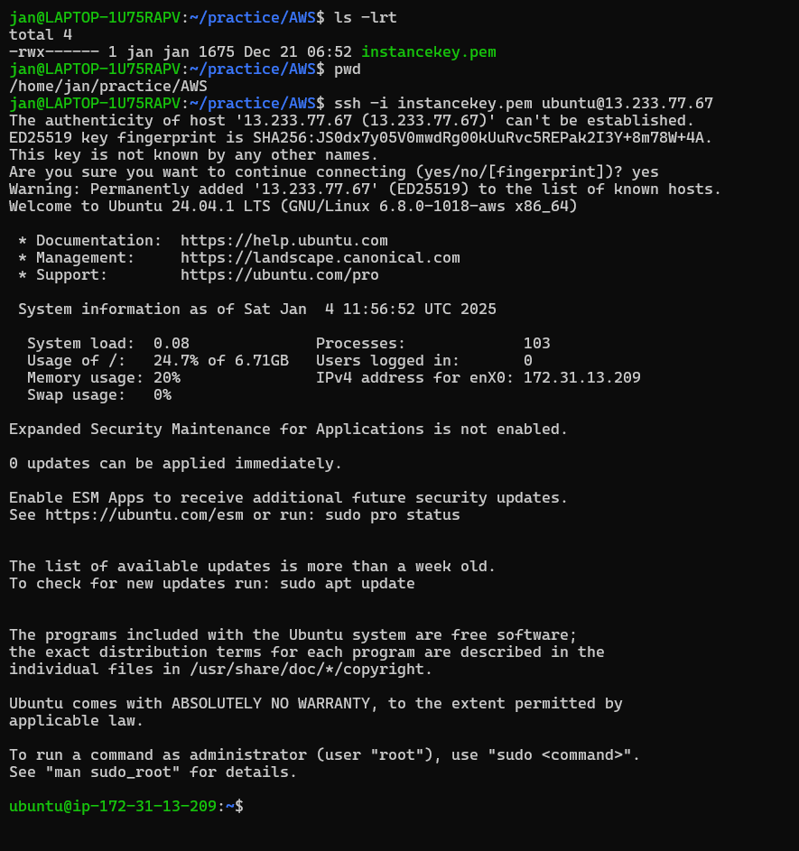

Installing docker:

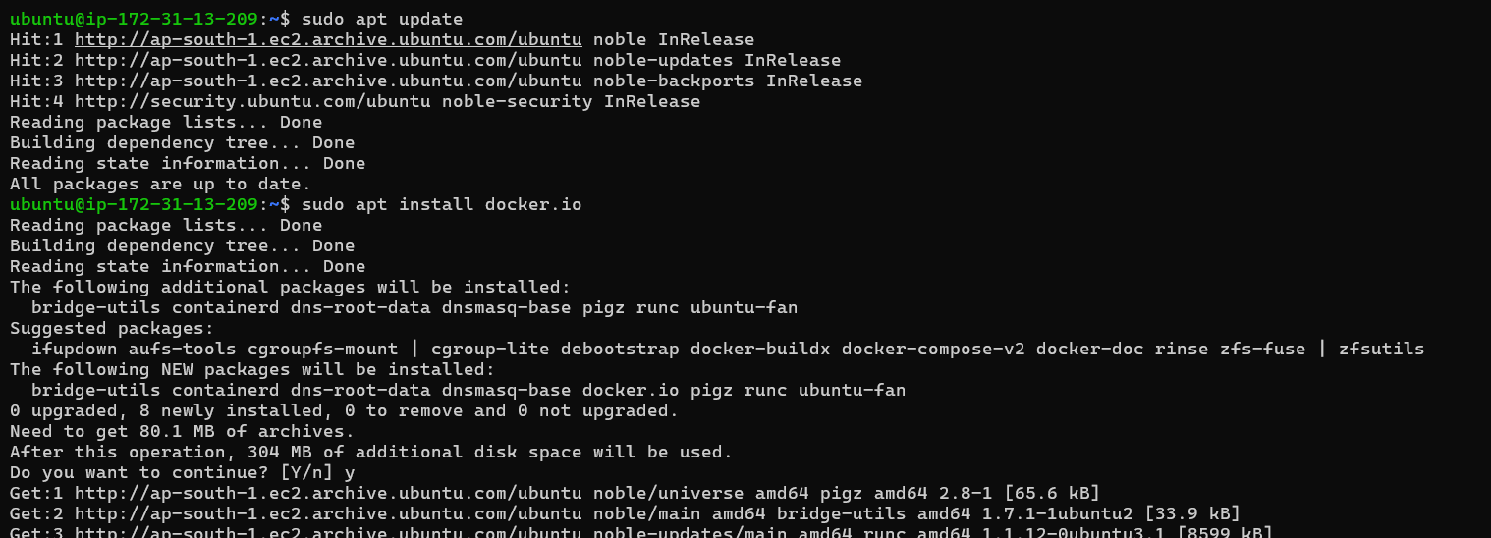

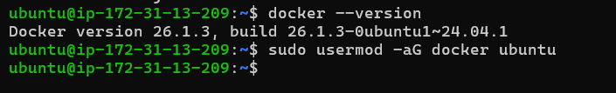

1. Docker Images Commands

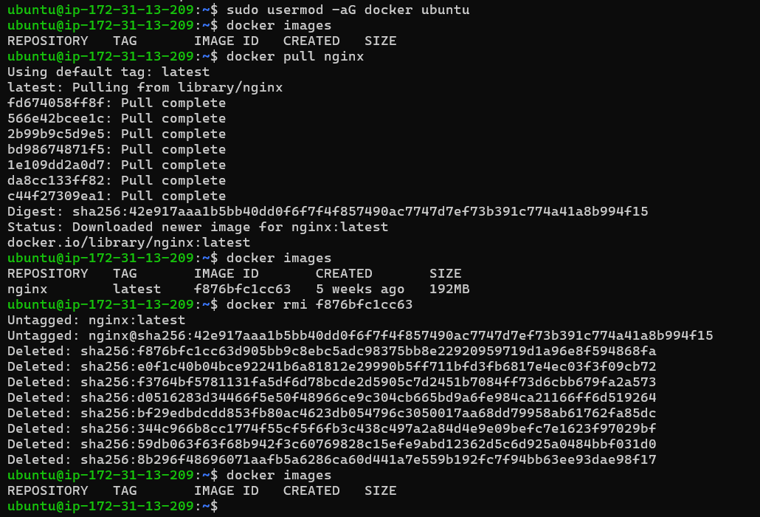

1. Docker Containers Commands

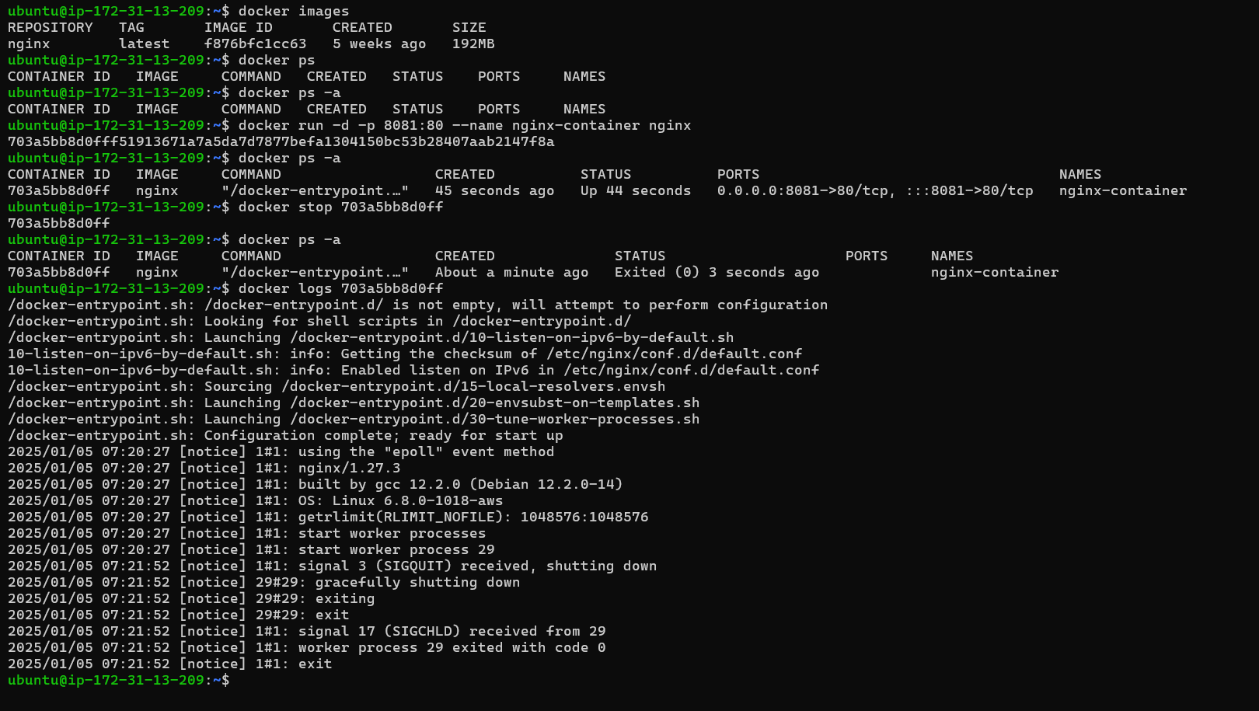

1. Docker Volumes Commands

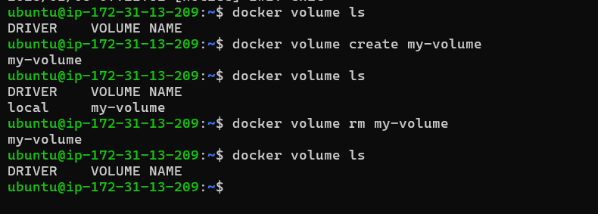

1. Docker Networks Commands

