**Task Description:**

1.

Get me the IP address of a particular domain (guvi.in).

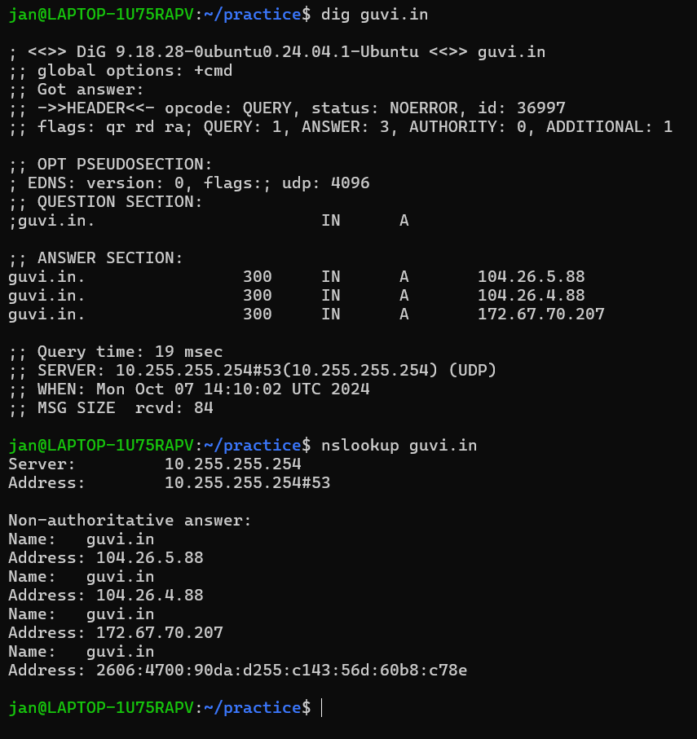

How do I find my CPU/memory usage of my server?.

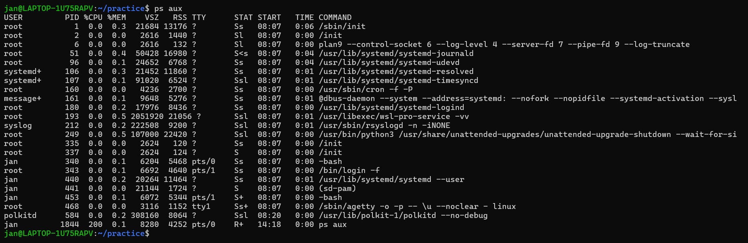

Test the connectivity between 2 nodes?

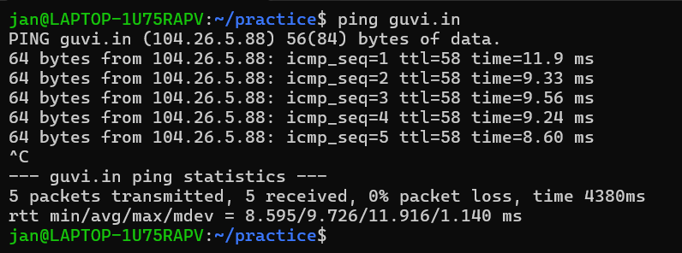

2.

I have deployed an application in guvi.com:9000, and logs show my app is running, but I’m unable to view the page. Check whether my port is open or not ?

