Launch Linux EC2 instances in two regions using a single Terraform file.

1. Aws configure:

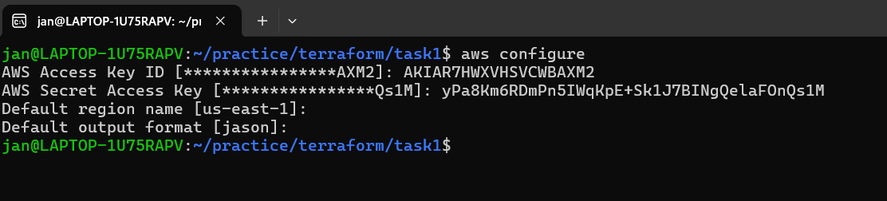

1. Create the Terraform file: main.tf:

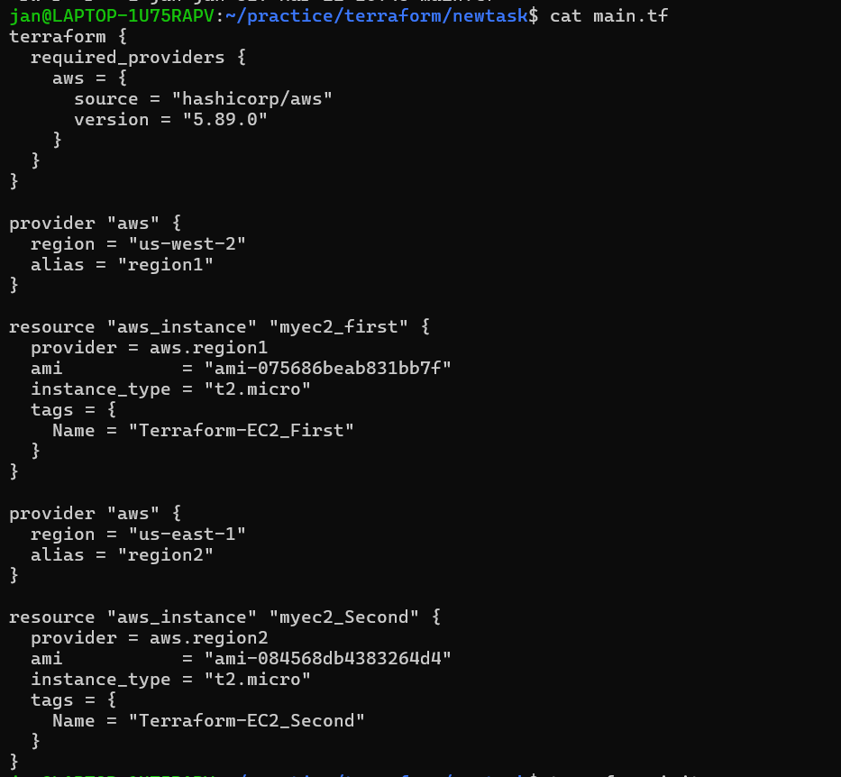

1. Apply the Terraform Configuration:

Terraform init:

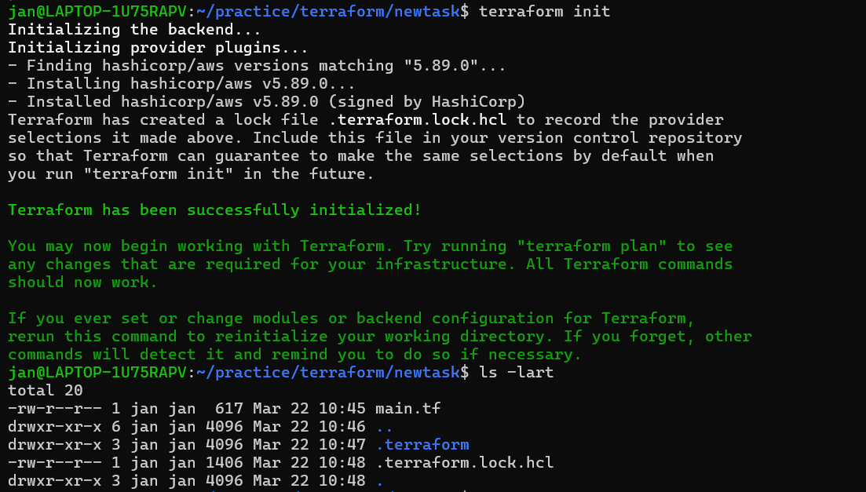

Terraform plan:

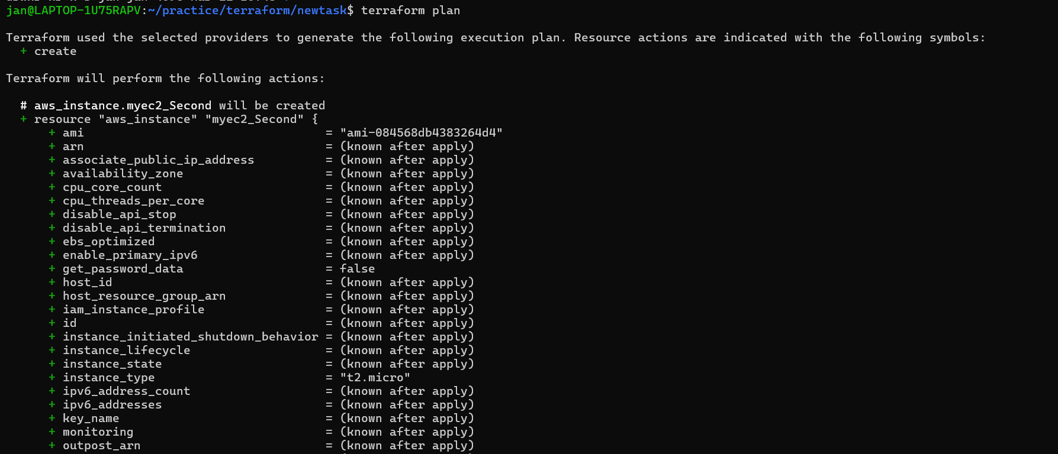

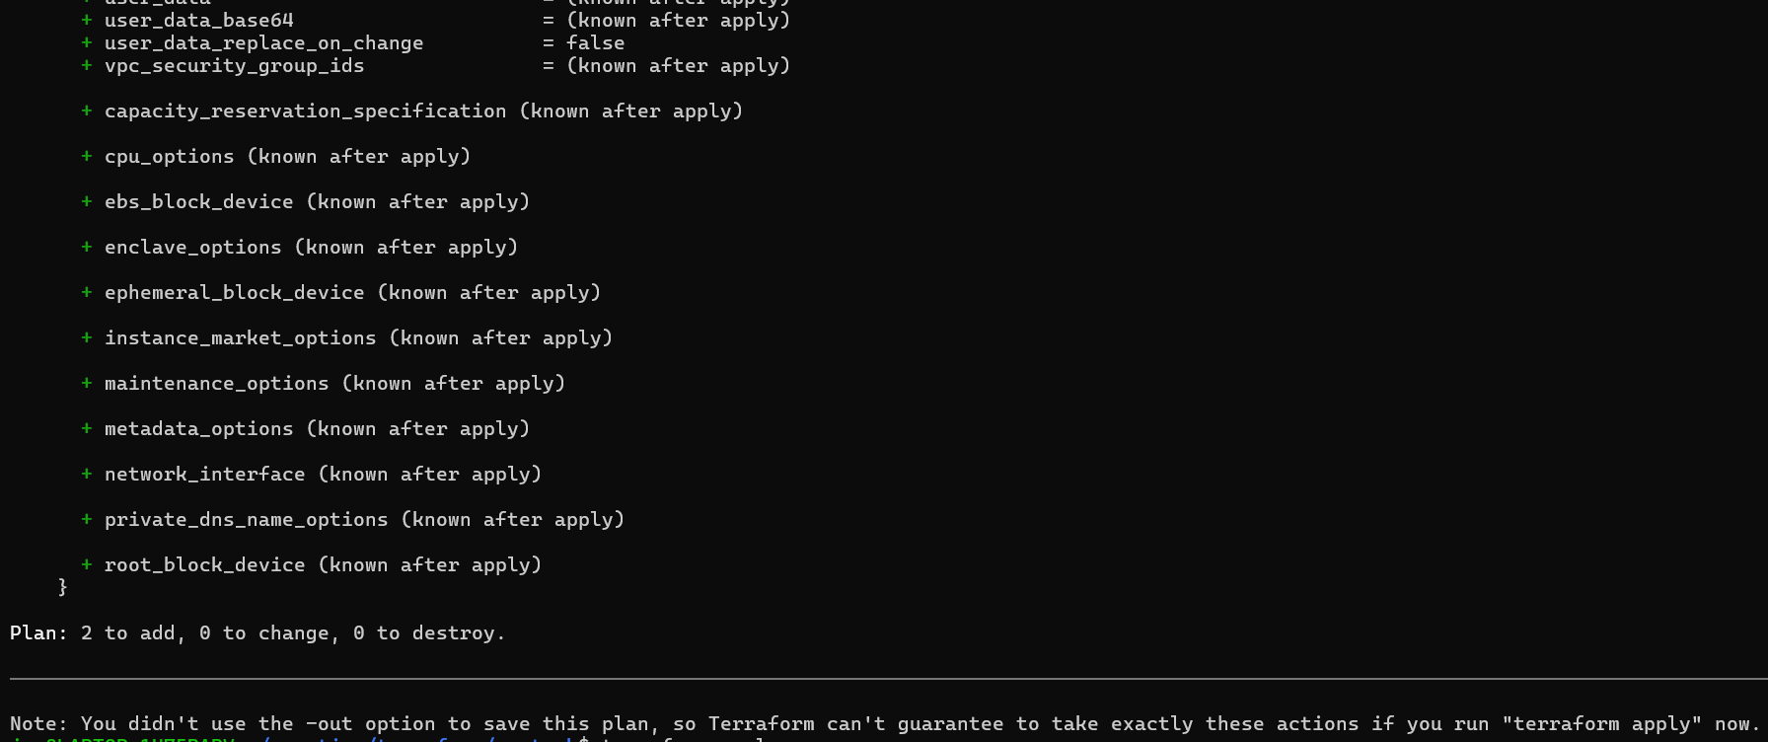

Terraform apply:

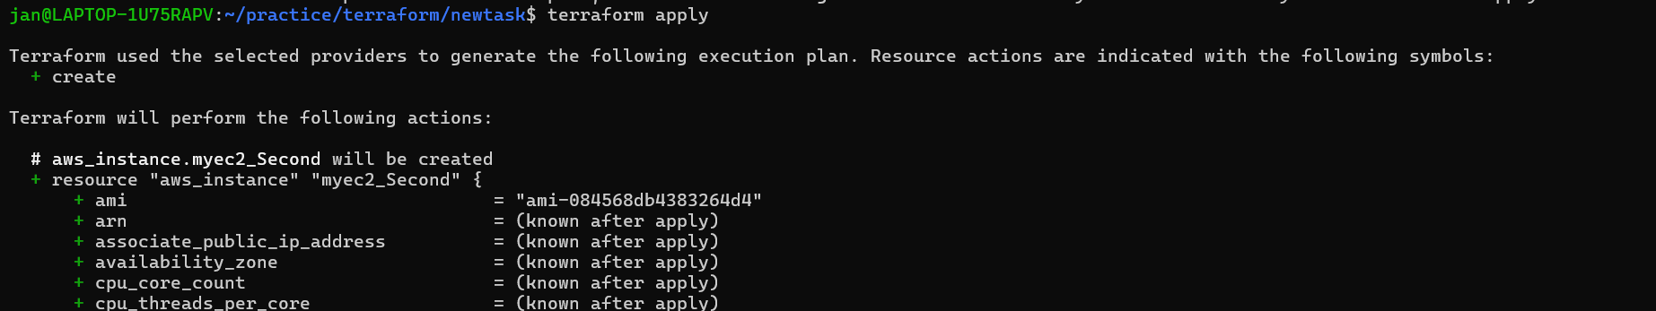

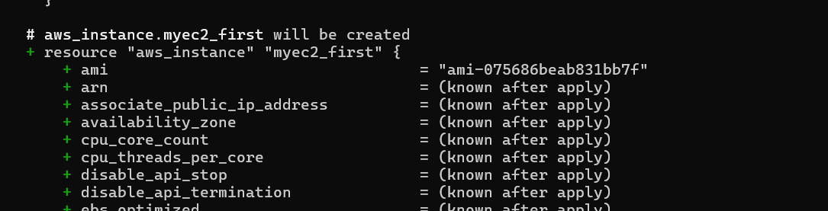

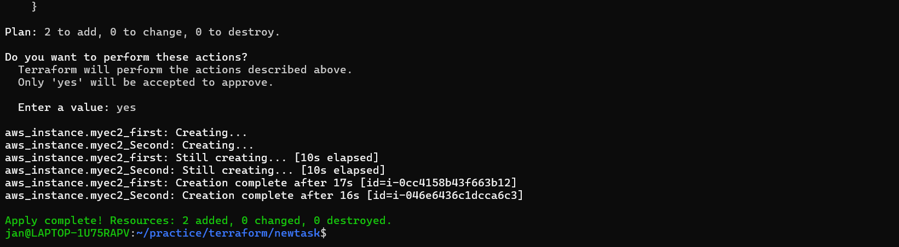

Instances created: Validated on AWS console:

