VCS Task:

Establish a new directory, populate it with script files, initiate an empty repository on GitHub, convert the local directory into a Git repository, and link it to GitHub for pushing the code into the repository.Perform merge, rebase, stash commands in following github repo.

- Establish a new directory, populate it with script files

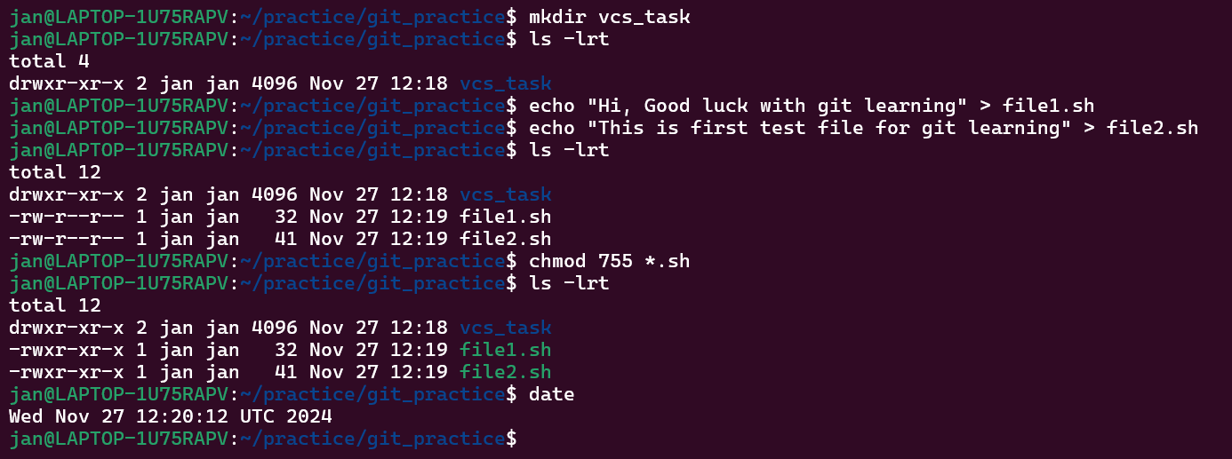

- initiate an empty repository on GitHub

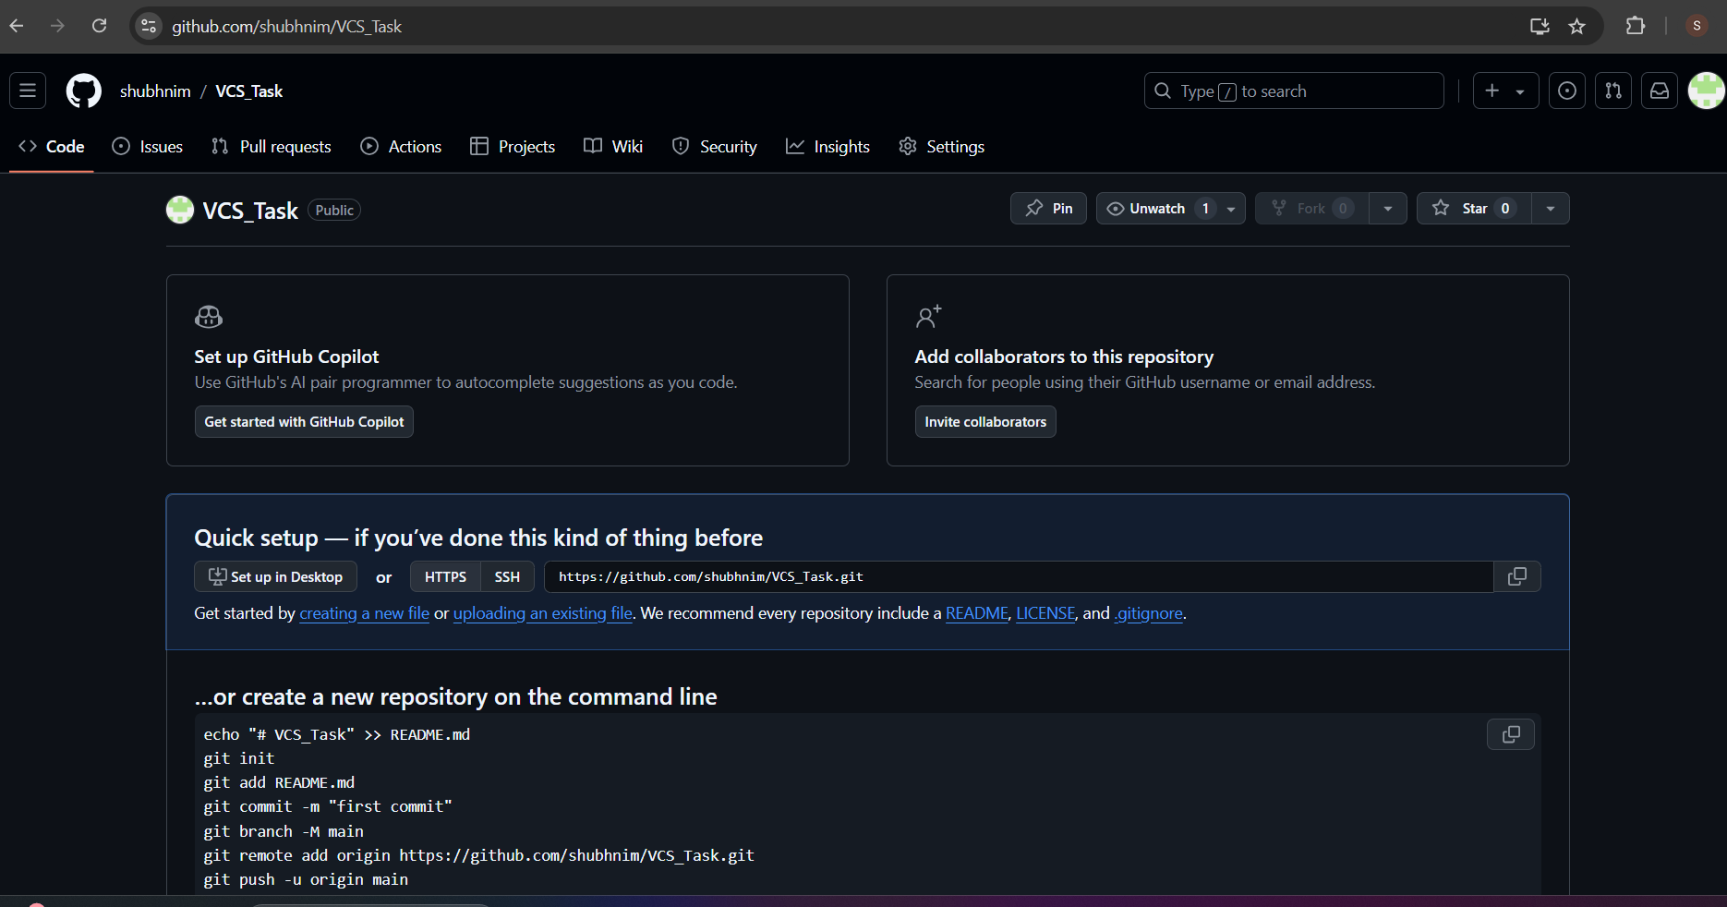

- convert the local directory into a Git repository,

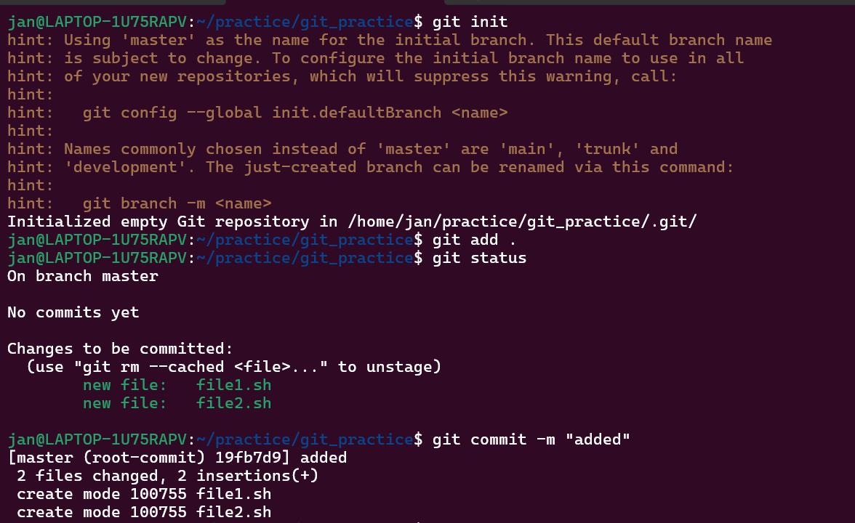

- Link Local Repository to GitHub Repository and push the code:

<https://github.com/shubhnim/VCS_Task.git>

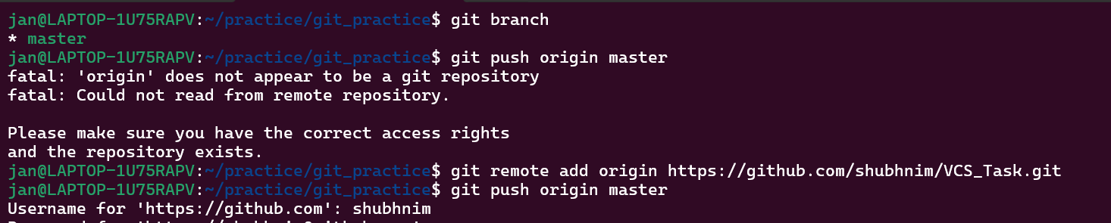

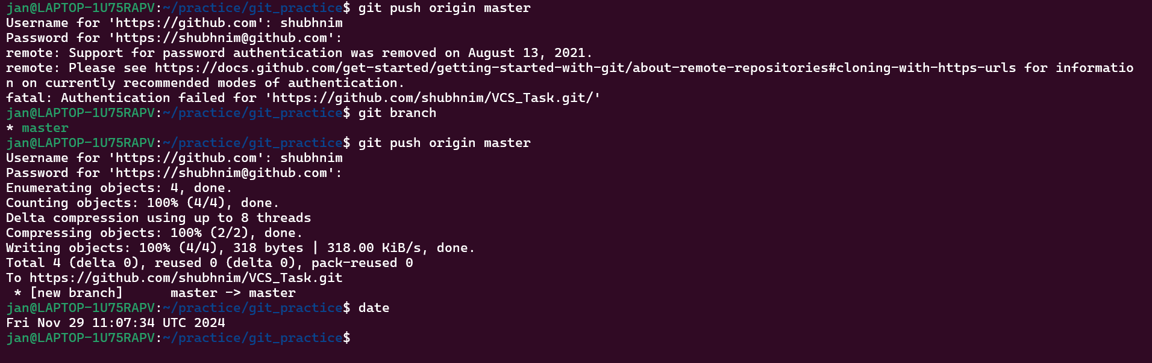

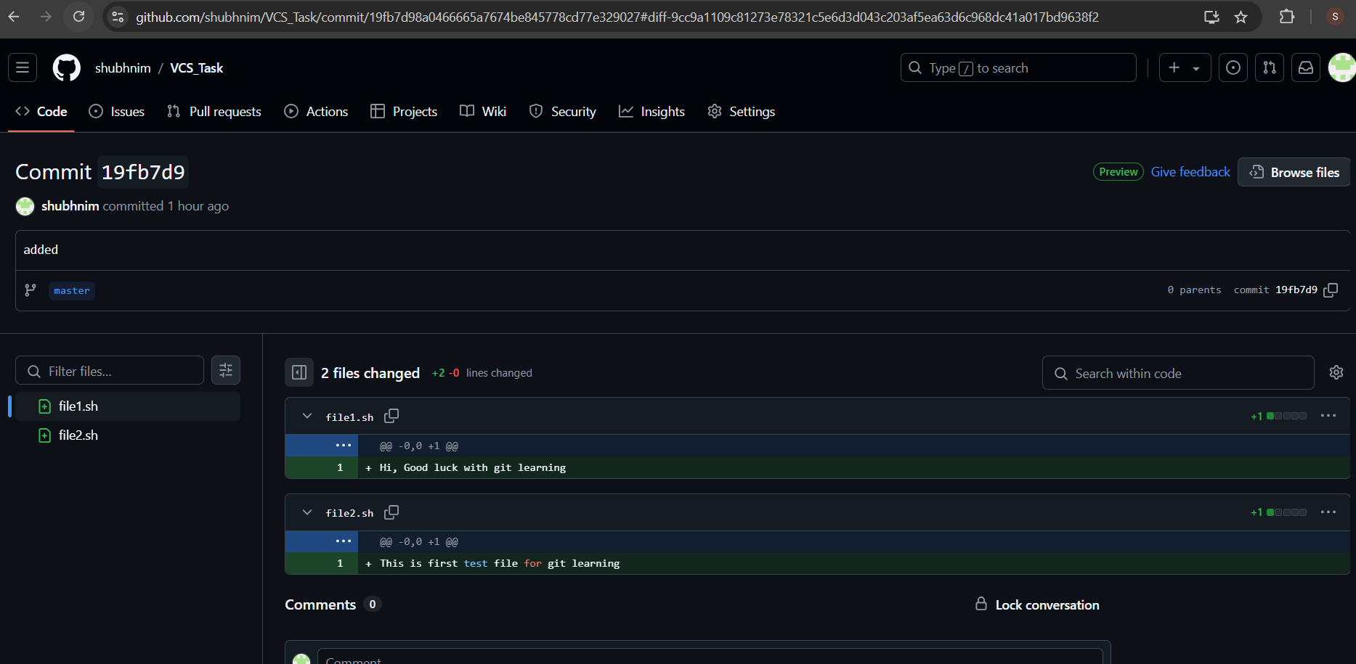

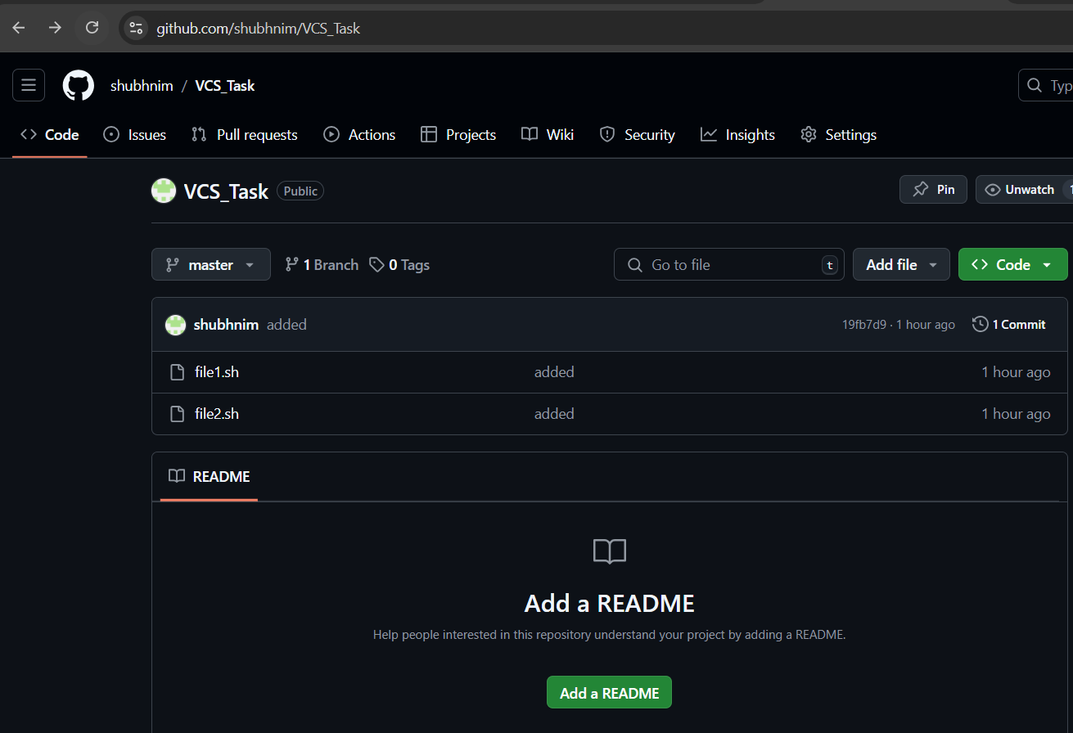

Perform merge, rebase, stash commands:

Merge:

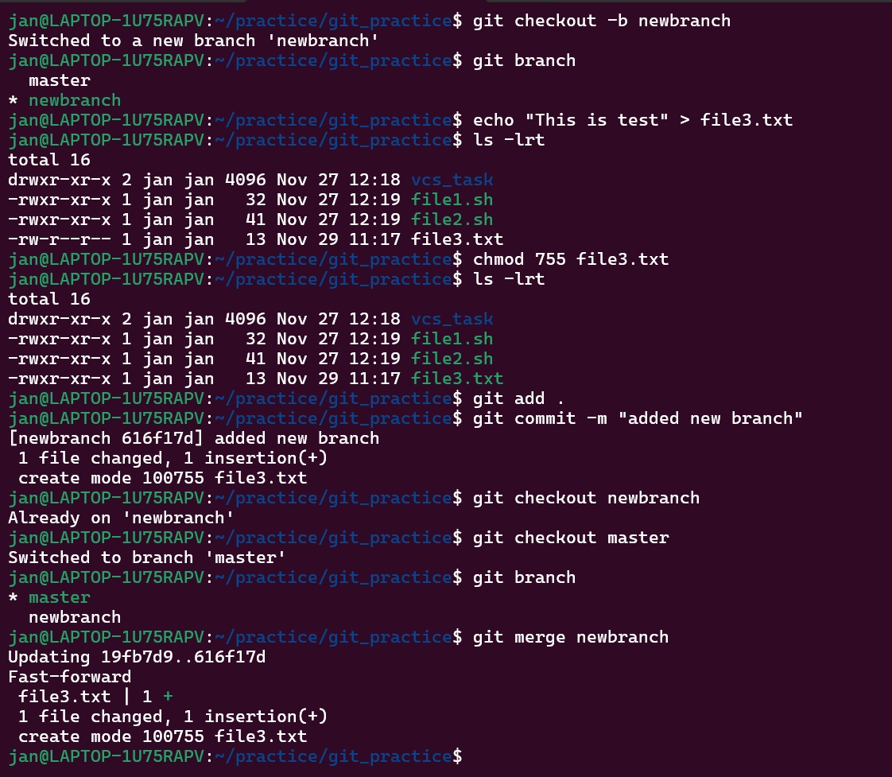

Rebase:

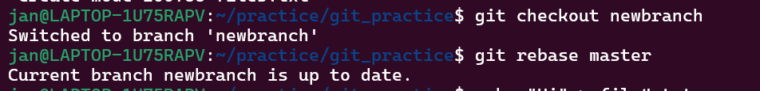

Stash:

