Shri Ramdeobaba College of Engineering & Management Nagpur-13

Department of Computer Application

Session: 2023-2024



Submission for Assignment

# Course Name: Advance Design Pattern Lab

Course Code: MCP549-2

Name of the Student: Shubhodeep Sarkar

Class Roll No: 53

Semester: MCA II semester

Shift: 02

Batch: 03

Under the Guidance of

Mr. Akhilesh Lunge

Date of submission: 19-04-2024

* **Steps to run project :-**

1. **Database Preparation**:
   * Ensure PostgreSQL is installed and configured with the appropriate schema and access credentials specified in **hibernate.cfg.xml**.
2. **Dependency Management**:
   * Check that your project includes all necessary dependencies, such as Hibernate ORM, PostgreSQL JDBC driver, and Lombok library. These dependencies should be properly configured in your project's build configuration (e.g., **pom.xml** for Maven projects).
3. **Entity Mapping**:
   * Validate that your entity classes (**Employee, EmployeeName, EmployeeAddress, EmployeeSalary, EmployeeResources, Project, Manager, Department** are accurately mapped to their corresponding database tables. Ensure they are annotated with the required JPA annotations (**@Entity**, **@Table**, **@Id**, etc.) to facilitate correct ORM (Object-Relational Mapping) functionality.
4. **Executing the Application**:
   * Run the main method located in the **Main** class. This action initiates the main menu interface, allowing users to select desired operations.
5. **Operation Selection**:
   * From the main menu, select the operation you wish to perform by entering the corresponding number.
6. **Providing Input**:
   * Follow the prompts provided by the application to input any required information. For example, when creating an employee, you may need to enter details such as name, joining date, etc.
7. **Validation and Confirmation**:
   * Upon completing an operation, verify the output to ensure it aligns with expectations. Check the database to confirm that any changes made by the operation are reflected accurately.
8. **Continuation or Termination**:
   * Choose whether to continue performing additional operations or exit the application once your tasks are complete.
9. **Error Handling**:
   * Monitor for any runtime errors or exceptions that may occur during the execution of the application. Promptly address and resolve any issues encountered to maintain smooth operation.
10. **Resource Management**:
    * Properly close Hibernate **SessionFactory** and release any other resources utilized by the application to prevent resource leaks and ensure efficient resource utilization.
11. **Customization and Adaptation**:
    * Customize database configuration settings (**create**, **update**, **delete**, **create-drop**) as necessary to suit the specific requirements and objectives of your project.

By adhering to these steps, you can effectively execute the project, interact with the database, and perform various operations with confidence and efficiency.

* **Output of the project :-**

**The main menu of the operations are as follows :-**

* **CRUD operations Main Menu**
* **Employee Main Menu**

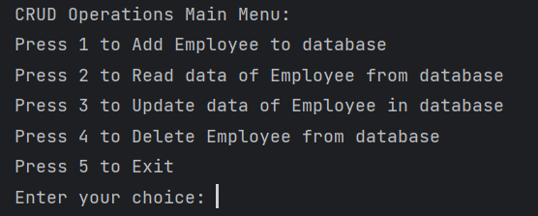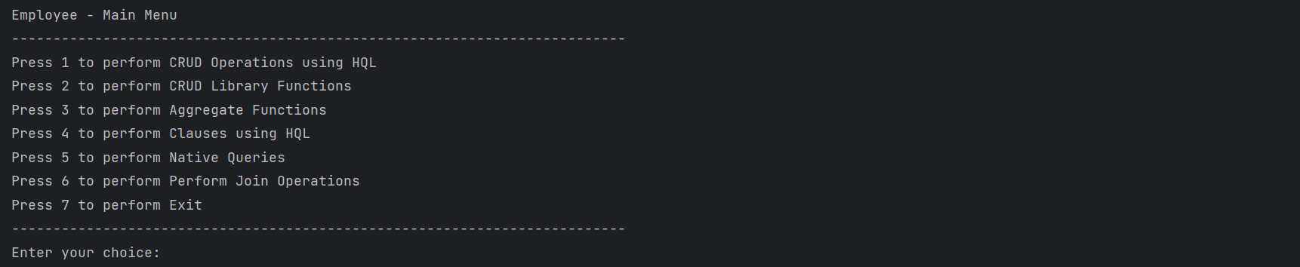

* **Aggregate Functions Main Menu**

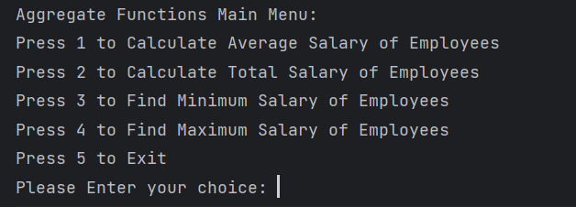

* **HQL clauses Main Menu**

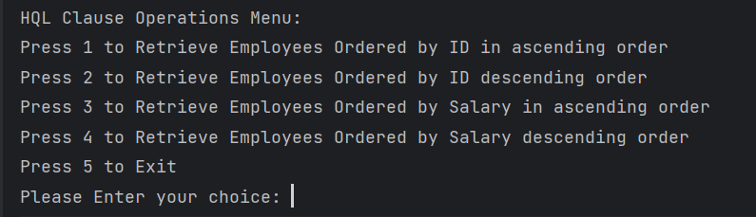

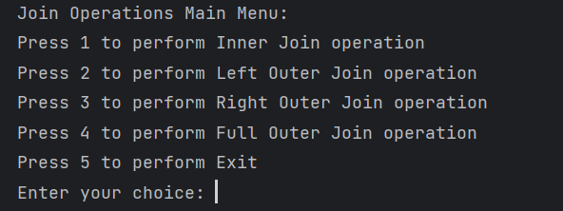

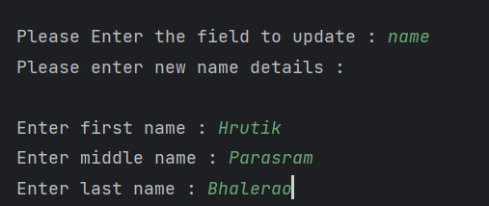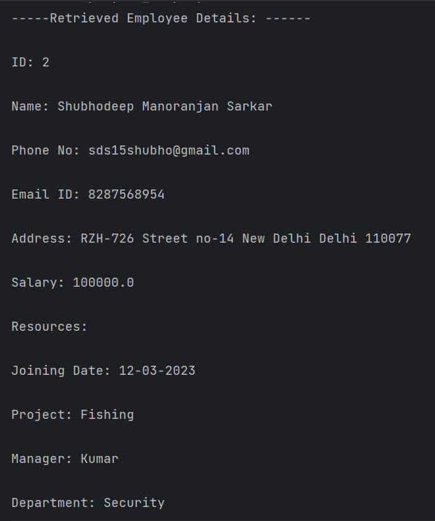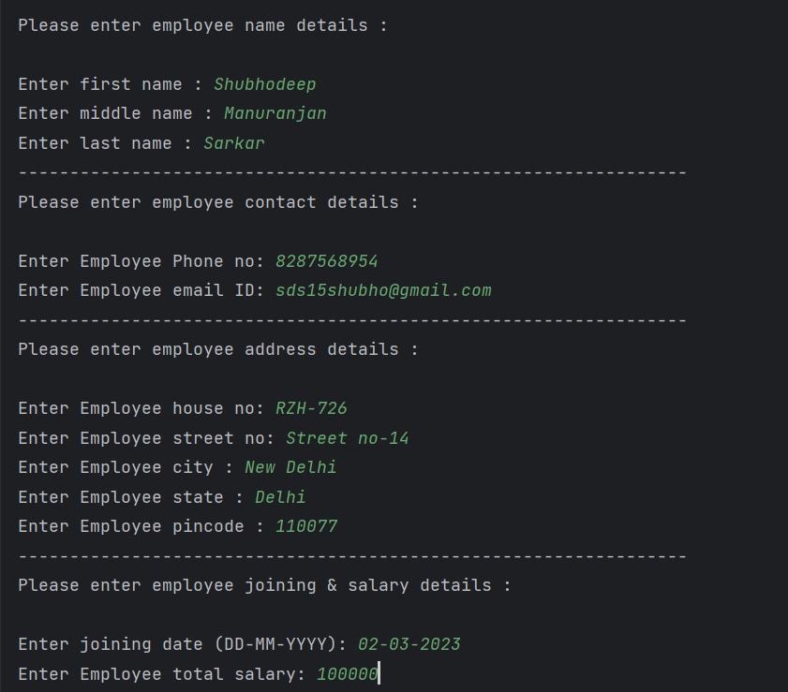

* **Update Employee Details**
* **Read Employee Details**
* **Create Employee Operation**
* **Join operations Main Menu**