Use Case Diagrams

## Automated Human Resource Monitoring System

# Scheduler Agent

**Use case 1.1 (Task Assign)**

Primary Actors: Admin, Database Server, Employees

Precondition: The admin must have access to the database server

Basic Flow of events:

* Admin Los into the System
* He searches the available jobs available to be done from the database server
* He searches the employee profiles
* Checks the employees work calendar
* Assigns available employee the task through the system
* Employee is notified through the system

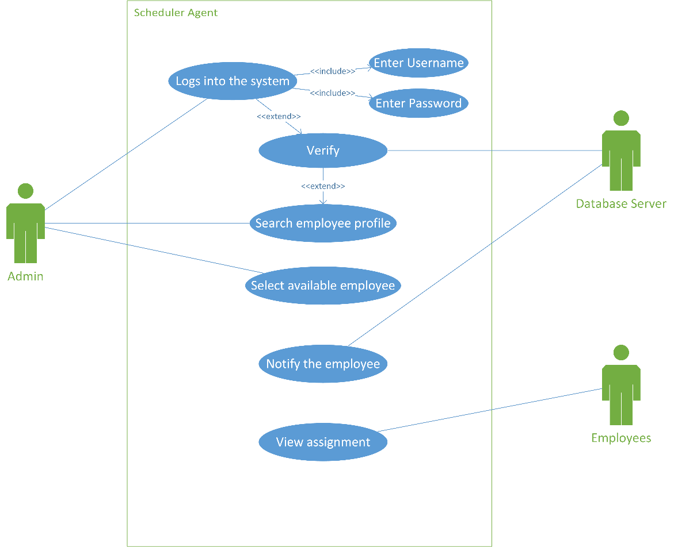

**Use case 1.2 (Task Receive)**

Primary Actors: Employees, Database Server, Email Client

Precondition: The employee must have access to the internet

Basic Flow of events:

* Employees logs into the system
* View Assign history through email client and system
* Download assigned task files
* Contact using the email client if necessary

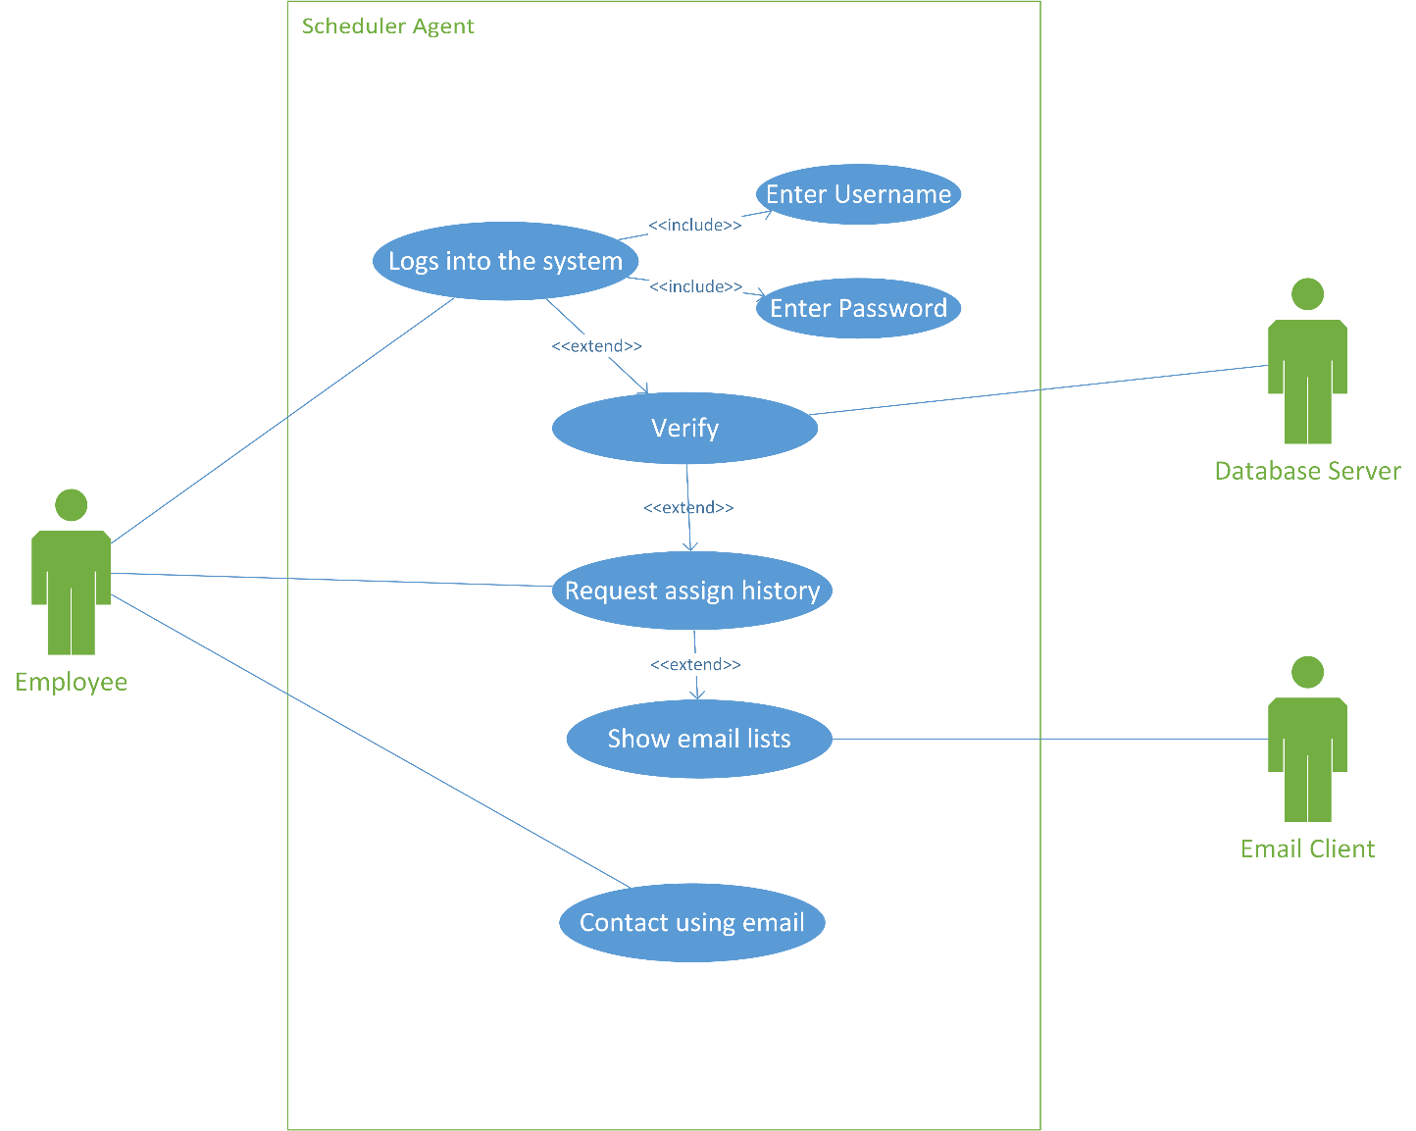

# Client Monitoring Agent

**Use case 2.1 (Resource Calculate)**

Primary Actors: Employees, Database Server, client monitoring agent

Precondition: The Admin must have access to the system

Basic Flow of events::

* Admin logs into the system
* Admin opens the employee log
* Client Agent activates on the background when activated by admin
* Client Monitoring Agent monitors the time worked by the employees
* Client Monitoring Agent calculates the internet bandwidth and volume used
* A detailed report is generated for each employee

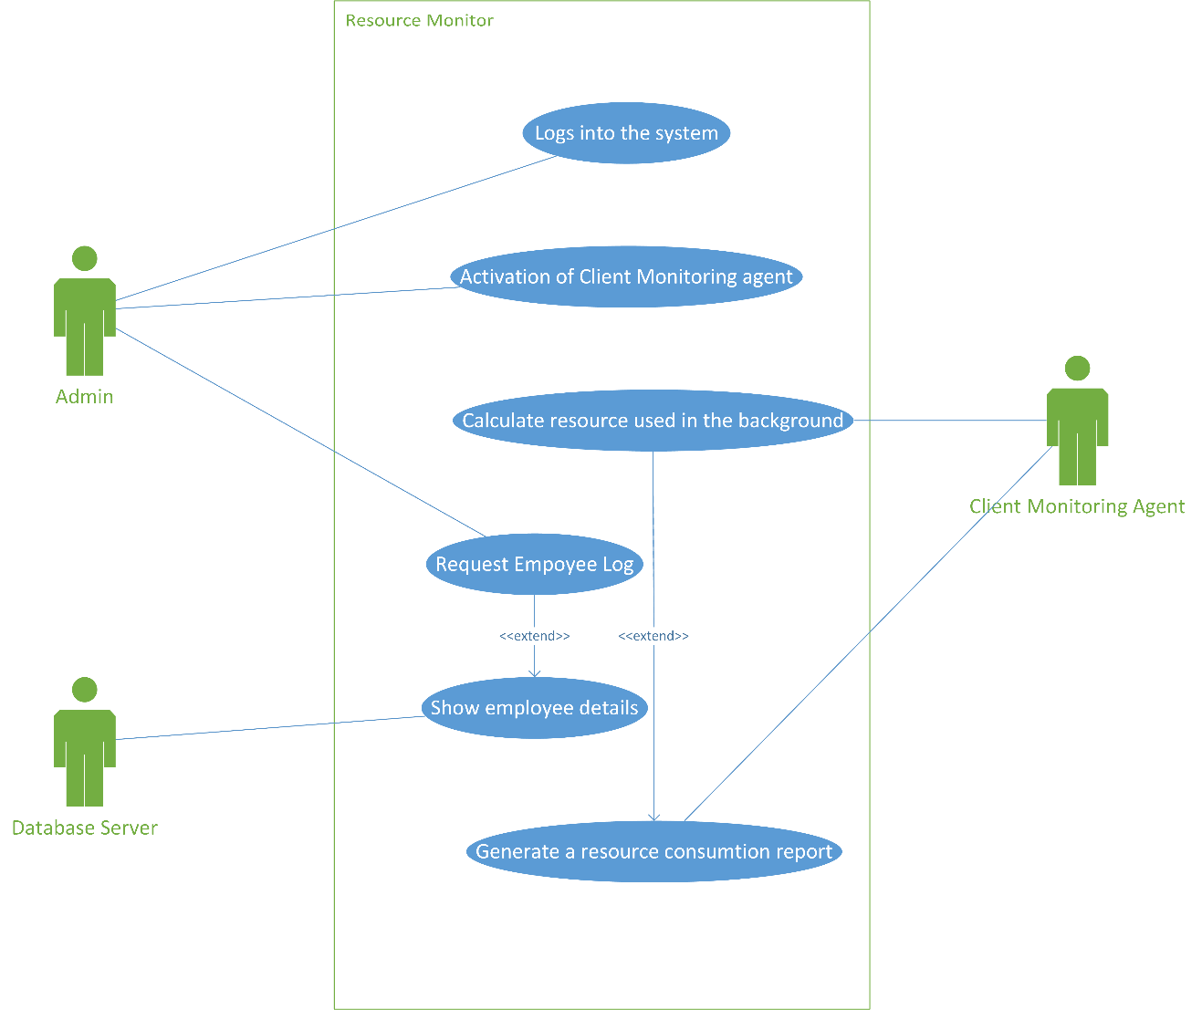

# Notifying Agent

**Use case 3.1 (Notify Scheduled Task)**

Primary Actors: Employees, Database Server, notifying agent

Precondition: The employee must have access to the system

Basic Flow of events::

* Employee logs into the system
* Checks the notifications in the system
* Open the inbox in his email client
* Views a list of emails
* Open a selected email

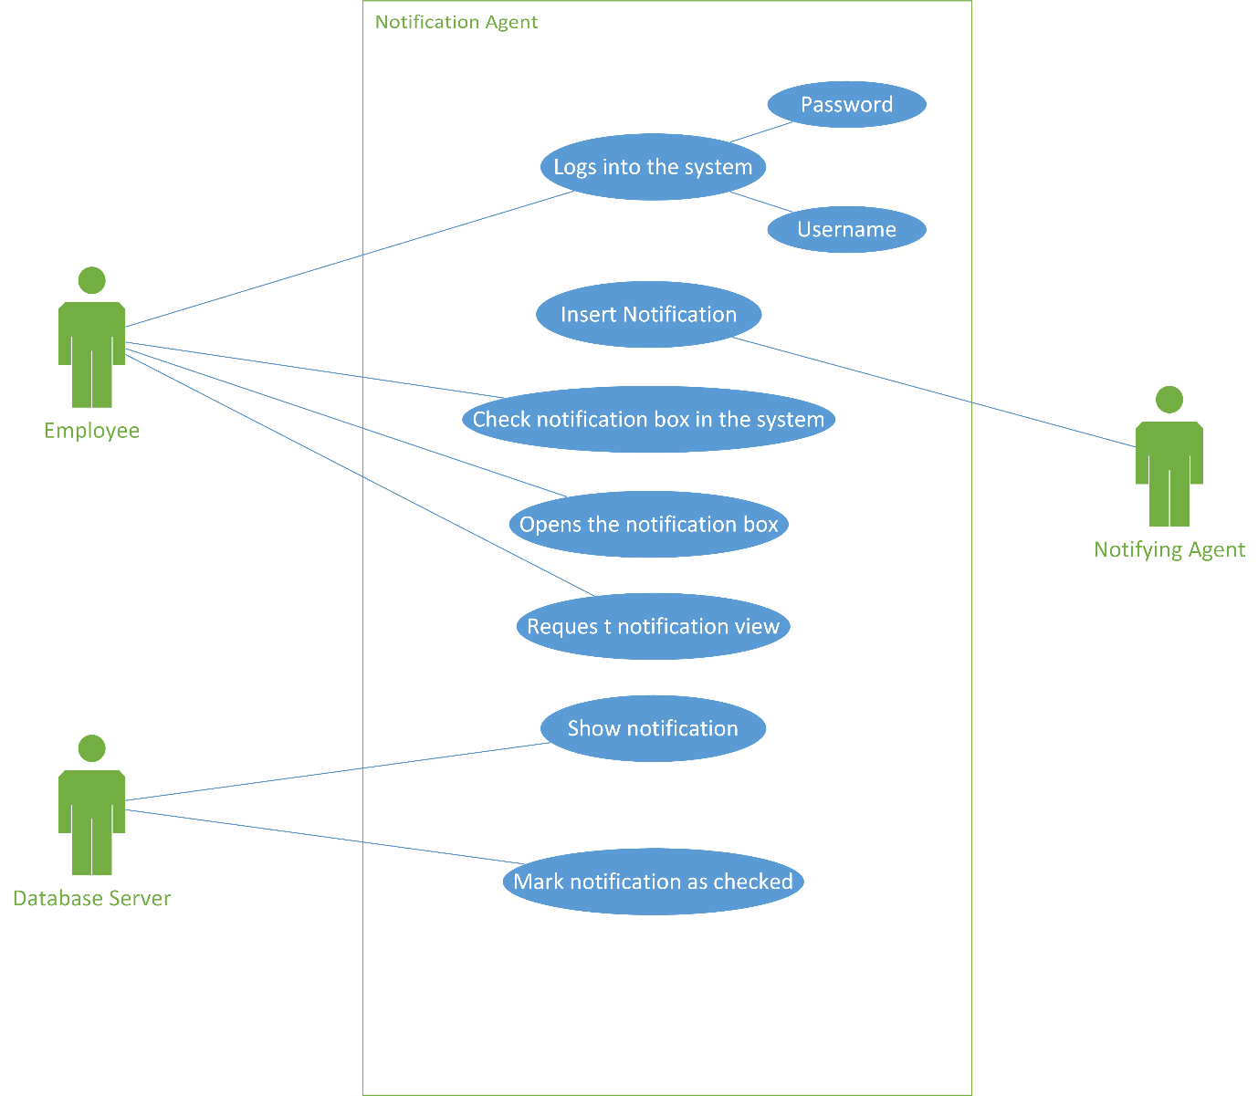

# Remote Scheduler

**Use case 4.1 (Schedule Task)**

Primary Actors: Employees, Admin, Database Server, notifying agent, Task Scheduler

Precondition: The employee must have access to the system and have updated calendar

Basic Flow of events::

* Employee logs into the system
* The task scheduler checks the employee calendar and detects available time
* The task scheduler sends the information to the admin
* Admin approves the proposal
* Admin assigns task to the employee
* Notifying agent notifies the employee

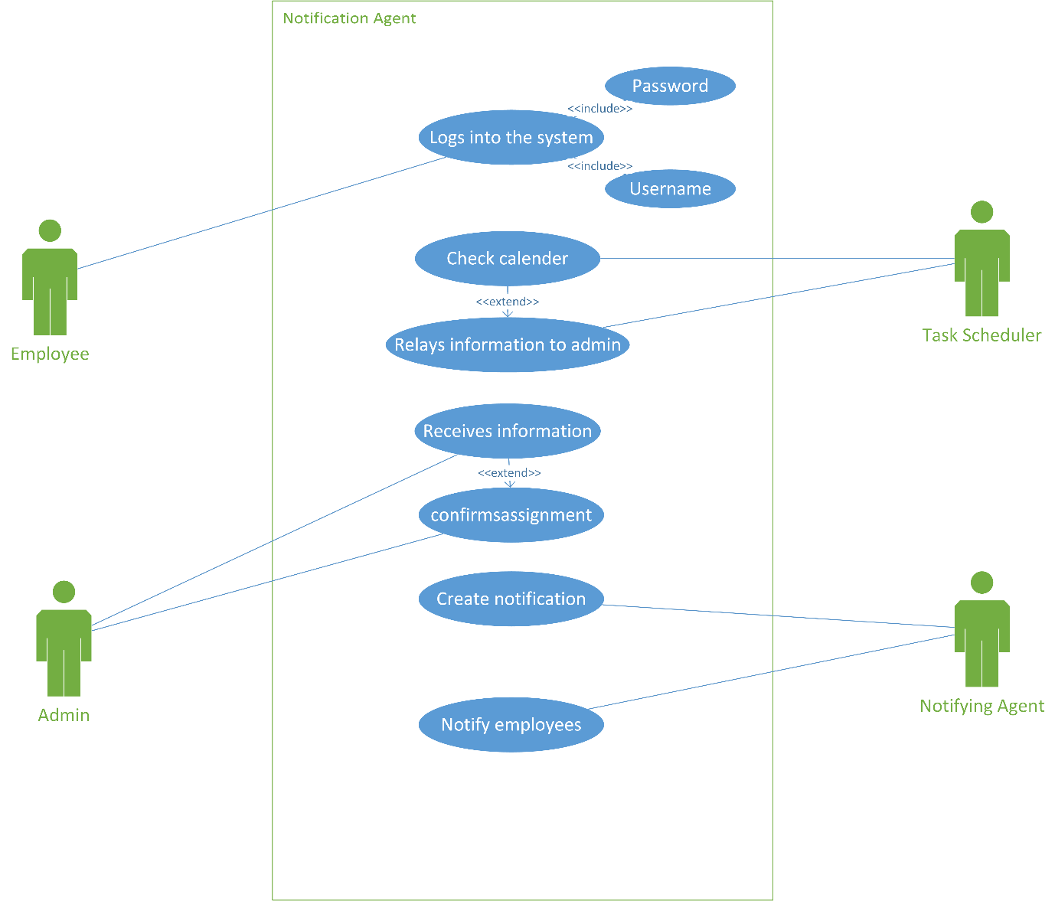

# Data Analyser

**Use case 5.1 (Data Analyse)**

Primary Actors: Admin, Database Server, Data Analyser

Precondition: The data analyser agent must have access to all the databases

Basic Flow of events::

* Admin request view of resource consumption
* Data analyser receives data from the client monitoring agent
* Data analyser analyses data
* Points most consumption resources and total loss of the organization
* Forwards the data to the database for update
* Database server shows the data to the admin request

