Detection Limits of Low-Pass Cell-Free DNA Sequencing for Haematological Cytogenetics: A Simulation Study
Abstract
Low-pass whole-genome sequencing of cell-free DNA is an attractive route to reading a haematological karyotype from a blood draw, but its published detection limits are derived almost entirely from prenatal whole-chromosome trisomies rather than from the arm-level and sub-arm lesions that define myeloid disease. We report an open simulation study that measures the detectability surface of a bin-count copy-number caller across sequencing depth, tumour fraction and lesion size, with the genome-wide false positive rate held at five percent by calibration against held-out normal libraries. We find three things. First, sensitivity plateaus at roughly 0.5$×$ coverage: increasing depth from 0.5$×$ to 5$×$, a tenfold increase in cost, improves the detection limit by a median of 4.9 percent, because library-to-library bias rather than counting noise sets the floor. Second, the detection limit scales with the inverse square root of lesion size, so a 5.5 Mb deletion requires a 39.5 percent tumour fraction at 0.1$×$ while a 434 Mb complex karyotype requires 7.2 percent. Third, balanced rearrangements are called at exactly the false positive rate at every depth and tumour fraction tested, and we give a closed form showing that the expected number of junction-spanning molecules is $cf/2$, independent of both genome length and fragment length. At 0.1$×$ and ten percent tumour fraction this is 0.004 reads, placing junction detection three orders of magnitude beyond an untargeted low-pass run and within reach of a 1.5 Mb capture panel. We conclude that the copy-neutral blind spot is a coverage-allocation problem rather than an algorithmic one. All code, data and figures are released under an MIT licence.
cell-free DNA, cytogenetics, copy number variation, haematological malignancy, low-pass sequencing, detection limits, simulation

Introduction
Cytogenetic characterisation drives risk stratification and treatment choice in myeloid malignancy [1], [2]. It also requires a bone marrow aspirate, an invasive procedure that cannot be repeated often enough to track a clone through treatment. Cell-free DNA offers a blood-based alternative, and shallow whole-genome sequencing of plasma DNA is already routine in prenatal aneuploidy screening [3], [4], where tools such as WisecondorX [5] and ichorCNA [6] call large copy-number changes from coverage as low as 0.1$×$.
Two gaps separate that success from a usable haematological assay.
The first is quantitative. Published detection limits for low-pass cell-free DNA are overwhelmingly derived for whole-chromosome trisomies in a prenatal setting, where the abnormal fraction is often high and the lesion spans an entire chromosome. The lesions that matter in marrow disease span two orders of magnitude in size, from a 5 Mb del(20q) to a complex karyotype covering more than 400 Mb, and no open sensitivity map exists across the joint space of lesion size, tumour fraction and sequencing depth with specificity held fixed. Sensitivity reported at uncalibrated specificity is not a measurement, and with thousands of candidate segments tested per library the difference is not subtle.
The second gap is structural, and it is the more important of the two. A balanced translocation changes no bin’s copy number. The rearrangements that define acute promyelocytic leukaemia, chronic myeloid leukaemia, core-binding factor leukaemia and their relatives [7] are therefore invisible to every bin-count method, not as a matter of tuning but as a matter of what the data contains. The literature addresses this mostly by noting it and moving on. We think the useful response is to price the alternative.
This paper makes three contributions:
- An open, reproducible detectability surface for myeloid-relevant lesions, spanning six depths, nine tumour fractions and ten lesions at 200 replicate libraries per condition, with the achieved genome-wide false positive rate reported at every depth rather than assumed.
- The observation and explanation of a sensitivity plateau: beyond roughly 0.5$×$, additional coverage is close to wasted, because the limiting noise source stops being Poisson and starts being library-to-library bias.
- A closed-form treatment of junction-level evidence for copy-neutral rearrangements, showing that the required coverage scales as the inverse of tumour fraction and that untargeted low-pass sequencing is three orders of magnitude short, while a small capture panel is not.
We deliberately do not propose a better copy-number caller. WisecondorX and ichorCNA have had years of refinement on within-sample normalisation, GC and mappability correction and reference-panel construction. A new entrant competes against the incumbent’s strongest axis. Measuring the class, and identifying precisely where it cannot go, is the more useful contribution.

Related Work

Bin-count copy-number detection
WISECONDOR [4] introduced the within-sample normalisation scheme that defines the class: bins are compared against a reference set of behaviourally similar bins, which removes much of the systematic coverage bias without requiring an explicit bias model. WisecondorX [5] extended it with improved normalisation and segmentation and is widely treated as the reference implementation for shallow whole-genome copy-number calling. ichorCNA [6] approaches the same data with a hidden Markov model that jointly estimates tumour fraction and copy-number state, which makes it the standard choice when the tumour fraction itself is the quantity of interest.
All of these share a dependency on read depth per bin as the sole signal, and all share the resulting blind spot for copy-neutral events. They also share a dependency on a reference panel of normal libraries prepared on the same protocol, a requirement that is easy to state and expensive to satisfy.

Coverage bias
GC bias in high-throughput sequencing is well characterised [8] and is the dominant systematic effect that bin-count callers must remove. What matters for detection limits, and what is less often modelled explicitly, is the decomposition of bias into a component that is reproducible across libraries, which a reference panel removes, and a component that is redrawn per library, which it cannot. Our simulation makes that split explicit, and it is the mechanism behind the plateau we report.

Beyond depth
Where depth is insufficient, the field has moved to other signals. Targeted error-suppressed sequencing of known variants achieves sensitivity far below what untargeted sequencing allows [9], and personalised assays built around a patient’s own rearrangements have been used to track disease at very low tumour fractions [10]. Fragmentomics exploits the non-random fragmentation of cell-free DNA [11], [12] to detect the presence of disease without localising a specific lesion. Our junction calculation quantifies exactly why the targeted route is the one that works for balanced rearrangements.

Methods
The full implementation is available [13]. This section states the model precisely enough to reimplement.

Binned genome
The 22 autosomes are divided into fixed 500 kb bins, giving 5,738 bins. Each bin carries a GC content, a mappability and a systematic bias multiplier. GC content is modelled as superposed sinusoids representing isochore structure plus local variation, centred on 0.41. Mappability is drawn from a Beta(18, 1.6) distribution attenuated towards each centromere, and bins below 0.55 are excluded, standing in for the unalignable regions every real pipeline drops. The systematic bias multiplier is log-normal with standard deviation 0.14 and is identical in every library simulated on the same genome.
These covariates are modelled rather than read from a reference assembly, which keeps the study free of large data dependencies. A production pipeline substitutes measured per-bin values at two attribute assignments and nothing downstream changes.

Coverage model
For bin $i$ in a library at depth $d$, the expected read count is
$$E\left[y_{i}\right]=\frac{d b}{ℓ}⋅s_{i}⋅u_{i}⋅g\left(x_{i};κ\right)⋅m_{i}⋅r_{i}$$
with $b$ the bin size, $ℓ$ the read length, $s_{i}$ the shared systematic bias, $u_{i}$ a per-library bias, $g\left(⋅\right)$ a GC efficiency curve with per-library sharpness $κ$, $m_{i}$ mappability and $r_{i}$ the copy-number ratio. Observed counts are Poisson about this expectation.
The decomposition in [eq:coverage] is the only modelling choice that materially affects our conclusions. The term $s_{i}$ is identical across libraries and is removed by reference-panel normalisation. The term $u_{i}$ is log-normal with standard deviation $0.045$ and is redrawn for every library, so no panel can learn it. A simulation omitting $u_{i}$ reports detection limits that improve without bound as coverage grows, which is both flattering and contrary to observed behaviour.
The copy-number ratio for a clone of copy number $c_{i}$ present at tumour fraction $f$ is
$$r_{i}=\frac{fc_{i}+\left(1−f\right)⋅2}{2}.$$
A single-copy loss therefore depresses expected depth by $f/2$ rather than by $f$. This factor of two is verified directly in the test suite against a diploid baseline on the same chromosome, which isolates the mixture arithmetic from chromosome-specific bias.

Lesions
Eight copy-number lesions spanning 5.5 Mb to 434 Mb were simulated: del(20q) at two sizes, del(13q), del(7q), del(5q), trisomy 8, monosomy 7, and a complex karyotype combining five simultaneous changes. Four balanced rearrangements, t(9;22), t(15;17), t(8;21) and inv(16), carry no copy-number change and serve as the negative control.

Detector
We reimplement the approach shared by WisecondorX and ichorCNA rather than either tool. A library is normalised to its own total, GC-corrected by a binned-median curve over 24 GC quantile groups, and converted to per-bin $z$ scores against a panel of 100 normal libraries. Medians rather than means are used for the GC curve so that a true lesion cannot drag the correction towards itself.
Candidate segments are every chromosome arm plus sliding windows of 8, 16, 32, 64, 128 and 256 bins at half-window steps, approximately 2,500 segments. For each, the statistic is the Stouffer combination [14] of its bin $z$ scores,
TS=1Si∈S​zi,
computed by prefix sums so that cost is independent of segment overlap. A library is called abnormal if any $\left|T_{S}\right|$ exceeds the threshold. This is a simpler segmentation than circular binary segmentation [15] and is deliberate: a fixed segment family makes the multiple-testing correction exact rather than approximate.

Threshold calibration
With roughly 2,500 segments tested per library, a per-segment threshold would call something in nearly every normal library. We instead calibrate on the distribution of the maximum statistic. Let $M^{\left(j\right)}=\max_{S}\left|T_{S}^{\left(j\right)}\right|$ for held-out normal library $j$. The threshold at genome-wide false positive rate $α$ is the $\left(1−α\right)$ quantile of $\{M^{\left(j\right)}\}$.
Three library sets are kept disjoint: 100 for the panel, 1,000 for calibration, and 500 for measuring the achieved rate. Only the third yields an out-of-sample number, and it is the one we report. Panels and thresholds are rebuilt at every depth, since a panel built at one depth does not transfer to another.

Sweep design
Six depths from 0.01$×$ to 5$×$, nine tumour fractions from one to 40 percent, ten lesions, 200 replicate libraries per condition: 540 conditions and 108,000 detector calls. Random streams are spawned from a single seed sequence per depth, so the study is reproducible and the depths are mutually independent.
The limit of detection is the smallest tumour fraction reaching 90 percent detection probability, linearly interpolated between bracketing grid points. Where the grid never reaches 90 percent the limit is recorded as unreached, which is a result and not a missing value.

Junction-level evidence
For a heterozygous balanced rearrangement, a library molecule carries the junction only if it derives from the derivative chromosome, one of two homologues, and physically spans the breakpoint. With $N$ molecules sequenced, fragment length $L$ and haploid genome length $G$, the probability that a given molecule spans a particular point is $L/G$ and the derivative allele supplies a fraction $f/2$ of molecules. Hence
$$E\left[\text{spanning}\right]=N⋅\frac{L}{G}⋅\frac{f}{2}=\frac{cf}{2},$$
where $c=NL/G$ is physical coverage. Genome length and fragment length both cancel.
Usable evidence is smaller still. A split read requires sufficient unique sequence on each side of the breakpoint, taken as 20 bases, so a fraction $\left(L−2a\right)/L=0.76$ of spanning molecules qualify on a 167-base fragment. Discordant-pair evidence is unavailable: for 150-base paired-end reads on 167-base fragments the pair covers the whole fragment, leaving no inner gap in which a junction could fall. Detection of at least $k$ supporting reads is then a Poisson tail probability with mean $0.38 cf$. We take $k=3$, since one or two supporting reads are not separable from mapping artefacts at scale.

Results

Specificity is controlled, and controlling it is harder than it looks
Table 1 reports the achieved genome-wide false positive rate at every depth, measured on 500 normal libraries seen by neither the panel nor the calibration set. Rates average 5.0 percent and scatter between 3.2 and 7.4 percent, consistent with quantile-estimation noise rather than bias.
Threshold calibration. Achieved rates are out of sample.
Depth | Threshold | Target FPR | Achieved FPR
0.01$×$ | 4.87 | 5.0% | 7.4%
0.05$×$ | 5.07 | 5.0% | 5.4%
0.1$×$ | 5.73 | 5.0% | 5.8%
0.5$×$ | 6.85 | 5.0% | 3.6%
1$×$ | 6.88 | 5.0% | 3.2%
5$×$ | 7.33 | 5.0% | 4.8%
That scatter is itself a finding. Reducing the calibration set from 1,000 to 300 libraries moves the achieved rate to approximately eight percent, a 60 percent inflation arising from calibration noise alone with every other component correct. For a laboratory without a large normal cohort this is a practical obstacle distinct from the better-known requirement that the panel match the assay chemistry.

Sensitivity plateaus near 0.5$×$
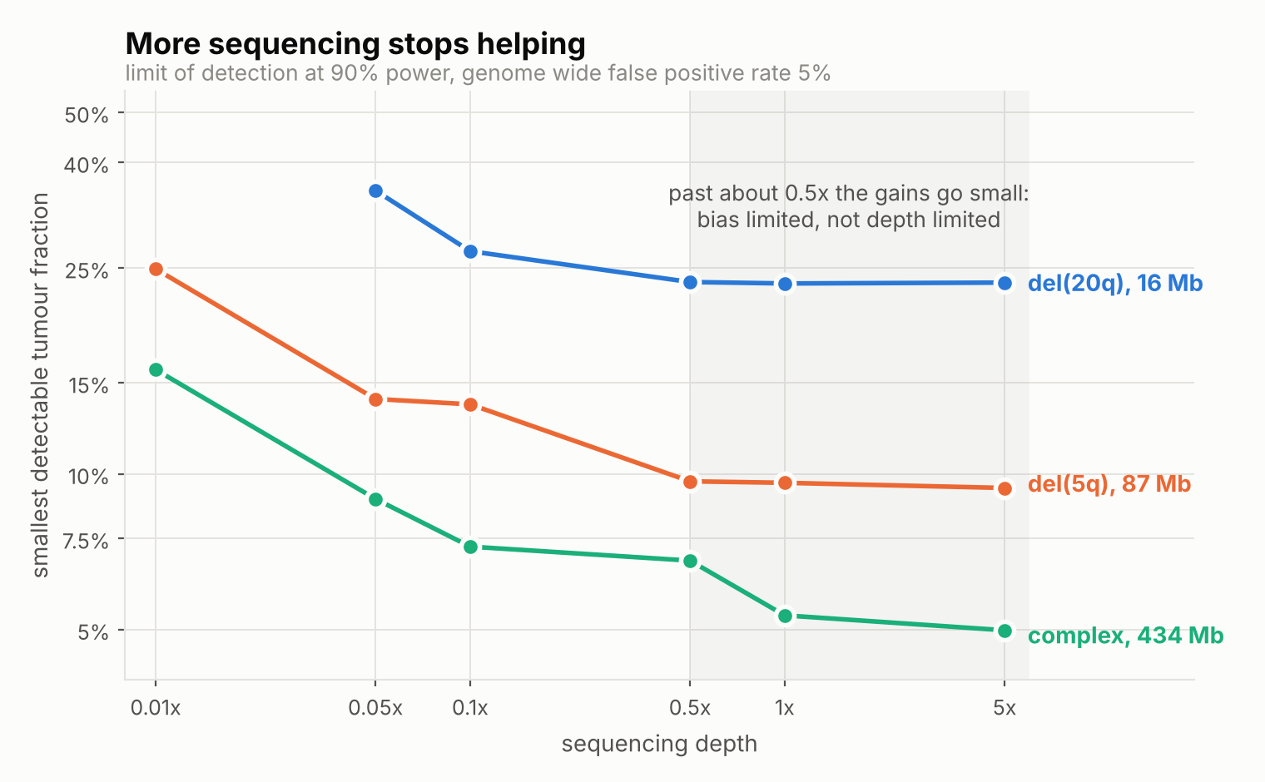
Limit of detection against sequencing depth at 90 percent power and a five percent genome-wide false positive rate. The curves flatten beyond approximately 0.5$×$, where library-to-library bias rather than counting noise becomes the limiting factor.
Table 2 gives the full surface. Increasing depth from 0.01$×$ to 0.1$×$ improves the detection limit by 45 to 58 percent, median 55. Increasing it from 0.5$×$ to 5$×$, a tenfold increase in sequencing cost, improves it by 0.3 to 27 percent, median 4.9, with six of eight lesions gaining under nine percent. The single large gain belongs to the complex karyotype, the easiest case, where the remaining headroom is comparable to the resolution of the tumour-fraction grid.
Smallest tumour fraction detected with 90 percent probability. “n.r.” denotes not reached at any tumour fraction up to 40 percent.
Lesion | 0.01$×$ | 0.05$×$ | 0.1$×$ | 0.5$×$ | 1$×$ | 5$×$
del(20q), 5.5 Mb | n.r. | n.r. | 39.5 | 37.8 | 37.2 | 37.0
del(20q), 16 Mb | n.r. | 35.3 | 27.0 | 23.5 | 23.3 | 23.4
del(13q), 33.5 Mb | 38.3 | 23.0 | 21.1 | 14.3 | 13.9 | 13.9
del(7q), 54 Mb | 35.9 | 22.1 | 16.3 | 13.7 | 13.4 | 12.8
del(5q), 86 Mb | 24.9 | 14.0 | 13.6 | 9.7 | 9.6 | 9.4
$+8$, 145 Mb | 23.7 | 13.1 | 10.0 | 8.1 | 7.3 | 7.4
$−7$, 159 Mb | 23.2 | 13.2 | 10.5 | 9.2 | 9.0 | 8.1
complex, 434 Mb | 15.9 | 8.9 | 7.2 | 6.8 | 5.3 | 5.0
The mechanism is visible in [eq:coverage]. At 0.01$×$ the per-bin Poisson variance dominates and additional reads reduce it directly. By 0.5$×$ the counting noise has fallen below the variance contributed by $u_{i}$, which does not shrink with depth at all. The practical implication is blunt: a laboratory running 1$×$ or 5$×$ cell-free DNA for cytogenetic purposes is purchasing coverage it cannot use, and the route past the plateau is a better reference panel or a different class of evidence rather than more reads.

Detection scales with the square root of lesion size
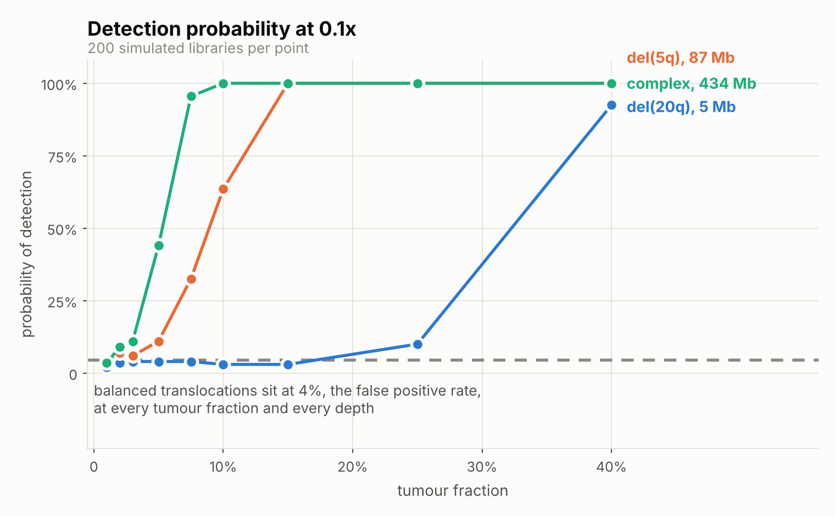
Detection probability against tumour fraction at 0.1$×$, with 200 simulated libraries per point. The dashed line is the false positive rate, where every balanced rearrangement sits regardless of tumour fraction.
Fitting the detection limit against lesion size on logarithmic axes gives a slope of $−0.40$ at 0.1$×$ and $−0.46$ at 5$×$, close to the $−0.5$ implied by [eq:stouffer]: the segment statistic grows as the square root of the number of bins averaged. Halving the detectable tumour fraction therefore requires a lesion four times larger. This is not a tuning deficiency but a property of averaging.
Localisation is not the limiting step. Among conditions at 0.1$×$ reaching 90 percent detection, calls covered at least half the true lesion in 94 percent of replicates. When the detector fires it fires in the right place; it does not fire often enough.

Balanced rearrangements are called at chance
Across all 108 copy-neutral conditions, four rearrangements by six depths by nine tumour fractions, mean detection was 5.3 percent against a five percent false positive rate, with a maximum of 11.5 percent and a regression slope on tumour fraction of $−0.007$, indistinguishable from zero.
This is the expected result and its absence would indicate a defect. The simulator confirms the premise directly: a balanced rearrangement at 90 percent tumour fraction yields a library numerically identical to a normal one under the same random seed.

The cost of junction-level evidence
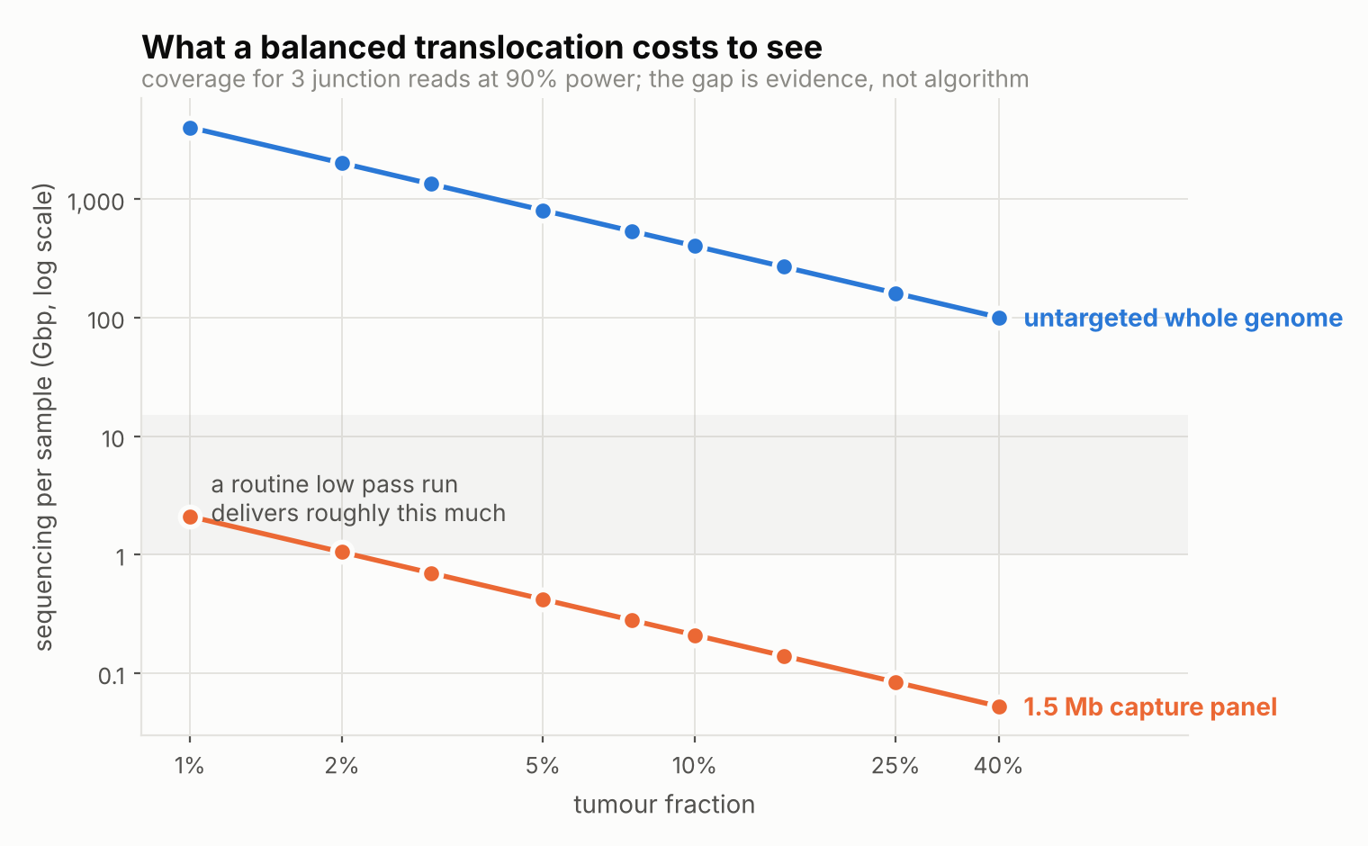
Sequencing required for three junction-spanning reads at 90 percent power, untargeted against a 1.5 Mb capture panel. The shaded band marks the yield of a routine low-pass run.
By [eq:junction], at 0.1$×$ and ten percent tumour fraction the expected usable junction evidence is 0.004 reads. This is not a detection probability of 0.004; it is four thousandths of a single read. Table 3 gives the coverage required for 90 percent power.
Sequencing required for three junction reads at 90 percent power.
Tumour fraction | Coverage | Untargeted (Gbp) | Capture (Gbp)
1% | 1400$×$ | 4339 | 2.10
2% | 700$×$ | 2170 | 1.05
5% | 280$×$ | 868 | 0.42
10% | 140$×$ | 434 | 0.21
25% | 56$×$ | 174 | 0.08
50% | 28$×$ | 87 | 0.04
A routine low-pass run delivers between one and 15 Gbp. Untargeted sequencing is short by two to three orders of magnitude. The recurrent haematological fusion breakpoints occupy approximately 1.5 Mb in total, 0.05 percent of the genome, so a capture panel tiling them concentrates coverage by a factor of about 2,000 and brings the same evidence within a fraction of a gigabase.

Discussion
The three findings have a common shape: each identifies a limit that is structural rather than algorithmic, and each therefore redirects effort rather than merely characterising it.
The plateau says that the marginal value of sequencing depth in this application collapses early. Any effort spent on deeper low-pass sequencing is better spent on reference-panel quality, since the panel is what removes the bias component that depth cannot touch.
The size scaling says that sub-arm lesions are outside the reach of untargeted low-pass sequencing at clinically interesting tumour fractions, and that no reasonable improvement in calling changes this, because the exponent follows from averaging rather than from implementation.
The junction calculation is the most consequential of the three, because it closes a line of enquiry. Detecting balanced rearrangements from untargeted low-pass cell-free DNA is not difficult, it is impossible at these budgets, and the impossibility is arithmetic rather than methodological. Fragmentomic approaches [12] remain interesting for detecting that an abnormal clone is present, but they cannot identify which rearrangement it carries, because that information is carried only by molecules that cross the junction.
What remains open is correspondingly narrower and more tractable. The design of a minimal capture panel covering the recurrent fusions is a pure optimisation problem on published breakpoint coordinates requiring no new data. Lowering the supporting-read threshold defensibly would reduce the required coverage proportionally. And the question of whether aggregate fragmentomic signal can flag clonal presence without localisation is untouched by anything here.

Limitations
The per-library bias standard deviation is a reasoned estimate rather than a fitted quantity, and it determines where the plateau sits. The existence of a plateau follows from any non-zero value, but the specific depth should be read as an order of magnitude. Fitting this parameter to real low-pass libraries is the single highest-value extension of this work.
Our detector is of the correct class but is not WisecondorX or ichorCNA, and a comparison against those implementations on the same simulated libraries is the obvious next step. The direction of any discrepancy is not obvious: a reimplementation may be weaker than a mature tool, but the genome-wide calibration used here is stricter on specificity than some published pipelines. The copy-neutral result is unaffected either way, since it depends on no implementation detail.
GC content and mappability are modelled rather than measured, lesions are clean where real karyotypes are subclonal and sometimes chromothriptic, and nothing here has been validated against a sample of known karyotype and measured tumour fraction. The study bounds what is possible under a stated model; it is not evidence about any particular assay. A complete limitations register is distributed with the code.

Conclusion
We measured, rather than assumed, what a bin-count copy-number caller can detect in low-pass cell-free DNA across the lesion sizes that matter in haematological malignancy. Sensitivity plateaus near 0.5$×$ because library-to-library bias rather than counting noise sets the floor; detection scales with the inverse square root of lesion size, placing sub-arm lesions outside reach at clinically relevant tumour fractions; and balanced rearrangements are detected at exactly the false positive rate, with junction-level evidence requiring coverage three orders of magnitude beyond a low-pass run unless that coverage is concentrated by capture. The copy-neutral blind spot is a problem of where the sequencing is pointed, not of how the reads are analysed.

Reproducibility
All code, simulated results, figures and the source of this manuscript are available at https://github.com/shubhodeepcx/low-pass-cfDNA under an MIT licence. The complete study runs in approximately five minutes on a laptop with no reference genome or alignment files required.
[1] H. Döhner, A. H. Wei, F. R. Appelbaum, et al., “Diagnosis and management of AML in adults: 2022 recommendations from an international expert panel on behalf of the ELN,” Blood, vol. 140, no. 12, pp. 1345–1377, 2022, doi: 10.1182/blood.2022016867.
[2] E. Bernard, H. Tuechler, P. L. Greenberg, et al., “Molecular international prognostic scoring system for myelodysplastic syndromes,” NEJM Evidence, vol. 1, no. 7, 2022, doi: 10.1056/EVIDoa2200008.
[3] Y. M. D. Lo, K. C. A. Chan, H. Sun, et al., “Maternal plasma DNA sequencing reveals the genome-wide genetic and mutational profile of the fetus,” Science Translational Medicine, vol. 2, no. 61, p. 61ra91, 2010, doi: 10.1126/scitranslmed.3001720.
[4] R. Straver, E. A. Sistermans, H. Holstege, A. Visser, C. B. M. Oudejans, and M. J. T. Reinders, “WISECONDOR: Detection of fetal aberrations from shallow sequencing maternal plasma based on a within-sample comparison scheme,” Nucleic Acids Research, vol. 42, no. 5, p. e31, 2014, doi: 10.1093/nar/gkt992.
[5] L. Raman, A. Dheedene, M. De Smet, J. Van Dorpe, and B. Menten, “WisecondorX: Improved copy number detection for routine shallow whole-genome sequencing,” Nucleic Acids Research, vol. 47, no. 4, pp. 1605–1614, 2019, doi: 10.1093/nar/gky1263.
[6] V. A. Adalsteinsson, G. Ha, S. S. Freeman, et al., “Scalable whole-exome sequencing of cell-free DNA reveals high concordance with metastatic tumors,” Nature Communications, vol. 8, p. 1324, 2017, doi: 10.1038/s41467-017-00965-y.
[7] F. Mitelman, B. Johansson, and F. Mertens, “The impact of translocations and gene fusions on cancer causation,” Nature Reviews Cancer, vol. 7, pp. 233–245, 2007, doi: 10.1038/nrc2091.
[8] Y. Benjamini and T. P. Speed, “Summarizing and correcting the GC content bias in high-throughput sequencing,” Nucleic Acids Research, vol. 40, no. 10, p. e72, 2012, doi: 10.1093/nar/gks001.
[9] A. M. Newman, A. F. Lovejoy, D. M. Klass, et al., “Integrated digital error suppression for improved detection of circulating tumor DNA,” Nature Biotechnology, vol. 34, pp. 547–555, 2016, doi: 10.1038/nbt.3520.
[10] C. Abbosh, N. J. Birkbak, G. A. Wilson, et al., “Phylogenetic ctDNA analysis depicts early-stage lung cancer evolution,” Nature, vol. 545, pp. 446–451, 2017, doi: 10.1038/nature22364.
[11] M. W. Snyder, M. Kircher, A. J. Hill, R. M. Daza, and J. Shendure, “Cell-free DNA comprises an in vivo nucleosome footprint that informs its tissues-of-origin,” Cell, vol. 164, no. 1–2, pp. 57–68, 2016, doi: 10.1016/j.cell.2015.11.050.
[12] S. Cristiano, A. Leal, J. Phallen, et al., “Genome-wide cell-free DNA fragmentation in patients with cancer,” Nature, vol. 570, pp. 385–389, 2019, doi: 10.1038/s41586-019-1272-9.
[13] Shubhodeep, “Low-pass-cfDNA: Detectability of cytogenetic lesions in low-pass cell-free DNA.” https://github.com/shubhodeepcx/low-pass-cfDNA, 2026.
[14] S. A. Stouffer, E. A. Suchman, L. C. DeVinney, S. A. Star, and R. M. Williams, The american soldier: Adjustment during army life. Princeton University Press, 1949.
[15] A. B. Olshen, E. S. Venkatraman, R. Lucito, and M. Wigler, “Circular binary segmentation for the analysis of array-based DNA copy number data,” Biostatistics, vol. 5, no. 4, pp. 557–572, 2004, doi: 10.1093/biostatistics/kxh008.

