Shubhom Bhattacharya

Kaggle Team: @shubhomb

ECE 4250: Digital Signal Processing

15 May 2019

Final Report

1. **Introduction**

In Milestone 2, a method for middle-coronal registration and segmentation was realized using 6 training and 2 validation samples, each of which had a manually segmented and non-segmented version. The general structure of the resulting pipeline was as follows:

1. Image preprocessing
2. Registering training (moving) images to validation (fixed)
   1. Image transformation
   2. Interpolation
   3. Optimization on defined objective
3. Applying optimal transformation parameters to corresponding segmentations
4. Label fusion strategy
5. Similarity metric (e.g. Jaccard) between automatic and manual segmentation

Inside of this setup several parts were tunable and modifiable to achieve a better resultant automatic segmentation, and the goal of Milestone 3 was to find a setup that resulted in a relatively high Jaccard overlap. Throughout this process, visualization of the processing, registration, and segmentation procedures was crucial to determining the effectiveness of each procedure.

1. **Image preprocessing**

The first significant improvement to the pipeline was max-intensity normalizing each image before inputting it into any optimization method. This greatly accelerated the optimization procedure runtime and in running the program yielded outputs that yielded a lower sum-of-squared differences (SSD) objective. It seemed that the derivative-free optimization methods used were better equipped for floating point arithmetic in the range [0,1] provided by max-intensity normalization.

Another candidate preprocessing technique was a Gaussian smoothing of the fixed and moving images. The motivation for this was that individual scans of the brain, however well aligned, will exhibit some innate differences. By applying a Gaussian smoothing kernel with sufficiently low variance σ, each image loses some very high frequency components that are unimportant in the segmentation problem, and thus can be disregarded. Ideally, this provides a more robust registration/segmentation pipeline that’s less sensitive to discrepancies between training images and testing images, thereby preventing the segmentation outputs from being overfitted to the training images. On the other hand, a large σ for the Gaussian kernel is undesirable as the registration becomes meaningless if the boundary regions for the regions of interest (or the scan itself) are indistinguishable, so a smaller σ (corresponding to the 3x3 or 5x5 kernel) is more suitable.

The next preprocessing technique considered was histogram equalization of intensities. For this task , two popular histogram equalization techniques were considered: the exact histogram equalization (EHE) algorithm covered in class and the contrast-limited adaptive histogram equalization (CLAHE) algorithm. For the image registration task in MRI-scans, CLAHE is preferred over EHE because EHE produces unnecessarily high contrasts and transforms intensity relative to global statistics. The registration SSD error for all images using CLAHE as opposed to EHE was significantly smaller. Interestingly, EHE made the registration error worse than that without any histogram equalization by approximately 10-20% per image, while CLAHE improved upon it by about 15%, so CLAHE was kept. Note that these approximate improvements are dependent on other image preprocessing decisions. The chosen parameters for the CLAHE procedure were 8x8 tile size with a clip limit of 2.0, which are the default of the OpenCV package. This meant that in the resulting histogram, the a pixel neighborhood consisted of the 8x8 region in which it was centered and that the top of the histogram was plateaued at an intensity equal to twice the minimum intensity of the neighborhood, with the histogram redistributed when an intensity pushes the peak over the clip limit.

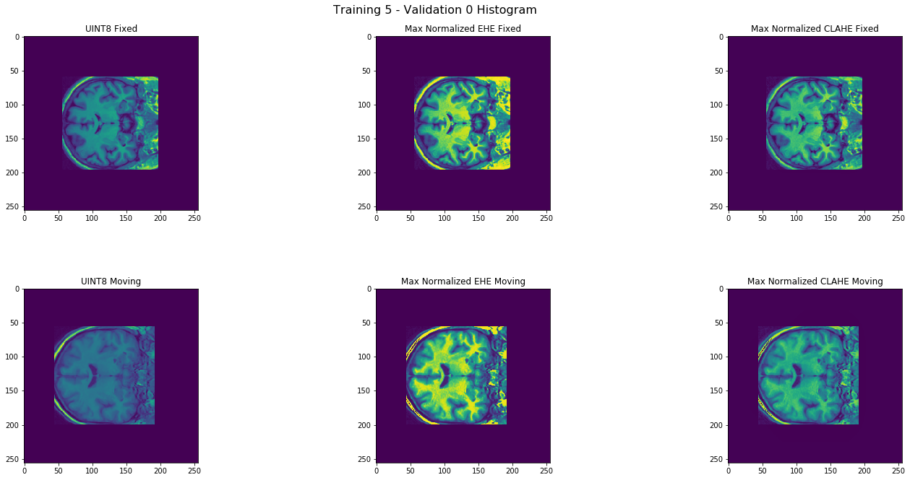

1. **Image registration**

In the registration problem, a moving image and a fixed image should be aligned as closely as possible. The objective function used to determine how close two images are was the SSD, with an added regularization term γ in Milestone 3 to encourage small transformation parameters, though this did not have a significant effect on registration results. In Milestone 2, a geometric transformation (rotation, scale, 2-D shift) was considered. In Milestone 3, a 2-D scaling was enabled and the general class of affine transformations was considered. In most cases, the provided training/validation images were similarly scaled to begin with so scale parameters were between 0.9 and 1.1 in both directions.

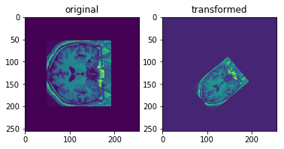

For the optimization routine used in the registration, a derivative-free algorithm was deemed desirable in place of a derivative-based method like gradient descent. The Nelder-Mead simplex method covered in class was the first considered algorithm, but this method was slower than the Powell conjugate direction method favored in Milestone 3. To ensure better optimization results, 1,000 iterations were allowed (though no registration took 1,000 iterations) and the convergence criterion parameter was decreased to 10-7.

1. **Label fusion strategies**

The original mode-based label fusion strategy was naïve, taking a mode of the segmentation of the training images to decide the labels of the output segmentation.

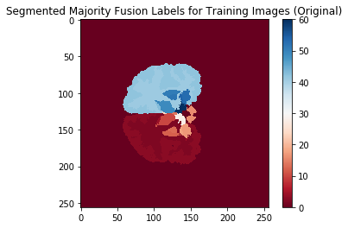

The next step was to reduce uncertainty by having labels in the majority vote with discrepancy removed. After taking the mode of the segmentations produced by the training images, the pixels with disagreement over some “bound” parameter were removed. This occurred most often near the boundaries of ROIs, as can be seen in the image below:

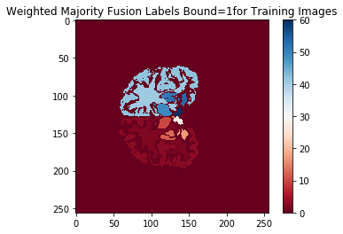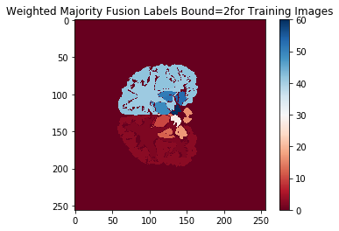

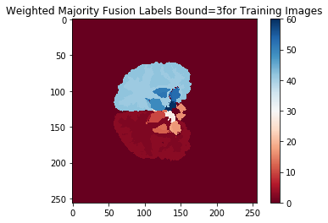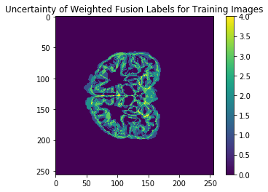

The intuition behind this modified voting process was that the “agreed upon” regions of overlap would prevent false negatives from occurring in the segmentation near boundary regions.

One last strategy for maintaining contiguous predicted segmentations was attempting to remove disconnected pixels from consideration. For example, in the final binary mask of the ROI, a small number pixels far from the actual ROI were active, presumably as a byproduct of ambiguity in validation label votes or a processing step. Pixels with fewer than a threshold number of active neighbors were turned off, using a sum filter convolved on the binary segmentation result that decided which pixels had enough active neighbors to remain in the image.

1. **Conclusions and Future Work**

The test subjects given were registered with respect to the training and validation images, and compared with the manual test segmentations held by the course instructors. Upon submission of several different results, it seemed that the Dice score was nearly 0.66, corresponding to a test Jaccard overlap of around 0.49 on average for the test results, a 0.14 improvement on the competition baseline of 0.35. Furthermore, the Jaccard overlap of the validation segments from Milestone 2 yielded scores around 0.2, so Milestone 3 saw significant improvement in the registration and segmentation pipeline.

This project gave students a chance to apply several ECE 4250 concepts to a real application, with a challenge to maximize the testing segmentation results. There are several areas I would research and implement further given more time to explore. First, there are a litany of hyperparameters to tune in each step of the process, and more complex methods introduce even more hyperparameters, so either manually tuning these or using automatic means such as Bayesian optimization over the hyperparameter space would be an interesting point of enquiry. Additionally, even though I attempted to improve the voted label fusion technique, both methods were somewhat crude and another point of research would be to find a more elegant solution to that: for example, it could be that one training image is contributing to more noise, for example, and a weighted scheme would ideally take that into account. Next, with regards to the segmentation problem, it is possible that machine-learning methods in computer vision such as convolutional neural networks (CNN) could find a mapping between the space of pixel intensities by pixel position to the space of pixel segmentation labels, providing an end-to-end solution that, due to spatial invariance introduced in these methods, may bypass the registration problem altogether. Given only 6 training examples, machine learning methods may be prone to overfitting themselves, but exploring this area with deep learning or traditional ML methods may provide more insights.