Tourism Experience Analytics
Classification, Prediction, and Recommendation System

Project Report
Prepared by: Shubhra Das
Date: 25 Feb 2026
Domain: Tourism Analytics

Skills demonstrated: Data Cleaning & Preprocessing • EDA & Visualization • SQL (DuckDB) • Machine Learning (Regression, Classification, Recommendation) • Streamlit Deployment

Table of Content
1. Executive Summary 1
2. Business Problem and Objectives 1
2.1 Problem Statement 1
2.2 Business Use Cases 1
2.3 ML Tasks 1
3. Dataset Description 1
3.1 Tables and Size (from execution output) 1
3.2 Core Columns Used 1
4. Data Cleaning, Integration, and Feature Engineering 1
4.1 Data Cleaning 1
4.2 Data Integration (JOINs) 1
4.3 Feature Engineering 1
5. Exploratory Data Analysis (EDA) 1
5.1 Univariate Charts (U) 1
5.2 Bivariate Charts (B) 1
5.3 Multivariate Charts (M) 1
6. Modeling and Evaluation 1
6.1 Regression: Predict Rating 1
Regression Model Comparison (test-set metrics) 1
Best Regression Model (Gradient Boosting) – Additional Metrics 1
6.2 Classification: Predict VisitMode 1
Classification Model Comparison (test-set metrics) 1
6.3 Recommendation System 1
Saved Recommender Artifacts 1
7. SQL Analytics (DuckDB) 1
8. Deployment: Streamlit Application 1
8.1 App Capabilities 1
8.2 How to Run 1
9. Results and Key Insights 1
9.1 Key Results 1
9.2 Business Interpretation 1
10. Limitations and Future Enhancements 1
10.1 Limitations 1
10.2 Future Work 1
Appendix A. Artifact Inventory 1
Artifacts (joblib) 1
Appendix B. Screenshot Checklist 1

1. Executive Summary
Tourism platforms generate rich interaction data (who visited which attraction, when, how, and how they rated the experience). This project builds an end-to-end analytics pipeline that converts multi-table tourism data into three decision engines: (1) rating prediction (regression), (2) visit-mode prediction (classification), and (3) personalized recommendations (hybrid recommender).
The solution includes data cleaning and integration, feature engineering, exploratory analysis (UBM rule), model training and evaluation, and deployment via a Streamlit app. Trained models and recommender artifacts are saved as joblib files for repeatable inference.

2. Business Problem and Objectives

2.1 Problem Statement
Item | Details
Problem | Enhance user experience by predicting satisfaction, classifying visit behavior, and recommending relevant attractions.
Why it matters | Better personalization improves engagement, conversion, and retention for tourism platforms.

2.2 Business Use Cases
- Personalized Recommendations: Suggest attractions based on user history and similarity signals.
- Tourism Analytics: Identify popular attractions, peak months, and regional trends to guide offerings and marketing.
- Customer Segmentation: Use visit behavior and predicted modes to target promotions more effectively.
- Retention: Improve loyalty through relevant suggestions and proactive experience management (e.g., low-rating risk).

2.3 ML Tasks
Task | Goal
Regression | Predict Rating (1–5) for a given user-attraction context.
Classification | Predict VisitMode (Business, Couples, Family, Friends, Solo).
Recommendation | Recommend Top-N attractions using collaborative filtering, content similarity, and hybrid scoring.

3. Dataset Description
The dataset is provided as multiple tables (transactions plus dimension/lookup tables). Excel files were converted to CSV for processing.

3.1 Tables and Size (from execution output)
Table | Rows | Notes
Transaction | 52,930 | User visits with ratings and visit context
User | 33,530 | User geography attributes (continent/region/country/city)
City | 9,143 | City names + country mapping
Item (Attractions) | 30 | Attraction details and addresses
Type | 17 | Attraction type lookup
Mode | 6 | VisitMode lookup (Business/Couples/Family/Friends/Solo)
Country | 165 | Country lookup with region mapping
Region | 22 | Region lookup with continent mapping
Continent | 6 | Continent lookup

3.2 Core Columns Used
- Transaction: TransactionId, UserId, VisitYear, VisitMonth, VisitMode, AttractionId, Rating
- User: UserId, ContinentId, RegionId, CountryId, CityId
- Item: AttractionId, AttractionCityId, AttractionTypeId, Attraction, AttractionAddress

4. Data Cleaning, Integration, and Feature Engineering

4.1 Data Cleaning
- Converted .xlsx files to .csv and loaded all tables into Pandas dataframes.
- Standardized column names (trim spaces, remove special characters).
- Converted key fields to numeric types safely (UserId, AttractionId, VisitYear, VisitMonth, Rating).
- Clipped Rating to the expected range (1 to 5).
- Dropped rows missing essential identifiers (UserId or AttractionId).

4.2 Data Integration (JOINs)
A consolidated dataset was created using the following join keys:
- transactions + users on UserId
- merged result + items on AttractionId
- cities joined twice to add UserCityName and AttractionCityName
- types joined to add AttractionType
- visit_modes joined to map VisitModeId to VisitMode label
Resulting consolidated dataset: 52,930 rows × 18 columns (before feature engineering).

4.3 Feature Engineering
To improve predictive power and support personalization, the following engineered features were added:
- Missing value handling: categorical missing → 'Unknown'; numeric missing → median (excluding Rating).
- User-level aggregates: user_rating_count, user_rating_mean, user_rating_std.
- Attraction-level aggregates: attraction_rating_count, attraction_rating_mean.
After feature engineering: 52,930 rows × 23 columns. Saved as master_cleaned.csv.

Figure 1. Data pipeline overview
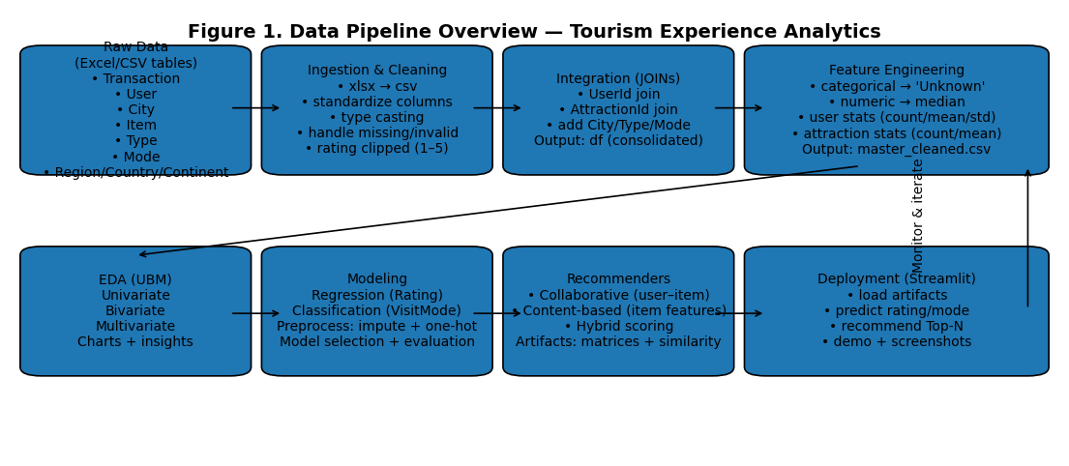

5. Exploratory Data Analysis (EDA)
EDA followed the U-B-M rule (Univariate, Bivariate, Multivariate) to surface distribution patterns, relationships, and segment-level behavior.

5.1 Univariate Charts (U)
- Rating distribution histogram (overall satisfaction profile).
- Visits by month (seasonality).
- Top attractions by visit count (popularity).
- Top countries by visit count (market concentration).
Figure 2. Rating Distribution (U)

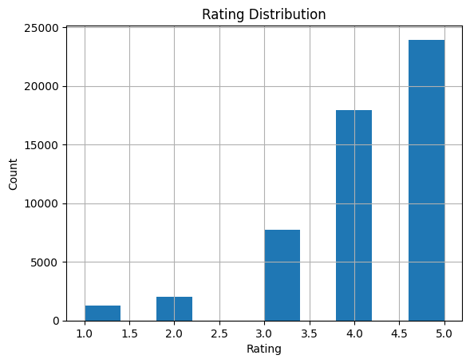

Figure 3. Visits by Month (U)

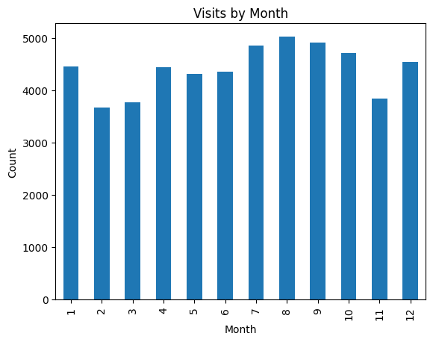

5.2 Bivariate Charts (B)
- Average rating by VisitMode (which trip types report higher satisfaction).
- Boxplot: rating distribution by AttractionType (variation across attraction categories).
- Visits over years and average rating trend over years.
Figure 4. Avg Rating by VisitMode (B)

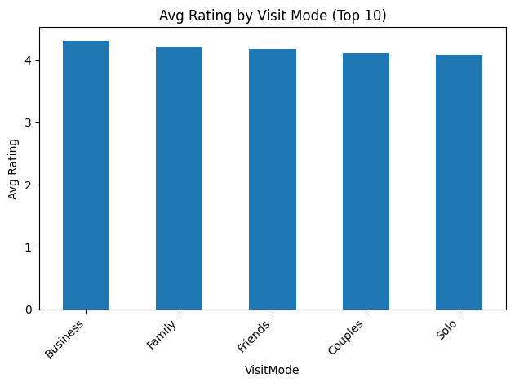

Figure 5. Rating by AttractionType (B)
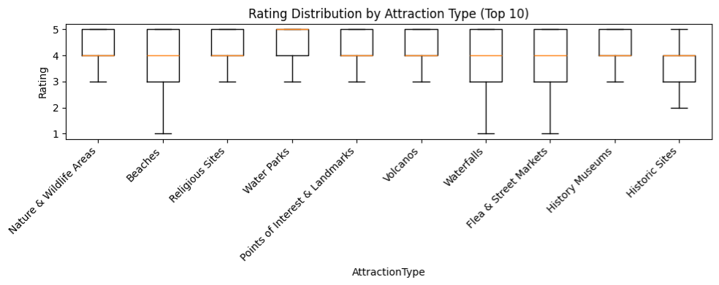

5.3 Multivariate Charts (M)
- Heatmap: Avg rating by VisitMode × AttractionType (interaction effects).
- Stacked bars: VisitMode mix by month (seasonality + segment mix).
- Bubble plot: AttractionType × Month (size=count, color=avg rating).
Figure 6. Heatmap: VisitMode × AttractionType (M)

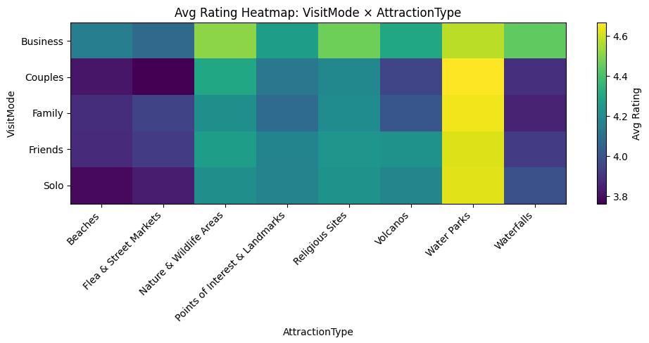

Figure 7. VisitMode Mix by Month (M)
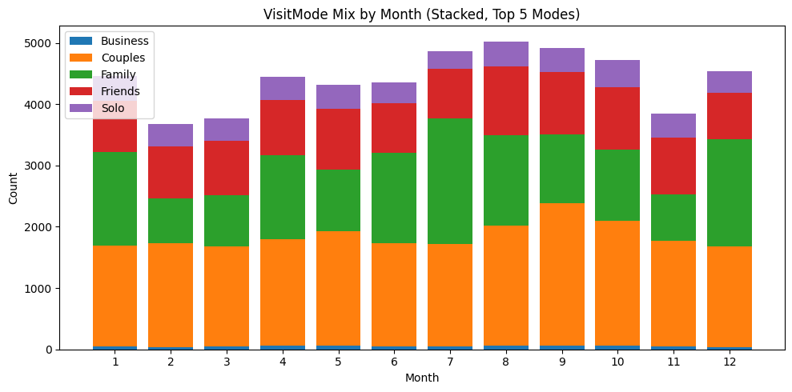

6. Modeling and Evaluation

6.1 Regression: Predict Rating
Target: Rating (1–5). Pipeline steps: numeric imputation (median) + categorical imputation (most frequent) + one-hot encoding, followed by model training.

Regression Model Comparison (test-set metrics)
Model | Metric (as computed) | Value | Notes
GradientBoostingRegressor | MSE (labeled RMSE in notebook) | 0.236257 | Best model selected (lowest error, strong R²)
LinearRegression | MSE | 0.247340 | Strong baseline; interpretable coefficients
RandomForestRegressor | MSE | 0.282296 | Non-linear model; slightly higher error
BaselineMean | MSE | 0.941818 | Sanity-check baseline

Best Regression Model (Gradient Boosting) – Additional Metrics
Metric | Value
MAE | 0.264200
R² | 0.749148

Saved artifact: artifacts/rating_regression_model.joblib

6.2 Classification: Predict VisitMode
Target: VisitMode. Features exclude VisitMode, TransactionId, and Rating to reduce leakage. Pipeline uses numeric imputation + one-hot encoding, then trains multiple classifiers.

Classification Model Comparison (test-set metrics)
Model | Accuracy | Macro F1 | Notes
RandomForestClassifier | 0.523238 | 0.423752 | Best model selected by Macro F1
GradientBoostingClassifier | 0.482052 | 0.295704 | Lower overall performance
LogisticRegression | 0.401568 | 0.152070 | Baseline linear classifier
BaselineMostFreq | 0.408464 | 0.116003 | Sanity-check baseline

Saved artifact: artifacts/visitmode_classifier.joblib
Figure 8. Confusion Matrix for VisitMode (Classification)
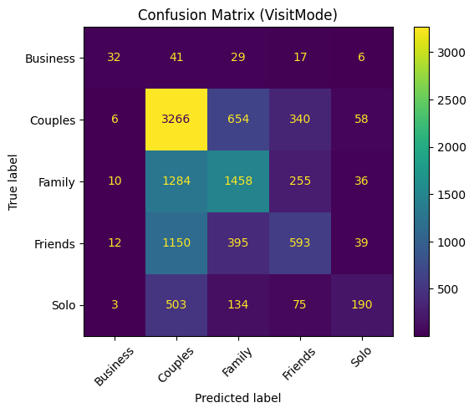

6.3 Recommendation System
Three recommenders were built: collaborative filtering (user-item ratings), content-based similarity (attraction attributes), and a hybrid model that blends both.
Recommendation components:
- Collaborative filtering: user-item matrix with cosine similarity (item-item).
- Content-based: one-hot encoded attraction features (type/city/region/country/continent) + cosine similarity.
- Hybrid scoring: weighted sum of normalized collaborative scores and content similarity boosts for liked items.

Saved Recommender Artifacts
Artifact | Purpose
user_item_matrix.joblib | User × Attraction rating matrix
item_similarity_collab.joblib | Item-item cosine similarity matrix (collaborative)
item_similarity_content.joblib | Item-item similarity matrix (content-based)

7. SQL Analytics (DuckDB)
DuckDB was used to run SQL directly against the consolidated dataframe for fast, reproducible analysis (e.g., top attractions, average rating by category, market distribution).

Sample SQL placeholders (add your final queries):
- Q1: Top attractions by average rating and count
- Q2: Visits by month and visit mode (seasonality)
- Q3: Country/region-wise visit volume
Figure 9. SQL Output (optional)
Top attractions by avg rating:
 | AttractionId | avg_rating | n
0 | 947 | 4.698795 | 83
1 | 841 | 4.646601 | 6429
2 | 888 | 4.611549 | 381
3 | 928 | 4.571429 | 28
4 | 1133 | 4.503704 | 135
5 | 920 | 4.318182 | 44
6 | 481 | 4.275665 | 2104
7 | 640 | 4.267086 | 13198
8 | 1278 | 4.256646 | 978
9 | 824 | 4.219411 | 3359
VisitMode distribution:
 | VisitMode | visits
0 | Couples | 21620
1 | Family | 15217
2 | Friends | 10945
3 | Solo | 4525
4 | Business | 623

8. Deployment: Streamlit Application
A Streamlit application was developed to demonstrate end-to-end usage: predicting VisitMode, predicting Rating, and generating Top-N attraction recommendations.

8.1 App Capabilities
- Predict VisitMode for a selected record or manually entered inputs (aligned to training feature columns).
- Predict Rating (1–5 scale) using the best regression pipeline.
- Generate hybrid recommendations using collaborative + content signals.
- Uses saved joblib artifacts for fast, repeatable inference.

8.2 How to Run
- Place app.py, master_cleaned.csv, and artifacts/ in the same project folder.
- Create/activate a Python environment with versions aligned to the artifacts (scikit-learn 1.6.1 recommended).
- Install dependencies (streamlit, pandas, numpy, scipy, scikit-learn, joblib).
- Run: streamlit run app.py
Figure 10. Streamlit UI – Predictions + Recommendations
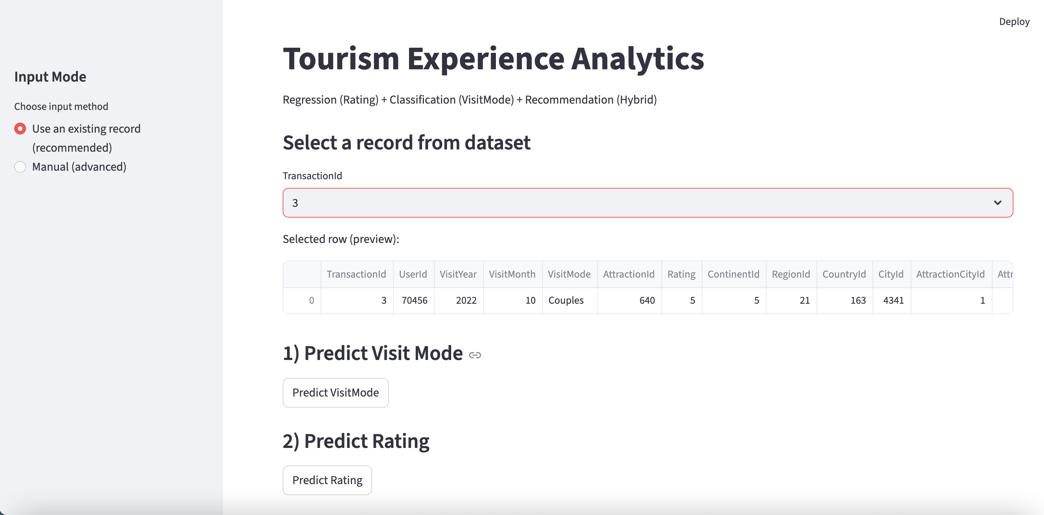
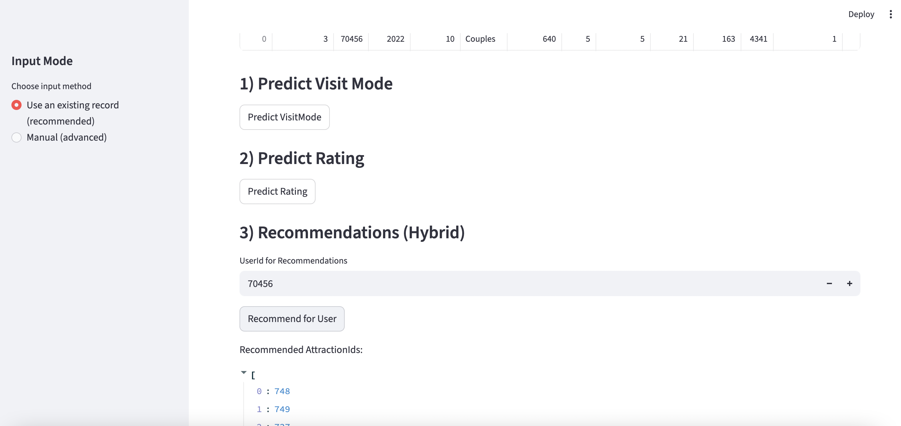
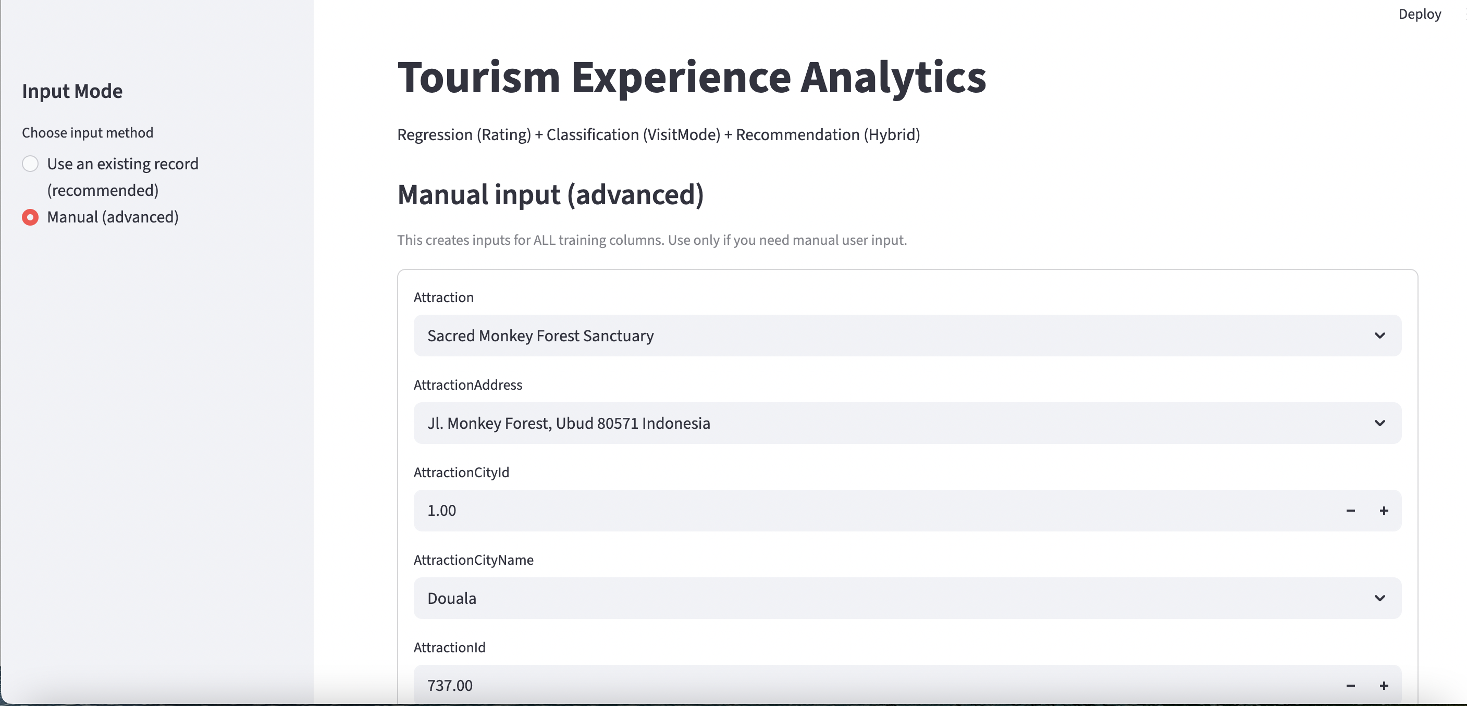

9. Results and Key Insights

9.1 Key Results
- Regression achieved strong predictive performance (R² ≈ 0.75) with Gradient Boosting, enabling satisfaction prediction and risk identification.
- Classification achieved moderate performance (Accuracy ≈ 0.52, Macro F1 ≈ 0.42), with opportunities to improve minority-class recognition via balancing.
- Hybrid recommendations produced meaningful Top-N suggestions and worked reliably in the deployed Streamlit app.

9.2 Business Interpretation
- Use predicted low ratings to trigger proactive interventions (expectation setting, improved service, alternative suggestions).
- Use predicted visit mode to tailor packages and messaging (family-friendly, couples experiences, business itinerary).
- Use recommendations to increase engagement and conversion (homepage, emails, in-app suggestions).

10. Limitations and Future Enhancements

10.1 Limitations
- Class imbalance can reduce VisitMode prediction quality for minority categories.
- Small number of attractions may limit recommender diversity; quality improves with more item variety.
- Ratings can be skewed toward high values, reducing sensitivity to subtle preference shifts.

10.2 Future Work
- Handle class imbalance (class weights, resampling) and add richer behavioral signals for classification.
- Improve recommender evaluation: hit-rate@K, coverage, novelty/diversity, and online A/B testing.
- Add monitoring for drift (ratings and visit patterns over time) and re-train on schedule.
- Deploy to Streamlit Cloud with pinned requirements to guarantee artifact compatibility.

Appendix A. Artifact Inventory

Artifacts (joblib)
File | Description
rating_regression_model.joblib | Best regression pipeline for predicting Rating
visitmode_classifier.joblib | Best classification pipeline for predicting VisitMode
user_item_matrix.joblib | User × Attraction matrix used for collaborative filtering
item_similarity_collab.joblib | Item-item similarity (collaborative)
item_similarity_content.joblib | Item-item similarity (content-based)

Appendix B. Screenshot Checklist
- EDA: Rating distribution, visits-by-month, avg rating by visit mode, heatmap.
- Models: Regression comparison table, classification report, confusion matrix.
- Streamlit: Home page + prediction outputs + recommendation output.
- SQL: at least one DuckDB query output table.

