1. Create IAM role > lambda > ec2 full access > create

2. lambda > create function(STOP) > author from scratch > runtime(python 3.9 latest) >x86-64 > existing role select > create > paste scripts

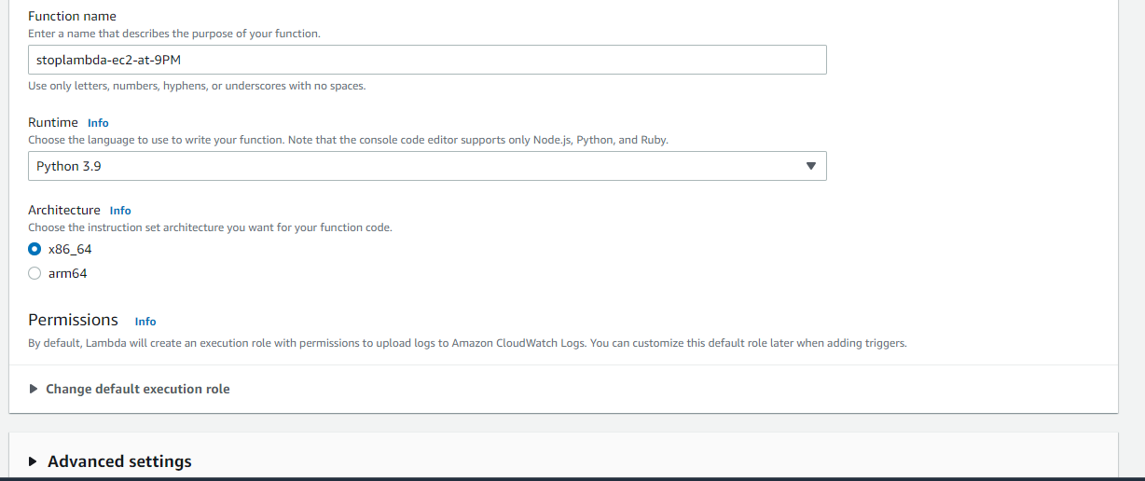

import boto3

region = 'us-west-1a'

instances = ['i-12345cb6de4f78g9h', 'i-08ce9b2d7eccf6d26']

ec2 = boto3.client('ec2', region_name=region)

def lambda_handler(event, context):

ec2.stop_instances(InstanceIds=instances)

print('stopped your instances: ' + str(instances))

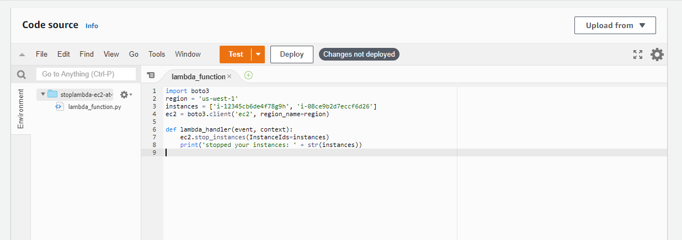

//change region & instance id only//

Then deploy & test > create new rule > private > save > test again (instance will be stopped)

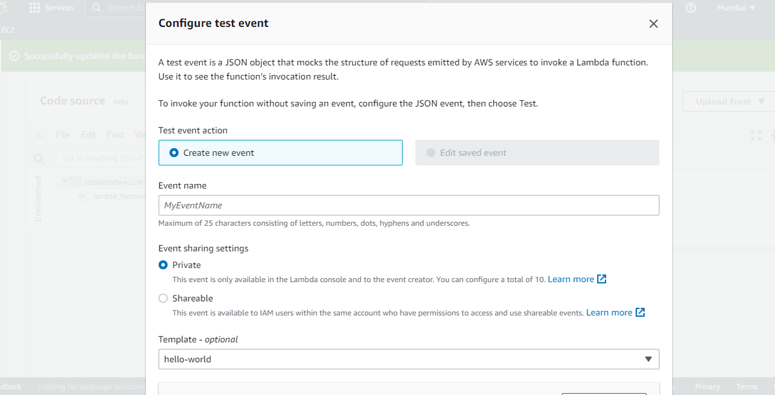

lambda > create function (START)> author from scratch > runtime(python 3.9 latest) >x86-64 > existing role select > create > paste scripts

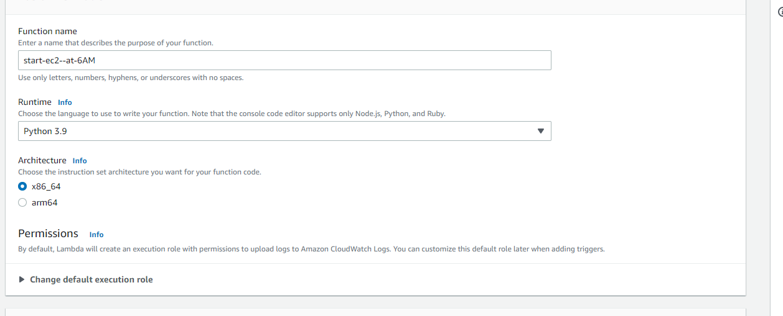

import boto3

region = 'us-west-1a'

instances = ['i-12345cb6de4f78g9h', 'i-08ce9b2d7eccf6d26']

ec2 = boto3.client('ec2', region_name=region)

def lambda_handler(event, context):

ec2.start_instances(InstanceIds=instances)

print('started your instances: ' + str(instances))

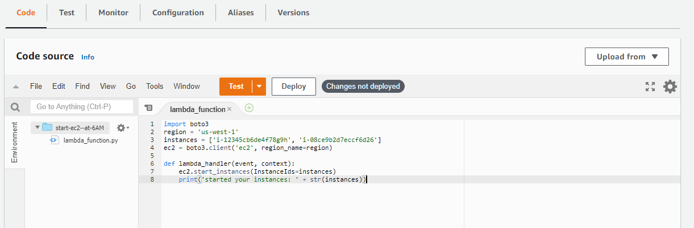

Then deploy & test > create new rule > private > save > test again (instance will be started)

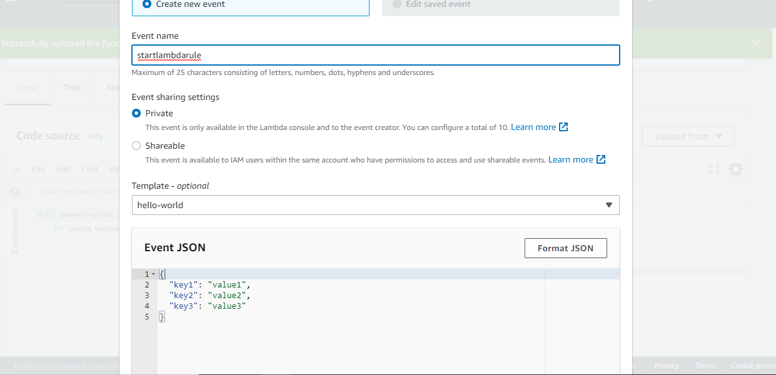

1. Lambda > add trigger > select (eventbridge) > create new rule > shedule expression > use crontab ( UTC time when you want to start or stop) > add

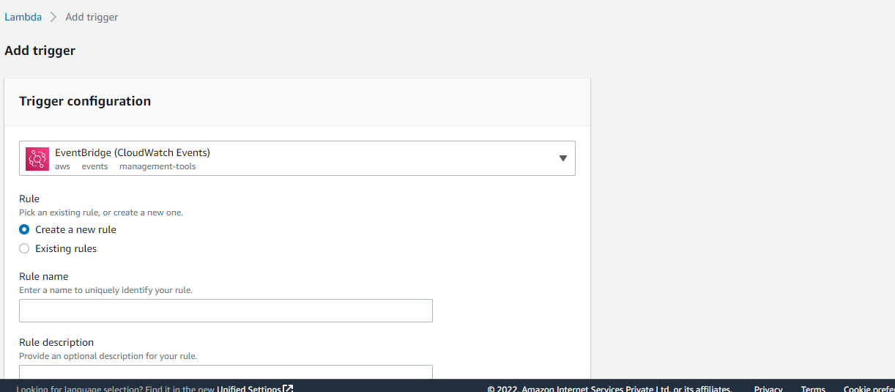

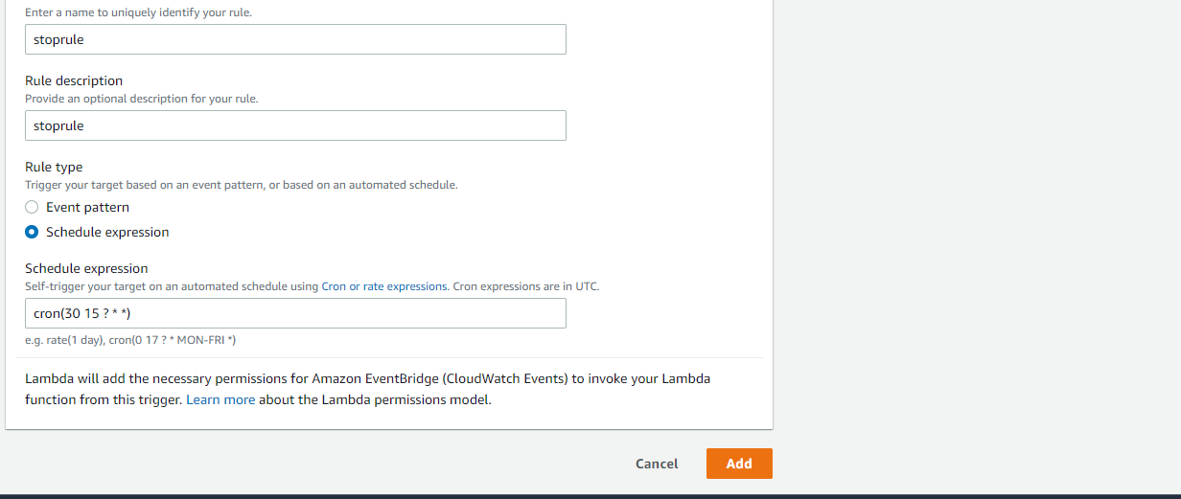

EX: Cron(30 15 ? * * *) // 30-minute, 15- o’clock, UTC-3:30 PM, IST-9PM

For pm 24 hours window for ex 11:30 PM – 30 23 ? * * * -utc 11:30 PM and 5 am ist

12pm ist - 6:30 pm utc – 30 6 ? * * *

Same as for start also:

Firstly change IST to UTC time after that check expression in <https://crontab.cronhub.io/>

<https://crontab.cronhub.io/> - for time confirmation

*** Check start and stop next day(AMI)

*** Check backup also next day(AMI)