Sudo su

Cd

**APACHE2**

apt update -y

sudo apt-get install apache2

sudo apt install apache2 libapache2-mod-fcgid -y //// For PHP-FPM

systemctl status apache2

systemctl enable apache2

http://your_server_ip

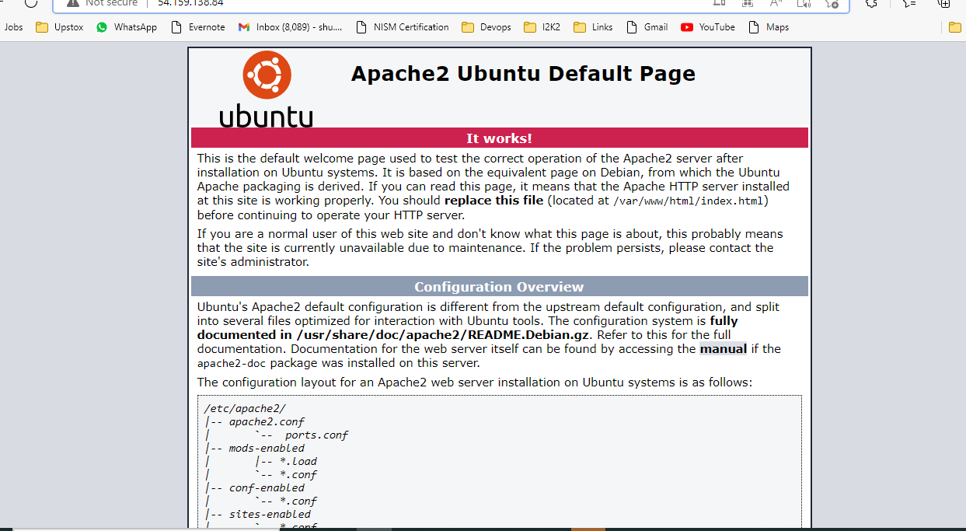

// If you do not know what your server’s public IP address

ip addr show eth0 | grep inet | awk '{ print $2; }' | sed 's/\/.*$//'

**MYSQL**

sudo apt install mysql-server

sudo apt install mysql-client

sudo mysql_secure_installation

y

2

Password

New password

sudo mysql

ALTER USER 'root'@'localhost' IDENTIFIED WITH mysql_native_password BY 'Qwer1234!'; ///To reset password///

flush privileges;

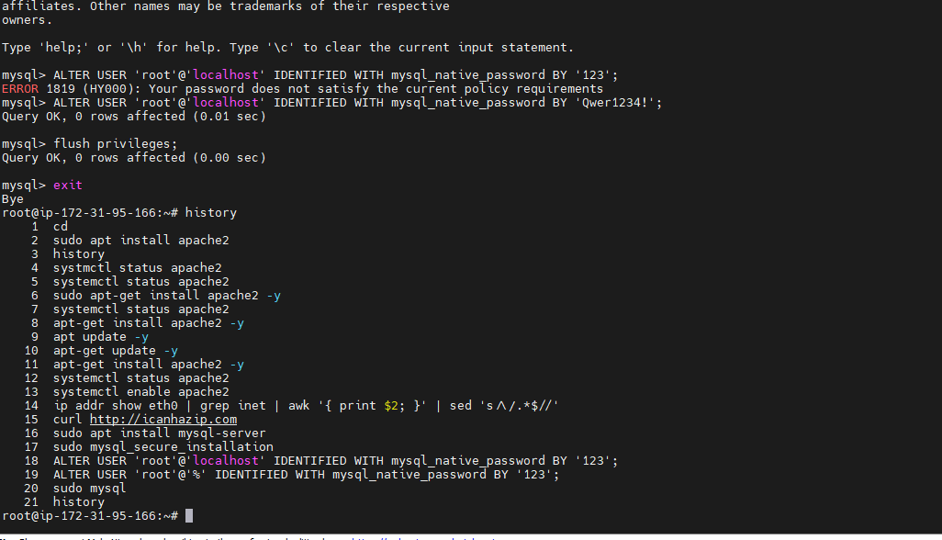

systemctl enable mysql

systemctl status mysql

**PHP-FPM**

sudo apt install software-properties-common

enter

sudo add-apt-repository ppa:ondrej/php

apt update -y

sudo apt install php7.4 php7.4-fpm –y

sudo a2enmod actions fcgid alias proxy_fcgi

sudo vim /etc/apache2/sites-available/000-default.conf

<VirtualHost *:80>

ServerName example.com

ServerAlias www.example.com

DocumentRoot /var/www/html

<Directory /var/www/html>

Options -Indexes +FollowSymLinks +MultiViews

AllowOverride All

Require all granted

</Directory>

<FilesMatch \.php$>

# 2.4.10+ can proxy to unix socket

SetHandler "proxy:unix:/var/run/php/php7.4-fpm.sock|fcgi://localhost"

</FilesMatch>

ErrorLog ${APACHE_LOG_DIR}/error.log

CustomLog ${APACHE_LOG_DIR}/access.log combined

</VirtualHost

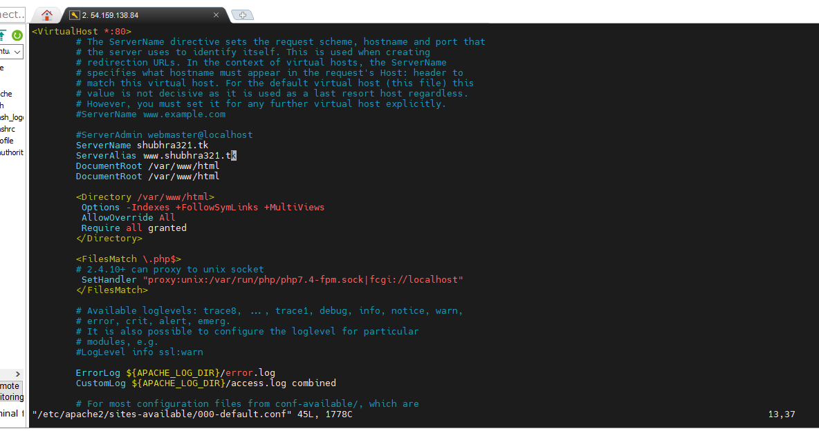

echo "<?php phpinfo(); ?>" > /var/www/html/info.php

systemctl restart apache2

To verify: 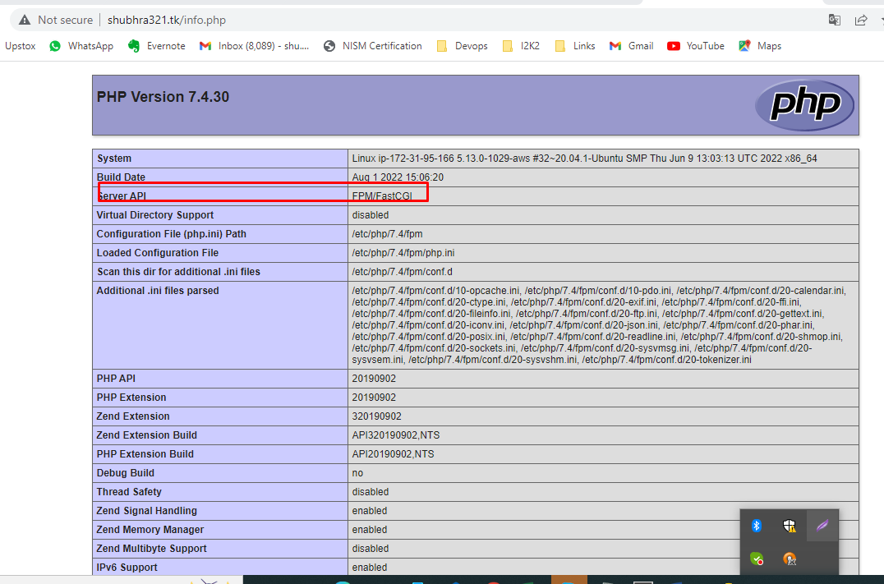

**APACHE2+MARIADB+PHP+PHPMYADMIN**

apt update -y

apt-get install apache2 -y

systemctl enable apache2

systemctl status apache2

apt-get install wget unzip -y

apt-get install mariadb-server –y

apt-get install mariadb-client –y

systemctl enable --now mariadb

mysql_secure_installation

Give password then Y

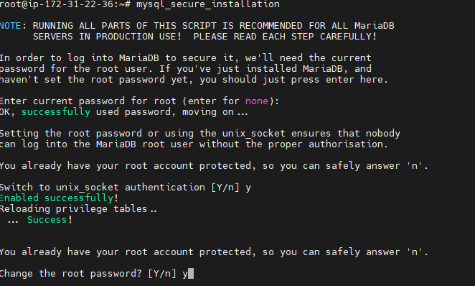

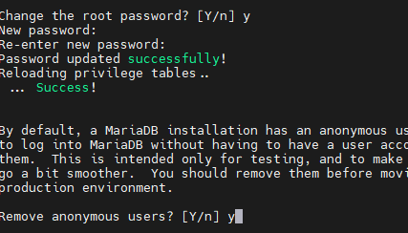









mysql -u root –p (Given Password)

apt-get install php*

apt install php php-mysql php-gd php-cli php-common -y

cd /var/www/html

vim info.php

<?php

phpinfo()

?>

apt-get install php7* -y

wget https://files.phpmyadmin.net/phpMyAdmin/4.4.5/phpMyAdmin-4.4.5-all-languages.zip

unzip phpMyAdmin-4.4.5-all-languages.zip

sudo apt install phpmyadmin php-mbstring php-zip php-gd php-json php-curl

Y

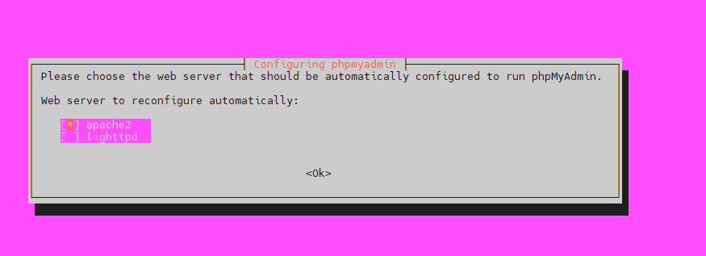

Space and tab then ENTER

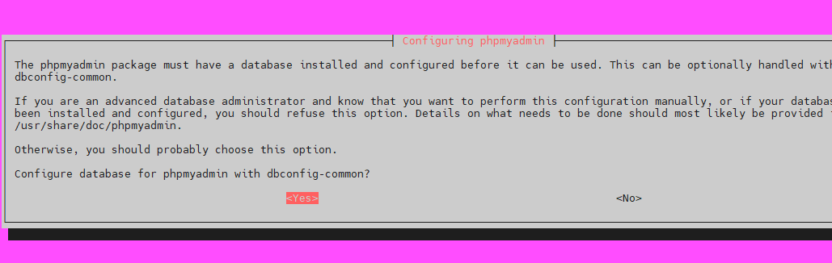

YES

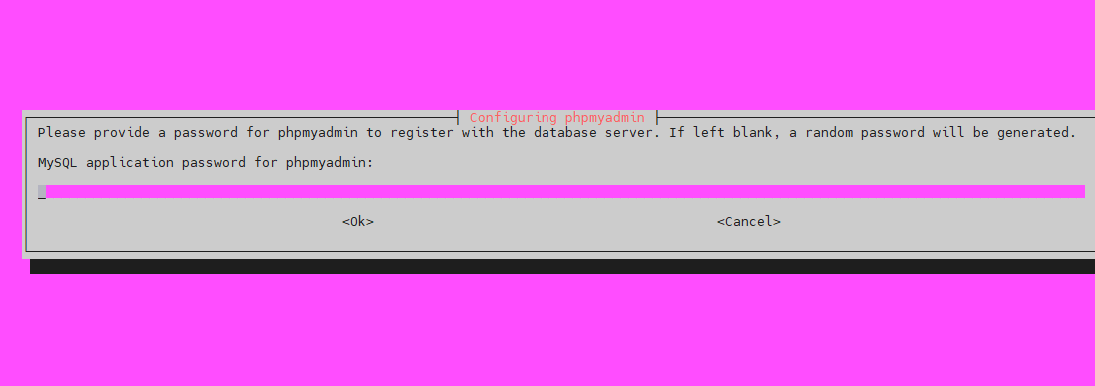

Given mysql password



mv phpMyAdmin-4.4.5-all-languages /var/www/html

cd /var/www/html

mv phpMyAdmin-4.4.5-all-languages phpmyadmin

systemctl restart apache2

<http://13.233.230.145/info.php>

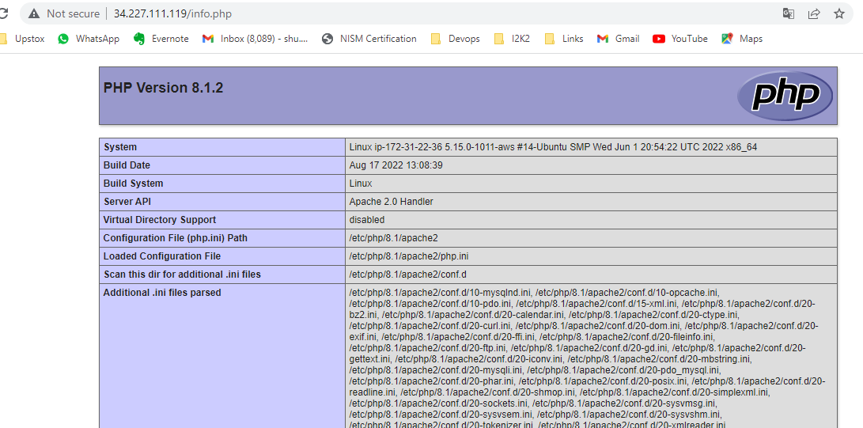

http://13.233.230.145/phpmyadmin(username-root and password which given)

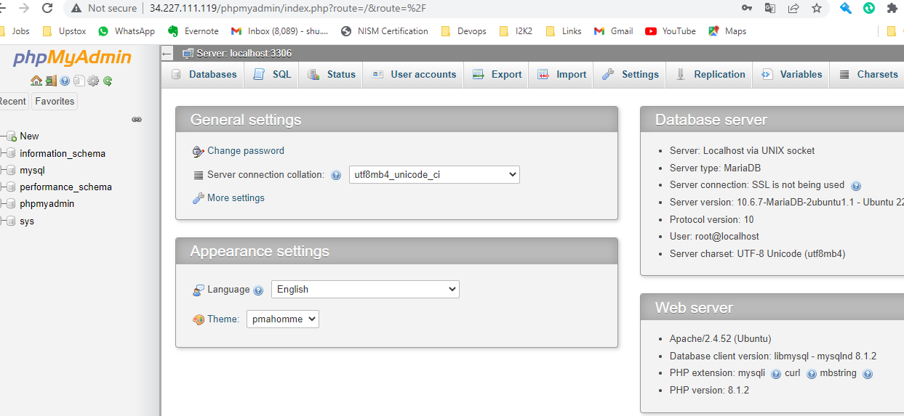

# [Access denied for user 'root'@'localhost'](https://stackoverflow.com/questions/36864206/sqlstatehy000-1698-access-denied-for-user-rootlocalhost)

mysql -u root

CREATE USER 'newuser'@'localhost' IDENTIFIED BY 'password';

GRANT ALL PRIVILEGES ON *.* TO 'newuser'@'localhost';

FLUSH PRIVILEGES;