Chapter 1 - Chemical Reactions and Equations
Quick Revision Cheatsheet · Class X CBSE
1. Chemical Reaction & Its Indications
Chemical reaction: a process in which reactants change into new substances (products) with different properties.
Five signs a reaction has occurred: change in colour · change in state · change in temperature · evolution of a gas · formation of a precipitate.
Reactant + Reactant → Product; e.g. 2Mg(s) + O₂(g) → 2MgO(s) (clean Mg ribbon first to remove the oxide layer).
2. Chemical Equations & Symbols
Skeletal equation: reactants and products written with correct formulae but not yet balanced.
Balanced equation: equal number of atoms of each element on both sides — obeys the Law of Conservation of Mass.
Symbol | Meaning
(s) , (l) , (g) | solid, liquid, gas
(aq) | aqueous — dissolved in water
→ / ⇌ | irreversible / reversible reaction
↑ / ↓ | gas evolved / precipitate formed
Δ (over arrow) | heat supplied (condition of reaction)

3. Balancing (Hit-and-Trial Method)
Steps: (1) write the correct skeletal equation; (2) start with the compound having the most atoms; (3) balance one element at a time using coefficients; (4) balance H and O last; (5) verify both sides and add state symbols.
Golden rule: balance only by changing the coefficients in front — NEVER change a formula (its subscripts).
Worked example: Fe + H₂O → Fe₃O₄ + H₂ becomes 3Fe(s) + 4H₂O(g) → Fe₃O₄(s) + 4H₂(g).

4. Types of Chemical Reactions
Type | What happens | Example
Combination | Two+ reactants → one product | CaO + H₂O → Ca(OH)₂ + heat
Decomposition | One reactant → two+ products | CaCO₃ →Δ→ CaO + CO₂
Displacement | More reactive metal displaces a less reactive one | Fe + CuSO₄ → FeSO₄ + Cu
Double displacement | Two compounds exchange ions | Na₂SO₄ + BaCl₂ → BaSO₄↓ + 2NaCl
Oxidation–Reduction (Redox) | One species oxidised, other reduced | CuO + H₂ → Cu + H₂O

Decomposition sub-types: thermal (heat) — CaCO₃ →Δ→ CaO + CO₂; photolytic (light) — 2AgCl →light→ 2Ag + Cl₂; electrolytic (electricity) — 2H₂O →elec.→ 2H₂ + O₂.
Precipitation reaction: a double-displacement reaction that forms an insoluble solid (precipitate), e.g. AgNO₃ + NaCl → AgCl↓ + NaNO₃.
5. Oxidation, Reduction & Redox
Oxidation | Reduction
Gain of oxygen | Loss of oxygen
Loss of hydrogen | Gain of hydrogen
Reducing agent is oxidised | Oxidising agent is reduced

In CuO + H₂ → Cu + H₂O: CuO loses oxygen → reduced (oxidising agent); H₂ gains oxygen → oxidised (reducing agent). Oxidation and reduction always occur together.
6. Key Reactions to Memorise
Reaction | Observation / Note
2Mg(s) + O₂(g) → 2MgO(s) | dazzling white flame; white ash (combination + oxidation)
CaO(s) + H₂O(l) → Ca(OH)₂(aq) + heat | quick lime → slaked lime; exothermic
2FeSO₄(s) →Δ→ Fe₂O₃(s) + SO₂(g) + SO₃(g) | green crystals → brown; smell of burning sulphur
2Pb(NO₃)₂(s) →Δ→ 2PbO(s) + 4NO₂(g) + O₂(g) | brown fumes of nitrogen dioxide
Fe(s) + CuSO₄(aq) → FeSO₄(aq) + Cu(s) | blue → pale green; brown Cu deposits (displacement)
Na₂SO₄(aq) + BaCl₂(aq) → BaSO₄(s)↓ + 2NaCl(aq) | white precipitate of barium sulphate
MnO₂ + 4HCl →Δ→ MnCl₂ + 2H₂O + Cl₂ | redox; MnO₂ reduced, HCl oxidised

7. Electrolysis of Water
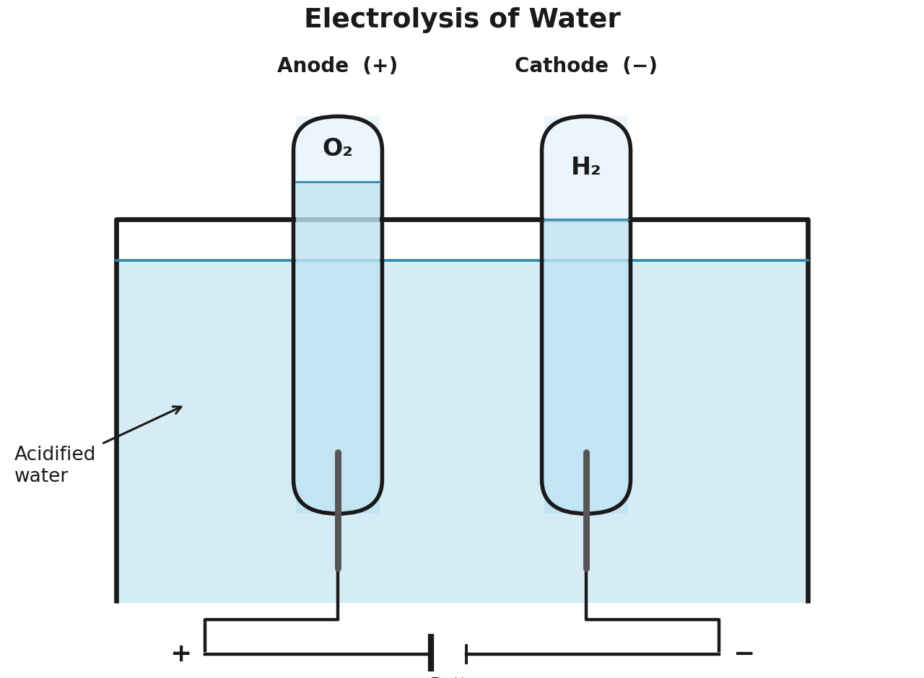
2H₂O(l) →elec.→ 2H₂(g) + O₂(g). H₂ collects at the cathode (−) and O₂ at the anode (+) in a 2 : 1 volume ratio. A little acid is added to make water conducting.
8. Effects of Oxidation in Daily Life
Corrosion: slow eating-up of a metal by air and moisture. Rusting of iron (reddish-brown Fe₂O₃·xH₂O) needs BOTH air and water; silver turns black, copper turns green. Prevention: painting, oiling, greasing, galvanising (zinc coat), chrome-plating, alloying.
Rancidity: oxidation of fats and oils in food, giving a bad smell and taste. Prevention: antioxidants, flushing packets with nitrogen, airtight containers, refrigeration.
9. Energy Changes & Common Traps
Exothermic: heat released — respiration, combustion, CaO + water, decomposition of vegetable matter. Endothermic: heat absorbed — decomposition of CaCO₃, dissolving NH₄Cl, electrolysis of water.
Traps to avoid: (1) 2H₂O → 2H₂ + O₂, not H₂O → H₂ + O₂; (2) Cu does not react with dilute HCl/H₂SO₄ (below H in the reactivity series); (3) always add acid to water, never the reverse; (4) most combination reactions are exothermic, most decomposition reactions are endothermic.

