DIGITAL ASSIGNMENT – 1

MACHINE LEARNING – CSE4020

SHUBHRANT SINGH 19BCE0503

Following is the dataset used in the implementation of the given algorithms.

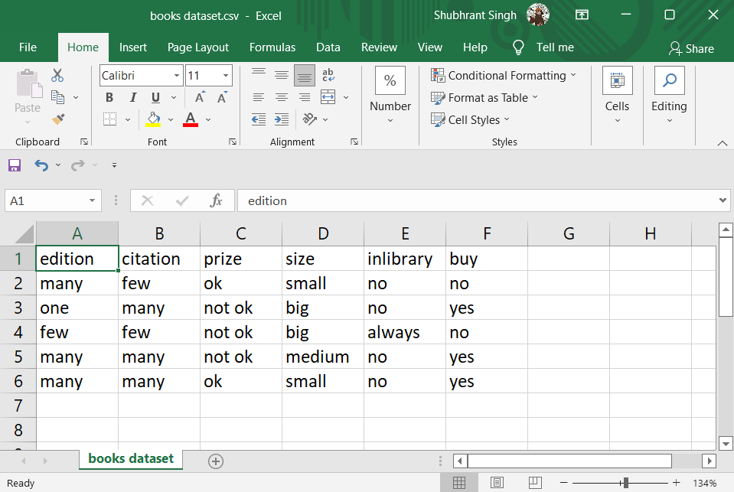

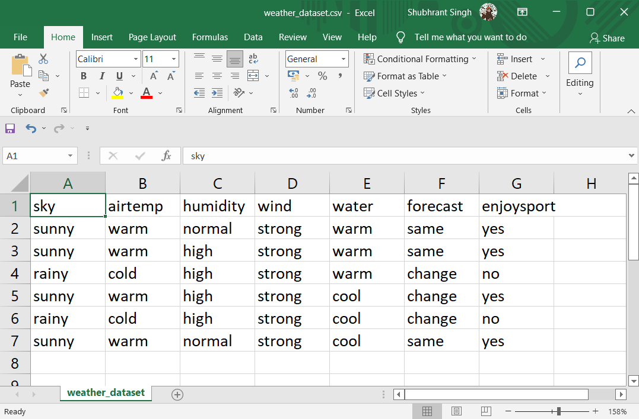

Ex – 1 A

Aim: **Implement Find S Algorithm**

Procedure:

1. Get the data ready

2. Form a general hypothesis as [“Φ”…]

3. Since Φ will not be matched with any row, put the first row as the general

Hypothesis.

4. Now compare the general hypothesis to each positive row of the dataset.

5. If any column in the hypothesis does not match with the data on the row, replace it

with “?”.

6. Finally, we will obtain the general hypothesis.

Code, Output and Results:

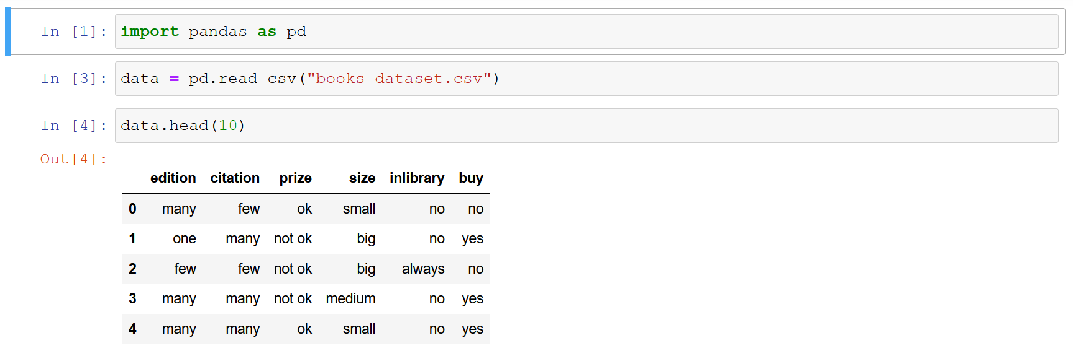

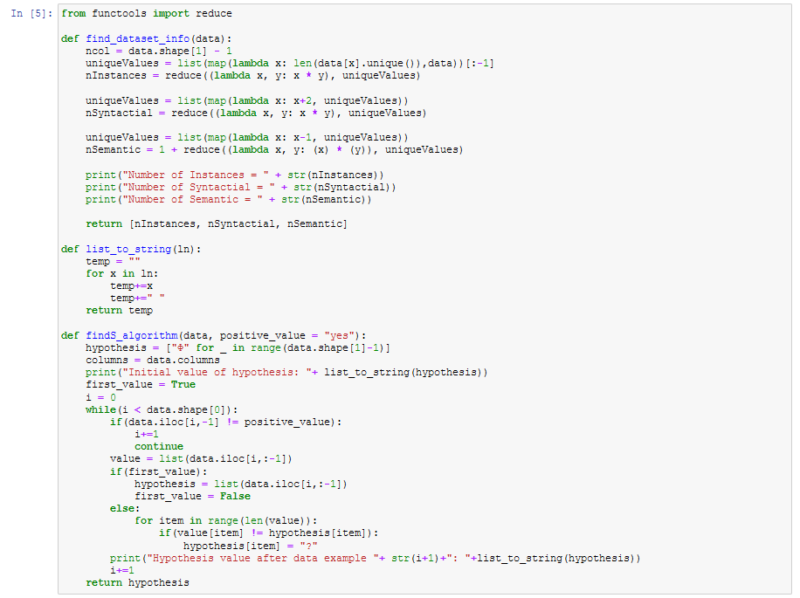

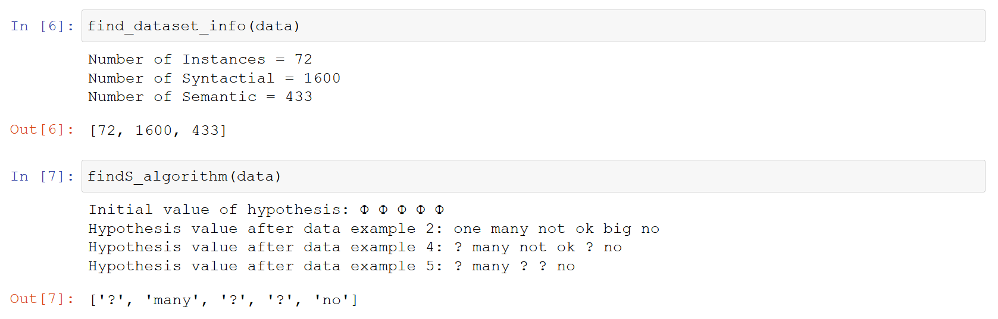

Ex – 1 B

Aim: **Implement list then eliminate algorithm**

Procedure:

1. Get the data ready

2. Get the hypothesis ready

3. Now run the function of item eliminate on the hypothesis

a. First each hypothesis will get iterated over the data to find matches with

same target value

b. After matching, the hypothesis will be compared with values from the

dataset.

c. The hypothesis will be segregated into consistent and inconsistent sets.

4. The function will return the inconsistent hypothesis set first and then the consistent set.

Code, Output and Results:

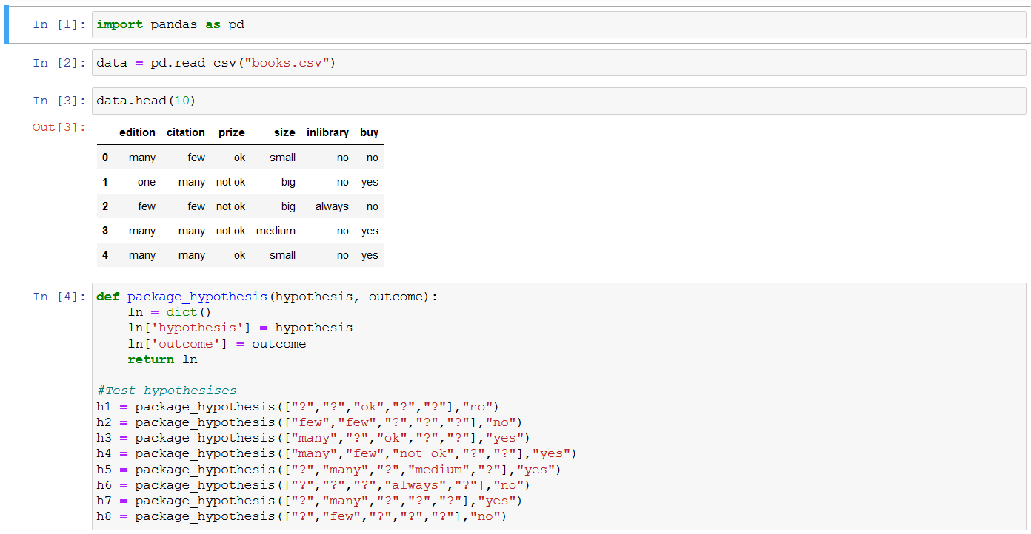

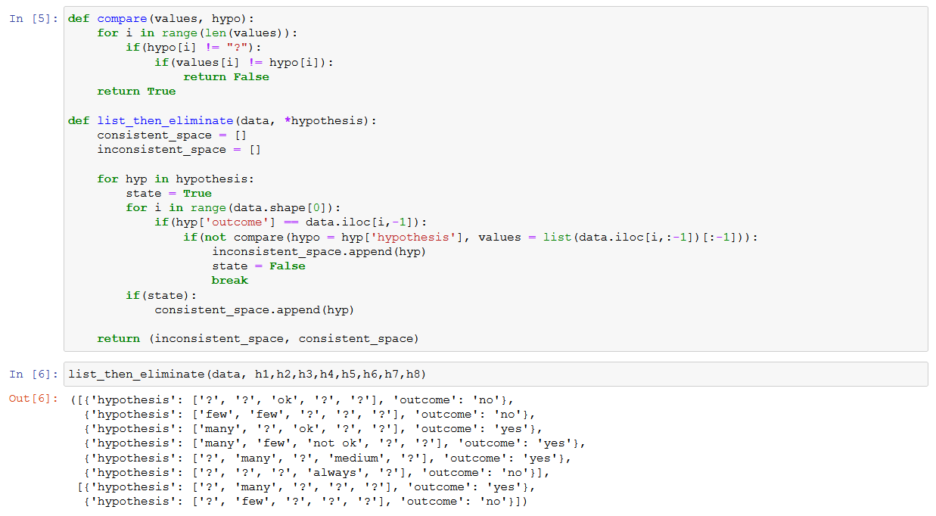

Ex – 1 C

Aim: **Implement Candidate Elimination Algorithm.**

Procedure:

1. Get the data ready

2. Get the hypothesis ready

3. Iterate over the values of the dataset

a. If the target variable is positive then iterate over the specific hypothesis such

that if any inconsistency is found between the values and specific hyp then

change the hypothesis value to “?” on both general and specific.

b. If the target is negative then iterate over the specific hypothesis such that if

any inconsistency is found between the values and specific hyp then change

the general hypothesis value to specific hypothesis. Else change the general

hypothesis value to “?”.

4. Print the general hypothesis bounds and the specific hypothesis.

Code, Output and Results:

