OSL Lab Report on CMS

*Content Management System – Wordpress Blog*

The report contains information about a small scale blog created using wordpress customizations and themes. It also contains information about the technologies used, scope, limitations, flow of the application and advantages of the project.

Shubham Kalaria

08-Nov-17

Abstract

A content management system (CMS) is a system used to organize and facilitate collaborative creation of documents and other content. CMS's allow end-users (typically authors of some sort) to provide new content in the form of articles. The articles are typically entered as plain text, perhaps with markup to indicate where other resources (such as pictures) should be placed. The system then uses rules to style the article, separating the display from the content, which has a number of advantages when trying to get many articles to conform to a consistent "look and feel". The system then adds the articles to a larger collection for publishing.

Scope of project

The project provided us with immense quality of knowledge about wordpress which is one of the best content management systems. We learnt managing blogs, viewing the traffic, customizations and themes available on wordpress. These kinds of systems enable us to manage the content we come across or write and allow us to manage it well. So, I think the project has a greater scope for me as it will give me a platform to upload my works and will allow me to handle it in a better way.

Technologies Used

The technology used in my project is Wordpress which is a Content Management System.

Project Flow Diagram

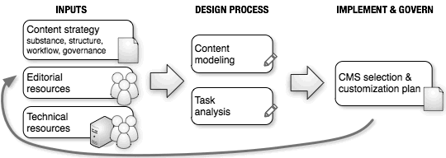

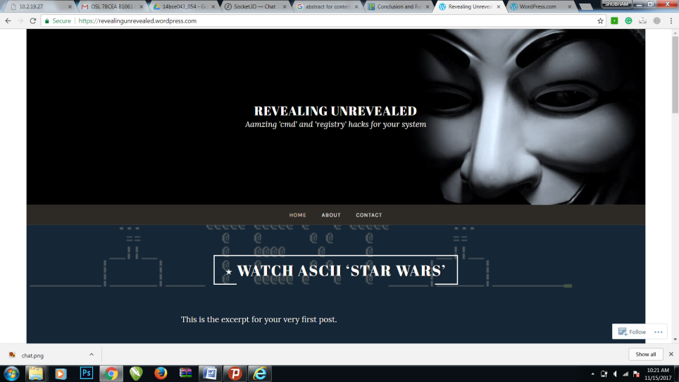

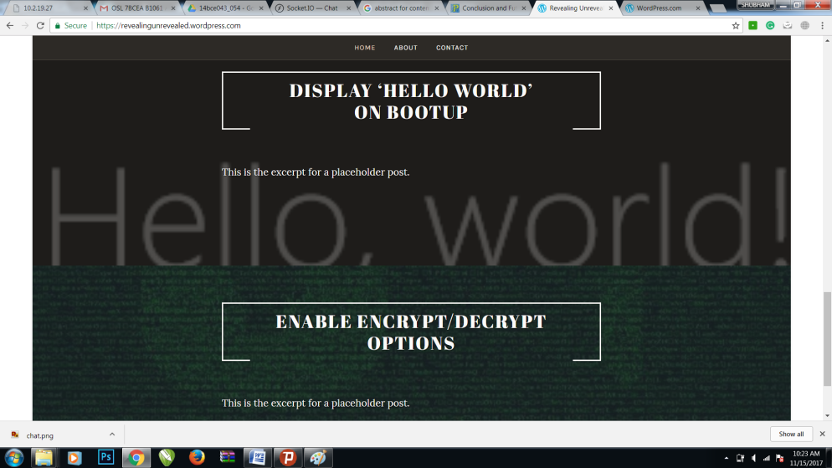

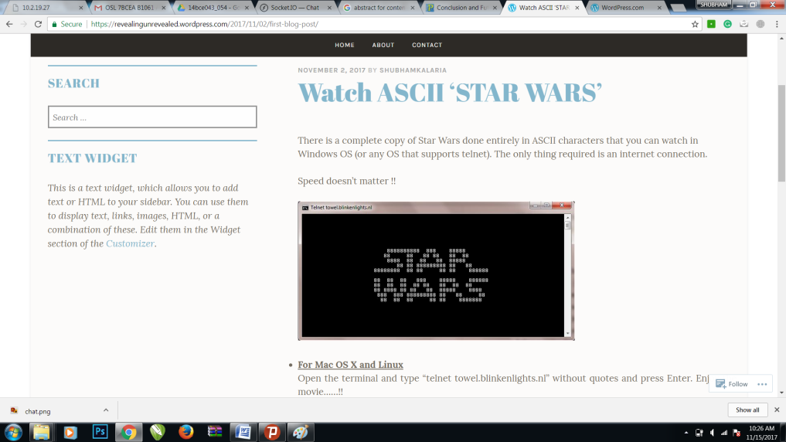

*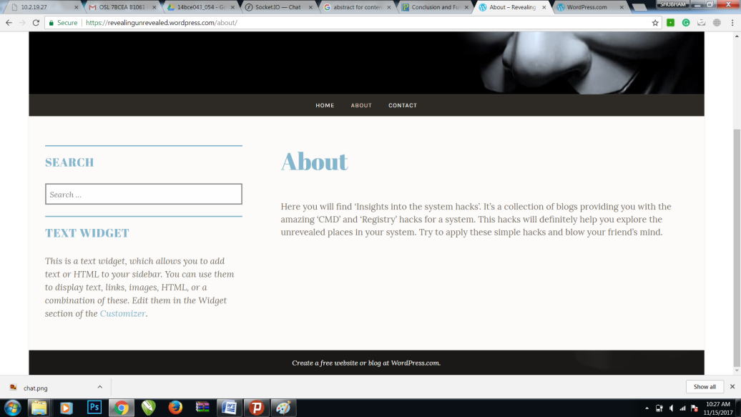*

*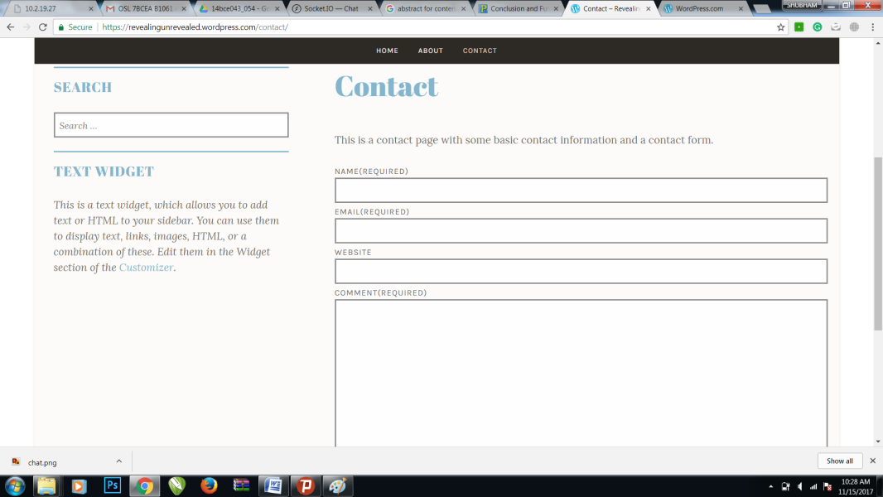*

Conclusion

Content Management System (CMS) is a product installed on a web server that allows managing pages, blogs and articles online, without storing them on a desktop computer and uploading each time when you need to make changes. You simply login to your website, write or modify content, and your website is instantly updated, unless you set a specific schedule for your content to be visible to website visitors. CMS products also allow multiple administrators or editors to maintain online content without conflicting with each other. And most importantly, CMS products provide separation between articles and web design, thus allowing you to focus on writing content and not worry about copying the web design from page to page.