T025 historical <analysis>
Project: Real synthetic CAD
Analysis: Deck reference · frozen revision 5
Run completed: 2026-10-15T04:02:19.861663+00:00
Report generated: 2026-10-15T04:02:20.559346+00:00
Display units: mm-N-MPa
Report bb9f002a-715e-4542-a549-6f161cfc1afd
Run 419f8707-5f91-40a0-a798-be2dcb13cf21
Input SHA-256 75b0abe469b97d165848352ce64554494ea5d403506bbfa3a4323fbe11349661

Scope, warnings and assumptions
Body 6f33a3928358ca77193419343abe0d6296faa1302201ba2451e64ad24f8716ef:b1: stress exceeds the supplied yield strength; linear elasticity does not model plastic deformation.
stress_singularity · all bodies · unassessed: Peaks near supports, reentrant corners or idealized load/bond edges may increase with refinement. No automatic singularity detection is claimed. Compare fixed physical locations away from these regions; a lower smoothed peak is not evidence of convergence or a design allowable.
yielding · 6f33a3928358ca77193419343abe0d6296faa1302201ba2451e64ad24f8716ef:b1 · triggered: Compare raw integration-point von Mises with the frozen supplied ductile yield. Yield exceedance does not model plastic deformation; missing yield cannot establish a factor. No fatigue, brittle failure, buckling or code check is implied.
small_deformation · 6f33a3928358ca77193419343abe0d6296faa1302201ba2451e64ad24f8716ef:b1 · not triggered: Maximum native displacement / largest body extent is a 1% screening heuristic. Exceedance requires review of small-deformation linear elasticity. Passing this heuristic does not bound local strain/rotation or certify validity; display exaggeration is irrelevant.
Linear static, small-deformation and supplied material assumptions apply. No automatic design-safety conclusion is generated.
Yield assessment does not assess fatigue, brittle failure, buckling or plasticity. Stress singularities require engineering review.
Passing equilibrium does not establish convergence, stability or physical validity. Target-laptop validation and remaining external references are pending; bounded M3 approval does not certify this design.
Figures are light report derivatives of retained verified data. Hidden bodies, clipping, smoothing and deformation do not alter all-body native extrema or warnings.

Selected figures and setup
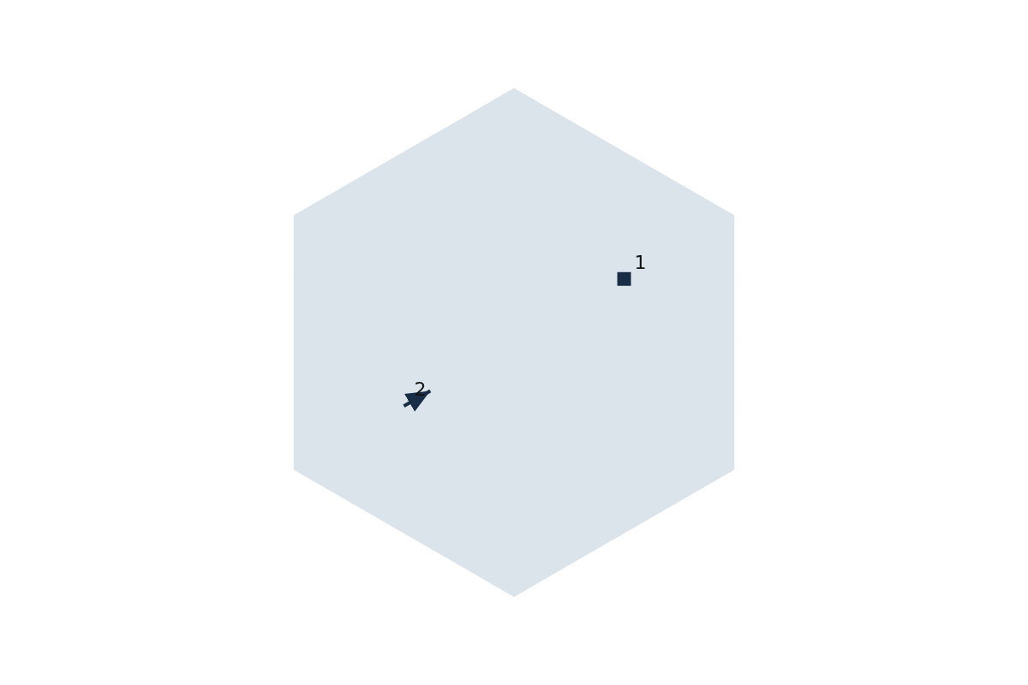
Figure 1. Frozen loads and supports on undeformed geometry. Arrows indicate global direction only; squares indicate fixed supports. Marker numbers resolve to the setup table; arrow lengths do not encode magnitude.
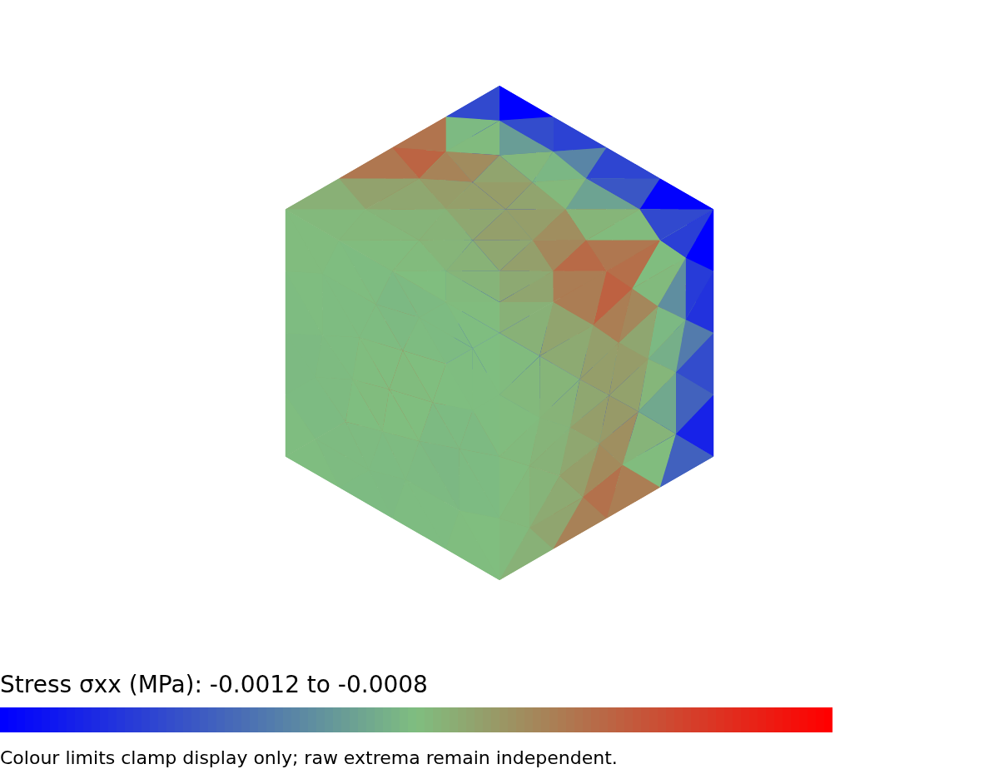
Figure 2. Stress σxx; global Cartesian; element-node boundary; Equal-weight arithmetic mean of incident element-node tensors at the same mesh node, partitioned by body and material; all incident volume elements contribute once. Invariants are calculated after tensor averaging. No spatial merging or FRD stress. Display derivative only; smoothing can hide element jumps and is not convergence evidence.. Deformation ×50; visible bodies 6f33a3928358ca77193419343abe0d6296faa1302201ba2451e64ad24f8716ef:b1. Flat triangle colour samples use the vertex-scalar mean; no numerical extrema are read from pixels. Camera and SI limits are retained in the report model.
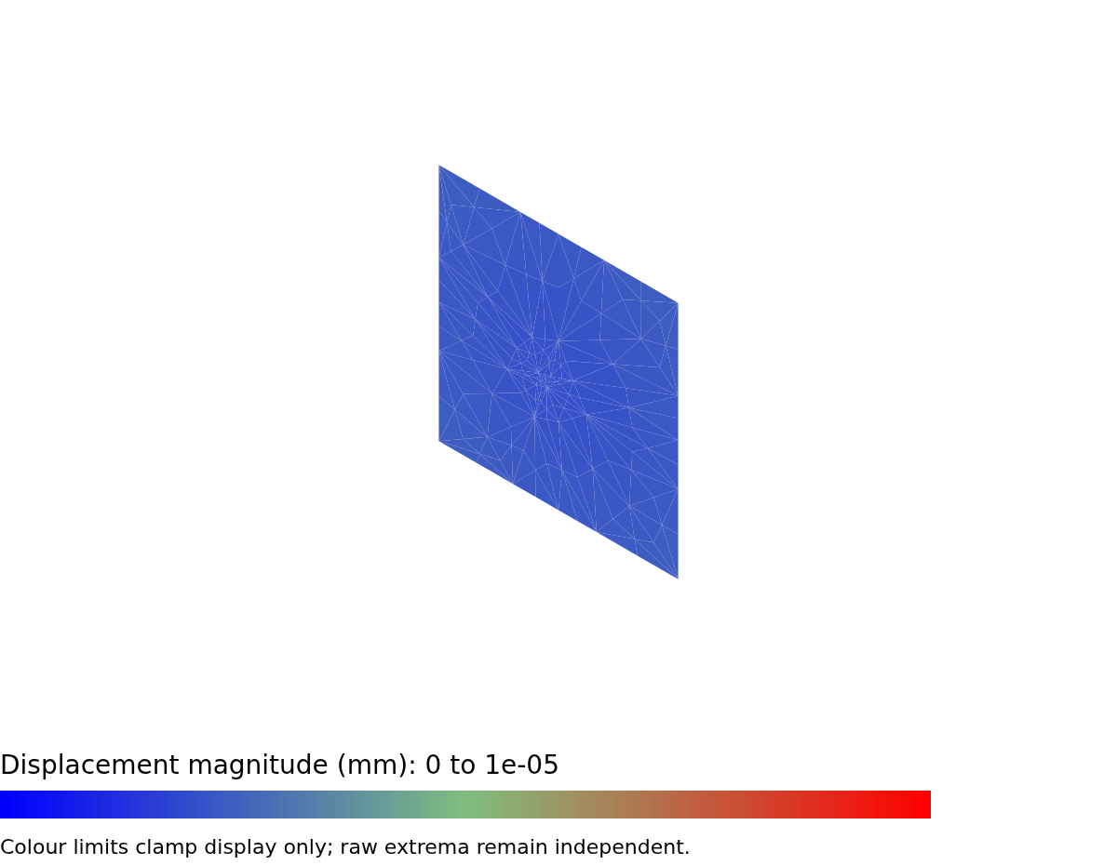
Figure 3. Displacement magnitude; global Cartesian; element-interpolated volume section {'point_m': [0.5, 0.5, 0.5], 'normal': [1.0, 0.0, 0.0]}; Native DAT nodal displacement. Deformation ×0; visible bodies 6f33a3928358ca77193419343abe0d6296faa1302201ba2451e64ad24f8716ef:b1. Flat triangle colour samples use the vertex-scalar mean; no numerical extrema are read from pixels. Camera and SI limits are retained in the report model.

Geometry and source units
Fact | Frozen value
Geometry revision | 39dcb635-c3aa-45db-a238-c1b8a364ee10
Source length unit | m
Bounds (mm) | [0, 0, 0, 1000, 1000, 1000]
Dimensions (mm) | [1000, 1000, 1000]
Bodies / faces | 1 / 6
Geometry SHA-256 | 6f33a3928358ca77193419343abe0d6296faa1302201ba2451e64ad24f8716ef

Material properties
Body / material | E (MPa) / Poisson ratio | Density (tonne/mm³) | Yield (MPa)
6f33a3928358ca77193419343abe0d6296faa1302201ba2451e64ad24f8716ef:b1 / Synthetic steel | 210000 / 0.3 | 7.85e-09 | 0.0005

Material provenance
Body | Detail | Source / assumption
6f33a3928358ca77193419343abe0d6296faa1302201ba2451e64ad24f8716ef:b1 | Grade / condition | Test only / Analytical fixture
6f33a3928358ca77193419343abe0d6296faa1302201ba2451e64ad24f8716ef:b1 | Temperature / assumptions | Room-temperature fixture / Synthetic isotropic reference; no certified allowable.
6f33a3928358ca77193419343abe0d6296faa1302201ba2451e64ad24f8716ef:b1 | Library / original units | None / None / mm-N-MPa
6f33a3928358ca77193419343abe0d6296faa1302201ba2451e64ad24f8716ef:b1 | Independent test definition | No URL supplied; accessed not supplied

Loads and supports
Assignment | Immutable targets | Physical value / direction
fixed / fixed | 6f33a3928358ca77193419343abe0d6296faa1302201ba2451e64ad24f8716ef:b1:f1 | All translations fixed
pressure / pressure | 6f33a3928358ca77193419343abe0d6296faa1302201ba2451e64ad24f8716ef:b1:f2 | Pressure MPa: 0.001

Setup figure markers
Marker | Assignment / kind | Position (mm) / global direction
1 | 3e2fecc8-b8ba-4d53-8c54-90c71eafdbcc / fixed | [0, 500, 500] / [0, 0, 0]
2 | 46b9ddcf-f16c-40e1-aabd-c66018fc2de6 / pressure | [1000, 500, 500] / [-1, 0, 0]

Bond review and gaps
Connection | Master / slave | Approved gap / review
None | No bonded connections | Single body or disconnected setup as frozen

Mesh and solver
Fact | Frozen value
Element / node count | C3D10 / 100 elements / 231 nodes
Quality | {"schema_version": 1, "accepted": true, "minimum_jacobian_m3": 0.031249999999996447, "minimum_mean_ratio": 0.639542072978345, "bad_elements": [], "warning_elements": [], "all_affine": true, "policy": {"jacobian_floor_m3": 1e-15, "mean_ratio_floor": 0.05, "mean_ratio_warning": 0.2, "subdivision_depth": 3, "method": "cubic tetrahedral Bernstein
 | certificate with outward rounding margin"}}
Mesh controls | {"schema_version": 1, "geometry_revision_id": null, "global_size_m": null, "source_global_size": null, "source_units": null, "local_sizes": [], "curvature_elements": 16, "recovery_enabled": false}
Solver | CalculiX 2.23
Solver binary SHA-256 | d55622f40e0435e738a86cbd364d525fff31524212ecca17d71d4c15ea2935f5
Original solve CPU/RAM/thread inventory | Not recorded in this legacy local run; resource policy and measured usage are retained in run artifacts.
Native build SHA-256 | 917a915f2aa78656131eeba825c13dece6cf81834d786a317d7dc9e6ef6db74d
Numerical method | Linear static / small deformation / global Cartesian / C3D10; no stabilization

Raw native extrema — all bodies
Field / location | Minimum | Maximum / identity
Displacement magnitude (mm); node | 0; node; node 1; element None; IP None; body None; material None; position [0, 0, 0] mm | 4.747774e-06; node; node 8; element None; IP None; body None; material None; position [1000, 1000, 1000] mm
Von Mises stress (MPa); integration_point | 0.000611224; integration_point; node None; element 116; IP 1; body 6f33a3928358ca77193419343abe0d6296faa1302201ba2451e64ad24f8716ef:b1; material M1; position [36.123, 745.922, 494.3482] mm | 0.001050867; integration_point; node None; element 104; IP 4; body 6f33a3928358ca77193419343abe0d6296faa1302201ba2451e64ad24f8716ef:b1; material M1; position [547.4404, 340.2749, 612.3494] mm
Displacement ux (mm); node | -4.63266e-06; node; node 8; element None; IP None; body None; material None; position [1000, 1000, 1000] mm | 0; node; node 1; element None; IP None; body None; material None; position [0, 0, 0] mm
Displacement uy (mm); node | -7.339082e-07; node; node 22; element None; IP None; body None; material None; position [1000, 0, 250] mm | 7.338232e-07; node; node 28; element None; IP None; body None; material None; position [1000, 1000, 250] mm
Displacement uz (mm); node | -7.27917e-07; node; node 25; element None; IP None; body None; material None; position [1000, 250, 0] mm | 7.405408e-07; node; node 32; element None; IP None; body None; material None; position [1000, 750, 1000] mm
Stress σxx (MPa); integration_point | -0.001200023; integration_point; node None; element 182; IP 4; body 6f33a3928358ca77193419343abe0d6296faa1302201ba2451e64ad24f8716ef:b1; material M1; position [36.123, 965.4508, 860.2295] mm | -0.0008453647; integration_point; node None; element 176; IP 1; body 6f33a3928358ca77193419343abe0d6296faa1302201ba2451e64ad24f8716ef:b1; material M1; position [367.6959, 38.86779, 963.877] mm
Stress σyy (MPa); integration_point | -0.000428839; integration_point; node None; element 168; IP 2; body 6f33a3928358ca77193419343abe0d6296faa1302201ba2451e64ad24f8716ef:b1; material M1; position [38.86779, 155.7411, 952.225] mm | 9.10996e-05; integration_point; node None; element 176; IP 1; body 6f33a3928358ca77193419343abe0d6296faa1302201ba2451e64ad24f8716ef:b1; material M1; position [367.6959, 38.86779, 963.877] mm
Stress σzz (MPa); integration_point | -0.0004552813; integration_point; node None; element 182; IP 4; body 6f33a3928358ca77193419343abe0d6296faa1302201ba2451e64ad24f8716ef:b1; material M1; position [36.123, 965.4508, 860.2295] mm | 8.830298e-05; integration_point; node None; element 176; IP 1; body 6f33a3928358ca77193419343abe0d6296faa1302201ba2451e64ad24f8716ef:b1; material M1; position [367.6959, 38.86779, 963.877] mm
Stress σxy (MPa); integration_point | -0.0002498031; integration_point; node None; element 171; IP 3; body 6f33a3928358ca77193419343abe0d6296faa1302201ba2451e64ad24f8716ef:b1; material M1; position [36.123, 47.775, 623.3969] mm | 0.0002369256; integration_point; node None; element 182; IP 3; body 6f33a3928358ca77193419343abe0d6296faa1302201ba2451e64ad24f8716ef:b1; material M1; position [36.123, 965.4508, 636.6228] mm
Stress σyz (MPa); integration_point | -6.411882e-05; integration_point; node None; element 162; IP 3; body 6f33a3928358ca77193419343abe0d6296faa1302201ba2451e64ad24f8716ef:b1; material M1; position [83.898, 917.6759, 929.3278] mm | 6.257278e-05; integration_point; node None; element 154; IP 3; body 6f33a3928358ca77193419343abe0d6296faa1302201ba2451e64ad24f8716ef:b1; material M1; position [74.99079, 86.64279, 916.102] mm
Stress σzx (MPa); integration_point | -0.0002403846; integration_point; node None; element 163; IP 1; body 6f33a3928358ca77193419343abe0d6296faa1302201ba2451e64ad24f8716ef:b1; material M1; position [38.86779, 616.6034, 51.82373] mm | 0.0002430674; integration_point; node None; element 168; IP 1; body 6f33a3928358ca77193419343abe0d6296faa1302201ba2451e64ad24f8716ef:b1; material M1; position [38.86779, 379.3479, 952.225] mm
Principal stress σ1 (MPa); integration_point | -0.0003430663; integration_point; node None; element 182; IP 4; body 6f33a3928358ca77193419343abe0d6296faa1302201ba2451e64ad24f8716ef:b1; material M1; position [36.123, 965.4508, 860.2295] mm | 0.0001233853; integration_point; node None; element 176; IP 1; body 6f33a3928358ca77193419343abe0d6296faa1302201ba2451e64ad24f8716ef:b1; material M1; position [367.6959, 38.86779, 963.877] mm
Principal stress σ2 (MPa); integration_point | -0.0004489453; integration_point; node None; element 182; IP 4; body 6f33a3928358ca77193419343abe0d6296faa1302201ba2451e64ad24f8716ef:b1; material M1; position [36.123, 965.4508, 860.2295] mm | 5.742027e-05; integration_point; node None; element 176; IP 1; body 6f33a3928358ca77193419343abe0d6296faa1302201ba2451e64ad24f8716ef:b1; material M1; position [367.6959, 38.86779, 963.877] mm
Principal stress σ3 (MPa); integration_point | -0.001282466; integration_point; node None; element 182; IP 4; body 6f33a3928358ca77193419343abe0d6296faa1302201ba2451e64ad24f8716ef:b1; material M1; position [36.123, 965.4508, 860.2295] mm | -0.0008467677; integration_point; node None; element 176; IP 1; body 6f33a3928358ca77193419343abe0d6296faa1302201ba2451e64ad24f8716ef:b1; material M1; position [367.6959, 38.86779, 963.877] mm

Yield assessment — frozen supplied strength / raw integration-point von Mises
Body / material | Yield (MPa) | Factor / critical location
6f33a3928358ca77193419343abe0d6296faa1302201ba2451e64ad24f8716ef:b1 / Synthetic steel | 0.0005 | 0.4757976; integration_point; node None; element 104; IP 4; body 6f33a3928358ca77193419343abe0d6296faa1302201ba2451e64ad24f8716ef:b1; material M1; position [547.4404, 340.2749, 612.3494] mm

External reactions about global origin
Body / constrained nodes / DOFs | Force (N) | Moment (N·mm)
6f33a3928358ca77193419343abe0d6296faa1302201ba2451e64ad24f8716ef:b1 / 37 / 111 | [1000, -2.74e-06, 1.062e-05] | [0.002051309, 500000, -500000]

Force and moment equilibrium
Balance | Residual | Reference | Criterion / limit | Outcome
force (N) | [-2.2e-05, -2.74e-06, 1.062e-05]; norm 2.458235e-05 | 1000 | relative; relative 2.458235e-08; allowed 5 | Passed
moment (N·mm) | [0.002051309, -0.0107625, 0.004837501]; norm 0.01197667 | 1000000 | relative; relative 1.197667e-08; allowed 5000 | Passed

Equilibrium method and actions
Fact | Value
Method | Frozen physical load magnitudes plus nonzero prescribed-component actuator reactions; moments about global origin; external constrained span only; internal ties/MPC/free-node RF excluded
Reaction method | DAT RF minus written equivalent CLOAD/pressure/consistent gravity, constrained global components only; unique nodes/DOFs per body; internal ties excluded
Moment origin (m) | [0, 0, 0]
Applied force (N) | [-1000, 4.064594e-15, 1.610784e-14]
Applied moment (N·mm) | [1.921697e-11, -500000, 500000]
Stress / extrema method | linear_C3D10_extrapolation_from_native_DAT_IP; element-owned tensors, then invariants; default unaveraged, optional body/material-partitioned smoothing; Displacement: all native DAT nodes; von Mises/yield factor: all raw DAT integration points, including interior

User-written conclusion
Attributed to the report author; this text is not a computed engineering finding.
User conclusion <script>alert('x')</script> & review required.

Reproducibility IDs
schema_version: 1
job_id: 419f8707-5f91-40a0-a798-be2dcb13cf21
analysis_id: dcef9881-a55f-4a92-b229-6eb7c3be1432
analysis_revision: 5
geometry_revision_id: 39dcb635-c3aa-45db-a238-c1b8a364ee10
input_sha256: 75b0abe469b97d165848352ce64554494ea5d403506bbfa3a4323fbe11349661
results_sha256: 04ac9d807310e43fcc237ce4ef084e1fb1d0e6e6ebccb9a8eaf9068c5a4e8647
mesh_sha256: dc8414afbdd9c8b9aff196867215cd75ceba3f3895ec634933e248a94f32921e
deck_sha256: 38487c20693567d61224142e9807b39cd37458e592415b831f7f5e811214c392
dat_sha256: bf2fb297921e2cb742b8213715549c46ecd1d7fddcacbe41244f65e22212f214
services/api/app/domain/comparisons.py: 7031bcf9a45c54cef209210382718a5057449d41e29fded6bab882316e389bc0
services/api/app/domain/refinement.py: b63ca772fc862a035dda9f2c3f63d06326fa3cbda50f093e5efae4b4c258a996
services/api/app/domain/results.py: c4c0b9b18b090bea8352ea59a2a09776d3b20783598f81c0db6b6ce18706b3ad
services/api/app/jobs/service.py: 638d211f21fa6e9d8b4dcce0e5a6fa5b5cace3c1ce1e2eee4e3131266965ae1e
services/worker/worker/actions.py: 1a8edff017a1397b45fa667d9056a2b5e9ebf250248812928855f64dec460e9b
services/worker/worker/calculix/results.py: da43f91763e9880a6e8728906202f1394d7b89a31af61e6a6f163c1190c29609
services/worker/worker/directions.py: 8de17d5705b81b651a5077ddf3b80e3b29a13b9f453af1c79fc2e82db06e4592
services/worker/worker/meshing.py: 1d71f8f57bd020f96804f284f4be1d2a0fd51bf89d0bc529f48cd1aad2a52e9e
services/worker/worker/postprocess/comparison.py: 8970cbe6b7e9686a77176bc4d8ae432217276bf4f2f57577c55c837941d8a3aa
services/worker/worker/postprocess/fields.py: 3201afd7ad773d0865f77b992e941c5264484d87490964b84866ff87e718c2cf
services/worker/worker/postprocess/inspection.py: 2671965a0e9881217553f96e8389289d24f389b7b002569b370fe92a01486f08
services/worker/worker/postprocess/tensors.py: 9dc5efb68ebfafc05d5f964019548b801fdcad8706032554334aa0c537767584
services/worker/worker/postprocess/view.py: 7ea99bb6c7c9daf7277201e6779148eba316d236c0699a9629348e8900124a8c
chromium_binary_sha256: 4fa61f0ba0b4f89b7bec242c32ca16d3bccf69dbfef0651924a9ba8fede5f9d6
font_dejavu_regular_sha256: 57f73e11f51999432bf7ab22ce55b6f945d5eca1bf824404cfa9ec2e3718c84e
generator_cpu_count: 3
generator_platform: Linux-6.18.44-x86_64-with-glibc2.41
generator_python: 3.12.14
node_binary_sha256: bc17c508ffeed0ec622934f9b7fa72f8e78da65350e63c3eceb56fa688aa5e12
package-lock.json: feb1470637caf3d65d9af3d08e89ca777ca097f49b055845452b610917c45fba
scripts/reports/pdf.mjs: 125def705cc32a64a6ace989b65a573dac6af6de54fd02c1ccd11064ea65c123
services/api/app/domain/report_service.py: 1e417c01670abd940a3d73f22e6555d96095dbfa88db782c6efc6380b42cd776
services/api/app/domain/reports.py: 45a4b8349f9ae22f3bb63d50f7ae8acce9e8129136a6969f2cbdfd8274789ca0
services/worker/worker/reports/figures.py: bedc9575b4b72309897e2eba8fc0664ac04e84b7de74615e1d595e29eca19047
services/worker/worker/reports/html.py: 03777a92c97a5012e174f71d0b1c8f6b448bedbd466d0f3cc1fc15dd5f10ff71
services/worker/worker/reports/model.py: adcb4b46695ab4ddad618402cd8d6bb613332fa0a2c3ddd97d6227d0caf7dd44
services/worker/worker/reports/render.py: 02f5ed8df22732bc9a458eee8f644315d923c347ba7a03537b1c46becd5f1ecc
source_commit: 9cb069ac99394c18e319eed2a81e2a425259fcde
source_dirty: false
uv.lock: ba9322c310e61bee9b6b005a8140ccc313123e00d76ab5a6b1a023df0acdd0fc
version: report-v1
Download the immutable report-model JSON for complete original inputs, view definitions, camera, quality and tool policy. Its SHA-256 and this PDF’s SHA-256 are in the report record.

Word export provenance
Editable Word copy. The recorded output checksum and run provenance identify the generated version only; they do not certify later user edits.
source_model_sha256: b08055d3f4d0f6ebefb6ae4193d6b37eb1d3b45eaaee4870ef1d840691c76cef
original_pdf_sha256: 83b2c0fe91830117a47950d16d3272a5641ae5ccf79ed1abdb6bbdf5d5d11ec3
version: word-v1
source_commit: 79a2fed107efe4fdd8ee057051896bdbd5d9faaf
source_dirty: false
generator_python: 3.12.14
generator_platform: Linux-6.18.44-x86_64-with-glibc2.41
generator_cpu_count: 3
font_dejavu_regular_sha256: 57f73e11f51999432bf7ab22ce55b6f945d5eca1bf824404cfa9ec2e3718c84e
chromium_binary_sha256: 4fa61f0ba0b4f89b7bec242c32ca16d3bccf69dbfef0651924a9ba8fede5f9d6
node_binary_sha256: bc17c508ffeed0ec622934f9b7fa72f8e78da65350e63c3eceb56fa688aa5e12
services/api/app/domain/reports.py: 45a4b8349f9ae22f3bb63d50f7ae8acce9e8129136a6969f2cbdfd8274789ca0
services/api/app/domain/report_service.py: 1e417c01670abd940a3d73f22e6555d96095dbfa88db782c6efc6380b42cd776
services/worker/worker/reports/model.py: adcb4b46695ab4ddad618402cd8d6bb613332fa0a2c3ddd97d6227d0caf7dd44
services/worker/worker/reports/figures.py: bedc9575b4b72309897e2eba8fc0664ac04e84b7de74615e1d595e29eca19047
services/worker/worker/reports/html.py: a266e66c2204f726528b7bc307935b2ef7096153fbbc58146ee5d7a7c1316bb9
services/worker/worker/reports/content.py: 5914c8af6cddf62125566746a8d881fcdb5a2ef8d40a84bc77095e248e929b3e
services/worker/worker/reports/render.py: 8b4f6ae521693827346fe2ab67de5e680cc583cdcdbf4d2780c6f70db0dd98de
scripts/reports/pdf.mjs: 125def705cc32a64a6ace989b65a573dac6af6de54fd02c1ccd11064ea65c123
package-lock.json: feb1470637caf3d65d9af3d08e89ca777ca097f49b055845452b610917c45fba
uv.lock: 36f59cf0e56b6442588403ba9ac6b47e732a46ce4a9d8cd7f3e5edcea741e261
python_docx: 1.2.0
lxml: 6.0.2
services/worker/worker/reports/docx.py: 3f49bf396f4cf1f17ebb0e81fa2b2719a007fdb1ad8ac7a60f6b20264c14f265
scripts/reports/word.py: ebebef88fadbcca30af97ef455d517dd54886543eaece51761c77012ad1a1817
scripts/reports/word.mjs: 013da5311a05ea7d1315b76ff25a22b44e98642ef0769a659a5b2a2444d9a0a7
services/api/app/domain/word_service.py: d9d973d303eef3d2366aacc8bc5c01e3327e577ea3da524d4f335ebfa4a5dc2e
services/api/app/domain/words.py: d6d1ed02ced3b400e3da5ca1c9b84f4a9613ea93067f2045dc126f44fec9a136

