**PIZZA SALES SQL QUERRIES**

**Step 1: Extract & Load Dataset**

I successfully extracted the required dataset from Kaggle in a .csv format. Subsequently, I imported this data into a MySQL Workbench environment for further analysis and processing.

**Step 2: Transform**

After a thorough examination of the database schema, I identified inconsistencies in the data types used for certain fields. To ensure optimal data integrity and performance, I've initiated a process to modify these data types to align more accurately with the nature of the data they store.

**Step 3: To address specific stakeholder inquiries, I formulated and executed targeted SQL queries to retrieve and analyse the requested data.**

**KPI:**

1. Total Revenue:





1. **Average Order Value:**

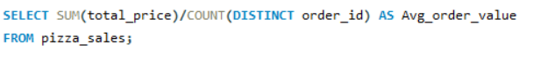



1. **Total Pizzas Sold:**





1. **Total Orders:**







1. **Daily trend for Total_Order**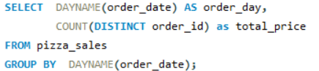

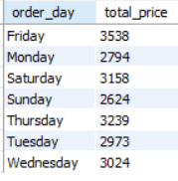

1. **Monthly Trend for Orders**

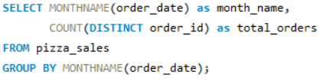

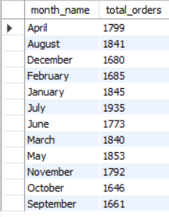

1. **% of Sales by Pizza Category**

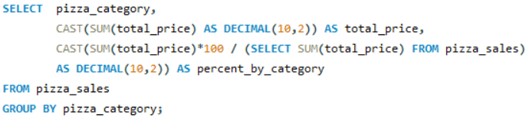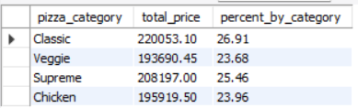

**8. % of Sales by Pizza Size**

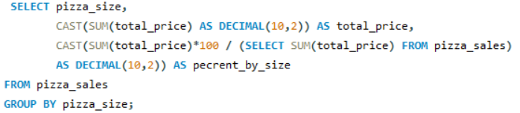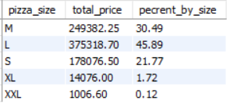

**9. Total Pizzas Sold by Pizza Category**

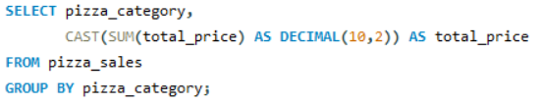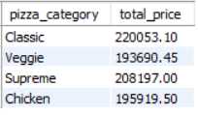

1. **Top 5 Pizzas by Revenue**

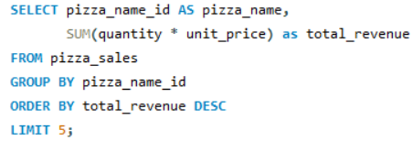

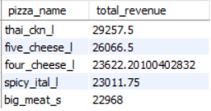

**11. Bottom 5 Pizzas by Revenue**

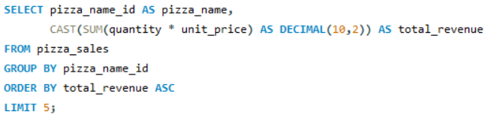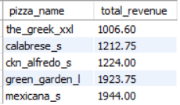

1. **Top 5 Pizzas by Quantity**

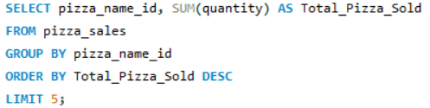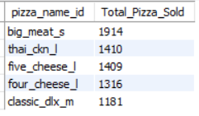

1. **Bottom 5 Pizzas by Quantity**

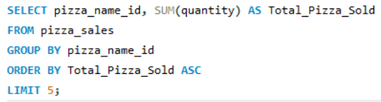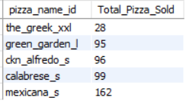

1. **Top 5 Pizzas by Total Orders**

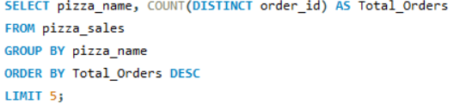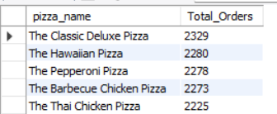

1. **Bottom 5 Pizzas by Total Orders**

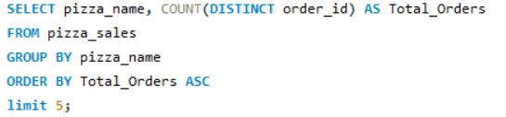

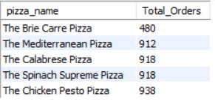

**CONCLUSION:**

This project successfully leveraged SQL queries to extract, transform, and analyze pizza sales data. By following a structured approach involving data extraction, transformation, and query execution, we were able to provide valuable insights to stakeholders. The project demonstrated the power of SQL in handling and analyzing real-world data, making it an essential tool for data-driven decision-making.