**Objectives**

* Configure a LAN Ethernet interface.
* Configure a WAN serial interface.
* Verify the interface configurations.

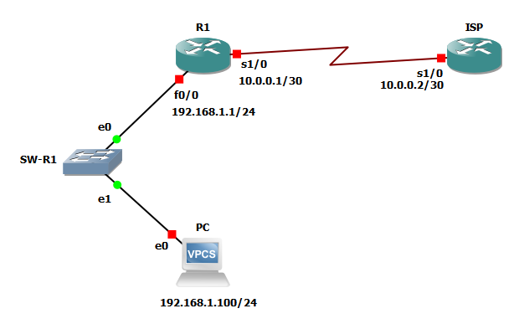

Configure the LAN Ethernet interface.

R1#configure terminal

R1(config)#interface fastEthernet 0/0

R1(config-if)#ip address 192.168.1.1 255.255.255.0

R1(config-if)#no shutdown

R1(config-if)#description LAN-INT

R1#show ip interface brief

**Task 3**

* Configure the WAN serial interface.

R1(config)#interface s1/0

R1(config-if)#ip address 10.0.0.1 255.255.255.252

R1(config-if)#no shut

R1(config-if)#description TO-WAN

**Task 4**

* Configure a default route using the ISP WAN IP address as the next-hop IP address.

R1(config)#ip route 0.0.0.0 0.0.0.0 10.0.0.2

**Task 5**

* Verify the default route configuration.

R1#show ip route