NSDC Virtual Data Science with Python Apprentice Intern
Week 2 Task: Advanced Data Visualization and Storytelling with Python
Dataset: Titanic Passenger Dataset

1. Introduction
The purpose of this Week 2 project is to move beyond basic exploratory charts and build a coherent visual story. Using the cleaned Titanic passenger dataset from Week 1, the analysis examines how passenger class, sex, age, fare, and family size are associated with survival. The objective is to communicate patterns clearly to a non-technical audience by combining comparisons, trends, distributions, and relationships rather than presenting isolated charts.

2. Analytical Approach
The dataset was first loaded with Pandas and enriched with two derived features: family_size, calculated from siblings/spouses and parents/children aboard, and age_group, created to make age-related patterns easier to communicate. The visualization sequence was deliberately arranged as a story: first establish the class effect, then add sex as a second dimension, examine age, explore fare and age together, investigate family size, and finally summarize numerical relationships with a correlation matrix.

3. Visualization Story

Figure 1: Survival Rate by Passenger Class
Why this visual: A bar chart makes class-to-class comparison immediate. It establishes the central story that survival was not evenly distributed across passenger classes.
Insight: The survival rate changes substantially across classes, with higher-class passengers showing stronger survival outcomes in this dataset.
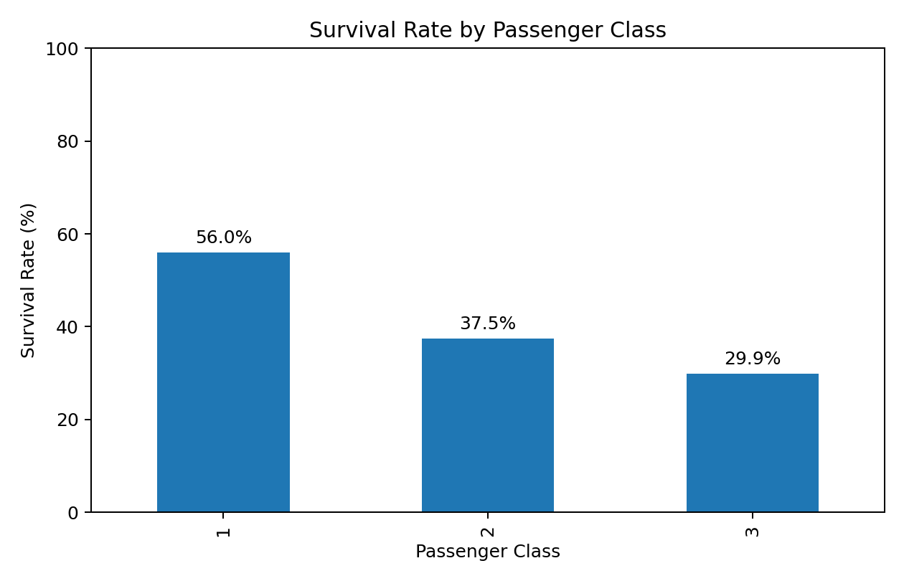

Figure 2: Survival Rate by Sex and Passenger Class
Why this visual: Grouped bars add sex as a second dimension without losing the class comparison.
Insight: Sex and class together provide a more informative picture than either variable alone; female survival is higher while class differences remain visible.
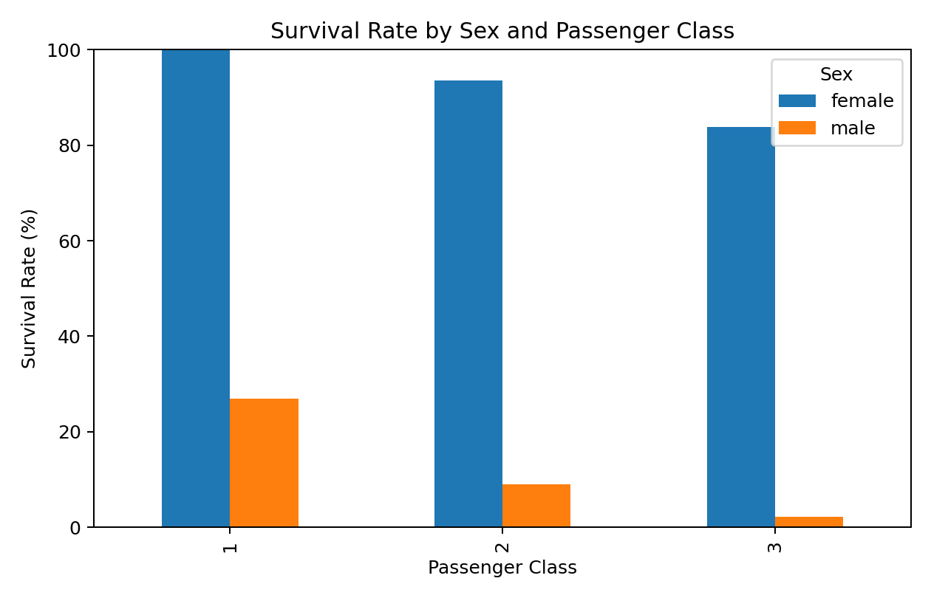

Figure 3: Survival Rate Across Age Groups
Why this visual: A line chart emphasizes the progression of survival rates across ordered age categories.
Insight: Survival patterns vary across age groups, showing that age should be considered alongside demographic and socioeconomic factors.
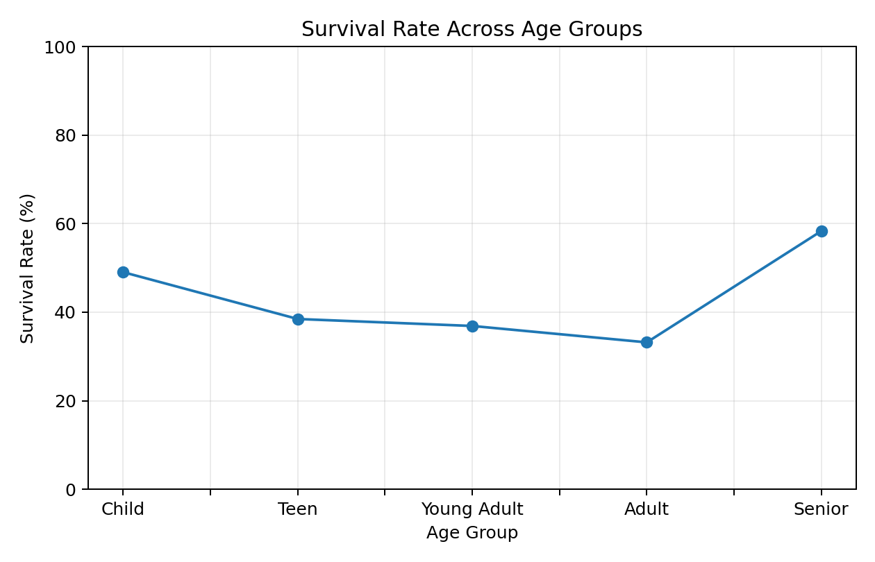

Figure 4: Fare and Age Relationship by Survival Outcome
Why this visual: A scatter plot reveals individual-level relationships and overlap that aggregated charts can hide.
Insight: Fare is strongly influenced by passenger class, while age has a weaker and less direct relationship with fare and survival.
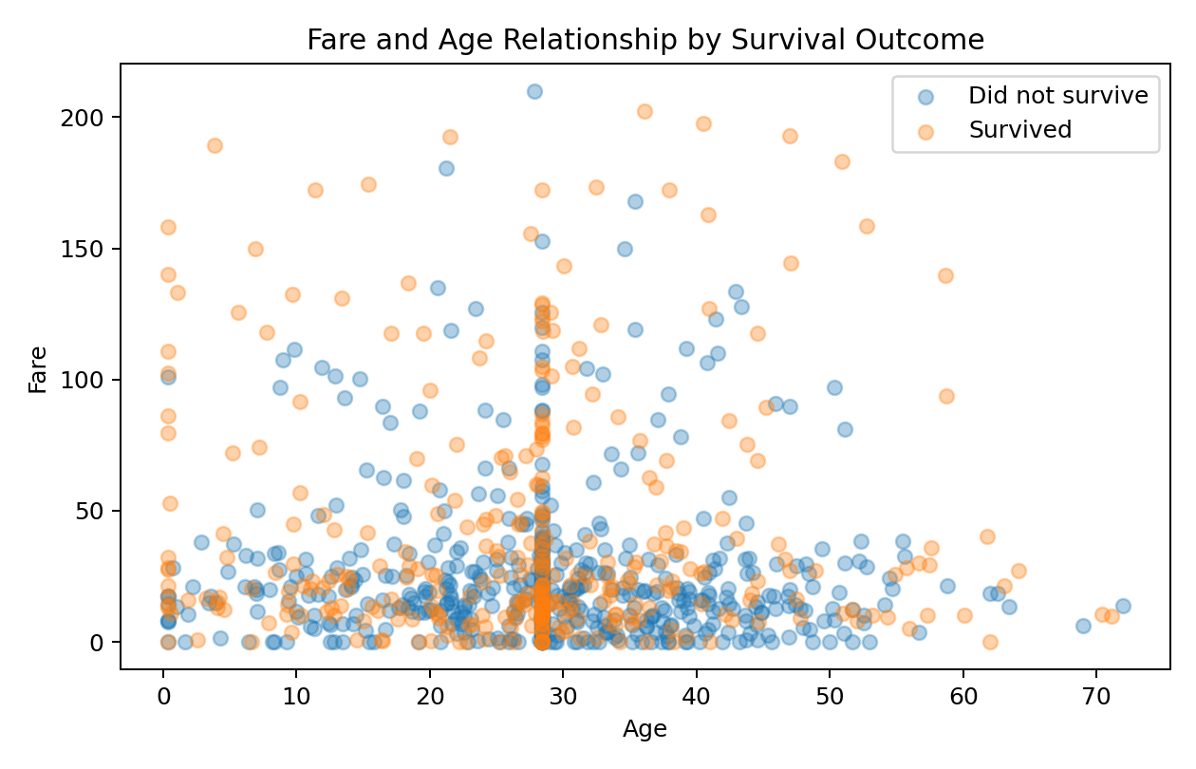

Figure 5: Survival Rate by Family Size
Why this visual: A bar chart communicates how survival changes with the number of accompanying family members.
Insight: Survival is not necessarily highest for the largest families; the relationship is non-linear and suggests that family structure may be useful for further modeling.
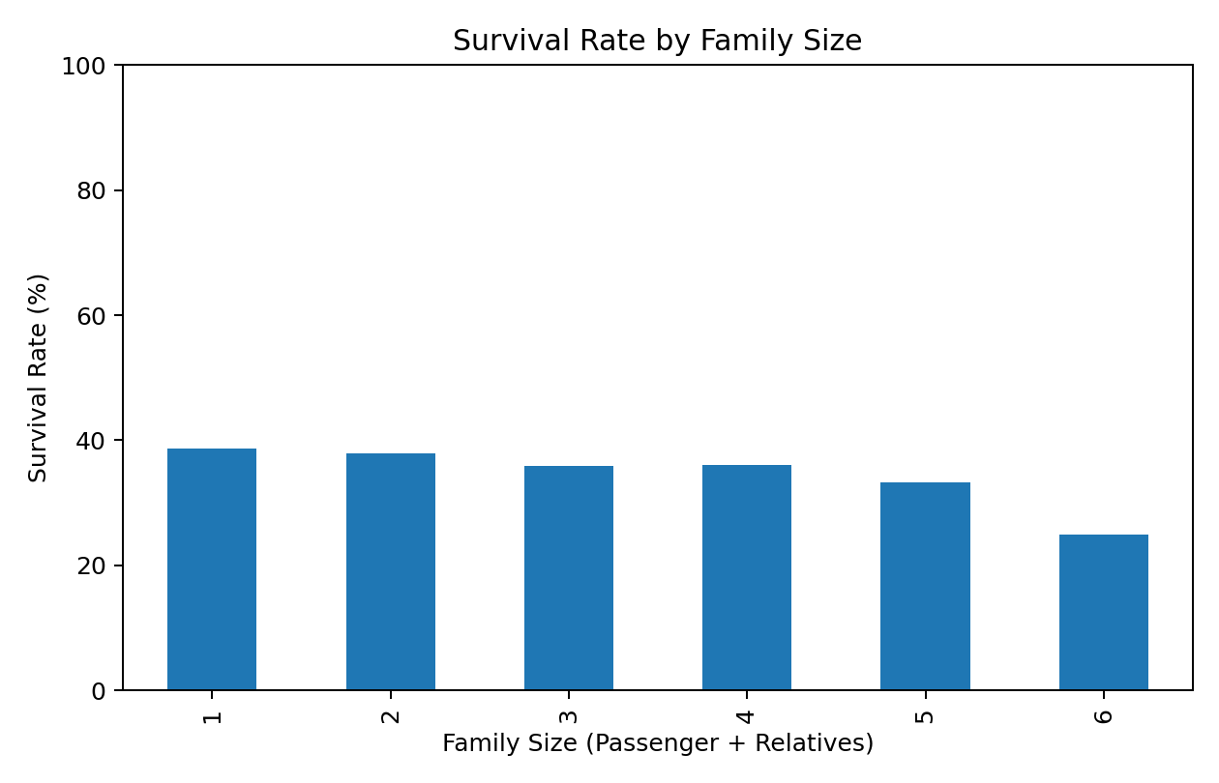

Figure 6: Correlation Matrix
Why this visual: A correlation matrix provides a compact overview of linear relationships among numerical variables.
Insight: Passenger class and fare show an inverse/positive relationship with other variables depending on coding, so variable definitions must be interpreted carefully. Correlation indicates association, not causation.
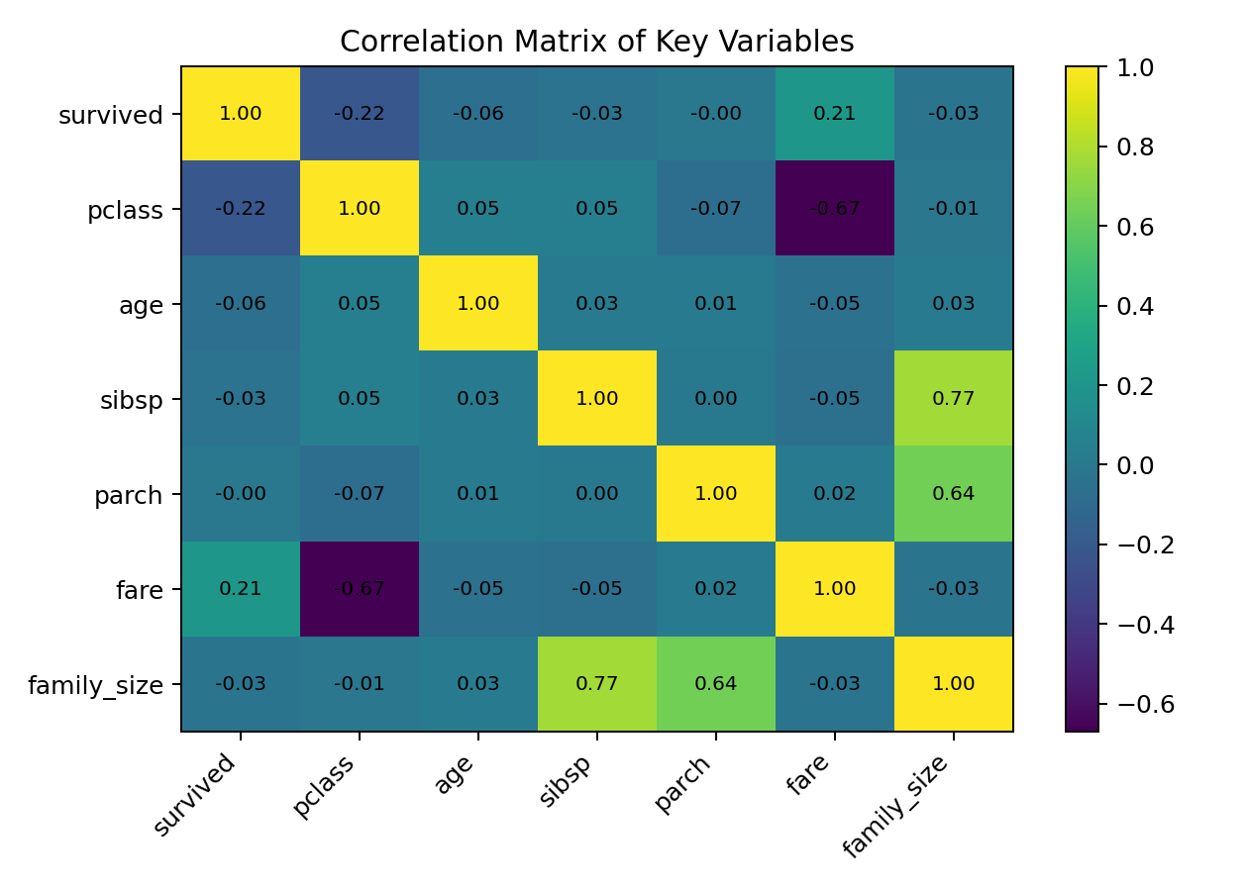

4. Business and Scientific Implications
- The analysis demonstrates why segmentation is important: an overall survival rate can hide large differences between passenger groups.
- Combining multiple dimensions such as sex and passenger class produces more actionable insights than relying on a single feature.
- Derived variables such as family size can expose non-linear patterns that are not obvious from the raw columns.
- For predictive modeling, passenger class, sex, fare, age, and family structure are reasonable candidate features, but relationships should be validated statistically and with appropriate model evaluation.
- For a non-technical audience, annotated comparisons and a logical visual sequence are more effective than presenting many unrelated charts.

5. Python Code Snippet
import pandas as pd
import matplotlib.pyplot as plt
df = pd.read_csv("titanic_cleaned.csv")
df["family_size"] = df["sibsp"] + df["parch"] + 1
df["age_group"] = pd.cut(
df["age"],
bins=[0, 12, 18, 35, 60, 100],
labels=["Child", "Teen", "Young Adult", "Adult", "Senior"],
include_lowest=True
)
survival_by_class = df.groupby("pclass")["survived"].mean() * 100
survival_by_class.plot(kind="bar")
plt.title("Survival Rate by Passenger Class")
plt.ylabel("Survival Rate (%)")
plt.show()

6. Conclusion
The Week 2 analysis converts the cleaned Titanic data into a structured visual narrative. Six visualizations were used to show class differences, the combined effect of sex and class, age-group patterns, individual fare-age relationships, family-size effects, and numerical correlations. The main lesson is that effective data storytelling depends not only on attractive charts but also on choosing an appropriate visual form, explaining why it was selected, ordering visuals logically, and translating analytical findings into implications that a non-technical audience can understand.

7. Submission Description (200+ Words)
This Week 2 report focuses on advanced data visualization and storytelling using Python. I continued with the cleaned Titanic passenger dataset from Week 1 and transformed the analysis into a structured visual narrative intended to be understandable to a non-technical audience. The project begins by creating two derived features, family size and age group, to make relationships in the data easier to interpret. I then developed six visualizations using Matplotlib and Pandas. The first visualization compares survival rates across passenger classes and establishes the main socioeconomic pattern. The second combines sex and passenger class to show how multiple factors can provide a more detailed explanation of survival. The third visualization examines survival across ordered age groups. The fourth uses a scatter plot to explore the relationship between age and fare while distinguishing survival outcomes. The fifth analyzes survival rates by family size and demonstrates that some relationships are non-linear. The sixth visualization summarizes correlations among important numerical variables. Each chart is accompanied by an explanation of why the visualization was selected, what pattern it communicates, and how it contributes to the overall story. The report also discusses business and scientific implications, including the importance of segmentation, feature engineering, and careful interpretation of associations. Through this task, I strengthened my ability to select appropriate chart types, organize multiple visuals into a coherent narrative, communicate analytical findings clearly, and connect exploratory observations with possible future predictive modeling. The project demonstrates that data visualization is not only about creating charts, but also about selecting evidence, providing context, highlighting meaningful comparisons, and communicating insights in a decision-friendly manner.

