NSDC Virtual Data Science with Python Apprentice Intern
Week 1 Task: Data Acquisition, Cleaning, and Exploratory Analysis
Dataset: Titanic Passenger Dataset

1. Introduction
This report documents a complete introductory data-science workflow using the publicly available Titanic passenger dataset. The objective was to practice data acquisition, quality inspection, cleaning, preprocessing, exploratory analysis, visualization, and interpretation using Python. The dataset contains numerical and categorical variables, making it suitable for demonstrating common data preparation challenges.

2. Data Acquisition
The Titanic dataset was selected from the widely used public Titanic dataset available through open data repositories and Python learning resources. It contains passenger survival outcome, passenger class, sex, age, family-related variables, fare, and embarkation port. The selected working table contains 891 passenger records and 8 variables.
The dataset was loaded into a Pandas DataFrame for inspection and subsequent processing.

3. Tools and Libraries
Python, Pandas, NumPy, Matplotlib, and Seaborn were used. Pandas handled tabular data and cleaning, NumPy supported numerical operations and reproducibility, and Matplotlib was used to create the visualizations.

4. Data Cleaning and Preprocessing
- Initial size: 891 rows × 8 columns.
- Missing values were inspected before cleaning. Age contained 177 missing values and Embarked contained 2 missing values.
- Missing Age values were replaced with the median age (28.4). Median imputation reduces the effect of extreme values.
- Missing Embarked values were replaced with the mode because Embarked is categorical.
- Sex and Embarked were converted to categorical data types.
- Duplicate rows were removed to avoid repeated observations.
- Finally, the cleaned data was exported as titanic_cleaned.csv.

5. Python Code Snippet
import pandas as pd
import matplotlib.pyplot as plt
df = pd.read_csv("titanic.csv")
print(df.info())
print(df.isnull().sum())
df["age"] = df["age"].fillna(df["age"].median())
df["embarked"] = df["embarked"].fillna(df["embarked"].mode()[0])
df = df.drop_duplicates()
print(df.describe())

6. Exploratory Analysis and Visualizations
The overall survival rate in the cleaned dataset was 37.8%. The median passenger age was 28.4 years and the median fare was 19.30. Survival was substantially different between sexes: females had a survival rate of 90.1% compared with 9.2% for males.
Survival also varied by passenger class: Class 1 = 56.0%, Class 2 = 37.5%, Class 3 = 29.9%.
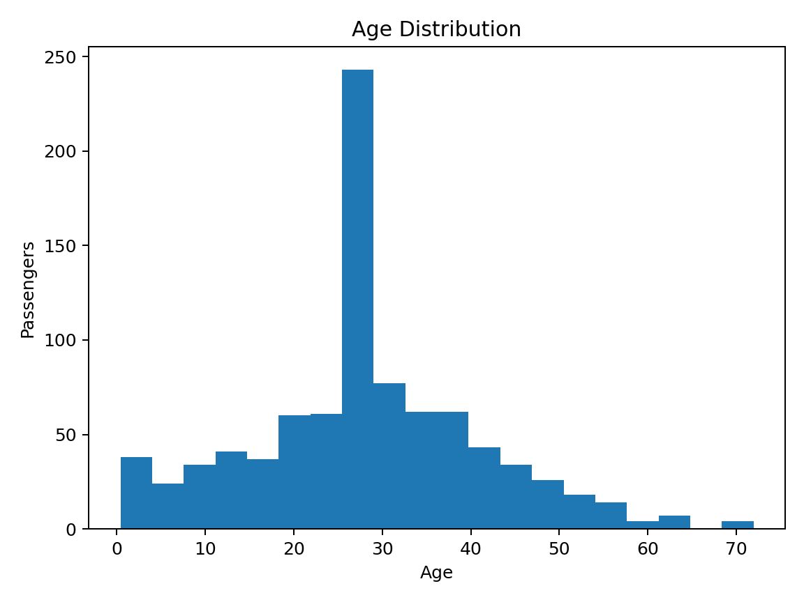
Figure 1. Age distribution after missing-value treatment.
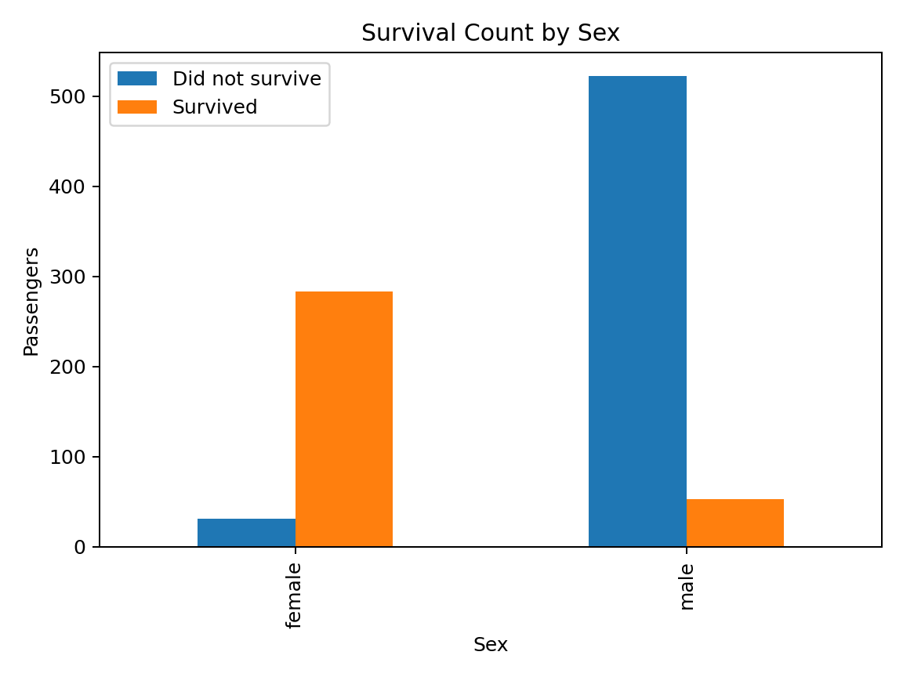
Figure 2. Survival counts by sex.
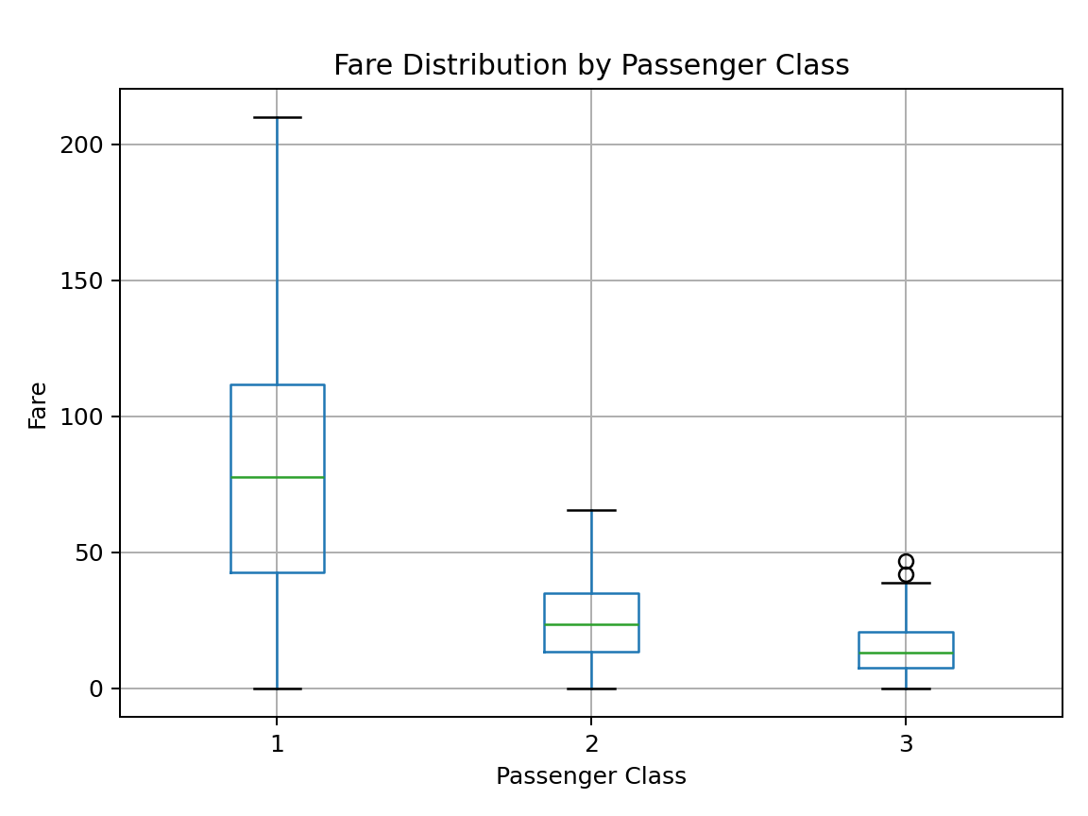
Figure 3. Fare distribution by passenger class.
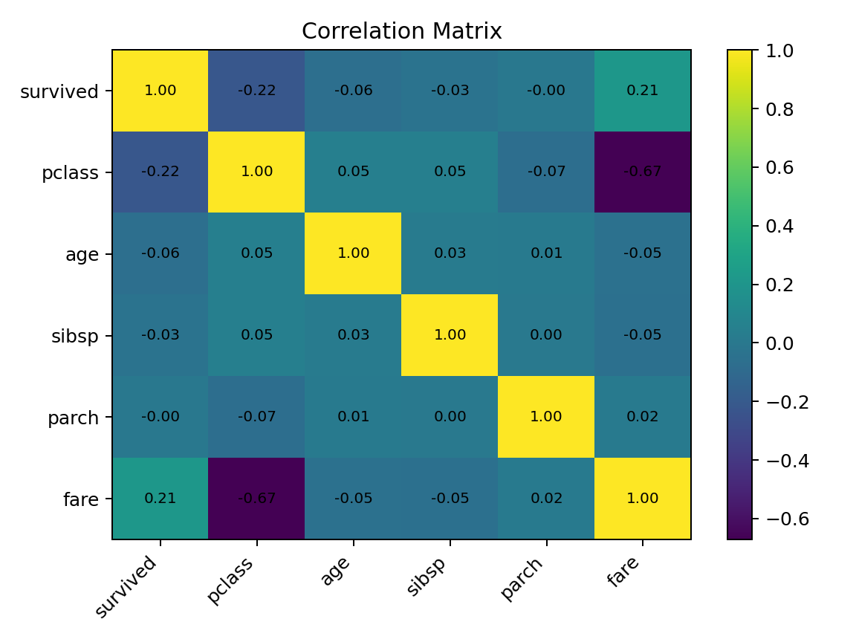
Figure 4. Correlation matrix of numerical variables.

7. Key Insights
- Female passengers show a much higher survival rate than male passengers, indicating a strong association between sex and survival.
- First-class passengers have the highest survival rate, while third-class passengers have the lowest.
- Fare distributions differ considerably across passenger classes, with higher fares generally associated with higher class.
- The age histogram shows that the passenger population is concentrated mainly in young and middle-age groups.
- Correlation can reveal association between variables, but it does not by itself prove causation.

8. Conclusion
This Week 1 exercise demonstrates the essential stages of a practical data-science project. The data was inspected, missing values were handled using defensible simple methods, duplicates were removed, and categorical variables were prepared for analysis. EDA and visualizations revealed meaningful relationships involving sex, passenger class, fare, age, and survival. The cleaned dataset and analysis provide a foundation for future feature engineering, statistical testing, and predictive modeling.

9. Submission Description (200+ Words)
This Week 1 report presents my practical work on Data Acquisition, Cleaning, and Exploratory Data Analysis using Python. I selected the publicly available Titanic passenger dataset because it contains both numerical and categorical variables and provides realistic examples of missing data and relationships between features. I began by loading the dataset into a Pandas DataFrame and examining its structure, dimensions, data types, summary statistics, and missing-value counts. During the cleaning stage, missing values in the age column were handled using median imputation because the median is less affected by extreme values. Missing values in the embarkation column were handled using the mode because it is a categorical field. I also converted appropriate fields to categorical data types and removed duplicate records to improve data quality. After preprocessing, I performed exploratory analysis using descriptive statistics and visualizations. The report includes an age-distribution histogram, a comparison of survival counts by sex, a box plot showing fare distribution across passenger classes, and a correlation matrix for important numerical variables. The analysis identified several useful patterns. Female passengers had a substantially higher survival rate than male passengers, and passenger class was also strongly associated with survival. First-class passengers showed better survival outcomes than passengers in lower classes, while fare values varied noticeably across classes. The visualization stage made these patterns easier to understand and communicate. Overall, this task strengthened my understanding of the complete data-science workflow, from acquiring and cleaning raw data to exploring patterns, creating visualizations, interpreting results, and documenting the methodology in a professional report.

