NSDC Week 4 - Machine Learning Model Development and Evaluation

Objective
Build and evaluate a Logistic Regression model on the cleaned Titanic dataset.

Data Preparation
Encoded sex, selected pclass, sex, age and fare as features, filled missing values with median and split data into training and testing sets.

Model Choice
Logistic Regression was selected because it is a simple, interpretable baseline classifier for binary survival prediction.

Evaluation Metrics
Accuracy: 0.916
Precision: 0.908
Recall: 0.896
F1-score: 0.902
ROC AUC: 0.958
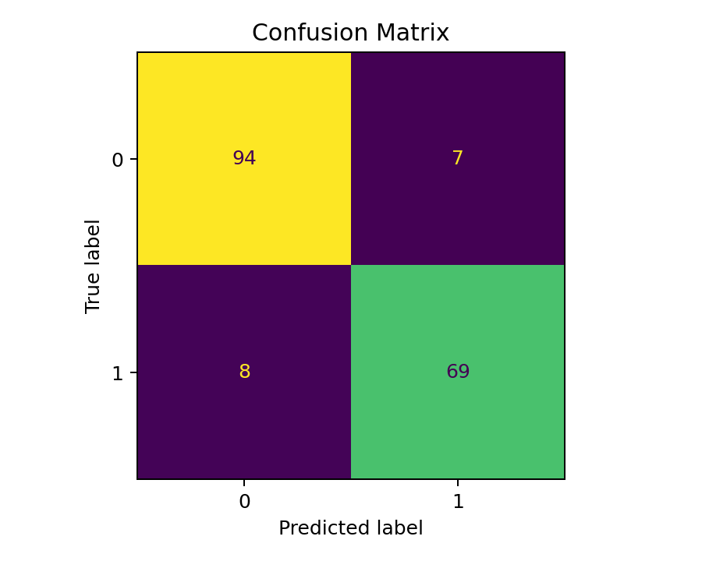
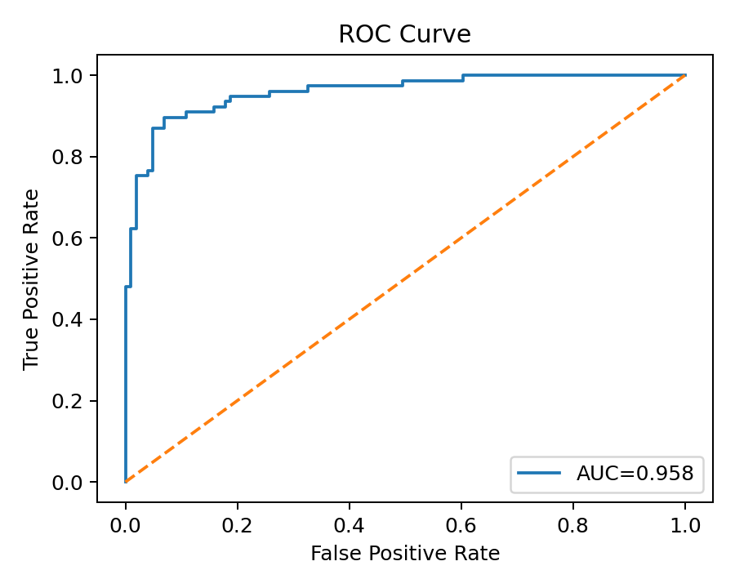

Sources of Error
Performance may be affected by limited features, missing-value imputation and class imbalance. More features and hyperparameter tuning could improve results while cross-validation can reduce overfitting risk.

Python Code
import pandas as pd
from sklearn.model_selection import train_test_split
from sklearn.preprocessing import LabelEncoder
from sklearn.linear_model import LogisticRegression
df=pd.read_csv('titanic_cleaned.csv')
df['sex']=LabelEncoder().fit_transform(df['sex'].astype(str))
X=df[['pclass','sex','age','fare']].fillna(df[['pclass','sex','age','fare']].median())
y=df['survived']
X_train,X_test,y_train,y_test=train_test_split(X,y,test_size=0.2,random_state=42)
model=LogisticRegression(max_iter=1000)
model.fit(X_train,y_train)
print(model.score(X_test,y_test))

Submission Description (200+ Words)
This Week 4 report demonstrates the complete machine learning model development process using Python and the cleaned Titanic passenger dataset. I prepared the data by selecting relevant features, converting categorical values into numerical form, handling missing values, and splitting the dataset into training and testing sets. I selected Logistic Regression because it is a simple and interpretable algorithm for binary classification problems. After training the model, I evaluated its performance using accuracy, precision, recall, F1-score, and the ROC AUC score. The report includes a confusion matrix and ROC curve to explain how the model performs on unseen data. I also discussed possible sources of prediction error, including limited features, missing-value handling, class imbalance, and overfitting or underfitting. Finally, I suggested improvements such as feature engineering, hyperparameter tuning, cross-validation, and trying advanced algorithms like Decision Trees or Random Forest. This project strengthened my understanding of the complete machine learning workflow from preprocessing and training to evaluation and interpretation.This Week 4 report demonstrates the complete machine learning model development process using Python and the cleaned Titanic passenger dataset. I prepared the data by selecting relevant features, converting categorical values into numerical form, handling missing values, and splitting the dataset into training and testing sets. I selected Logistic Regression because it is a simple and interpretable algorithm for binary classification problems. After training the model, I evaluated its performance using accuracy, precision, recall, F1-score, and the ROC AUC score. The report includes a confusion matrix and ROC curve to explain how the model performs on unseen data. I also discussed possible sources of prediction error, including limited features, missing-value handling, class imbalance, and overfitting or underfitting. Finally, I suggested improvements such as feature engineering, hyperparameter tuning, cross-validation, and trying advanced algorithms like Decision Trees or Random Forest. This project strengthened my understanding of the complete machine learning workflow from preprocessing and training to evaluation and interpretation.

