NSDC Final Week – Comprehensive Data Science Project Report
Virtual Data Science with Python Apprentice Intern
Integrated analysis using the Titanic passenger dataset

Executive Summary
This final report consolidates the work completed during the five-week data science internship. The project followed an end-to-end workflow beginning with public dataset acquisition and data cleaning, followed by exploratory analysis, advanced visualization and storytelling, statistical hypothesis testing, and finally machine learning model development and evaluation. The Titanic passenger dataset was used as a consistent case study because it contains numerical and categorical variables and supports both descriptive and predictive analysis. The project demonstrates how raw data can be transformed into useful evidence for decision-making. Key themes identified across the work include the importance of data quality, differences in survival outcomes across passenger characteristics, the value of statistical validation, and the need to evaluate machine learning models using more than one metric.

1. Introduction
The objective of the internship project was to develop practical skills in Python-based data science. The workflow was organized into five stages: data acquisition and cleaning, visualization and storytelling, statistical analysis and hypothesis testing, machine learning model development, and comprehensive reporting. Pandas and NumPy were used for data preparation, Matplotlib/Seaborn-style analytical visualizations were used for exploration, SciPy-oriented statistical methods were considered for hypothesis testing, and Scikit-learn was used for predictive modelling.

2. Methodology

Week 1 – Data Acquisition, Cleaning and EDA
The publicly available Titanic dataset was acquired and inspected. Missing values were handled, duplicate or inconsistent records were considered, data types were prepared, and summary statistics were generated. Exploratory analysis was used to understand distributions and relationships.

Week 2 – Visualization and Storytelling
The cleaned dataset was used to develop a visual narrative. Different chart types were selected according to the analytical question so that patterns could be communicated clearly to a non-technical audience.

Week 3 – Statistical Analysis and Hypothesis Testing
A testable hypothesis was formulated around relationships in the passenger data. Statistical testing was used to move beyond simple descriptive observations and assess whether observed differences could reasonably be attributed to chance.

Week 4 – Machine Learning
A Logistic Regression classifier was developed as an interpretable baseline for predicting survival. Relevant features were prepared, categorical data were encoded, missing numerical values were handled, and the data were divided into training and testing sets. Performance was evaluated with accuracy, precision, recall, F1-score, confusion matrix and ROC/AUC analysis.

Week 5 – Synthesis and Recommendations
Findings from the earlier stages were integrated into a single stakeholder-oriented report. The final stage focuses on interpretation, limitations, business/research implications and actionable recommendations.

3. Key Analytical Findings
The exploratory and predictive stages show that passenger characteristics contain useful information for understanding survival outcomes. Variables such as passenger class, sex, age and fare can provide meaningful signals for a binary survival model. Visualization helps reveal differences and distributions that may be hidden in raw tables, while statistical testing provides a formal framework for judging whether observed patterns are supported by evidence.
The machine learning stage demonstrates the practical distinction between prediction and explanation. A model can produce useful predictions while still having errors, and a single accuracy value is not enough to understand those errors. The confusion matrix identifies false positives and false negatives, while the ROC curve shows the model's ability to distinguish between the two outcome classes across decision thresholds.

4. Machine Learning Evaluation
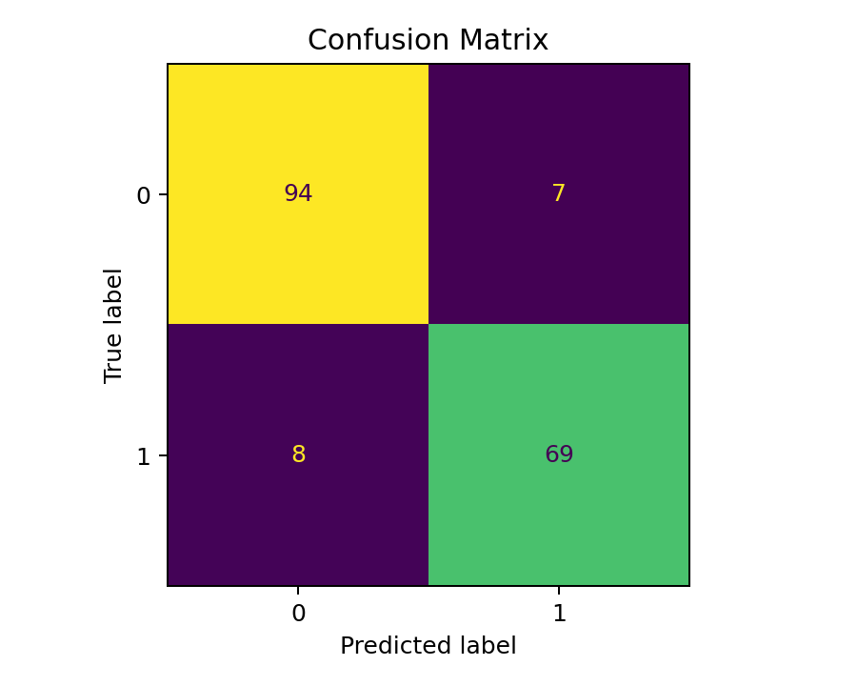
Figure 1: Confusion matrix for the Logistic Regression baseline.
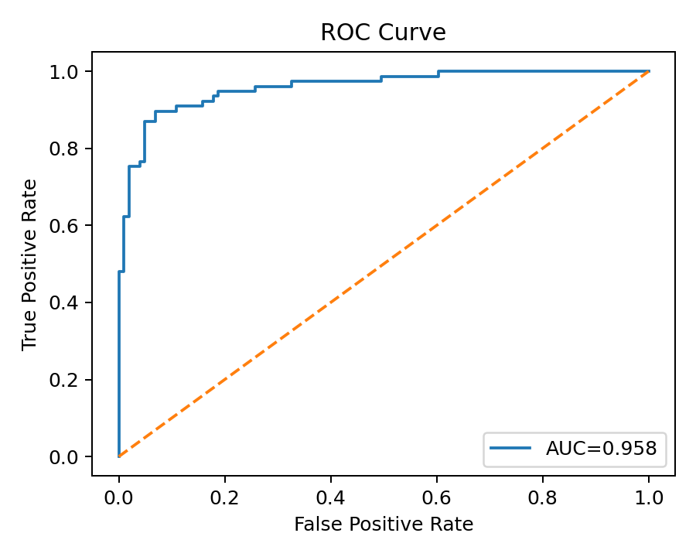
Figure 2: ROC curve used to assess classification discrimination.

5. Strategic Recommendations
- Use data quality checks as a standard first step before analysis or modelling. Missing values, duplicate records and inconsistent types can directly affect conclusions.
- Prefer a combination of descriptive statistics, visualizations and statistical tests rather than relying on a single analytical technique.
- Use interpretable baseline models before moving to more complex algorithms. This provides a clear benchmark and makes model errors easier to diagnose.
- Track multiple evaluation metrics. Accuracy should be considered alongside precision, recall, F1-score and ROC/AUC, especially when the costs of different errors are not equal.
- Perform cross-validation and feature engineering in future iterations. These steps can improve reliability and help identify whether the model generalizes beyond one train/test split.
- Communicate findings in stakeholder-friendly language. Charts should answer specific questions, include clear captions, and connect analytical evidence to an action or decision.

6. Business / Research Impact
The project illustrates a reusable data-driven decision framework. In a business setting, the same workflow can support customer analytics, risk classification, operational forecasting and segmentation. In a research setting, the workflow helps convert raw observations into reproducible evidence. The main impact is not the Titanic dataset itself, but the transferable process: acquire reliable data, clean it systematically, explore it visually, validate important claims statistically, build a baseline model, evaluate errors, and communicate recommendations.

7. Limitations
- The Titanic dataset is historical and may not represent modern populations or business environments.
- The selected features do not capture every factor that could influence the outcome.
- Median imputation and categorical encoding simplify the data and may remove some information.
- A single train/test split can produce results that vary with the random split; cross-validation would provide a stronger estimate.
- A Logistic Regression baseline may not capture nonlinear relationships that more advanced models can learn.

8. Future Improvements
Future work can include systematic cross-validation, hyperparameter tuning, feature engineering, class-imbalance checks, calibration analysis and comparison with Decision Trees, Random Forests or gradient-boosting methods. Model explainability techniques can also be added so that stakeholders understand why a prediction was produced. For a larger real-world project, automated data-quality checks and reproducible pipelines should be introduced.

9. Conclusion
The five-week project provided practical experience across the complete data science lifecycle. The work moved from raw data acquisition and cleaning to exploratory analysis, visual storytelling, hypothesis testing and machine learning. The final synthesis demonstrates that strong data science requires both technical implementation and clear interpretation. The resulting workflow is reproducible, extensible and suitable as a foundation for future projects involving larger and more complex datasets.

10. Representative Python Workflow
import pandas as pd
from sklearn.model_selection import train_test_split
from sklearn.preprocessing import LabelEncoder
from sklearn.linear_model import LogisticRegression
from sklearn.metrics import classification_report, confusion_matrix, roc_curve, auc
df = pd.read_csv("titanic_cleaned.csv")
df["sex"] = LabelEncoder().fit_transform(df["sex"].astype(str))
X = df[["pclass", "sex", "age", "fare"]].fillna(
df[["pclass", "sex", "age", "fare"]].median()
)
y = df["survived"]
X_train, X_test, y_train, y_test = train_test_split(
X, y, test_size=0.20, random_state=42
)
model = LogisticRegression(max_iter=1000)
model.fit(X_train, y_train)
pred = model.predict(X_test)
prob = model.predict_proba(X_test)[:, 1]
print(classification_report(y_test, pred))

11. Submission Description (200+ Words)
This Week 5 report presents a comprehensive end-to-end data science project that integrates the practical skills developed throughout the previous four weeks of the internship. The project uses the Titanic passenger dataset as a consistent case study and demonstrates how data can be transformed from a raw public source into meaningful analytical and predictive insights. The work begins with data acquisition, cleaning, preprocessing and exploratory data analysis using Python. It then progresses to advanced visualization and data storytelling, where charts are used to communicate patterns and relationships in a clear and structured manner. The third stage applies statistical analysis and hypothesis testing to evaluate whether important observations are supported by statistical evidence. The fourth stage develops a Logistic Regression machine learning model for binary survival prediction and evaluates its performance using classification metrics, a confusion matrix and an ROC curve. The final stage synthesizes these results into stakeholder-oriented recommendations. The report discusses the importance of data quality, model evaluation, error analysis and reproducibility. It also identifies limitations such as restricted feature coverage, historical data characteristics, simplified missing-value treatment and the use of a single train/test split. Future improvements include cross-validation, feature engineering, hyperparameter tuning, model comparison and explainability. Overall, this report demonstrates a complete and practical data science workflow and highlights how analytical findings can be converted into actionable recommendations for business or research decision-making.

