NSDC Virtual Data Science with Python Apprentice Intern
Week 3 Task: Statistical Analysis and Hypothesis Testing in Python
Dataset: Titanic Passenger Dataset

1. Introduction
This project applies inferential statistics to the cleaned Titanic passenger dataset. The objective is to test whether observed differences and associations are statistically meaningful rather than relying only on descriptive charts. Three complementary tests are used: a chi-square test of independence for sex and survival, a Welch independent-samples t-test for passenger fare by survival outcome, and a one-way ANOVA for differences in mean fare across passenger classes. A significance level of 0.05 is used throughout.

2. Hypotheses
Hypothesis 1 — Chi-square test
H0: Sex and survival status are independent in the Titanic dataset.
H1: Sex and survival status are associated in the Titanic dataset.
Hypothesis 2 — Welch t-test
H0: The mean fare is the same for survivors and non-survivors.
H1: The mean fare differs between survivors and non-survivors.
Hypothesis 3 — One-way ANOVA
H0: Mean passenger fare is equal across passenger classes.
H1: At least one passenger class has a different mean fare.

3. Methodology
The cleaned CSV from Week 1 was loaded with Pandas. Missing values were excluded only for the variables required by each test. The chi-square test evaluates association between two categorical variables. The Welch t-test compares two independent means and does not require equal variances, making it a safer choice for fare data. One-way ANOVA compares the mean fare across the three passenger classes. The results are interpreted using p-values against α = 0.05. Statistical significance is not treated as proof of causation.

4. Results

4.1 Chi-square Test: Sex vs Survival
The contingency table produced a chi-square statistic of 562.072 with 1 degree(s) of freedom and a p-value of 2.97718e-124. Because the p-value is below 0.05, the null hypothesis is rejected. This indicates that sex and survival are statistically associated in this sample.
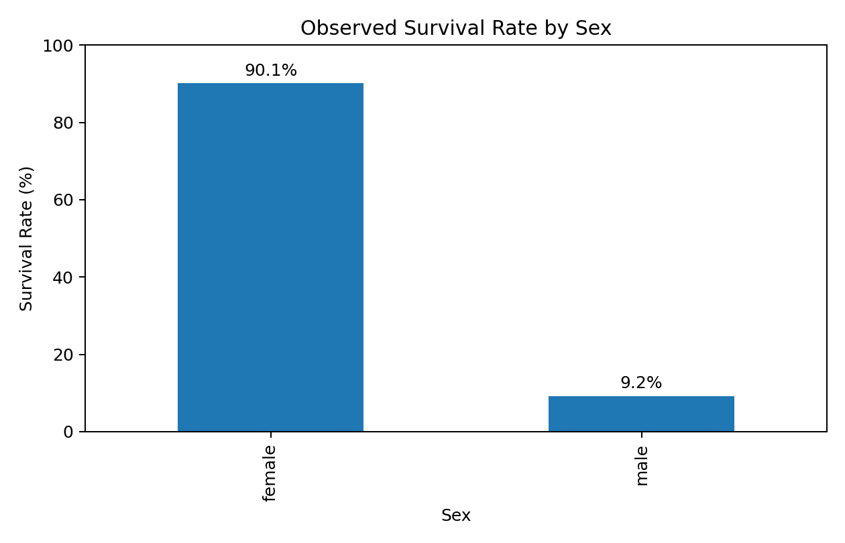

4.2 Welch Independent-Samples t-Test: Fare vs Survival
Survivors had a mean fare of 42.16, while non-survivors had a mean fare of 25.76. The Welch t-statistic was 5.809, with p = 1.11277e-08. The estimated difference in means (survivors minus non-survivors) was 16.40. The 95% confidence interval for this difference was [10.85, 21.95]. Since the p-value is below 0.05, the null hypothesis is rejected.
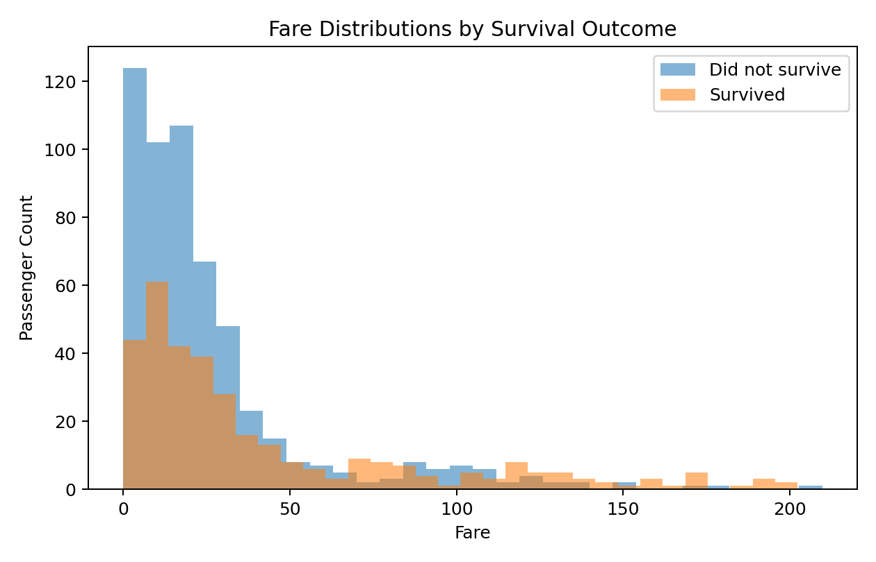
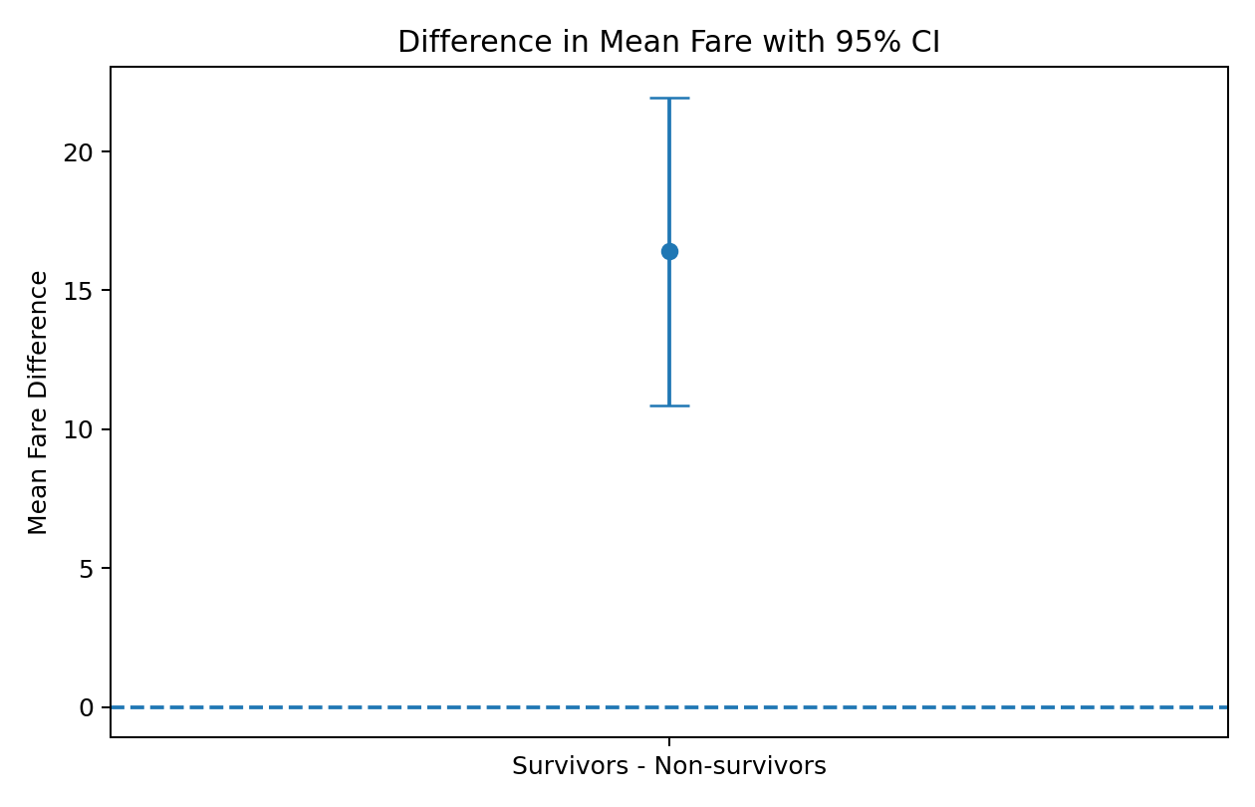

4.3 One-way ANOVA: Fare vs Passenger Class
The ANOVA returned F = 459.281 and p = 1.38193e-137. Because the p-value is below 0.05, the null hypothesis is rejected, indicating that mean fares are not equal across all passenger classes.
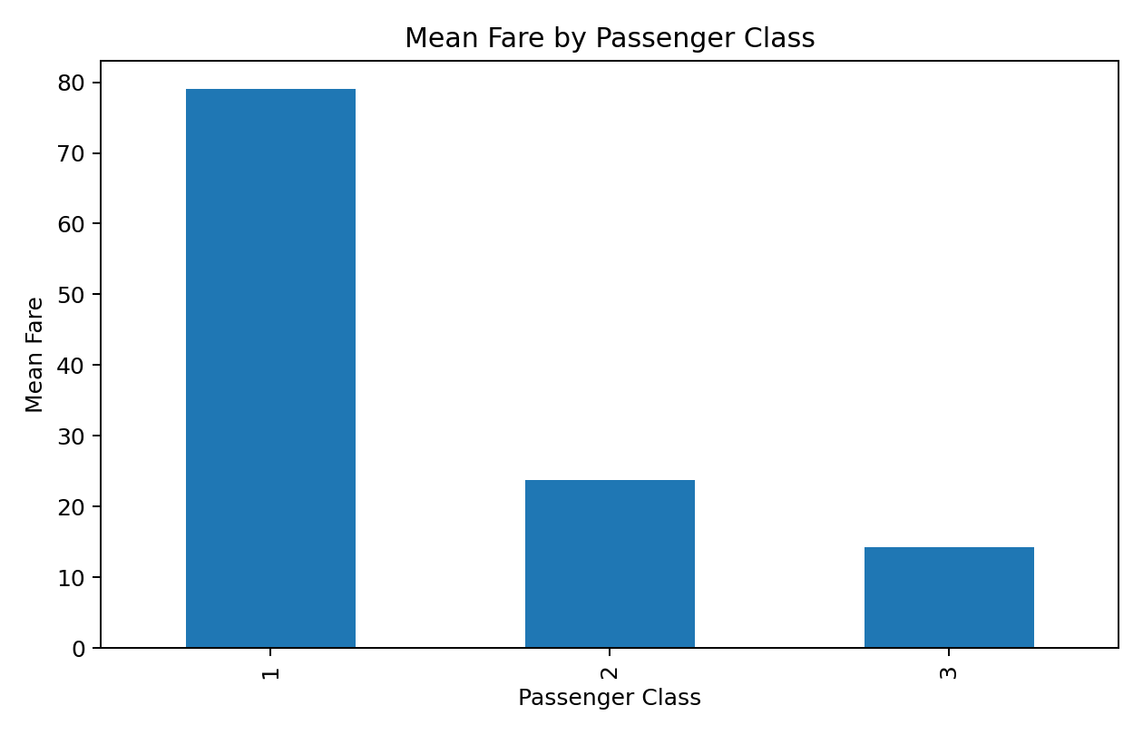

5. Assumptions and Limitations
- Observations are treated as independent for the tests.
- The chi-square test requires adequate expected cell counts; the contingency table has sufficiently large counts for this application.
- The Welch t-test is used instead of the equal-variance t-test because fare variability can differ between groups.
- ANOVA assumes independent observations and approximately normal residuals within groups; with this large dataset, the test is useful as a comparison of group means, but strong skew in fare should be kept in mind.
- The dataset represents historical passengers, so statistical association should not be interpreted as causal evidence.
- Multiple hypothesis tests increase the chance of a false positive. A future analysis could apply a multiple-comparison correction when testing a larger family of hypotheses.

6. Interpretation and Practical Implications
The statistical results show that passenger characteristics are associated with outcomes in the dataset. The sex-survival test provides evidence of an association, while the fare analysis indicates that the fare distributions of survivors and non-survivors differ. The ANOVA confirms substantial differences in mean fare among passenger classes. These findings support using demographic and socioeconomic variables as candidate predictors in a later predictive modeling task. However, statistical significance alone does not establish why the differences occurred. A deeper study would control for confounding variables such as class, age, sex, and family structure and could use regression or causal methods.

7. Python Code Used
import pandas as pd
from scipy import stats
df = pd.read_csv("titanic_cleaned.csv")
# H1: Sex and survival are associated.
contingency = pd.crosstab(df["sex"], df["survived"])
chi2, p_value, dof, expected = stats.chi2_contingency(contingency)
print("Chi-square statistic:", chi2)
print("Chi-square p-value:", p_value)
# H2: Mean fare differs between survivors and non-survivors.
survived_fare = df.loc[df["survived"] == 1, "fare"].dropna()
not_survived_fare = df.loc[df["survived"] == 0, "fare"].dropna()
t_stat, p_value = stats.ttest_ind(
survived_fare, not_survived_fare, equal_var=False
)
print("Welch t statistic:", t_stat)
print("Welch t-test p-value:", p_value)
# H3: Mean fare differs among passenger classes.
fare_groups = [
group["fare"].dropna()
for _, group in df.groupby("pclass")
]
f_stat, p_value = stats.f_oneway(*fare_groups)
print("ANOVA F statistic:", f_stat)
print("ANOVA p-value:", p_value)
# 95% CI for the difference in mean fare
print("Mean fare - survivors:", survived_fare.mean())
print("Mean fare - non-survivors:", not_survived_fare.mean())

8. Conclusion
This Week 3 project demonstrates how Python can be used to move from descriptive analysis to formal hypothesis testing. The chi-square test was used for a categorical association, the Welch t-test for a two-group mean comparison, and ANOVA for a three-group mean comparison. P-values and a 95% confidence interval were used to make evidence-based decisions at the 5% significance level. The analysis highlights the importance of matching a statistical test to the data type and research question, checking assumptions, and distinguishing statistical association from causation.

9. Submission Description (200+ Words)
This Week 3 report presents a practical statistical analysis and hypothesis testing project using Python and the cleaned Titanic passenger dataset from the earlier weeks. The main objective was to move beyond descriptive statistics and determine whether important differences and relationships observed in the data are statistically significant. I formulated three testable hypotheses with real-world relevance. The first hypothesis examined whether passenger sex and survival status were associated, and I used a chi-square test of independence because both variables are categorical. The second hypothesis investigated whether the average passenger fare differed between survivors and non-survivors. For this comparison I used Welch's independent-samples t-test, which is appropriate when two independent groups are compared without assuming equal variances. The third hypothesis tested whether average fare differed among the three passenger classes, for which I applied one-way ANOVA. I used a significance level of 0.05 and interpreted the p-values accordingly. The report includes four supporting visualizations covering survival rates, fare distributions, mean fare by passenger class, and a confidence interval for the difference in mean fares. I also documented the methodology, assumptions, limitations, statistical results, and practical implications. Missing values were excluded only where necessary for a particular test, and the analysis was designed to avoid treating statistical significance as evidence of causation. The results demonstrate that statistical testing can validate patterns that appear during exploratory analysis and can provide a stronger basis for conclusions. This task improved my understanding of hypothesis formulation, selection of appropriate statistical tests, p-value interpretation, confidence intervals, assumptions, and responsible communication of statistical findings. The project also provides a foundation for future predictive modeling by identifying variables that may be useful as candidate features while recognizing the need to account for confounding factors and model assumptions.

