## Department of Computer Engineering Academic Term: First Term 2023-24

**Class: T.E /Computer Sem – V / Software Engineering**

|  |  |  |  |  |  |  |  |
| --- | --- | --- | --- | --- | --- | --- | --- |
| **Practical No:** | | | **5** | | | | |
| **Title:** | | | **Estimating project cost using COCOMO Model** | | | | |
| **Date of Performance:** | | | **04-09-2023** | | | | |
| **Roll No:** | | | **9606** | | | | |
| **Team Members:** | | | **Shubham Ghadigaonkar** | | | | |
| Sr. No | Performance Indicator | Excellent | | Good | Below Average | Total Score |  |
| 1 | On time Completion & Submission (01) | 01 (On  Time ) | | NA | 00 (Not on Time) |  |
| 2 | Theory Understanding(02) | 02(Correct) | | NA | 01 (Tried) |  |
| 3 | Content Quality (03) | 03(All used) | | 02 (Partial) | 01 (rarely followed) |  |
| 4 | Post Lab Questions (04) | 04(done well) | | 3 (Partially Correct) | 2(submitted) |  |

## Signature of the Teacher:

**Lab Experiment 05**

# Experiment Name: Estimating Project Cost Using COCOMO Model in Software Engineering

**Objective:** The objective of this lab experiment is to introduce students to the COCOMO (Constructive Cost Model) estimation technique for estimating software project cost and effort. Students will gain practical experience in using the COCOMO model to estimate the development effort, duration, and resources required for a sample software project.

**Introduction:** COCOMO is a widely used algorithmic cost estimation model in software engineering. It helps in quantifying the effort and resources needed for software development based on project size, complexity, and other factors.

# Lab Experiment Overview:

1. Introduction to COCOMO Model: The lab session begins with an introduction to the COCOMO model, explaining the different versions (Basic, Intermediate, and Advanced) and their application in software cost estimation.
2. Defining the Sample Project: Students are provided with a sample software project along with its functional and non-functional requirements, complexity, and size metrics.
3. COCOMO Parameters: Students learn about the COCOMO model parameters, such as Effort Adjustment Factor (EAF), Scale Factors, and Cost Drivers, and how they influence the project's effort estimation.
4. Effort and Duration Estimation: Using the COCOMO model formula, students estimate the effort and duration required to complete the sample project based on the provided size and complexity metrics.
5. Resource Allocation: Students estimate the number of required resources, such as developers, testers, and project managers, based on the calculated effort and project duration. 6. Sensitivity Analysis: Students perform sensitivity analysis by varying the COCOMO parameters to observe their impact on the project cost estimation.

7. Conclusion and Reflection: Students discuss the significance of COCOMO in software project estimation and reflect on their experience in estimating project cost using the COCOMO model.

**Learning Outcomes:** By the end of this lab experiment, students are expected to:

* + Understand the COCOMO model and its application in software cost estimation. ∙ Gain practical experience in using the COCOMO model to estimate effort, duration, and resources for a software project.
  + Learn to consider various project factors and adjust COCOMO parameters for accurate cost estimation.
  + Develop estimation skills for resource allocation and project planning.
  + Appreciate the importance of data accuracy and project size metrics in project cost estimation.

Dr. B. S. Daga Fr. CRCE, Mumbai

P a g e | **14**

**Pre-Lab Preparations:** Before the lab session, students should familiarize themselves with the COCOMO model, its parameters, and the cost estimation formula. They should also review the factors that influence the project's size and complexity.

# Materials and Resources:

* + Project brief and details for the sample software project
  + COCOMO model guidelines and cost estimation formula
  + Calculators or spreadsheet software for performing calculations

**Conclusion:** The lab experiment on estimating project cost using the COCOMO model provides students with practical insights into software cost estimation techniques. By applying the COCOMO model to a sample software project, students gain hands-on experience in assessing effort, duration, and resource requirements. The sensitivity analysis allows them to understand the impact of various factors on cost estimation. The lab experiment encourages students to use COCOMO in real-world scenarios, promoting informed decision-making in software project planning and resource allocation. Accurate cost estimation using COCOMO enhances project management and contributes to the successful execution of software engineering projects.

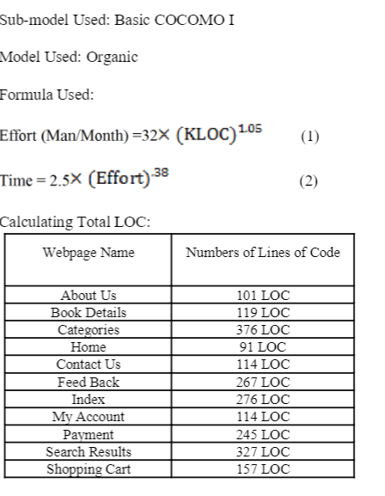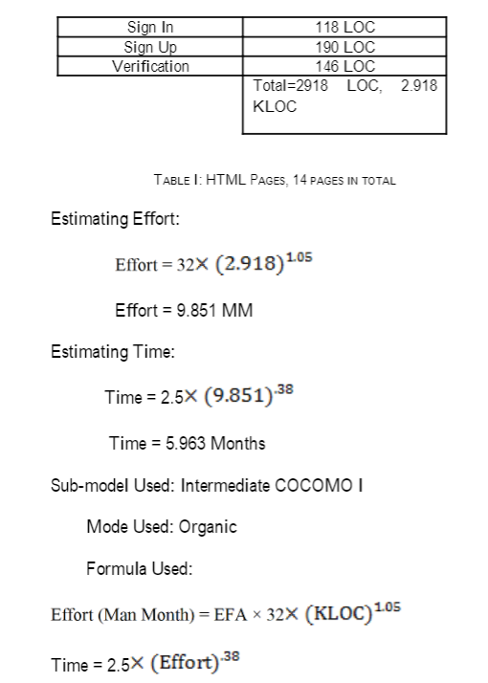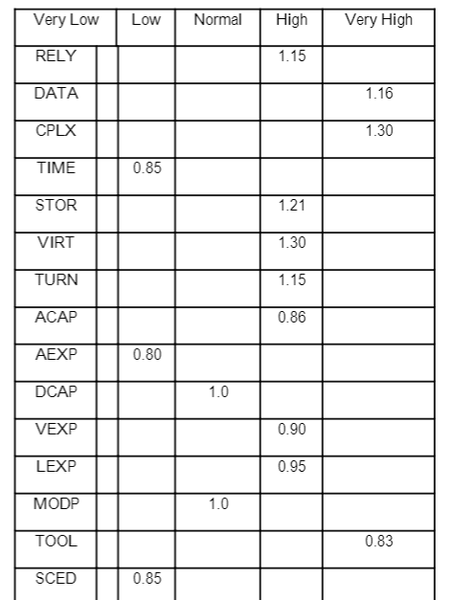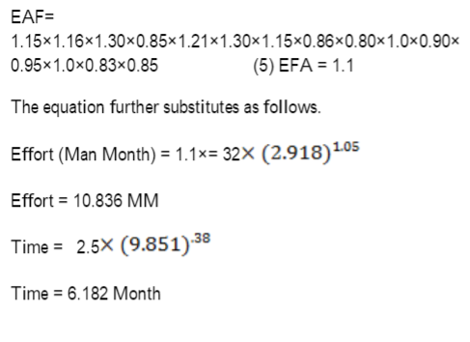

## RESULTS:

**Postlabs:**

## Analyse the COCOMO model and its different modes (Organic, Semi- detached, Embedded) to determine the most suitable mode for a specific project type.

The COCOMO (COnstructive COst MOdel) is a widely used software cost estimation model that helps project managers and developers predict the effort, time, and resources required for a software project. COCOMO comes in different modes, including Organic, Semi-Detached, and Embedded. The choice of the most suitable mode depends on the type of project. Let's analyze these modes and determine their suitability for specific project types:

1. Organic Mode:

* Project Characteristics: The Organic mode is suitable for relatively small and simple software projects. These projects have well-understood requirements, a small development team, and low complexity.
* Implications: In this mode, the development team works cohesively, and the project environment is stable. The team is experienced and the software requirements are well-documented.
* Suitability for Project Types: Organic mode is suitable for small-scale projects like standalone applications, personal projects, or relatively simple web applications.

1. Semi-Detached Mode:

* Project Characteristics: The Semi-Detached mode is appropriate for medium-sized projects with some complexity. It lies between the Organic and Embedded modes in terms of project characteristics.
* Implications: In this mode, the project might have moderate size and complexity, and it could require some interaction with external systems or components. The development team may be moderately experienced, and there might be some uncertainty in the project environment. - Suitability for Project Types: Semi-Detached mode is suitable for projects like medium-sized e-commerce platforms, custom database applications, or projects that require interfacing with external systems.

1. Embedded Mode:

* Project Characteristics: The Embedded mode is ideal for large and complex projects. These projects often involve significant software integration and interdependencies. They may require extensive interaction with other systems or have stringent regulatory requirements.
* Implications: In this mode, the project is large and complex, and the development team might be distributed across different locations or organizations. The project environment is often dynamic, with evolving requirements and changing constraints.
* Suitability for Project Types: Embedded mode is suitable for projects such as large-scale enterprise resource planning (ERP) systems, complex software products, or projects in domains with strict regulatory compliance.

Choosing the Most Suitable Mode:

* To choose the most suitable mode, consider the size, complexity, and requirements of your project.

- Assess the experience and capabilities of your development team.

* Evaluate the stability and predictability of the project environment.
* Consider any external interactions, dependencies, and regulatory constraints.
* Select the COCOMO mode that aligns best with the project's characteristics and constraints.

It's important to note that COCOMO provides a framework for estimation, but it's not a one-size-fits-all solution. Project managers should use their judgment and consider specific project details when selecting the most appropriate mode. Additionally, the COCOMO model may be supplemented with other estimation techniques and adjusted as the project progresses and more information becomes available.

## Apply the COCOMO model to estimate the project cost and effort required for a given software development project.

The COCOMO (COnstructive COst MOdel) model is a well-established software cost estimation model that helps project managers and developers estimate the effort and cost required for a software development project. To apply the COCOMO model, you'll need specific data and parameters.

Assumptions:

Let's assume we have a software development project to build a basic e-commerce website. Parameters and Data:

1. Lines of Code (LOC): You need to estimate the size of the project in lines of code. For this example, let's say the estimated LOC is 50,000 lines.
2. Development Mode: You should determine whether the project is Organic, Semi-Detached, or Embedded. For our example, we'll assume it's a Semi-Detached project.
3. Person-Months: The COCOMO model estimates the effort in person-months, where one person-month is equivalent to one person working full-time for a month.
4. Cost per Person-Month: This is the cost per person-month, which can vary based on factors like location, skill level, and other cost factors. Let's assume the cost is $10,000 per person-month.

Application of COCOMO:

We'll use the COCOMO II model, which includes different sub-models for Organic, Semi-Detached, and Embedded projects.

1. Calculate Effort (E): For Semi-Detached mode, you can use the following formula to estimate effort:

\[E = a \times (LOC)^b\]

- For Semi-Detached, the values of 'a' and 'b' are typically 2.5 and 1.05, respectively. Plug in the values:

\[E = 2.5 \times (50,000)^{1.05}\]

\[E \approx 130 person-months\]

1. Calculate Project Duration: The project duration can be calculated based on the estimated effort and the number of team members. For instance, if you have a team of 5 developers working full-time, it would take approximately:

\[Duration (months) = \frac{Effort}{Number of Team Members}\]

\[Duration (months) = \frac{130 person-months}{5}\]

\[Duration \approx 26 months\]

1. Calculate Project Cost: To calculate the project cost, multiply the effort in person-months by the cost per person-month:

\[Cost = Effort \times Cost per Person-Month\]

\[Cost = 130 person-months \times $10,000/person-month\]

\[Cost = $1,300,000\]

Result:

For the given e-commerce website project, the COCOMO model estimates an effort of approximately 130 person-months, a duration of about 26

months with 5 developers, and a project cost of $1,300,000.

Please note that this is a simplified example, and in practice, COCOMO estimation would involve more factors and parameters, as well as a more detailed analysis of the project's characteristics. Additionally, real-world projects may have uncertainties and variations that need to be considered in the estimation process.

## Evaluate the factors influencing COCOMO estimates, such as project size, personnel capabilities, and development tools, and their implications on project planning and scheduling.

COCOMO (COnstructive COst MOdel) is a widely used software cost estimation model that helps project managers and developers predict the effort, time, and resources needed for a software project. COCOMO estimates are influenced by several critical factors, including project size, personnel capabilities, and development tools. These factors have significant implications on project planning and scheduling:

1. Project Size:
   * Influence on COCOMO Estimates: The size of the project, typically measured in lines of code or function points, is a primary driver of COCOMO estimates. Larger projects generally require more effort and resources.
   * Implications on Project Planning and Scheduling:
   * Larger projects require more extensive planning and resource allocation.
   * Scheduling must account for the longer duration associated with larger projects.
   * Proper scope management and requirement analysis are critical to avoid unnecessary project size increases, which can lead to cost and schedule overruns.
2. Personnel Capabilities:
   * Iinfluence on COCOMO Estimates: The skills and experience of the development team significantly influence the productivity and efficiency of the project. Highly skilled and experienced teams can complete tasks more efficiently.
   * Implications on Project Planning and Scheduling:
   * Project managers must consider the capabilities of the team when estimating effort and timelines.
   * Training and skill development may be necessary to bridge capability gaps.
   * Task allocation and resource management should account for the varying skill levels within the team.
3. Development Tools:
   * Influence on COCOMO Estimates: The tools and technologies used in the development process can have a substantial impact on productivity. Efficient tools and modern technologies often lead to increased productivity and reduced effort.
   * Implications on Project Planning and Scheduling:
   * Careful selection of development tools can significantly improve project efficiency.
   * Project schedules should consider the learning curve associated with new tools or technologies.
   * The use of appropriate development methodologies and automation tools can reduce manual effort and speed up the development process.
4. Project Complexity:
   * Influence on COCOMO Estimates: The complexity of the software, including its architecture, integration requirements, and interdependencies, influences the effort needed for development and testing.
   * Implications on Project Planning and Scheduling:
   * Highly complex projects require thorough planning and detailed documentation.
   * Scheduling should allocate more time for design and testing phases in complex projects.
   * Effective risk management and mitigation strategies are crucial to address complexity-related challenges.
5. Project Environment:
   * Influence on COCOMO Estimates: The project's environment, including regulatory requirements, customer expectations, and the availability of existing code or reusable components, can influence the estimation of effort and resources.
   * Implications on Project Planning and Scheduling:
   * Compliance with regulatory requirements may increase development effort and time.
   * Customer expectations and feedback cycles should be integrated into the project schedule.
   * Effective project planning should consider the availability of existing assets to avoid redundant work.

In summary, COCOMO estimates are influenced by various factors, and project planning and scheduling must account for these factors to create realistic and achievable project plans. Careful consideration of project size, personnel capabilities, development tools, project complexity, and the project environment is essential for accurate estimations and successful project management. Properly managing these factors can help reduce the risk of cost overruns and project delays.