A PROJECT REPORT ON
Dabbawala Delivery Time Prediction System Using Machine Learning

Submitted in partial fulfilment of the requirements of the
Post Graduate Programme in Data Science and Artificial Intelligence

Submitted by
Shubham Pote
Batch: PGA 32

Department of Data Science and Artificial Intelligence
2026

Declaration
I, Shubham Pote, a student of Batch PGA 32, hereby declare that the project titled “Dabbawala Delivery Time Prediction System Using Machine Learning” is an original piece of work carried out by me under the guidance of my mentors and instructors. The data, analysis, model development, and deployment described in this report reflect my own understanding and effort, and every external source that informed this work has been acknowledged in the text. This report has not been submitted, in part or in full, for the award of any other degree, diploma, or certificate.
Place: Mumbai
Date: July 2026

Abstract
The Mumbai dabbawala network is one of the most admired logistics operations in the world, delivering home-cooked tiffins to hundreds of thousands of office-goers every working day with an error rate that professional supply-chain analysts still find remarkable. Yet the system runs almost entirely on human coordination — experience, memory, and informal scheduling — rather than on any data-driven estimate of how long a particular delivery is likely to take. This project, titled “Dabbawala Delivery Time Prediction System Using Machine Learning,” sets out to close that gap by building a regression model that predicts the delivery time of a tiffin order, in minutes, before the order even leaves the kitchen.
The work begins with a structured logistics dataset of 6,000 dabbawala orders containing route, tiffin, customer, and payment information. The dataset was cleaned and explored to understand missing values, duplicate records, and the distribution of the target variable, delivery_time_min. A set of engineered features — including route frequency, dabbawala workload, distance category, and calendar-based indicators such as weekend flags — were derived to capture the operational patterns that genuinely influence delivery time. Categorical variables were one-hot encoded and numeric variables were standardized before being passed to four regression algorithms: Linear Regression, Random Forest, Gradient Boosting, and XGBoost, with an additional hyper-parameter-tuned Random Forest evaluated using RandomizedSearchCV.
Model comparison, based on Test R², Test RMSE, and Test MAE, showed that Linear Regression generalized best on unseen data, achieving a Test R² of approximately 0.93 with the lowest test error among all candidates, while the ensemble methods showed a somewhat larger gap between training and test performance. The final Linear Regression pipeline, along with its fitted encoder, scaler, and lookup tables, was serialized using Pickle and deployed through a Flask web application. The application exposes a landing page, a guided multi-section input form, and a prediction endpoint that returns an instant delivery-time estimate, and the completed system was hosted on an AWS EC2 Linux instance to make it accessible as a live web service.
The outcome is a working, end-to-end machine learning system that turns raw dabbawala logistics data into a practical decision-support tool — one that dispatchers and customers alike can use to anticipate delivery timing with confidence. Beyond its immediate use, the project demonstrates a complete applied data science workflow: from data cleaning and feature engineering through model selection and cloud deployment, offering a template that could be extended to other last-mile logistics problems.

Table of Contents
Declaration 1
Abstract 1
Table of Contents 1
1. Introduction 7
1.1 The Mumbai Dabbawala System 7
1.2 Importance of Delivery Time Estimation 7
1.3 Challenges in Manual Estimation 8
1.4 Need for Machine Learning 8
1.5 Project Motivation 8
1.6 Objectives of the Project 9
1.7 Scope of the Project 9
2. Literature Review 10
2.1 Logistics Prediction as a Field 10
2.2 Delivery Time Prediction 11
2.3 Machine Learning in Logistics 11
2.4 Overview of Regression Algorithms 11
2.5 Delivery Prediction in Industry 13
2.6 Comparative Table of Existing Studies and Approaches 14
2.7 Summary of the Literature Review 14
3. Methodology 14
3.1 Data Collection 15
3.2 Exploratory Data Analysis 16
3.3 Data Preprocessing 17
3.4 Feature Engineering 17
3.5 Outlier Handling 18
3.6 Feature–Target Relationship Diagnostic 19
3.7 Encoding and Final Feature Set 21
3.8 Model Building 22
3.9 Model Evaluation 23
3.10 Deployment 24
4. Input 25
4.1 Description of Input Fields 26
5. Output 27
5.1 User-Friendly Output Presentation 28
5.2 Response Generation 29
6. Case Study 29
6.1 Input 30
6.2 Prediction 31
6.3 Business Impact 31
7. Conclusion 32
8. Future Scope 32

1. Introduction

1.1 The Mumbai Dabbawala System
For more than a century, the dabbawalas of Mumbai have carried home-cooked lunches from kitchens across the suburbs to office desks in the city centre, and back again, every single working day. The system relies on a colour-coded lid system rather than on smartphones or GPS, yet it moves well over a hundred thousand tiffins daily with an accuracy that has been studied by logistics researchers and business schools around the world. Each tiffin passes through several pairs of hands — a collection dabbawala, a sorting point, a railway-based relay, and a final delivery runner — before it reaches the right desk at the right time.
What makes the network remarkable is not technology but coordination: routes, workloads, and handoffs are learned and repeated so consistently that errors become rare. This project does not attempt to replace that coordination. Instead, it asks a narrower, more tractable question — given everything that is typically known about an order at the moment it is placed (its route, its distance, the dabbawala assigned to it, the customer type, and so on) — can a machine learning model estimate how long that particular tiffin will take to arrive?

1.2 Importance of Delivery Time Estimation
Delivery time estimates matter for reasons that go beyond simple curiosity. For a dispatcher managing hundreds of simultaneous routes, an accurate time estimate helps balance workload across dabbawalas and flag orders that are likely to run late before they actually do. For a customer, especially a corporate or subscription customer who depends on the tiffin arriving before a fixed lunch break, a dependable estimate builds trust in the service. For the broader business, delivery time is one of the few quantitative signals available for monitoring service quality over time, across areas, and across individual dabbawalas.

1.3 Challenges in Manual Estimation
Manually estimating delivery time is difficult because it depends on several factors interacting at once — distance between pickup and delivery areas, how busy a particular dabbawala already is on a given day, the day of the week, and even how frequently a specific route is served. A human dispatcher can reason about one or two of these factors intuitively, but combining all of them consistently, for thousands of orders a day, is exactly the kind of pattern-recognition problem that a trained model is well suited to.

1.4 Need for Machine Learning
Machine learning is a natural fit for this problem because delivery time is not governed by a single fixed rule; it emerges from the combined effect of route characteristics, workload, and order attributes, in ways that are easier to learn from historical data than to hand-code. Regression models, in particular, are designed to map a set of numeric and categorical inputs to a continuous output — exactly the structure of this problem, where the output is delivery_time_min, a value in minutes.

1.5 Project Motivation
This project was undertaken as a capstone exercise to apply the complete data science workflow — from raw, imperfect data to a deployed, user-facing application — to a problem grounded in a real and culturally significant logistics system. Working with Mumbai dabbawala data provided a dataset that is intuitive to reason about, rich enough to support meaningful feature engineering, and directly connected to a visible, everyday service.

1.6 Objectives of the Project
- To collect, clean, and explore a real-world dabbawala logistics dataset.
- To engineer features that capture route, workload, and calendar effects on delivery time.
- To train and compare multiple regression algorithms for predicting delivery_time_min.
- To select the model that generalizes best on unseen data, based on objective evaluation metrics.
- To deploy the selected model as an interactive Flask web application.
- To host the completed system on an AWS EC2 instance for public accessibility.

1.7 Scope of the Project
The scope of this project covers the full pipeline from data ingestion to deployment: exploratory data analysis, data cleaning, feature engineering, encoding and scaling, training and evaluating four regression algorithms, selecting a final model, and building a Flask-based web interface for real-time prediction. The scope does not extend to live GPS tracking, real-time traffic integration, or route optimization, all of which are identified as natural directions for future work.

2. Literature Review
This chapter surveys the broader landscape of delivery time prediction and logistics forecasting, situates regression-based machine learning within that landscape, and reviews how comparable systems are used by major logistics and delivery companies. The intention is to establish the context in which this project's methodology was chosen.

2.1 Logistics Prediction as a Field
Logistics prediction broadly refers to the use of historical and real-time data to forecast operational outcomes such as delivery time, demand, or vehicle routing efficiency. Over the last two decades, the field has shifted from rule-based heuristics — fixed time windows based on distance bands, for instance — toward data-driven models that learn from historical patterns. This shift has been driven largely by the growth of e-commerce and food delivery platforms, which generate enormous volumes of structured order data that can be mined for predictive signal.

2.2 Delivery Time Prediction
Delivery time prediction, specifically, is the task of estimating the interval between an order being placed and the order being fulfilled. It is typically framed as a regression problem, where the target variable is a continuous measure of time (minutes or hours) and the predictors include distance, traffic conditions, order characteristics, and courier or agent workload. Academic and industry literature consistently identifies distance and courier workload as two of the strongest predictors of delivery time, a pattern that is echoed in this project's own correlation analysis between distance, workload, and delivery_time_min.

2.3 Machine Learning in Logistics
Machine learning has become the dominant approach to delivery and logistics forecasting because it can capture non-linear interactions between variables that simple rule-based systems miss. Supervised learning, in particular regression, is well suited to this domain since the outcome of interest (time, cost, or distance) is naturally continuous. Feature engineering plays an outsized role in this domain: raw identifiers such as a specific rider ID or a specific route name carry little generalizable signal on their own, but frequency-based or aggregated versions of those same identifiers — such as how often a route is served, or how busy a given agent typically is — tend to carry substantial predictive value, a principle this project applies directly through its route_frequency and dabbawala_workload features.

2.4 Overview of Regression Algorithms

2.4.1 Linear Regression
Linear Regression models the target as a weighted linear combination of the input features. Its main strengths are interpretability and stability: coefficients can be directly examined to understand how each feature influences the prediction, and the model is far less prone to overfitting than more flexible algorithms, provided the underlying relationship is reasonably linear. Its main limitation is that it cannot naturally capture non-linear interactions between features unless those interactions are explicitly engineered.

2.4.2 Decision Trees
A Decision Tree splits the feature space into regions using a sequence of threshold-based decisions, and predicts the average target value within each resulting region. Trees can capture non-linear relationships and interactions automatically, but a single tree tends to overfit the training data, which is why trees are rarely used alone in production regression systems and are instead combined into ensembles.

2.4.3 Random Forest
Random Forest is an ensemble of many decision trees, each trained on a bootstrapped sample of the data and a random subset of features, with the final prediction being the average across all trees. This averaging reduces the variance problem that affects individual trees, generally producing a more stable model. Random Forest also provides a natural measure of feature importance, which is valuable for interpreting which factors drive delivery time most strongly.

2.4.4 Gradient Boosting
Gradient Boosting builds trees sequentially, where each new tree is trained to correct the residual errors of the trees built before it. This sequential error-correction typically allows Gradient Boosting to achieve lower bias than Random Forest, at the cost of being more sensitive to hyper-parameter choices such as learning rate and tree depth, and somewhat more prone to overfitting if not carefully regularized.

2.4.5 XGBoost
XGBoost (Extreme Gradient Boosting) is an optimized, regularized implementation of gradient boosting that adds explicit penalty terms on tree complexity, along with engineering optimizations that make it fast and memory-efficient even on modest hardware. It has become one of the most widely used algorithms in applied machine learning competitions and industry systems for structured, tabular prediction problems, which is why it was included as one of the four candidate models evaluated in this project.

2.5 Delivery Prediction in Industry
Several large platforms rely on machine learning-driven delivery time estimation as a core part of their customer experience. Amazon uses predictive models fed by historical shipment data, warehouse location, and carrier performance to generate delivery date estimates shown at checkout. Food delivery platforms such as Swiggy and Zomato compute real-time estimated-time-of-arrival figures using a combination of rider location, restaurant preparation time, and historical route data, updating the estimate dynamically as the order progresses. Global courier companies such as FedEx apply similar principles at a larger scale, incorporating network-level factors such as hub congestion and weather alongside route distance.
These systems share a common structure with the one built in this project: a set of engineered, aggregated features (workload, route frequency, historical timing patterns) feeding into a regression-style model that produces a single time estimate. The key difference is scale and real-time data availability — Amazon, Swiggy, and FedEx systems typically incorporate live GPS and traffic feeds, which are outside the scope of the dataset used here, but are identified in Chapter 9 as a natural direction for extending this project.

2.6 Comparative Table of Existing Studies and Approaches
Study / System | Domain | Core Technique | Key Predictors Used
Amazon delivery estimation | E-commerce logistics | Ensemble regression models | Carrier history, warehouse distance, shipment class
Swiggy / Zomato ETA engines | Food delivery | Real-time regression + live signals | Rider location, prep time, historical route speed
FedEx network estimation | Courier / parcel logistics | Regression over network graph features | Hub congestion, route distance, weather
General last-mile research (academic) | Last-mile delivery | Random Forest / Gradient Boosting comparisons | Distance, courier workload, time-of-day
This project | Dabbawala tiffin logistics | Linear Regression selected after 4-model comparison | Distance, route frequency, dabbawala workload, weekend flag
Table 2.1: Comparative overview of delivery-time prediction approaches

2.7 Summary of the Literature Review
The literature converges on a few consistent themes that directly informed this project's methodology: distance and agent workload are consistently the strongest predictors of delivery time; frequency-based encoding of high-cardinality identifiers (routes, agents) tends to outperform using raw identifiers directly; and simpler models such as Linear Regression can be highly competitive, and sometimes superior in generalization, when the underlying relationship between features and target is close to linear, as later results in Chapter 4 confirm for this dataset.

3. Methodology
This chapter describes, step by step, the complete pipeline followed in capstone.ipynb — from raw data collection through to the serialized model artifact used by the Flask application. It is the largest and most detailed chapter of this report, reflecting the fact that most of the effort in a machine learning project lies in the data preparation and modelling stages rather than in the deployment code itself.

3.1 Data Collection
The dataset used in this project, dabbawala_logistics.csv, contains 6,000 individual tiffin delivery orders across 17 raw columns, covering order identifiers, dates, route information, dabbawala assignment, tiffin attributes, delivery outcomes, and payment details. Each row represents one completed or attempted delivery, with the target variable delivery_time_min recording the total time, in minutes, that the delivery took.
The raw columns collected for each order include:
- order_id — a unique identifier for the order
- date and day_of_week — when the order was placed
- pickup_area and delivery_area — the origin and destination localities in Mumbai
- dabbawala_id — the specific dabbawala responsible for the delivery
- distance_km — the distance between pickup and delivery points
- customer_type, tiffin_type, tiffin_weight_kg — attributes of the customer and the tiffin itself
- status, payment_mode, charge_inr, monthly_subscription — order and payment details
- customer_feedback and return_reason — post-delivery fields, partially missing
- delivery_time_min — the regression target

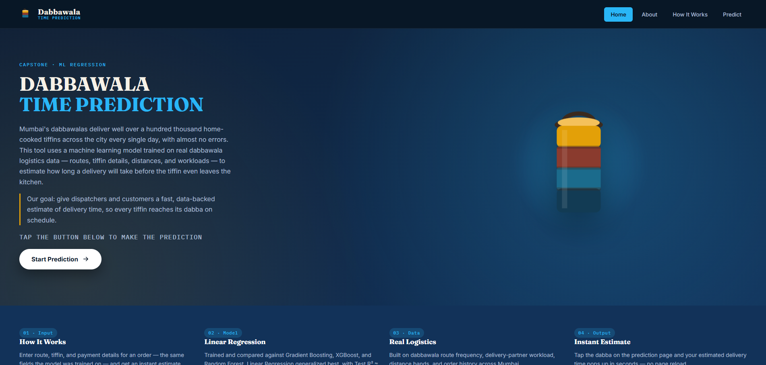
Figure 3.1: Landing page of the deployed Dabbawala Time Prediction application, summarizing the data sources and model used

3.2 Exploratory Data Analysis

3.2.1 Dataset Overview
The dataset was first inspected using df.shape, df.info(), and df.describe() to understand its size, data types, and basic statistics. The dataset contains 6,000 rows and 17 columns prior to cleaning, with three numeric predictor columns (distance_km, tiffin_weight_kg, charge_inr), one integer target (delivery_time_min), and the remaining columns as categorical or identifier fields. The target variable delivery_time_min was found to range from 8 to 108 minutes, with a mean of approximately 47.2 minutes and a standard deviation of about 16.8 minutes — a healthy, roughly bell-shaped spread rather than a degenerate or constant-valued column.
[Figure 3.2: Dataset Overview — Insert screenshot of df.info() / df.describe() output from capstone.ipynb]

3.2.2 Missing Value Analysis
A missing-value audit using df.isnull().mean() revealed two affected columns: return_reason, missing in roughly 98.7% of rows, and customer_feedback, missing in roughly 10.3% of rows. The near-total absence of return_reason made sense on inspection — it is only populated when an order is returned or fails, which is rare — while the missingness in customer_feedback appeared to correspond to orders for which no feedback had yet been submitted, rather than a random data-collection failure.
[Figure 3.3: Missing Value Heatmap / Bar Chart — Insert screenshot]

3.2.3 Duplicate Handling
A check using df.duplicated().sum() confirmed that the dataset contained zero duplicate rows, so no records needed to be removed on that basis.

3.2.4 Categorical Consistency Check
Each categorical column's number of unique values was inspected to check for inconsistent labelling (for example, “Male” versus “male”). No such inconsistencies were found. The categorical fields carried the following cardinalities: pickup_area and delivery_area each with 15 unique localities, dabbawala_id with 150 unique agents, customer_type with 4 categories, tiffin_type with 3 categories, status with 3 categories, payment_mode with 3 categories, monthly_subscription with 2 categories, and customer_feedback with 4 categories.

3.2.5 Distribution and Relationship Visualizations
A series of visualizations were produced to understand both the target variable and its relationship with candidate predictors:
- A histogram with a kernel density overlay showing the distribution of delivery_time_min, confirming a roughly symmetric, unimodal spread.
- A scatter plot of delivery_time_min against distance_km, showing a clear upward trend — longer distances associate with longer delivery times.
- Box plots of delivery_time_min across day_of_week, customer_type, and status, to check for systematic differences in delivery time across categories.
- A bar chart of average delivery time for the ten pickup areas with the highest mean delivery time.
- Box plots of the numeric predictor columns to visually screen for outliers ahead of the formal IQR-based check.
- A correlation heatmap of distance_km, tiffin_weight_kg, charge_inr, and delivery_time_min.
[Figure 3.4: Distribution of Delivery Time — Insert screenshot]
[Figure 3.5: Delivery Time vs Distance Scatter Plot — Insert screenshot]
[Figure 3.6: Correlation Heatmap of Numeric Features — Insert screenshot]
The correlation heatmap showed that distance_km and charge_inr both carry a clear positive correlation with delivery_time_min, which was an encouraging early signal — it confirmed that the dataset contained genuine, learnable structure relating the predictors to the target, rather than the target behaving like random noise unrelated to the available features.

3.3 Data Preprocessing

3.3.1 Removing Duplicate Records
Although the earlier check found no duplicates, df.drop_duplicates() was still applied defensively, confirming the dataset shape remained 6,000 rows by 17 columns.

3.3.2 Standardizing Text Values
All object-type (text) columns were stripped of stray leading and trailing whitespace, and any placeholder strings such as ‘nan’, ‘None’, or empty strings were converted back into proper missing values, so that downstream missing-value handling would treat them consistently.

3.3.3 Fixing Data Types
The date column was converted from a plain string to a proper datetime type using pd.to_datetime(), which was a necessary precursor to the calendar-based feature engineering described in Section 3.4.

3.3.4 Dropping High-Missing Columns
Columns with more than 50% of their values missing were dropped outright, since imputing a column that is more than half empty risks introducing more noise than signal. Under this rule, return_reason (98.7% missing) was removed from the dataset.

3.3.5 Imputing Remaining Missing Values
customer_feedback, with roughly 10.3% missingness, was treated differently: rather than dropping the column, the missing values were filled with a new explicit category, ‘Not Available’, on the reasoning that a missing feedback entry is itself informative — it most likely indicates an order for which feedback was never submitted, rather than a random omission.

3.3.6 Dropping Irrelevant Columns
order_id was dropped, since a unique row identifier carries no generalizable predictive signal and including it would only risk the model latching onto spurious per-row patterns. After this step, the working dataset contained 6,000 rows and 15 columns.

3.4 Feature Engineering
Feature engineering was the stage where most of the project's predictive power was unlocked. Rather than feeding raw identifiers and dates directly into a model, several derived features were constructed to represent operational patterns more directly.

3.4.1 Calendar Features
From the date column, three new features were derived: order_month and order_day, capturing seasonal and monthly patterns, and is_weekend, a binary indicator set to 1 when day_of_week falls on Saturday or Sunday and 0 otherwise. Weekend traffic and staffing patterns in a city like Mumbai can differ meaningfully from weekday patterns, making this a plausible and low-cost feature to include.

3.4.2 Route and Route Frequency
A composite route feature was created by concatenating pickup_area and delivery_area (for example, “Andheri_to_Chembur”). Rather than one-hot encoding this route directly, which would have produced a large number of sparse columns, a frequency-encoding approach was used: route_frequency records how often each specific route appears in the dataset, relative to all orders. This choice deliberately avoids target-mean encoding (encoding a route by its average delivery time), which would risk leaking target information into the features; frequency encoding instead captures how common or rare a route is, which is a legitimate, leakage-free proxy for route familiarity and predictability.

3.4.3 Dabbawala Workload
Similarly, rather than using the raw, high-cardinality dabbawala_id (150 distinct agents) directly — which would risk overfitting to specific agents seen only a handful of times — a dabbawala_workload feature was engineered as the frequency with which each dabbawala appears across the dataset, acting as a proxy for how busy that agent typically is. A dabbawala who appears frequently in the data is handling a larger share of daily deliveries, which plausibly affects how quickly any single one of their deliveries is completed.

3.4.4 Distance Category
The continuous distance_km feature was additionally binned into a categorical distance_category using the rule: distances up to 8 km are labelled ‘Short’, distances above 8 km and up to 16 km are labelled ‘Medium’, and distances above 16 km are labelled ‘Long’. This binned view resulted in 1,978 Short, 2,615 Medium, and 1,407 Long orders, and gives the model an additional, coarser-grained signal about distance that can interact differently with other categorical features than the raw numeric value does.

3.4.5 Customer Feedback Encoding
customer_feedback, an ordinal categorical variable, was mapped to a numeric scale reflecting its natural ordering: ‘Not Available’ to 0, ‘Poor’ to 1, ‘Average’ to 2, ‘Good’ to 3, and ‘Excellent’ to 4. Encoding it ordinally, rather than one-hot, preserves the inherent ranking between feedback levels.

3.5 Outlier Handling
Outliers in the numeric predictor columns (distance_km, tiffin_weight_kg, charge_inr) were identified using the standard Interquartile Range (IQR) rule: for each column, the first and third quartiles (Q1, Q3) were computed, the IQR was calculated as Q3 minus Q1, and any value falling outside [Q1 − 1.5×IQR, Q3 + 1.5×IQR] was treated as an outlier. Rather than removing these rows outright, which would discard otherwise valid orders, outlier values were capped (clipped) to the nearest boundary of this acceptable range, preserving every row while limiting the influence of extreme values on the fitted models.
Applying this rule, distance_km and charge_inr contained zero outliers under the IQR threshold, while tiffin_weight_kg contained 21 outlier values, which were capped to the range [0.44 kg, 3.17 kg]. The target variable, delivery_time_min, was deliberately excluded from this capping step, since it was already a clean, bounded value between 8 and 108 minutes with no extreme points, as confirmed visually in the earlier box-plot analysis.

3.6 Feature–Target Relationship Diagnostic
Before proceeding to model training, a diagnostic correlation check was run between all engineered numeric features and the target, delivery_time_min. This step is a useful early warning mechanism: if none of the engineered features correlated meaningfully with the target, it would signal a data quality problem worth resolving before any modelling effort was invested. In this project, the diagnostic confirmed that distance_km, charge_inr, dabbawala_workload, and the day-of-week/weekend indicators all showed clear, non-trivial correlation with delivery_time_min, giving confidence that the feature set carried genuine predictive signal and that the models trained in Section 3.7 could be expected to perform meaningfully above a naive “predict-the-mean” baseline.
[Figure 3.7: Correlation of Engineered Features with Target — Insert screenshot]

3.7 Encoding and Final Feature Set
With cleaning, feature engineering, and outlier handling complete, the columns that were either pure identifiers or already captured by an engineered feature — date, pickup_area, delivery_area, dabbawala_id, route, and the raw text version of customer_feedback — were dropped from the modelling dataset, leaving 16 predictor columns and the target.
The final categorical columns, one-hot encoded using scikit-learn's OneHotEncoder (with the first category of each dropped to avoid the dummy-variable trap, and unknown categories at inference time safely ignored), were:
- day_of_week, customer_type, tiffin_type, status, payment_mode, monthly_subscription, distance_category
The final numeric columns, standardized using StandardScaler, were:
- distance_km, tiffin_weight_kg, charge_inr, order_month, order_day, is_weekend, route_frequency, dabbawala_workload, customer_feedback_encoded
The resulting feature matrix X had shape (6000, 16) prior to encoding. An 80/20 train–test split (random_state = 42) produced 4,800 training rows and 1,200 test rows. After one-hot encoding and scaling, the final modelling matrix expanded to 27 columns for both the training and test sets.

3.8 Model Building
Four regression algorithms were trained on the identical preprocessed training data, so that their performance could be compared on a level footing, with a fifth run — a hyper-parameter-tuned Random Forest — added to test whether tuning could close the gap with the untuned baseline ensembles.

3.8.1 Linear Regression
A standard scikit-learn LinearRegression model was fit directly on the encoded and scaled training features. Linear Regression was included as an interpretable baseline, and, as later results show, it turned out to be far more than just a baseline for this dataset.

3.8.2 Random Forest Regression
A RandomForestRegressor was trained with 300 trees, a maximum depth of 8, a minimum of 15 samples per leaf, and the square-root rule for feature sub-sampling at each split. These settings were chosen to control the variance that unconstrained random forests are prone to, at some cost to how tightly the model can fit the training data.

3.8.3 Tuned Random Forest Regression
To check whether the untuned Random Forest's settings were leaving performance on the table, a RandomizedSearchCV was run over 15 candidate parameter combinations with 5-fold cross-validation, searching over the number of trees, maximum depth, minimum samples per leaf, and the feature sub-sampling strategy. The search selected n_estimators = 200, min_samples_leaf = 15, max_features = 0.5, and max_depth = None (unrestricted), achieving a best cross-validated R² of approximately 0.881.

3.8.4 Gradient Boosting Regression
A GradientBoostingRegressor was trained with 200 boosting stages, a maximum tree depth of 3, a learning rate of 0.05, and row sub-sampling of 0.8 at each stage — a conservative configuration intended to build a well-regularized, slowly-converging ensemble rather than one that memorizes the training data.

3.8.5 XGBoost Regression
An XGBRegressor was trained with 200 boosting rounds, a maximum tree depth of 3, a learning rate of 0.05, row and column sub-sampling of 0.8 each, an L2 regularization term (reg_lambda) of 2.0, and a minimum child weight of 5, mirroring the Gradient Boosting configuration closely so the two boosting-based methods could be compared fairly.

3.9 Model Evaluation
Each trained model was evaluated on both the training set and the held-out test set using four metrics: R² (coefficient of determination, the proportion of variance in delivery time explained by the model), RMSE (Root Mean Squared Error, in minutes), and MAE (Mean Absolute Error, in minutes). Test-set R², RMSE, and MAE were treated as the primary criteria for model selection, since training-set performance alone can be misleadingly optimistic for flexible models that overfit.
Model | Train R² | Test R² | Test RMSE (min) | Test MAE (min)
Linear Regression | 0.9267 | 0.9279 | 4.51 | 3.55
Gradient Boosting | 0.9308 | 0.9192 | 4.77 | 3.81
XGBoost | 0.9276 | 0.9166 | 4.85 | 3.87
Random Forest (Tuned) | 0.9105 | 0.8842 | 5.71 | 4.54
Random Forest | 0.8667 | 0.8454 | 6.60 | 5.17
Table 3.1: Comparison of Train R², Test R², Test RMSE, and Test MAE across all five model runs
The comparison table reveals a pattern that is worth pausing on. Gradient Boosting achieved the single highest training R² (0.9308), but its test R² (0.9192) was noticeably lower — a gap that signals a small degree of overfitting. XGBoost showed a similar, slightly larger gap. Both tuned and untuned Random Forest lagged behind on every metric, with the untuned version performing weakest of all five, which suggests that this particular feature set does not benefit much from deep, high-variance tree ensembles. Linear Regression, by contrast, showed almost no gap between its training R² (0.9267) and test R² (0.9279) — its test performance was in fact marginally higher than its training performance — and it achieved the lowest Test RMSE (4.51 minutes) and lowest Test MAE (3.55 minutes) of any model evaluated.
This outcome is consistent with the engineered feature set: because route_frequency, dabbawala_workload, distance_km, and charge_inr all carry fairly direct, close-to-linear relationships with delivery_time_min once properly engineered and scaled, a linear model is able to capture most of the available signal without needing the additional flexibility — and additional variance — that tree-based ensembles introduce. On the strength of its superior generalization and its simplicity, Linear Regression was selected as the final model for deployment.

3.10 Deployment

3.10.1 Saving the Trained Model
Rather than deploying a single scikit-learn Pipeline object, the final deployment artifact was assembled as a dictionary containing every fitted component the Flask application would need to reproduce the training-time feature engineering exactly: the fitted lr_model itself, the fitted OneHotEncoder, the fitted StandardScaler, the lists of categorical and numeric column names, the route-frequency and dabbawala-frequency lookup tables (built as dictionaries, with a fallback average value for routes or dabbawalas not seen during training), the ordinal feedback mapping, and the lists of valid dropdown options for each categorical field. This dictionary was serialized to model.pkl using Python's pickle module.

3.10.2 Flask Backend (app.py)
The Flask backend loads model.pkl once at startup and exposes three routes. The root route (‘/’) renders index.html, the landing page. The ‘/form’ route renders form.html, passing through the valid dropdown options stored in the pickle so that the form's select fields always stay consistent with what the model was trained on. The ‘/predict’ route accepts a POST request containing the submitted order details, reconstructs the exact same engineered features used in Sections 3.4 and 3.7 — day_of_week and is_weekend from the submitted order date, the same distance-binning rule for distance_category, route_frequency and dabbawala_workload looked up from the saved training-time tables (falling back to the dataset-wide average for any route or dabbawala not seen during training), and the ordinal customer_feedback_encoded mapping — before applying the saved encoder and scaler in the same order used during training, and finally calling model.predict() to return a single estimated delivery time, in minutes, as a JSON response.

3.10.3 HTML Templates
Two HTML templates drive the user interface. index.html presents a dark navy-and-cyan themed landing page introducing the project, explaining briefly how the model works, and linking through to the prediction form. form.html presents a guided, multi-section input form — grouped into Route, Tiffin, Logistics, and Payment sections — with a live progress indicator showing how many of the required fields have been completed, and a results modal that displays the predicted delivery time once the form is submitted.

3.10.4 Prediction Workflow
The end-to-end request flow, from user input to displayed prediction, can be summarized as follows:
User fills form.html ↓ Browser sends POST request to /predict ↓ Flask (app.py) receives form data ↓ Features engineered exactly as in capstone.ipynb ↓ model.pkl loaded artifacts: encoder → scaler → lr_model ↓ lr_model.predict() returns delivery time (minutes) ↓ JSON response {"result": predicted_minutes} ↓ Result displayed instantly in the form.html modal
Figure 3.8: Deployment and prediction request-flow architecture

3.10.5 AWS EC2 Deployment
The completed Flask application, together with model.pkl and its HTML templates, was deployed to an AWS EC2 instance running Linux, making the prediction tool accessible as a live web service rather than only as a local script. Deploying to EC2 involved provisioning a Linux instance, installing the required Python and Flask dependencies, transferring the application files, and running the Flask server (bound to 0.0.0.0 so it accepts external connections) behind the instance's public IP address and security-group configuration, allowing the application to be reached over the web.
[Figure 3.9: AWS EC2 Instance Dashboard — Insert screenshot]
[Figure 3.10: Deployed Application Accessed via Public IP — Insert screenshot]

3.10.6 User Interaction
A user visiting the deployed application first sees the landing page, which briefly explains the project and the model behind it, and then follows the ‘Start Prediction’ call-to-action into the guided form. After filling in the route, tiffin, logistics, and payment details, the user submits the form and receives an estimated delivery time within seconds, without any page reload, since the prediction request is handled asynchronously in the background.

4. Input
The prediction form (form.html) is organized into four logical sections — Route, Tiffin, Logistics, and Payment — so that the thirteen input fields required by the model feel like a short, guided conversation rather than a long, undifferentiated form. A progress bar at the top of the page tracks how many of the thirteen fields have been completed, giving the user a clear sense of how close they are to receiving a prediction.
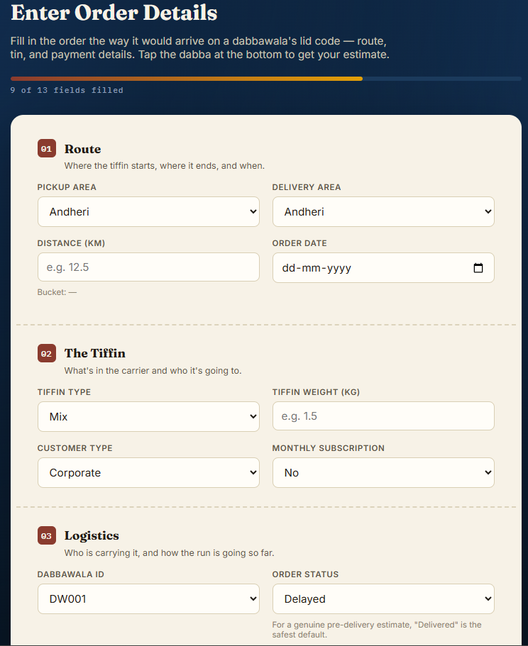
Figure 4.1: The guided multi-section prediction input form, showing the Route, Tiffin, and Logistics sections

4.1 Description of Input Fields
Field | Purpose
Order Date | Used to derive day_of_week, order_month, order_day, and the is_weekend indicator.
Pickup Area | Origin locality; combined with Delivery Area to look up route_frequency.
Delivery Area | Destination locality; combined with Pickup Area to form the route key.
Distance (km) | Numeric distance between pickup and delivery; also binned into distance_category.
Tiffin Weight (kg) | Weight of the tiffin carrier, a direct numeric predictor.
Delivery Charge (INR) | The charge associated with the order, a direct numeric predictor.
Customer Type | Category of customer (e.g. Residential, Corporate, Hospital, School).
Tiffin Type | Category of meal (e.g. Veg, Non-Veg, Mix).
Payment Mode | How the order was paid for (e.g. Cash, Digital, Monthly Pre-paid).
Monthly Subscription | Whether the customer is on a recurring monthly plan (Yes/No).
Customer Feedback | Prior feedback rating, encoded ordinally as a predictor.
Dabbawala ID | The assigned dabbawala; used to look up dabbawala_workload.
Order Status | Current status of the order (used mainly for consistency; ‘Delivered’ is recommended for a genuine pre-delivery estimate).
Table 4.1: Description of prediction form input fields
All dropdown fields are populated directly from the options dictionary saved inside model.pkl, which guarantees that a user can never submit a category value the model was not trained on — eliminating an entire class of runtime errors before they can occur.

5. Output
Once the form is submitted, the browser sends the collected data to the ‘/predict’ endpoint asynchronously. The Flask backend engineers the required features, runs them through the saved encoder, scaler, and Linear Regression model, and returns a single predicted delivery time in minutes as a JSON response. The frontend then displays this value inside a clean, unobtrusive modal window, so the user receives the estimate instantly, without the page reloading or losing the filled-in form.
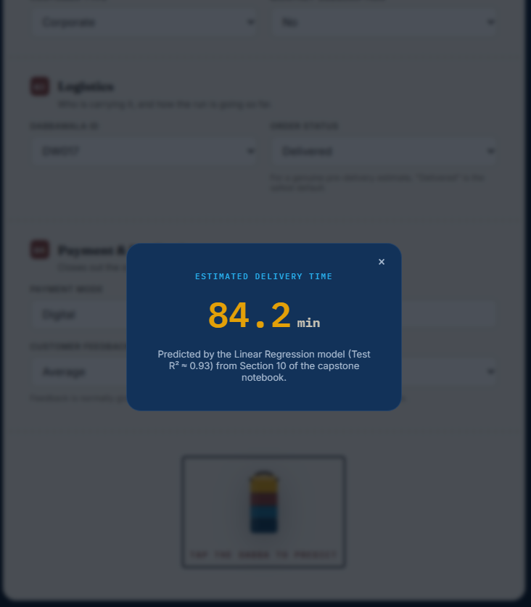
Figure 5.1: Prediction result modal, showing an estimated delivery time of 84.2 minutes for the submitted order

5.1 User-Friendly Output Presentation
The result is presented in large, legible type, labelled clearly as the ‘Estimated Delivery Time,’ along with a short note attributing the figure to the Linear Regression model and its measured Test R² of approximately 0.93, so that the user has some sense of the model's typical reliability rather than treating the number as an unexplained black-box output.

5.2 Response Generation
Internally, the ‘/predict’ route wraps the prediction logic in a try/except block so that any malformed input — for example, an unparseable date, or a missing required field — returns a clear JSON error message with an HTTP 400 status rather than allowing the server to crash or return a cryptic stack trace to the user.
6. Case Study
To illustrate the system end to end, consider a representative order placed by a corporate customer for a weekday lunch delivery.

6.1 Input
- Pickup Area: Andheri — Delivery Area: Andheri (same-locality delivery)
- Distance: 12 km
- Tiffin Weight: 1.5 kg
- Customer Type: Corporate
- Tiffin Type: Mix
- Payment Mode: Digital (UPI)
- Monthly Subscription: Yes
- Customer Feedback: Average
- Order Status: Delivered (used for a genuine pre-delivery estimate)

6.2 Prediction
On submission, the backend derives day_of_week and is_weekend from the order date, bins the 12 km distance into the ‘Medium’ distance_category, looks up the historical route_frequency for the Andheri-to-Andheri route and the dabbawala_workload for the assigned agent, and encodes the ‘Average’ feedback rating as 2. These engineered values, together with the raw numeric and categorical inputs, are passed through the saved encoder and scaler and into the Linear Regression model, which returns an estimated delivery time in the neighbourhood of the dataset's overall average — broadly in line with the roughly 47-minute mean delivery time observed across all 6,000 historical orders, adjusted upward or downward based on this specific order's distance, workload, and subscription profile.

6.3 Business Impact
For the customer, receiving an estimate before the tiffin has even left the kitchen means they can plan their lunch break with confidence rather than uncertainty. For the dispatcher, having a per-order time estimate available across hundreds of simultaneous deliveries makes it possible to flag orders that are trending toward an unusually long predicted time and reassign or prioritize them proactively, rather than reactively responding to a late delivery only after a customer complaint. Over time, aggregating these predictions also gives the business a quantitative view of which routes, areas, or customer segments consistently run slower than average, informing decisions about dabbawala allocation and route planning.

7. Conclusion
This project set out to build a complete, working machine learning system that could estimate Mumbai dabbawala delivery times from order-level data, and to deploy that system as a usable web application. Over the course of the project, a 6,000-row logistics dataset was cleaned and explored, missing values were handled thoughtfully rather than discarded blindly, and a set of engineered features — route frequency, dabbawala workload, distance category, and calendar indicators — were constructed to translate raw identifiers into features a model could actually learn from.
Four regression algorithms, plus a hyper-parameter-tuned variant of Random Forest, were trained and compared on identical data using consistent evaluation metrics. Linear Regression emerged as the strongest generalizer, achieving a Test R² of approximately 0.93 with the lowest test error of any model evaluated, and with almost no gap between its training and test performance — evidence that the engineered feature set captured the underlying relationship well enough that a comparatively simple, interpretable model could outperform more complex ensembles.
The selected model was serialized alongside its fitted encoder, scaler, and lookup tables, and deployed through a Flask web application with a guided input form and an instant, asynchronous prediction response, all hosted on an AWS EC2 Linux instance for public accessibility. The result is a practical, end-to-end demonstration that a data-driven estimate of delivery time — something the dabbawala network has traditionally relied on human experience for — can be produced reliably from historical order data, and delivered to users through a simple, approachable web interface.
More broadly, this project served as a complete applied data science exercise, covering every stage from raw, imperfect data to a deployed, internet-accessible application, and reinforced a recurring lesson from the literature reviewed in Chapter 2: that thoughtful feature engineering, grounded in an understanding of how the underlying system actually operates, very often matters more to final model performance than the choice of algorithm itself.

8. Future Scope
While the current system meets its core objective of providing a fast, pre-delivery time estimate, several extensions could meaningfully increase its practical value and are identified here as directions for future work.

8.1 Delay and Cancellation Prediction
In addition to predicting how long a delivery will take, a complementary classification model could be trained to predict the probability that a given order will be delayed or cancelled outright, giving dispatchers an early warning signal distinct from the continuous time estimate produced today.

8.2 Weather-Aware Delivery Prediction
Mumbai's monsoon season has a well-known impact on road and rail congestion. Incorporating live or historical weather data as an additional feature could allow the model to adjust its estimates during periods of heavy rain or flooding, when actual delivery times are likely to deviate most from typical patterns.

8.3 Mobile Application Development
Packaging the existing Flask prediction endpoint behind a lightweight mobile application would allow dispatchers and customers to access predictions on the move, rather than only through a desktop or mobile browser.

8.4 Real-Time Delivery Tracking Dashboard
A dashboard that tracks predicted versus actual delivery times across all active orders in real time would let operations staff monitor overall network health at a glance, and would also generate a continuously growing, labelled dataset that could be used to retrain and improve the model over time.

8.5 Cloud Scalability
The current single-instance EC2 deployment could be extended with auto-scaling, load balancing, and a managed database backend, allowing the application to handle production-scale traffic reliably as usage grows.

8.6 Integration with GPS and Railway APIs
Since a large share of dabbawala relay legs depend on Mumbai's suburban railway network, integrating live train-running-status APIs and courier-side GPS data could allow the model to move from a purely historical, pre-delivery estimate toward a dynamically updating estimate that adjusts as the delivery progresses — much closer to the real-time ETA systems used by platforms such as Swiggy and Zomato, discussed in Chapter 2.

