**A REPORT ON ONLINE FRUIT SORTING MECHANISM**

**PREPARED BY :** SHUBH VACHHER, BITS PILANI, GOA

**PROJECT LEADER :** MR. MOHAMMED IQBAL

(SENIOR SCIENTIST AND DEPUTY DIRECTOR, CEERI)

**ABSTRACT:**

This project concentrates on grading the fruit (Sweet limes) coming down a conveyer belt into two different grades A and B based on its weight and color. The fruits move along a conveyor belt where they get weighed by a weighing scale then imaged by a USB camera. The image is processed by a laptop and the grade of the fruit is given to a micro controller, an Arduino, that sorts them into their corrosponding basket.

Heavy and Yellow fruits are seperated out into grade A while the rest of the fruits are sent to grade B.

**THE CODING:**

Our project runs entirely based on two codes. One code is written in the Arduino language using the Arduino software (and it needs to be uploaded onto an Arduino UNO board) and the other one is written in python and should be run on a microprocessor, in our case a laptop.

The code running on the Arduino is used to perform the weighing of the fruit and to actuate the opening of the baskets of various grade at the right time.

The code running on the laptop ,written in python, takes the weight input from the Arduino and triggers the USB camera to capture the image of the fruit. It then processes the image for color of fruit and returns the grade of the respective fruit to the Arduino based on its weight and color.

Both the codes are provided below for reference.

Python code running on the laptop :

The code running on the Micro-Controller(Arduino):

The entire functioning of these two codes can be explained with the help of the below flow chart.



**THE IMAGE PROCESSING:**

The image processing is done using Open CV and is written in python language. The aim of the image processing done in this project is to extract the color of the fruit from its image on the conveyer belt. The code takes the image and converts it into a black and white image, then does an adaptive thresholding on the black and white image. It then prepares a mask, to delete the extras in the image-like the rollers, railings of the conveyor etc. and then uses this mask on the color image taken initially. Now we just have the color image of the fruit without all of its environment. The color of the fruit is thus obtained by converting the image from the BGR(Blue-Green-Red) format to HSV(Hue-Saturation-Value) format.

**THE ELECTRONICS:**

Coding and Electronics go hand in hand in our project. The electronic systems play an equally important role in the process. The electronics part is divided in to modules so that it would be simpler for the reader to understand the basic operation.

The first and the foremost module would be the Arduino.

**ARDUINO**

We have used an Arduino Uno board for all the purposes in this project.

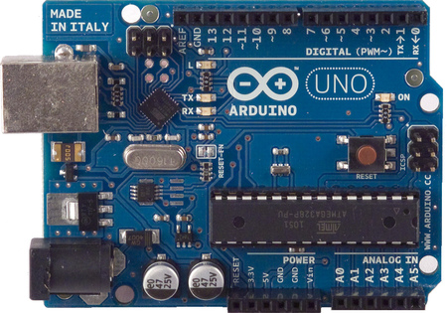

The Arduino acts as a medium that takes the inputs from all the sensors that are used in the system and provides the appropriate responses to the corresponding inputs.

The Arduino is powered by a 12V(or 5V) power source and is connected to the laptop via a USB to UART converter.Thus the laptop is just connected only for Serial communication and not for powering up the Arduino. The Arduino is connected to the output from the weighing scale, to the optical proximity switch and also to the level shifter IC - ULN 2803A by means of the several Digital and Analog pins available on it. All these modules will be explained in a greater detail in the following sections.

The next module would be the USB to UART converter.

**USB TO UART CONVERTER**:

This module is used in our system in order to attain stable serial communication between the PC and the Arduino board without allowing the PC to power up the Arduino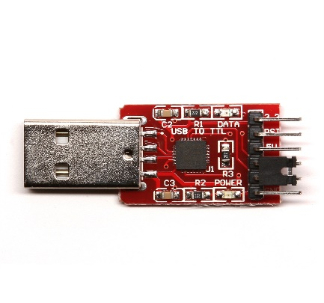

It looks similar to the one shown in the picture.

The module has six pins and they are 3V3, GND, VBUS, TXD, RXD, DTR (top to bottom).

The DTR pin is used to RESET the Arduino during upload time and hence is connected to the RESET pin of the Arduino with a capacitor in between (for proper RESET operation).

The RXD (Receive Output) pin is connected to the TX pin on the Arduino board. The TXD (Transmit Output) pin is connected to the RX pin on the Arduino board.

The GND pin is connected to the GND pin of the Arduino.

The VBUS and the 3V3 pin are left unused.

The next module would be that of the level shifter IC.

**IC ULN 2803A:**

This IC steps up( shifts the level- as the name suggests) the outputs of the Arduino(0/5V) and gives outputs that are either zero or 24V.These outputs are fed to the solinoids to control the falling of the fruits.

Only two pins of the IC are used as we have only two baskets for the fruits to fall into.

This picture shows the exact pinout of the IC. The pins 1B and 2B are connected to the 7 and 8 pins of the Arduino. The pins 1C and 2C go to the solinoids.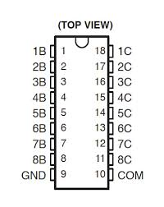

The IC has 8 Darlington pairs (with NPN transistors) and the pins 1B-8B are the 8 base inputs each corresponding to a particular Darlington pair. The pins 1C-8C are the collector outputs corresponding to a particular Darlington pair. The picture of a single Darlington pair is shown below.

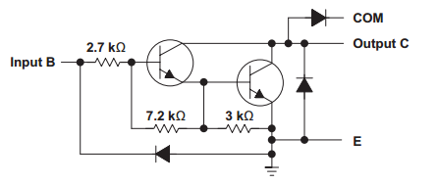

The next module would be that of the sensors.

In order to trigger the USB camera to take the images of the fruits, the weighing machine input has been used in the beginning. Later on to trigger the opening of the right basket, the optical proximity switch is used.

The optical proximity switch is used to detect the presence of the fruit on the roller at the end of the conveyor so that the Arduino knows exactly when to actuate the basket solinoid.

**OPTICAL PROXIMITY SWITCH**:

The proximity switch that is used in our system is similar to the one that is shown in the figure.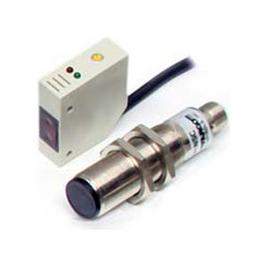

This sensor has four wires and they are RED, BLUE, WHITE and BLACK.

The RED and BLUE wires of the sensor are connected to 5V and GND pins of the Arduino respectively. The BLACK wire gives an output of 5V when an object is sensed by the sensor and is connected to one of the Analog pins. The WHITE wire is left unused.

This sensor is chosen as it is highly accurate and easily available.

As all the important modules of the system have been explained in an explicit manner, we move on to showing the detailed connections of the hardware.

**DETAILED CONNECTIONS OF THE HARDWARE**

**CONCLUSION:**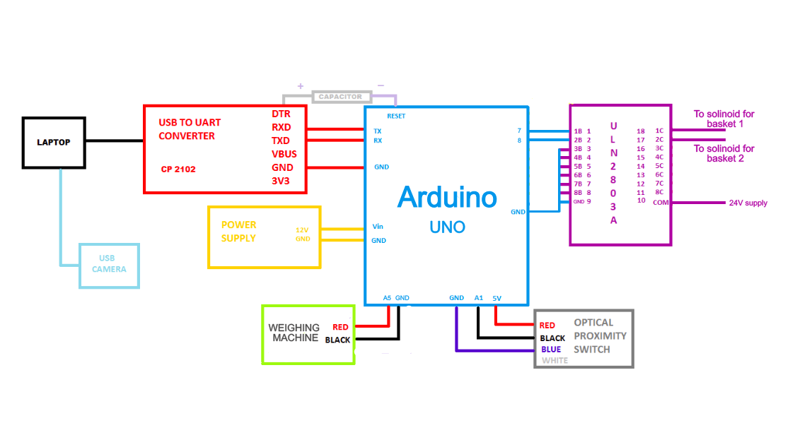

A final flowchart has been attached that gives us the complete operation of the system.

This flowchart is made with the following assumptions:

* Arduino code has been uploaded on to the Arduino UNO board.
* Python code is running on the laptop at current time.
* The laptop is connected to both Arduino and the imaging device.

**FLOWCHART DEPICTING THE COMPLETE OPERATION OF THE SYSTEM**



**(.xml file made in the website draw.io)**

The flow of the system is as follows:

1. The weighing scale input is read by the Arduino.
2. When a fruit is detected to pass above the weighing scale the weight of the fruit is sent to the computer via the Arduino.
3. The computer then activates the USB Camera and takes as well as processes the image taken.
4. A grade of the imaged fruit is sent back to the Arduino and is stored in the fruitList variable.
5. Now the Arduino waits for the optical proximity switch to detect if a fruit is near the baskets at the end of the conveyer.
6. Using the fruitList variable, the Arduino knows which fruit crosses the optical proximity switch when and accordingly actuates the right solinoid to sort the fruit into the correct grade basket.