THAKUR POLYTECHNIC

Diploma in Computer Engineering



# CO2I-B

## SECOND SEMISTER [2020-2021] GROUP NO-17

WEB PAGE DESIGNING

|  |  |
| --- | --- |
| Shivraj.T | 100 |
| Shery Shah | 101 |
| Shubg Agarwal | 102 |
| Karan Shukla | 103 |
| Siddhi Mehta | 104 |
| Himani Singh | 105 |

Guided by:- **Mrs. Smitha Dandge**



**Seal of Institution**

**MAHARASHTRA STATE BOARD OF TECHNICAL EDUCATION**

This is to certify that the following group of students roll no. **100- 105** of **2ND** semester of Diploma in **COMPUTER ENGINEERING** of institute, THAKUR POLYTECHNIC **(Code:0522)** have completed the **Micro Project** satisfactorily in subject – **WPD (Code:22014)** for the academic year 20**20** –20**21** as prescribed in the curriculum.

# Place: Mumbai Enrollment No. 2005220356 Date: 6th March 2021 Seat No. 286565

Subject teacher Head of Department Principal

**-** Design a website for Online Car Rental System **-**

MICRO – PROJECT PROPOSAL

## Aims/Benefits of the Micro-Project.

* + - Learning HTML will be able to fine-tune site's blogposts or even & whole theme.
    - HTML can Integrate Easily with Other Languages
    - It will help gain experience on how to design an online car rental system.
    - It Will help gain experience on how online car rental system works and work needed to develop them
    - We will have the Knowledge to Build and Understand the Fundamentals of the Web.

## Course Outcomes Addressed.

* + - Use block level formatting tags to present content on web page.
    - Use text level formatting tags to present content on web page.
    - Apply hyper linking on webpage.
    - Organize the content using table and frames.

## Proposed Methodology.

We Started By creating a main page leading the user to navigate to what information he wants which includes home page and Car Rent Page, about us page, contact us page and Sign Up & Login Page etc.

* + - Main page or Home Page - This will help the user select the information he is searching for.
    - Sign Up & Login Page - This Will Help user to input his information and save his info by signing up whenever he/she wants.
    - Car Rent Page - This page provides Different types of available cars for rent with pricing.
    - About us page - About us page provides information of our store and website etc.
    - Contact us page - Contact Us Page gives information to the user of our address, contact numbers and other social media links.

## Action Plan:

|  |  |  |  |  |
| --- | --- | --- | --- | --- |
| SR NO | DETAILS OF ACTIVITY | PLANNED START DATE | PLANNED FINISH DATE | NAME OF RESPONSIBLE TEAM MEMBERS |
| 1. | Information search | 07/04/2021 | 12/04/2021 | Himani Singh, Siddhi Mehta & Shivraj.T |
| 2. | Group Discussion | 13/04/2021 | 27/04/2021 | All team members |
| 3. | Taking reference | 28/04/2021 | 03/05/2021 | Karan Shukla & Shubh Agrawal |
| 4. | Executions | 04/05/2021 | 11/05/2021 | Shrey Shah |
| 5. | Compilation of reports | 12/05/2021 | 20/05/2021 | Shivraj.T |
| 6. | Presentation and reportsubmission | During LAST week of May. | During LAST week of May | All team members |

1. Resources Required:

|  |  |  |  |  |
| --- | --- | --- | --- | --- |
| SR.N0 | NAME OF RESOURCE/MATERIAL | SPECIFICATION | QUANTITY | REMARKS |
| 1. | Html | Programming language | N.A | Available |
| 2. | Google Chrome | cross-platform web browser | N.A | Available |
| 3. | Windows 10 Pro | Operating System | N.A | Available |
| 4. | Atom Code Editor | Software | N.A | Available |

## Name of Team Members

|  |  |  |
| --- | --- | --- |
| SR.NO | NAME OF MEMBERS | Roll No. |
| 1. | SHIVRAJ.T | 100 |
| 2. | SHREY SHAH | 101 |
| 3. | SHUBH AGRAWAL | 102 |
| 4. | KARAN SHUKLA | 103 |
| 5. | SIDDHI MEHTA | 104 |
| 6. | HIMANI SINGH | 105 |

**-** Design a website for Online Car Rental System **-**

* 1. Rationale.

MICRO – PROJECT REPORT

* + - Website design is a board term that encompasses a wide variety of task, all involved In the formation of webpage. There are essentially two types of web design approaches, which are dynamic and static design. Static web design is typically based on basic HTML code. It is essential for diploma student to learn HTML since the task of static website design is performed by using HTML coding. Even in dynamic website, the task of presentation of content is handled through HTML coding. This course introduces web page design using HTML5 and also gives emphasis on learning CSS which is style sheet language used for describing the presentation of document written in a markup language for formatting and styling of content.

## Aims/Benefits of the Micro-Project:

* + - Learning HTML will be able to fine-tune site's blogposts or even & whole theme.
    - HTML can Integrate Easily with Other Languages
    - It will help gain experience on how to design an online car rental system.
    - It Will help gain experience on how online car rental system works and work needed to develop them
    - We will have the Knowledge to Build and Understand the Fundamentals of the Web.

## Course Outcomes Achieved:

* + - Use block level formatting tags to present content on web page.
    - Use text level formatting tags to present content on web page.
    - Apply hyper linking on webpage.
    - Organize the content using table and frames.

## 4.0Literature Review:

* <!DOCTYPE> Defines the document type
* <a> Defines a hyperlink
* <abbr> Defines an abbreviation or an acronym
* <form> Defines an HTML form for user input
* <input> Defines an input control
* <textarea> Defines a multiline input control (text area)
* <button> Defines a clickable button
* <select> Defines a drop-down list
* <optgroup> Defines a group of related options in a drop-down list
* <option> Defines an option in a drop-down list
* <label> Defines a label for an <input> element
* <fieldset> Groups related elements in a form
* <legend> Defines a caption for a <fieldset> element
* <datalist> Specifies a list of pre-defined options for input controls
* <output> Defines the result of a calculation
* <img> Defines an image
* <map> Defines a client-side image map
* <area> Defines an area inside an image map
* <canvas> Used to draw graphics, on the fly, via scripting (usually JavaScript)
* <figcaption> Defines a caption for a <figure> element
* <figure> Specifies self-contained content
* <picture> Defines a container for multiple image resources
* <svg> Defines a container for SVG graphics
* <html> Defines an HTML document
* <head> Contains metadata/information for the document
* <title> Defines a title for the document
* <body> Defines the document's body
* <h1> to <h6> Defines HTML headings
* <p> Defines a paragraph

## Actual Methodology Followed:

We Started By creating a main page leading the user to navigate to what information he wants which includes home page and Car Rent Page, about us page, contact us page and Sign Up & Login Page etc.

* + - Main page or Home Page - This will help the user select the information he is searching for.
    - Sign Up & Login Page - This Will Help user to input his information and save his info by signing up whenever he/she wants.
    - Car Rent Page - This page provides Different types of available cars for rent with pricing.
    - About us page - About us page provides information of our store and website etc.
    - Contact us page - Contact Us Page gives information to the user of our address, contact numbers and other social media links.

## 6.0. Resources Required:

|  |  |  |  |  |
| --- | --- | --- | --- | --- |
| SR.N0 | NAME OF RESOURCE/MATERIAL | SPECIFICATION | QUANTITY | REMARKS |
| **1.** | Html | Programming language | N.A | Available |
| 2. | Google Chrome | cross-platform web browser | N.A | Available |
| 3. | Windows 10 Pro | Operating System | N.A | Available |
| 4. | Atom Code Editor | Software | N.A | Available |

7.0. Outputs of the Micro – Project:

## HOME PAGE HTML

<html lang="en" dir="ltr">

<head>

<meta charset="utf-8">

<link rel="stylesheet" href="Style.css">

<title> MicroProject </title>

<meta name="viewpoint" content="width=device-width, initial-scale">

</head>

<!-- This is My code -->

<body>

<nav class="PK1">

<div class="wrapper">

<ul>

<li><img class="Khan" src=img/CarLogo.png alt="myimage"></li>

<li><a href="file:///C:/Users/Admin/OneDrive/Desktop/Project%20root/Index.html">Home</a></li>

<li><a href="file:///C:/Users/Admin/OneDrive/Desktop/Project%20root/about%20us.html">About Us</a></li>

<li><a href="file:///C:/Users/Admin/OneDrive/Desktop/Project%20root/contact%20us.html">Contact Us</a></li>

<li><a href="file:///C:/Users/Admin/OneDrive/Desktop/Project%20root/Login%20in.html">Log In</a></li>

<li><a href="file:///C:/Users/Admin/OneDrive/Desktop/Project%20root/sign%20up.html">Sign Up</a></li>

</ul>

</div>

</nav>

<div class="Back1">

<button class="Back" onclick="goBack()">Go Back</button></div>

<div class="Heading1">

<h1>Welcome To RentACar </h1>

</div>

<div class="Heading2">

<h1>YOUR FAVOURITE RIDE IS HERE!</h1>

</div>

<div class="container">

<div class="CAR"><img src="img/FCAR.png" alt="CARS"></div>

<a href="file:///C:/Users/Admin/OneDrive/Desktop/Project%20root/Page2.html"><button class="btn btn1">EXPLORE YOUR OPTIONS</button></a>

</div>

<script>

function goBack() { window.history.back();

}

</script>

</body>

</html>

## CSS

* { margin: 0;

padding: 0; body {

background-repeat: repeat;

background-size: auto; background-color: #eee; font-family: Arial;

}

.wrapper {

margin: 0 auto 0 60px; width: 1000px;

font-family: Arial; margin-left: -70px;

}

nav {

width: 100%; height: 100px;

background-color: #080808;

}

ul{

}

ul li {

list-style: none; display: inline-block; float: left;

line-height: 100px;

}

ul li a { display: block;

text-decoration: none; font-size: 14px;

font-family: arial; color: #ffffff; padding: 0 10px; margin-left: 60px;

}

ul li a:hover { color: Blue;

}

.Khan { width: 90px; padding:0;

margin-left: 100px; margin-top: 35px; margin-right: -20px;

}

.Heading1 {

text-align: center;

text-transform: uppercase; margin-top: 100px;

font-size: 50px;

}

.Heading2 {

text-align: center; margin-top: 30px; font-size: 10px

}

.container{

text-align: center; margin-top: 50px;

}

.btn {

border: 1px solid Black; background: none; padding: 10px 20px; font-size: 20px;

font-family: "Arial"; cursor: pointer; margin: 10px; transition: 0.8s; position: relative; overflow: hidden;

}

.btn1{

color: Black; margin-top:50px; text-align: center;

}

.btn2{

color: Black;

}

.btn1:hover{ color: White;

}

.btn2:hover{ color: White;

}

.btn1::before{ content: ""; position: absolute; left: 0;

width: 100%;

height: 0%; background: Black; z-index: -1; transition: 0.5s;

.btn2::before{ content: ""; position: absolute; left: 0;

width: 100%;

height: 0%; background: Black; z-index: -1; transition: 0.5s;

}

.btn1::before{ top: 0;

border-radius: 0 0 50% 50%;

}

.btn2::before{ top: 0;

border-radius: 0 0 50% 50%;

}

.btn3::before,.btn4::before{ height: 180%;

}

.btn1:hover::before{ height: 180%;

}

.btn2:hover::before{ height: 180%;

}

.CAR {

text-align: center; margin-left: 00px;

.back {

border: 1px solid Black; background: none; padding: 10px 20px; font-size: 15px;

font-family: "Arial"; cursor: pointer; margin: 10px; transition: 0.8s; position: relative; overflow: hidden; padding-top: 5px;

}

.back:hover{ color: White;

}

.back::before{ content: ""; position: absolute; left: 0;

top: -10;

width: 100%;

height: 0%; background: Black; z-index: -1; transition: 0.5s;

}

.back:hover::before{ height: 200%;

}

## OUTPUT

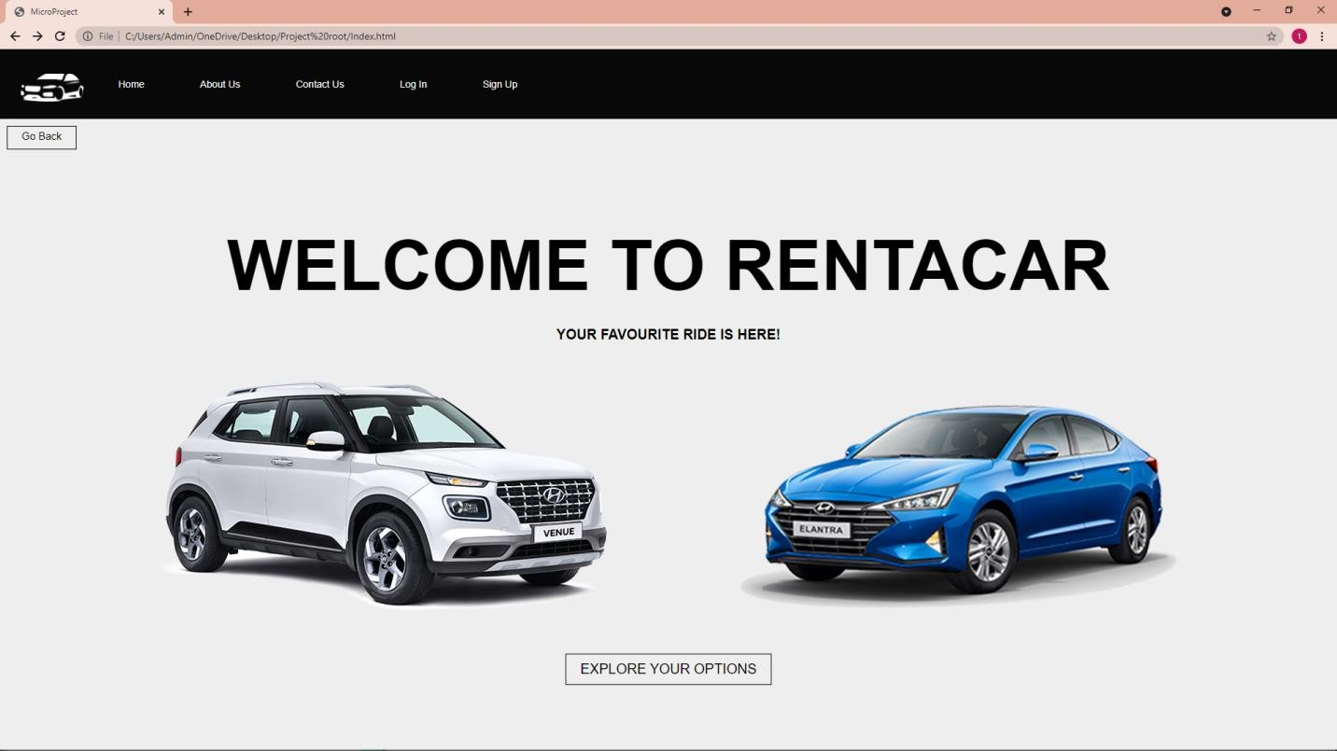

PAGE 2

## HTML

<html lang="en" dir="ltr">

<head>

<meta charset="utf-8">

<link rel="stylesheet" href="Style3.css">

<title> MicroProject </title>

<meta name="viewpoint" content="width=device-width, initial-scale">

</head>

<!-- This is My code -->

<body>

<nav class="PK1">

<div class="wrapper">

<ul>

<li><img class="Khan" src=img/CarLogo.png alt="myimage"></li>

<li><a href="file:///C:/Users/Admin/OneDrive/Desktop/Project%20root/Index.html">Home</a></li>

<li><a href="file:///C:/Users/Admin/OneDrive/Desktop/Project%20root/about%20us.html">About Us</a></li>

<li><a href="file:///C:/Users/Admin/OneDrive/Desktop/Project%20root/contact%20us.html">Contact Us</a></li>

<li><a href="file:///C:/Users/Admin/OneDrive/Desktop/Project%20root/Login%20in.html">Log In</a></li>

<li><a href="file:///C:/Users/Admin/OneDrive/Desktop/Project%20root/sign%20up.html">Sign Up</a></li>

</ul>

</div>

</nav>

<button class="Back" onclick="goBack()">Go Back</button></div>

<script>

function goBack() { window.history.back();

}

</script>

<div class="Heading1">

<h1>CHOOSE YOUR BRAND RIDE</h1>

</div>

<div class="LOGO">

<a href="file:///C:/Users/Admin/OneDrive/Desktop/Project%20root/MS.html"><img class="A" src="img2/1.png" alt=""></a>

<a href="file:///C:/Users/Admin/OneDrive/Desktop/Project%20root/NextPage.html"> <img class="B" src="img2/2.png" alt=""></a>

<a href="file:///C:/Users/Admin/OneDrive/Desktop/Project%20root/NextPage.html"> <img class="C" src="img2/F.png" alt=""></a>

<a href="file:///C:/Users/Admin/OneDrive/Desktop/Project%20root/NextPage.html"><img class="D" src="img2/D.png" alt="">

</a> </div>

</body>

## CSS

* { margin: 0;

padding: 0;

box-sizing: border-box;

}

body {

background-repeat: repeat; background-size: auto; background-color: #eee; font-family: Arial;

}

.wrapper {

margin: 0 auto 0 60px; width: 1000px;

font-family: Arial; margin-left: -70px;

}

nav {

width: 100%; height: 100px;

background-color: #080808;

}

ul{

}

ul li {

list-style: none; display: inline-block; float: left;

line-height: 100px;

}

ul li a { display: block;

text-decoration: none; font-size: 14px;

font-family: arial; color: #ffffff; padding: 0 10px; margin-left: 60px;

}

ul li a:hover { color: Blue;

}

.Khan { width: 90px; padding:0;

margin-left: 100px; margin-top: 35px; margin-right: -20px;

}

.Heading1 {

font-size: 20px; margin-top: 10px; text-align: center;

}

1. {

width: 200px; margin-top: 250px; margin-left: 50px; margin-right: 70px;

}

.A:hover { border: #eee;

border-style: double; border-width: thick; background-color: #eee1;

}

1. {

width: 200px; margin-top: 250px; margin-left: 200px; margin-right: 70px;

}

.B:hover { border: #eee;

border-style: double;

}

1. {

width: 200px; margin-top: 250px; margin-left: 250px; margin-right: 70px;

}

.C:hover { border: #eee;

border-style: double;

}

1. {

width: 200px; margin-top: 100px; margin-left: 300px; margin-right: 70px;

margin-bottom: 25px;

}

.D:hover { border: #eee;

border-style: double;

}

.back {

border: 1px solid Black; background: none; padding: 10px 20px; font-size: 15px;

font-family: "Arial"; cursor: pointer; margin: 10px; transition: 0.8s; position: relative; overflow: hidden; padding-top: 5px;

}

.back:hover{ color: White;

}

.back::before{ content: ""; position: absolute; left: 0;

top: 0%;

width: 100%;

height: 0%; background: Black; z-index: -1;

transition: 0.5s;

}

.back:hover::before{ height: 200%;

}

## OUTPUT

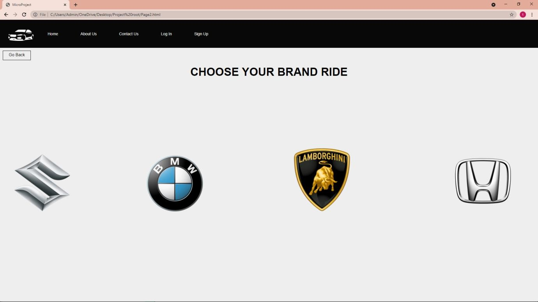

<html lang="en" dir="ltr">

<head>

<meta charset="utf-8">

<link rel="stylesheet" href="Style4.css">

<title> MicroProject </title>

## PAGE 3 HTML

<meta name="viewport" content="width=device-width, initial-scale=1">

</head>

<!-- This is My code -->

<body>

<nav class="PK1">

<div class="wrapper">

<ul>

<li><img class="Khan" src=img/CarLogo.png alt="myimage"></li>

<li><a href="file:///C:/Users/Admin/OneDrive/Desktop/Project%20root/Index.html">Home</a></li>

<li><a href="file:///C:/Users/Admin/OneDrive/Desktop/Project%20root/about%20us.html">About Us</a></li>

<li><a href="file:///C:/Users/Admin/OneDrive/Desktop/Project%20root/contact%20us.html">Contact Us</a></li>

<li><a href="file:///C:/Users/Admin/OneDrive/Desktop/Project%20root/Login%20in.html">Log In</a></li>

<li><a href="file:///C:/Users/Admin/OneDrive/Desktop/Project%20root/sign%20up.html">Sign Up</a></li>

</ul>

</div>

</nav>

<button class="Back" onclick="goBack()">Go Back</button>

<script>

function goBack() { window.history.back();

}

</script>

<div class="Heading1">

<h1>MARUTHI SUZUKI</h1>

</div>

<div class="row">

<div class="column">

<img class="orange" src="img3/1.png" alt=" "style="width:85%">

</div>

<div class="column">

<img class="KL" src="img3/2.png" alt="" style="width:85%">

</div>

<div class="column">

<img class="GG" src="img3/3.png" alt="" style="width:85%">

</div>

</div>

<div class="container">

<button class="btn btn1">RENT NOW <br> <b> $250 / Day </b></button>

<button class="btn btn2">RENT NOW <br> <b> $454 / Day </b></button>

<button class="btn B3">RENT NOW <br> <b> $456 / Day </b></button>

</div>

<div class="row2">

<div class="SC">

<img class="A" src="img3/4.png" alt="" style="width:85%">

</div>

<div class="SC">

<img class="B" src="img3/5.png" alt=""style="width:85%">

</div>

<div class="SC">

<img class="CARP" src="img3/6.png" alt="" style="width:85%" >

<div class="container2">

<button class="btn9 btn4">RENT NOW <br> <b> $769 / Day </b></button>

<button class="btn9 OB">RENT NOW <br> <b> $546 / Day </b></button>

<button class="btn9 btn6"> PREMIUM </button>

</div>

</div>

</div>

</Body>

</html>

## CSS

* { margin: 0;

padding: 0;

box-sizing: border-box;

}

body {

background-repeat: repeat; background-size: auto; background-color: #eee; font-family: Arial;

}

.wrapper {

margin: 0 auto 0 60px; width: 1000px;

font-family: Arial; margin-left: -70px;

}

.back {

border: 1px solid Black; background: none; padding: 10px 20px; font-size: 15px;

font-family: "Arial"; cursor: pointer; margin: 10px; transition: 0.8s; position: relative; overflow: hidden; padding-top: 5px;

.back:hover{ color: White;

}

.back::before{ content: ""; position: absolute; left: 0;

top: -10;

width: 100%;

height: 1%; background: Black; z-index: -1; transition: 0.5s;

}

.back:hover::before{ height: 200%;

}

nav {

width: 100%; height: 100px;

background-color: #080808;

}

ul{

}

ul li {

list-style: none; display: inline-block; float: left;

line-height: 100px;

ul li a { display: block;

text-decoration: none; font-size: 14px;

font-family: arial; color: #ffffff; padding: 0 10px; margin-left: 60px;

}

ul li a:hover { color: Blue;

}

.Khan { width: 90px; padding:0;

margin-left: 100px; margin-top: 35px; margin-right: -20px;

}

.Heading1 {

text-transform: uppercase; margin-top: -20px;

margin-left: 10px; text-align: center;

}

.column { float: left;

width: 33.33%; padding: 5px;

}

.row::after {

content: ""; clear: both; display: table;

}

.SC{

float: left; width: 33.33%; padding: 5px;

}

1. {

margin-top: 40px;

}

1. {

margin-top: 50px;

}

.CARP {

margin-top: 50px; margin-bottom: -50px;

}

.btn1 {

margin-top: 20px; margin-left: 200px;

}

.container{

text-align: Left;

}

.btn {

border: 1px solid Black; background: none; padding: 10px 20px; font-size: 20px;

font-family: "Arial"; cursor: pointer; margin: 10px; transition: 0.8s; position: relative; overflow: hidden;

}

.btn1{

color: Black; margin-top: 10px; font-size: 20px; margin-left: 200px;

}

.btn1:hover{ color: White;

}

.btn1::before{ content: ""; position: absolute; left: 0;

width: 100%;

height: 0%; background: Black; z-index: -1; transition: 0.5s;

}

.btn1::before{ top: 0;

border-radius: 0 0 50% 50%;

}

.btn1:hover::before{

height: 180%;

}

.btn2{

color: Black; margin-top: 10px; font-size: 20px; margin-left: 500px;

}

.btn2:hover{ color: White;

}

.btn2::before{ content: ""; position: absolute; left: 0;

width: 100%;

height: 0%; background: Black; z-index: -1; transition: 0.5s;

}

.btn2::before{ top: 0;

border-radius: 0 0 50% 50%;

}

.btn2:hover::before{ height: 180%;

}

.B3{

color: Black; font-size: 20px;

margin-left: 500px; margin-top: -100px;

}

.B3:hover{ color: White;

}

.B3::before{

content: ""; position: absolute; left: 0;

width: 100%;

height: 0%; background: Black; z-index: -1; transition: 0.5s;

}

.B3::before{ top: 0;

border-radius: 0 0 50% 50%;

}

.B3:hover::before{ height: 180%;

}

.GG {

margin-top: 40px;

}

.KL {

margin-top: 40px;

}

.container2{ text-align: Left;

}

.btn9 {

border: 1px solid Black; background: none; padding: 10px 20px; font-size: 20px;

font-family: "Arial"; cursor: pointer; margin: 10px; transition: 0.8s; position: relative; overflow: hidden; margin-bottom: 100px;

}

.btn4 {

color: Black; margin-top: -100px; font-size: 20px; margin-left: 250px;

}

.btn4:hover{ color: White;

}

.btn4::before{ content: ""; position: absolute; left: 0;

width: 100%;

height: 0%; background: Black; z-index: -1;

transition: 0.5s;

}

.btn4::before{ top: 0;

border-radius: 0 0 50% 50%;

}

.btn4:hover::before{ height: 180%;

}

.OB{

color: Black; margin-top: 100px; font-size: 20px;

margin-left: -1500px;

}

.OB:hover{ color: White;

}

.OB::before{

content: ""; position: absolute; left: 0;

width: 100%;

height: 0%; background: Black; z-index: -1; transition: 0.5s;

}

.OB::before{ top: 0;

border-radius: 0 0 50% 50%;

}

.OB:hover::before{ height: 180%;

}

.btn6{

color: #FF4500; font-size: 20px; margin-left: 500px;

}

.btn6:hover{ color: Black;

}

.btn6::before{ content: ""; position: absolute; left: 0;

width: 100%;

height: 0%; background: #FFD700; z-index: -1;

transition: 0.5s;

}

.btn6::before{ top: 0;

border-radius: 0 0 50% 50%;

}

.btn6:hover::before{ height: 180%;

}

.orange {

margin-top: 50px ;}

## OUTPUT

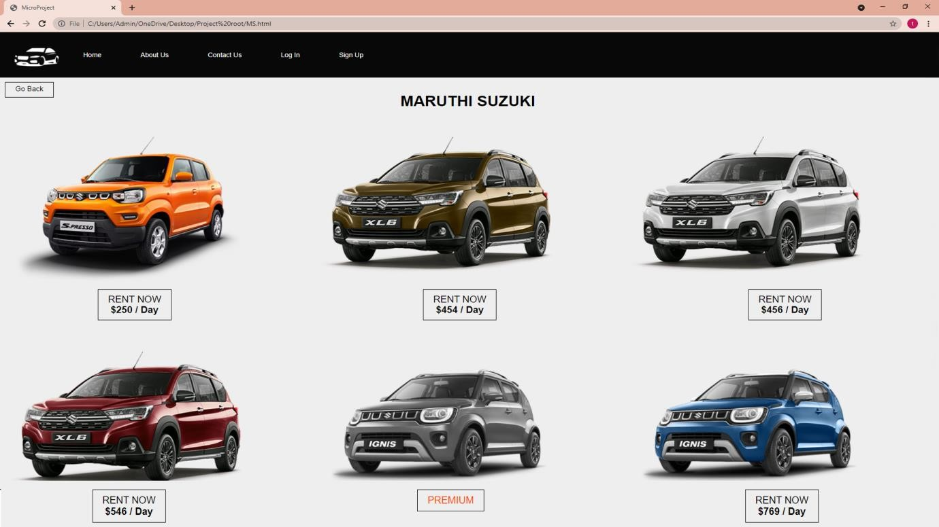

PAGE 4

## HTML

<html lang="en" dir="ltr">

<head>

<meta charset="utf-8">

<link rel="stylesheet" href="Style2.css">

<title> MicroProject </title>

<meta name="viewpoint" content="width=device-width, initial-scale">

</head>

<!-- This is My code -->

<body>

<nav class="PK1">

<div class="wrapper">

<ul>

<li><img class="Khan" src=img/CarLogo.png alt="myimage"></li>

<li><a href="file:///C:/Users/Admin/OneDrive/Desktop/Project%20root/Index.html">Home</a></li>

<li><a href="file:///C:/Users/Admin/OneDrive/Desktop/Project%20root/about%20us.html">About Us</a></li>

<li><a href="file:///C:/Users/Admin/OneDrive/Desktop/Project%20root/contact%20us.html">Contact Us</a></li>

<li><a href="file:///C:/Users/Admin/OneDrive/Desktop/Project%20root/Login%20in.html">Log In</a></li>

<li><a href="file:///C:/Users/Admin/OneDrive/Desktop/Project%20root/sign%20up.html">Sign Up</a></li>

</ul>

</div>

</nav>

<button class="Back" onclick="goBack()">Go Back</button></div>

<script>

function goBack() { window.history.back();

}

</script>

<div class="Heading1">

<h1>BMW</h1>

</div>

<div class="row">

<div class="column">

<img src="img/1.png" alt=" "style="width:85%">

</div>

<div class="column">

<img class="KL" src="img/2.png" alt="" style="width:85%">

</div>

<div class="column">

<img class="GG" src="img/10.png" alt="" style="width:85%">

</div>

</div>

<div class="container">

<button class="btn btn1">RENT NOW <br> <b> $700 / Day </b></button>

<button class="btn btn2">RENT NOW <br> <b> $4050 / Day </b></button>

<button class="btn B3">RENT NOW <br> <b> $980 / Day </b></button>

</div>

<div class="row2">

<div class="SC">

<img class="A" src="img/4.png" alt="" style="width:85%">

</div>

<div class="SC">

<img class="B" src="img/6.png" alt=""style="width:85%">

</div>

<div class="SC">

<img class="CARP" src="img/3R.png" alt="" style="width:75%" >

<div class="container2">

<button class="btn9 btn4">RENT NOW <br> <b> $1050 / Day </b></button>

<button class="btn9 OB">RENT NOW <br> <b> $9800 / Day </b></button>

<button class="btn9 btn6">COMING <b> SOON</b></button>

</div>

</div>

</div>

</body>

</html>

## CSS

* { margin: 0;

padding: 0;

box-sizing: border-box;

}

body {

background-repeat: repeat; background-size: auto; background-color: #eee; font-family: Arial;

}

.wrapper {

margin: 0 auto 0 60px; width: 1000px;

font-family: Arial; margin-left: -70px;

}

.back {

border: 1px solid Black; background: none; padding: 10px 20px; font-size: 15px;

font-family: "Arial"; cursor: pointer; margin: 10px; transition: 0.8s; position: relative; overflow: hidden; padding-top: 5px;

}

.back:hover{ color: White;

}

.back::before{ content: ""; position: absolute; left: 0;

top: -10;

width: 100%;

height: 1%; background: Black; z-index: -1; transition: 0.5s;

}

.back:hover::before{ height: 200%;

}

nav {

width: 100%; height: 100px;

background-color: #080808;

}

ul{

}

ul li {

list-style: none; display: inline-block; float: left;

line-height: 100px;

}

ul li a { display: block;

text-decoration: none; font-size: 14px;

font-family: arial; color: #ffffff; padding: 0 10px; margin-left: 60px;

}

ul li a:hover { color: Blue;

}

.Khan { width: 90px; padding:0;

margin-left: 100px; margin-top: 35px; margin-right: -20px;

}

.Heading1 {

text-transform: uppercase; margin-top: -20px;

margin-left: 10px; text-align: center;

}

.column { float: left;

width: 33.33%;

padding: 5px;

}

.row::after {

content: ""; clear: both; display: table;

}

.SC{

float: left; width: 33.33%; padding: 5px;

}

1. {

margin-top: 40px;

}

1. {

margin-top: 80px;

}

.CARP {

margin-top: 50px; margin-bottom: -50px;

}

.btn1 {

margin-top: 20px; margin-left: 200px;

}

.container{

text-align: Left;

}

.btn {

border: 1px solid Black; background: none; padding: 10px 20px; font-size: 20px;

font-family: "Arial"; cursor: pointer; margin: 10px;

transition: 0.8s; position: relative; overflow: hidden;

}

.btn1{

color: Black; margin-top: 10px; font-size: 20px; margin-left: 200px;

}

.btn1:hover{ color: White;

}

.btn1::before{ content: ""; position: absolute; left: 0;

width: 100%;

height: 0%; background: Black; z-index: -1; transition: 0.5s;

}

.btn1::before{ top: 0;

border-radius: 0 0 50% 50%;

}

.btn1:hover::before{ height: 180%;

}

.btn2{

color: Black; margin-top: 10px; font-size: 20px; margin-left: 500px;

}

.btn2:hover{

color: White;

}

.btn2::before{ content: ""; position: absolute; left: 0;

width: 100%;

height: 0%; background: Black; z-index: -1; transition: 0.5s;

}

.btn2::before{ top: 0;

border-radius: 0 0 50% 50%;

}

.btn2:hover::before{ height: 180%;

}

.B3{

color: Black; font-size: 20px;

margin-left: 500px; margin-top: -100px;

}

.B3:hover{ color: White;

}

.B3::before{

content: ""; position: absolute; left: 0;

width: 100%;

height: 0%; background: Black; z-index: -1; transition: 0.5s;

}

.B3::before{ top: 0;

border-radius: 0 0 50% 50%;

}

.B3:hover::before{ height: 180%;

}

.GG {

margin-top: 80px;

}

.KL {

margin-top: 40px;

}

.container2{ text-align: Left;

}

.btn9 {

border: 1px solid Black; background: none; padding: 10px 20px; font-size: 20px;

font-family: "Arial"; cursor: pointer; margin: 10px; transition: 0.8s; position: relative; overflow: hidden;

}

.btn4 {

color: Black; margin-top: -100px; font-size: 20px; margin-left: 250px;

}

.btn4:hover{ color: White;

}

.btn4::before{ content: ""; position: absolute; left: 0;

width: 100%;

height: 0%; background: Black; z-index: -1; transition: 0.5s;

}

.btn4::before{ top: 0;

border-radius: 0 0 50% 50%;

}

.btn4:hover::before{ height: 180%;

}

.OB{

color: Black; margin-top: 100px; font-size: 20px;

margin-left: -1500px;

}

.OB:hover{ color: White;

}

.OB::before{

content: ""; position: absolute; left: 0;

width: 100%;

height: 0%; background: Black; z-index: -1; transition: 0.5s;

}

.OB::before{ top: 0;

border-radius: 0 0 50% 50%;

}

.OB:hover::before{ height: 180%;

}

.btn6{

color: RED; font-size: 20px;

margin-left: 500px; margin-top:-10PX;

}

.btn6:hover{ color: White;

}

.btn6::before{ content: ""; position: absolute; left: 0;

width: 100%;

height: 0%; background: RED; z-index: -1; transition: 0.5s;

}

.btn6::before{ top: 0;

border-radius: 0 0 50% 50%;

}

.btn6:hover::before{ height: 180%;

}

## OUTPUT

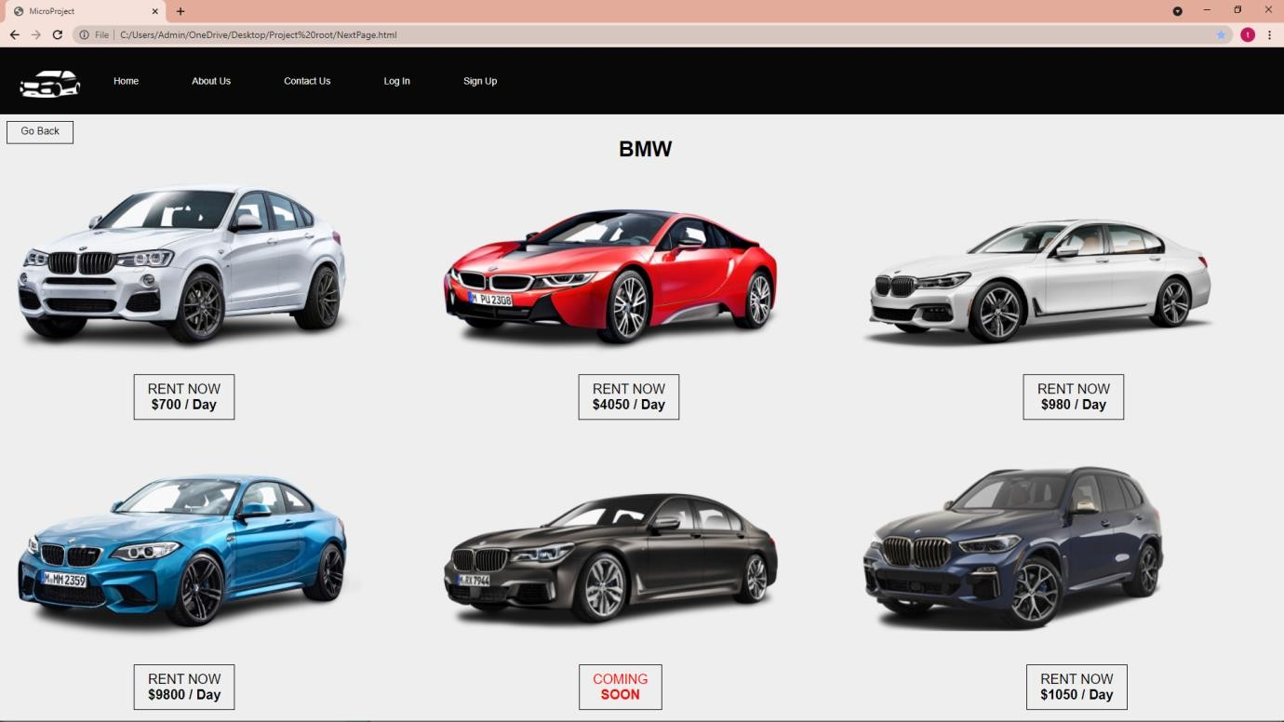

ABOUT US PAGE

## HTML

<html lang="en" dir="ltr">

<head>

<meta charset="utf-8">

<link rel="stylesheet" href="Style5.css">

<title> MicroProject </title>

<meta name="viewpoint" content="width=device-width, initial-scale">

</head>

<!-- This is My code -->

<body>

<nav class="PK1">

<div class="wrapper">

<ul>

<li><img class="Khan" src=img/CarLogo.png alt="myimage"></li>

<li><a href="file:///C:/Users/Admin/OneDrive/Desktop/Project%20root/Index.html">Home</a></li>

<li><a href="file:///C:/Users/Admin/OneDrive/Desktop/Project%20root/about%20us.html">About Us</a></li>

<li><a href="file:///C:/Users/Admin/OneDrive/Desktop/Project%20root/contact%20us.html">Contact Us</a></li>

<li><a href="file:///C:/Users/Admin/OneDrive/Desktop/Project%20root/Login%20in.html">Log In</a></li>

<li><a href="file:///C:/Users/Admin/OneDrive/Desktop/Project%20root/sign%20up.html">Sign Up</a></li>

</ul>

</div>

</nav>

<div class="about-section">

<button class="Back" onclick="goBack()">Go Back</button>

<script>

function goBack() { window.history.back();

}

</script>

<h1>About Us</h1>

<p>We were established in 2006 and have since been developing low cost car rental software for all size of vehicle rental companies. We have a complete software solution for the vehicle rental industry. It is now used by hundreds of operators and agents across the United States, Australia, New Zealand, Europe and the UK . We are committed to bringing you the best auto rental software available today and in the future.</p>

</div>

<h2 style="text-align:center">Our Team</h2>

<div class="row" >

<div class="column">

<div class="card" >

<img src="img/DP.png" alt="Jane" style="width:100%">

<div class="container" >

<h2>Shivraj.T</h2>

<p class="title">CEO & Founder</p>

<p>Roll No. <b> 100 </b></p>

<p>[Shivrajt@gmail.com](mailto:Shivrajt@gmail.com)</p>

<p><button class="button">Contact</button></p>

</div>

</div>

</div>

<div class="column">

<div class="card">

<img src="img/DP.png" alt="Mike" style="width:100%">

<div class="container">

<h2>Shrey Shah</h2>

<p class="title">Chief Financial Officer</p>

<p>Roll NO.101</p>

<p>[ShreyShah@gmail.com<](mailto:ShreyShah@gmail.com)/p>

<p><button class="button">Contact</button></p>

</div>

</div>

</div>

<div class="column">

<div class="card">

<img src="img/DP.png" alt="John" style="width:100%">

<div class="container">

<h2>Shubh Agarwal</h2>

<p class="title">Chief Business Officer</p>

<p>Roll No. 102 </p>

<p>[Shubh@gmail.com](mailto:Shubh@gmail.com)</p>

<p><button class="button">Contact</button></p>

</div>

</div>

</div>

</div>

<div class="column">

<div class="card">

<img src="img/DP.png" alt="John" style="width:100%">

<div class="container">

<h2>Karan Shukla</h2>

<p class="title">Chief Operating Officer</p>

<p>Roll No. 103</p>

<p>[KaranShukla@gmail.com<](mailto:KaranShukla@gmail.com)/p>

<p><button class="button">Contact</button></p>

</div>

</div>

</div>

<div class="column">

<div class="card">

<img src="img/FDP.png" alt="John" style="width:100%">

<div class="container">

<h2>Siddhi Mehta</h2>

<p class="title">Chief Marketing Officer</p>

<p>Roll No. 104</p>

<p>[SiddhiMehta@gmail.com<](mailto:SiddhiMehta@gmail.com)/p>

<p><button class="button">Contact</button></p>

</div>

</div>

</div>

<div class="column">

<div class="card">

<img src="img/FDP.png" alt="John" style="width:100%">

<div class="container">

<h2>Himani Singh</h2>

<p class="title">Chief Technology Officer</p>

<p>Roll No. 105</p>

<p>[HimaniSing@gmail.com<](mailto:HimaniSing@gmail.com)/p>

<p><button class="button">Contact</button></p>

</div>

</div>

</div>

</body>

</html>

## CSS

* { margin: 0;

padding: 0;

box-sizing: border-box;

}

body {

background-repeat: repeat; background-size: auto; background-color: #eee; font-family: Arial;

}

.wrapper {

margin: 0 auto 0 60px; width: 1000px;

font-family: Arial; margin-left: -70px;

}

nav {

width: 100%; height: 100px;

background-color: #080808;

}

ul{

}

ul li {

list-style: none; display: inline-block; float: left;

line-height: 100px;

}

ul li a { display: block;

text-decoration: none; font-size: 14px;

font-family: arial; color: #ffffff; padding: 0 10px; margin-left: 60px;

}

ul li a:hover { color: Blue;

}

.Khan { width: 90px; padding:0;

margin-left: 100px; margin-top: 35px; margin-right: -20px;

}

.back {

border: 1px solid white; background: none; padding: 10px 20px;

font-size: 15px; font-family: "Arial"; cursor: pointer; color: white; transition: 0.8s;

margin-left: -1770px; margin-top: -35px; position: relative; overflow: hidden; padding-top: 5px;

}

.back:hover{ border-color: red; color: red;

}

.back::before{ content: ""; position: absolute; left: 0;

top: 0%;

width: 100%;

height: 0%; background: Red; z-index: -1; transition: 0.5s;

}

.back:hover::before{ height: 200%;

}

body {

font-family: Arial, Helvetica, sans-serif;

margin: 0;

}

html {

box-sizing: border-box;

}

*, *:before, *:after { box-sizing: inherit;

}

.column { float: left; width: 33.3%;

margin-bottom: 16px; padding: 0 8px;

}

.card {

box-shadow: 0 4px 8px 0 rgba(0, 0, 0, 0.2); margin: 8px;

}

.about-section { padding: 50px; text-align: center;

background-color: #000000; color: white;

}

.container { padding: 0 16px;

}

.container::after, .row::after { content: "";

clear: both; display: table;

}

.title {

color: grey;

}

.button { border: none; outline: 0;

display: inline-block; padding: 8px;

color: white; background-color: #000; margin-top: 20px;

text-align: center; cursor: pointer; width: 100%;

}

.button:hover { background-color: #555;

}

@media screen and (max-width: 650px) {

.column { width: 100%; display: block;

}

## OUTPUT

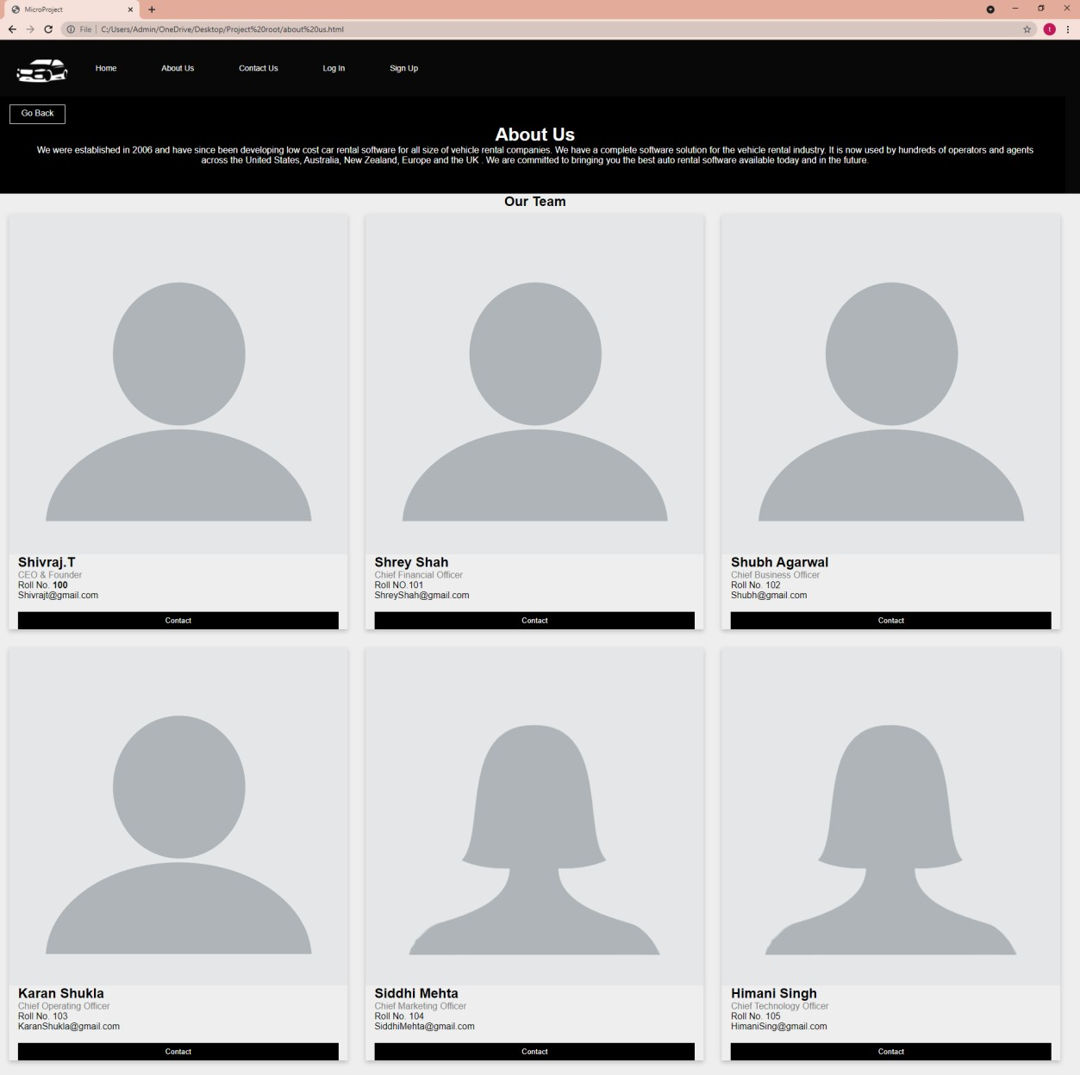

CONTACT US PAGE

## HTML

<html lang="en" dir="ltr">

<head>

<meta charset="utf-8">

<link rel="stylesheet" href="Style6.css">

<title> MicroProject </title>

<meta name="viewport" content="width=device-width, initial-scale=1">

</head>

<!-- This is My code -->

<body>

<nav class="PK1">

<div class="wrapper">

<ul>

<li><img class="Khan" src=img/CarLogo.png alt="myimage"></li>

<li><a href="file:///C:/Users/Admin/OneDrive/Desktop/Project%20root/Index.html">Home</a></li>

<li><a href="file:///C:/Users/Admin/OneDrive/Desktop/Project%20root/about%20us.html">About Us</a></li>

<li><a href="file:///C:/Users/Admin/OneDrive/Desktop/Project%20root/contact%20us.html">Contact Us</a></li>

<li><a href="file:///C:/Users/Admin/OneDrive/Desktop/Project%20root/Login%20in.html">Log In</a></li>

<li><a href="file:///C:/Users/Admin/OneDrive/Desktop/Project%20root/sign%20up.html">Sign Up</a></li>

</ul>

</div>

</nav>

<div class="about-section">

<button class="Back" onclick="goBack()">Go Back</button>

<script>

function goBack() { window.history.back();

}

</script>

<div class="Heading1">

<h3>Contact Form</h3>

</div>

<div class="container">

<form action="/action_page.php">

<label for="fname">First Name</label>

<input type="text" id="fname" name="firstname" placeholder="Your name..">

<label for="lname">Last Name</label>

<input type="text" id="lname" name="lastname" placeholder="Your last name..">

<label for="country">Country</label>

<select id="country" name="country">

<option value="australia">India</option>

<option value="canada">United States</option>

<option value="usa">Spain</option>

</select>

<label for="subject">Subject</label>

<textarea id="subject" name="subject" placeholder="Write something.." style="height:200px"></textarea>

<div class="popup" onclick="myFunction()">

<input class="Bu" type="button" value="Submit">

<span class="popuptext" id="myPopup">Your Form has been submitted</span>

</div>

<script>

// When the user clicks on div, open the popup function myFunction() {

var popup = document.getElementById("myPopup"); popup.classList.toggle("show");

}

</script>

</form>

</div>

</body>

</html>

## CSS

* { margin: 0;

padding: 0;

box-sizing: border-box;

}

body {

background-repeat: repeat; background-size: auto; background-color: #eee; font-family: Arial;

}

.wrapper {

margin: 0 auto 0 60px; width: 1000px;

font-family: Arial; margin-left: -70px;

}

.back {

border: 1px solid Black; background: none; padding: 10px 20px; font-size: 15px;

font-family: "Arial"; cursor: pointer; margin: 10px; transition: 0.8s; position: relative; overflow: hidden; padding-top: 5px; color: Black;

}

.back:hover{ color: White;

}

.back::before{ content: ""; position: absolute; left: 0;

top: -10;

width: 100%;

height: 1%; background: Black; z-index: -1; transition: 0.5s;

}

.back:hover::before{ height: 200%;

}

nav {

width: 100%; height: 100px;

background-color: #080808;

}

ul{

}

ul li {

list-style: none; display: inline-block; float: left;

line-height: 100px;

}

ul li a { display: block;

text-decoration: none;

font-size: 14px; font-family: arial; color: #ffffff; padding: 0 10px; margin-left: 60px;

}

ul li a:hover { color: Blue;

}

.Khan { width: 90px; padding:0;

margin-left: 100px; margin-top: 35px; margin-right: -20px;

}

body {font-family: Arial, Helvetica, sans-serif;}

* {box-sizing: border-box; color;} input[type=text], select, textarea { width: 100%;

padding: 12px;

border: 1px solid White; border-radius: 0px;

box-sizing: border-box; margin-top: 6px; margin-bottom: 16px; resize: vertical;

}

input[type=submit] { background-color: white; color: Black;

padding: 12px 20px; border: none; border-radius: 0px; cursor: pointer;

}

input[type=submit]:hover { background-color: Black; color: white;

border-color: white;

}

.container {

border-radius: 5px; background-color: Non; padding: 50px;

margin-left: 100px; margin-right: 100px;

}

.Heading1 {

text-align: center;

text-transform: uppercase; font-size: 30px;

}

position: relative; display: inline-block; cursor: pointer;

-webkit-user-select: none;

-moz-user-select: none;

-ms-user-select: none; user-select: none;

}

* The actual popup */

.popup .popuptext { visibility: hidden; width: 160px;

background-color: #555; color: #fff;

text-align: center; border-radius: 6px; padding: 8px 0; position: absolute; z-index: 1;

bottom: 125%;

left: 50%;

margin-left: -80px;

}

/* Popup arrow */

.popup .popuptext::after { content: "";

position: absolute; top: 100%;

left: 50%; margin-left: -5px;

border-width: 5px; border-style: solid;

border-color: #555 transparent transparent transparent;

}

/* Toggle this class - hide and show the popup */

.popup .show { visibility: visible;

-webkit-animation: fadeIn 1s;

animation: fadeIn 1s;

}

/* Add animation (fade in the popup) */ @-webkit-keyframes fadeIn {

from {opacity: 0;}

to {opacity: 1;}

}

@keyframes fadeIn { from {opacity: 0;}

to {opacity:1 ;}

}

.Bu {

border: 1px solid Black; background: none; padding: 10px 20px; font-size: 15px;

font-family: "Arial"; cursor: pointer; margin: 10px; transition: 0.8s; position: relative; overflow: hidden; padding-top: 5px;

}

.Bu:hover{ color: white;

background-color: Black;

}

.Bu::before{

content: ""; position: absolute;

left: 0;

width: 100%;

height: 0%; background: Black; z-index: -1; transition: 0.5s;

}

.Bu:hover::before{ height: 200%;

}

## OUTPUT

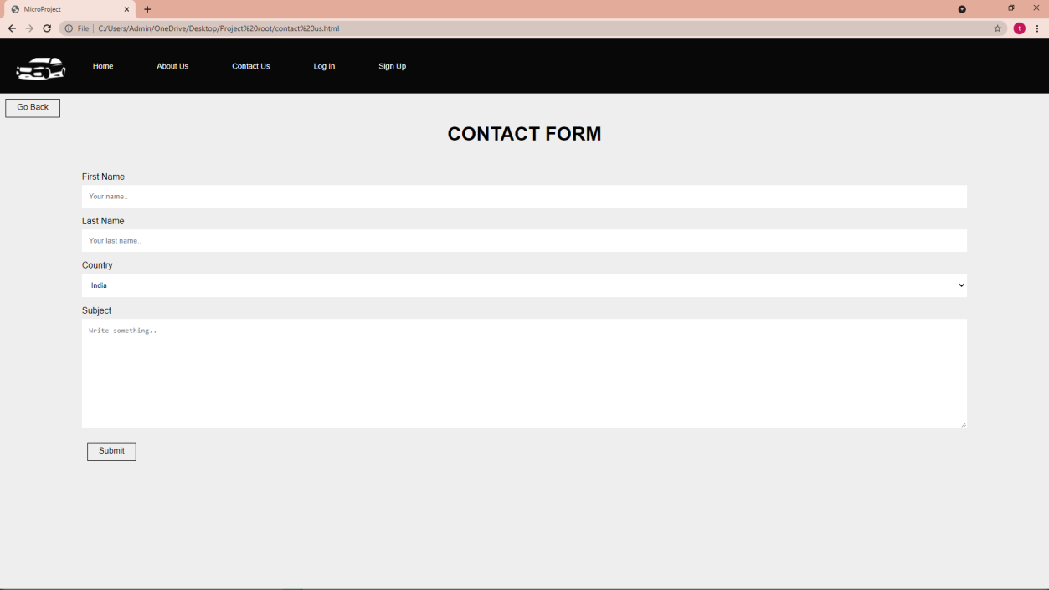

LOG IN PAGE HTML

<html lang="en" dir="ltr">

<head>

<meta charset="utf-8">

<link rel="stylesheet" href="style7.css">

<title> MicroProject </title>

<meta name="viewpoint" content="width=device-width, initial-scale">

</head>

<!-- This is My code -->

<body>

<nav class="PK1">

<div class="wrapper">

<ul>

<li><img class="Khan" src=img/CarLogo.png alt="myimage"></li>

<li><a href="file:///C:/Users/Admin/OneDrive/Desktop/Project%20root/Index.html">Home</a></li>

<li><a href="file:///C:/Users/Admin/OneDrive/Desktop/Project%20root/about%20us.html">About Us</a></li>

<li><a href="file:///C:/Users/Admin/OneDrive/Desktop/Project%20root/contact%20us.html">Contact Us</a></li>

<li><a href="file:///C:/Users/Admin/OneDrive/Desktop/Project%20root/Login%20in.html#">Log In</a></li>

<li><a href="file:///C:/Users/Admin/OneDrive/Desktop/Project%20root/sign%20up.html">Sign Up</a></li>

</ul>

</div>

</nav>

<div class="Back1">

<button class="Back" onclick="goBack()">Go Back</button></div>

<script>

function goBack() { window.history.back();

}

</script>

<body>

<div class="main">

<p class="sign" align="center">Log In</p>

<form class="form1">

<input class="un " type="text" align="center" placeholder="Username">

<input class="pass" type="password" align="center" placeholder="Password">

<a class="submit" align="center">Log In</a>

<p class="forgot" align="center"><a href="#">Forgot Password?</p>

</div>

</body>

</html>

# CSS

* { margin: 0;

padding: 0;

box-sizing: border-box;

}

body {

background-repeat: repeat; background-size: auto; background-color: #eee; font-family: Arial;

}

.wrapper {

margin: 0 auto 0 60px; width: 1000px;

font-family: Arial; margin-left: -70px;

}

.back {

border: 1px solid Black; background: none; padding: 10px 20px; font-size: 15px;

font-family: "Arial"; cursor: pointer; margin: 10px; transition: 0.8s; position: relative; overflow: hidden; padding-top: 5px;

}

.back:hover{ color: White;

}

.back::before{ content: ""; position: absolute; left: 0;

top: -10;

width: 100%;

height: 1%; background: Black; z-index: -1; transition: 0.5s;

}

.back:hover::before{ height: 200%;

}

nav {

width: 100%;

height: 100px;

background-color: #080808;

}

ul{

}

ul li {

list-style: none; display: inline-block; float: left;

line-height: 100px;

}

ul li a { display: block;

text-decoration: none; font-size: 14px;

font-family: arial; color: #ffffff; padding: 0 10px; margin-left: 60px;

}

ul li a:hover { color: Blue;

}

.Khan { width: 90px; padding:0;

margin-left: 100px; margin-top: 35px; margin-right: -20px;

}

body {

background-color: #eee;

font-family: 'Ubuntu', sans-serif;

}

.main {

background-color: #FFFFFF; width: 400px;

height: 400px; margin: 7em auto; border-radius: 1.5em;

box-shadow: 0px 11px 35px 2px rgba(0, 0, 0, 0.14);

}

.sign {

padding-top: 40px; color: Black;

font-family: 'Ubuntu', sans-serif; font-weight: bold;

font-size: 23px;

}

.un {

width: 76%;

color: rgb(38, 50, 56);

font-weight: 700; font-size: 14px; letter-spacing: 1px;

background: rgba(136, 126, 126, 0.04); padding: 10px 20px;

border: none; border-radius: 20px; outline: none;

box-sizing: border-box;

border: 2px solid rgba(0, 0, 0, 0.02);

margin-bottom: 50px; margin-left: 46px; text-align: center; margin-bottom: 27px;

font-family: 'Ubuntu', sans-serif;

}

form.form1 {

padding-top: 40px;

}

.pass {

width: 76%;

color: rgb(38, 50, 56);

font-weight: 700; font-size: 14px; letter-spacing: 1px;

background: rgba(136, 126, 126, 0.04); padding: 10px 20px;

border: none; border-radius: 20px; outline: none;

box-sizing: border-box;

border: 2px solid rgba(0, 0, 0, 0.02); margin-bottom: 50px;

margin-left: 46px; text-align: center; margin-bottom: 27px;

font-family: 'Ubuntu', sans-serif; margin-bottom: 40px;

}

.un:focus, .pass:focus {

border: 2px solid rgba(0, 0, 0, 0.18) !important;

}

.submit {

cursor: pointer; border-radius: 5em; color: #fff; background: Black; border: 0;

padding-left: 40px; padding-right: 40px; padding-bottom: 10px; padding-top: 10px;

font-family: 'Ubuntu', sans-serif; margin-left: 35%;

font-size: 13px;

box-shadow: 0 0 20px 1px rgba(0, 0, 0, 0.04);

}

.forgot {

text-shadow: 0px 0px 3px rgba(117, 117, 117, 0.12); color: Black;

padding-top: 15px; margin-top: 30px;

}

a {

text-shadow: 0px 0px 3px rgba(117, 117, 117, 0.12); color: Black;

text-decoration: none

}

@media (max-width: 600px) {

.main {

border-radius: 0px;

}

# OUTPUT

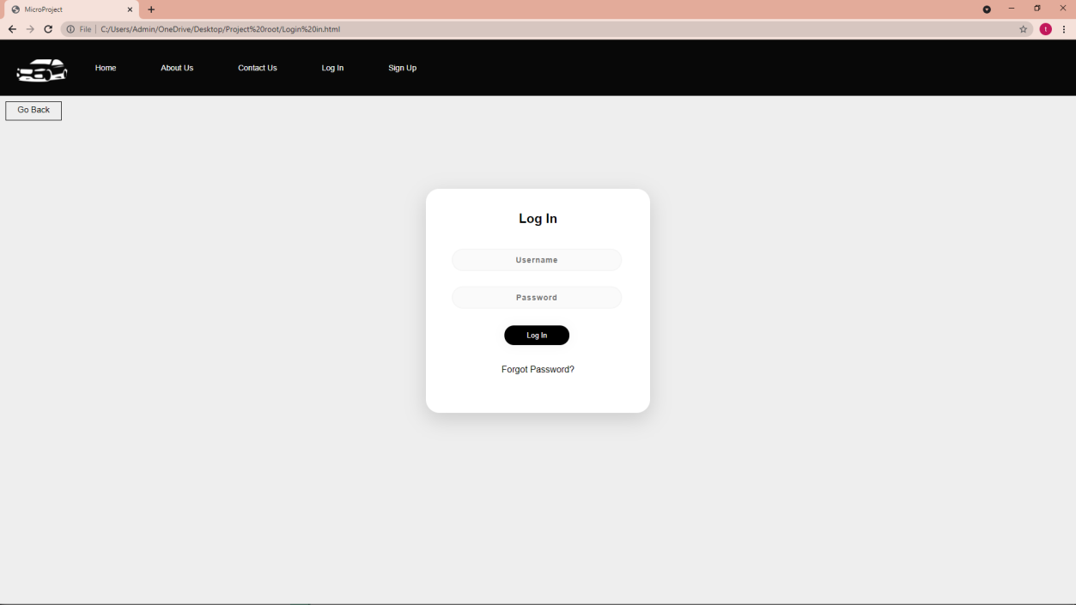

SIGN UP PAGE

# HTML

<html lang="en" dir="ltr">

<head>

<meta charset="utf-8">

<link rel="stylesheet" href="style8.css">

<title> MicroProject </title>

<meta name="viewpoint" content="width=device-width, initial-scale">

</head>

<!-- This is My code -->

<body>

<nav class="PK1">

<div class="wrapper">

<ul>

<li><img class="Khan" src=img/CarLogo.png alt="myimage"></li>

<li><a href="file:///C:/Users/Admin/OneDrive/Desktop/Project%20root/Index.html">Home</a></li>

<li><a href="file:///C:/Users/Admin/OneDrive/Desktop/Project%20root/about%20us.html">About Us</a></li>

<li><a href="file:///C:/Users/Admin/OneDrive/Desktop/Project%20root/contact%20us.html">Contact Us</a></li>

<li><a href="file:///C:/Users/Admin/OneDrive/Desktop/Project%20root/Login%20in.html#">Log In</a></li>

<li><a href="file:///C:/Users/Admin/OneDrive/Desktop/Project%20root/sign%20up.html">Sign Up</a></li>

</ul>

</div>

</nav>

<div class="Back1">

<button class="Back" onclick="goBack()">Go Back</button></div>

<script>

function goBack() { window.history.back();

}

</script>

<body>

<div class="main">

<p class="sign" align="center">Sign Up</p>

<form class="form1">

<input class="un " type="text" align="center" placeholder="Email">

<input class="un " type="text" align="center" placeholder="Confirm Email">

<input class="un " type="text" align="center" placeholder="Username">

<input class="pass" type="password" align="center" placeholder="Password">

<input class="pass" type="password" align="center" placeholder="Confirm Password">

<a class="submit" align="center">Sign Up</a>

</div>

# CSS

* { margin: 0;

padding: 0;

box-sizing: border-box;

}

body {

background-repeat: repeat; background-size: auto; background-color: #eee; font-family: Arial;

}

.wrapper {

margin: 0 auto 0 60px; width: 1000px;

font-family: Arial; margin-left: -70px;

}

.back {

border: 1px solid Black; background: none; padding: 10px 20px; font-size: 15px;

font-family: "Arial"; cursor: pointer; margin: 10px; transition: 0.8s; position: relative; overflow: hidden; padding-top: 5px;

}

.back:hover{ color: White;

}

.back::before{ content: ""; position: absolute; left: 0;

top: -10;

width: 100%;

height: 1%; background: Black; z-index: -1; transition: 0.5s;

}

.back:hover::before{ height: 200%;

}

nav {

width: 100%; height: 100px;

background-color: #080808;

}

ul{

}

ul li {

list-style: none; display: inline-block; float: left;

line-height: 100px;

ul li a { display: block;

text-decoration: none; font-size: 14px;

font-family: arial; color: #ffffff; padding: 0 10px; margin-left: 60px;

}

ul li a:hover { color: Blue;

}

.Khan { width: 90px; padding:0;

margin-left: 100px; margin-top: 35px; margin-right: -20px;

}

body {

background-color: #eee;

font-family: 'Ubuntu', sans-serif;

}

.main {

background-color: #FFFFFF; width: 400px;

height: 400px; margin: 7em auto; border-radius: 1.5em;

box-shadow: 0px 11px 35px 2px rgba(0, 0, 0, 0.14);

.sign {

padding-top: 40px; color: Black;

font-family: 'Ubuntu', sans-serif; font-weight: bold;

font-size: 23px;

}

.un {

width: 76%;

color: rgb(38, 50, 56);

font-weight: 700; font-size: 14px; letter-spacing: 1px;

background: rgba(136, 126, 126, 0.04); padding: 10px 20px;

border: none; border-radius: 20px; outline: none;

box-sizing: border-box;

border: 2px solid rgba(0, 0, 0, 0.02); margin-bottom: 50px;

margin-left: 46px; text-align: center; margin-bottom: 27px;

font-family: 'Ubuntu', sans-serif;

}

form.form1 {

padding-top: 40px;

}

.pass {

width: 76%;

color: rgb(38, 50, 56);

font-weight: 700; font-size: 14px; letter-spacing: 1px;

background: rgba(136, 126, 126, 0.04); padding: 10px 20px;

border: none; border-radius: 20px; outline: none;

box-sizing: border-box;

border: 2px solid rgba(0, 0, 0, 0.02); margin-bottom: 50px;

margin-left: 46px; text-align: center; margin-bottom: 27px;

font-family: 'Ubuntu', sans-serif; margin-bottom: 40px;

}

.un:focus, .pass:focus {

border: 2px solid rgba(0, 0, 0, 0.18) !important;

}

.submit {

cursor: pointer; border-radius: 5em; color: #fff; background: Black; border: 0;

padding-left: 40px; padding-right: 40px; padding-bottom: 10px; padding-top: 10px;

.forgot {

text-shadow: 0px 0px 3px rgba(117, 117, 117, 0.12); color: Black;

padding-top: 15px; margin-top: 30px;

}

a {

text-shadow: 0px 0px 3px rgba(117, 117, 117, 0.12); color: Black;

text-decoration: none

}

@media (max-width: 600px) {

.main {

border-radius: 0px;

}

# OUTPUT

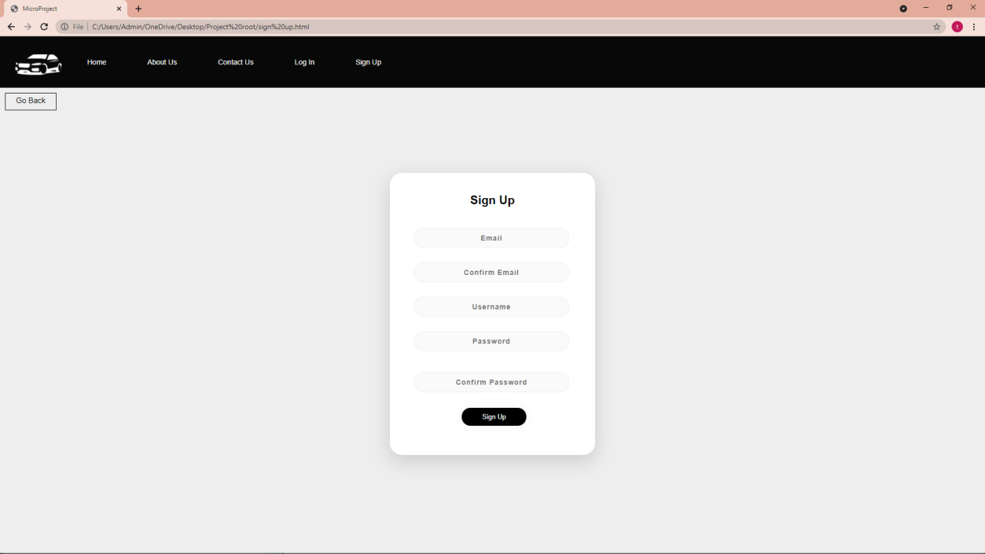

## Skill Developed / Learning outcomes of this Micro – Project.

* + - Creation of the web pages that enable users to input commands and get output, sign up and sign out functionality to use the application such as Gmail. Creation of the communication channels between two user accounts. Visualization of data/information and connectivity with the source on the single web page from existed websites on the internet such as Google. A connection between two bank accounts and other options to transfer and receive money.

## Application of this Micro – Project

* + - Web pages development: HTML is heavily used for creating pages that are displayed on the World Wide Web. Every page contains a set of HTML tags including hyperlinks which are used for connecting to other pages.
    - Web document creation: Document creation on the internet is dominated by HTML and its basic concept via tag and DOM i.e. document object model. HTML tags are inserted before and afterward or phrases to locate their format and location on the page.
    - Internet navigation: This is one of the most important uses of HTML which is revolutionary. This navigation is possible by utilizing the concept of Hypertext. It is basically a text which refers to other web pages or text and when user clicks on it, would navigate to referenced text or page. HTML is heavily used to embed the hyperlink within the web pages.

Smitha Dandge (Subject Teacher)