Anatomy of a PDF Document
• Header: Identifies the PDF version (e.g., %PDF-1.7).
• Body: Contains the actual building blocks—fonts, images, text blocks, and page dimensions—stored as numbered "Objects."
• Cross-Reference Table (Xref): This is the directory. It tells the PDF reader exactly which byte offset in the file holds Object #42.
• Trailer: A PDF reader actually starts reading from the bottom of the file. The trailer points the reader to the Xref table so it knows where everything is.
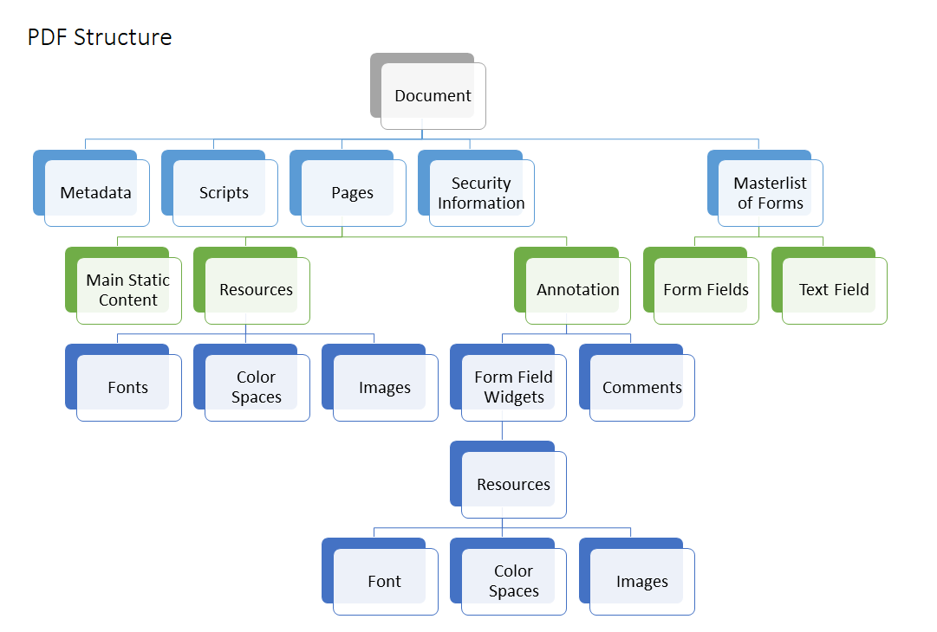

Recommended References
- The Bible: Adobe PDF Reference, Sixth Edition (PDF 32000-1:2008). Do not read this cover to cover. Use it as a dictionary when you need to look up exactly how a ToUnicode table works.
- Practical Coding Docs: PyMuPDF Documentation. Their guides on text extraction are highly practical and explain the internal mechanics very well.
- OCR Concepts: Read the documentation and academic papers behind Tesseract OCR (specifically version 4+, which introduced LSTM networks).
- Industry Authority: The PDF Association (pdfa.org) publishes excellent technical articles and deep dives into text extraction edge cases.

1. The Header (The Signature)
Just like many file formats, a PDF starts with a magic number and a version.
- It sits at the very first line of the file (e.g., %PDF-1.7).
- It simply tells the parser, "I am a PDF, and here is the specification version you need to read me."
2. The Body (The Graph Nodes)
This is where all the actual data lives. The body is a giant collection of isolated data objects. In DSA terms, these are the nodes of your graph.
- Each object is assigned a unique identifier (e.g., 4 0 obj means Object #4, Generation 0).
- Objects can be basic data types like strings, integers, or booleans.
- Objects can be Dictionaries (key-value pairs, structured exactly like a hash map or JSON object).
- Objects can be Streams (raw byte arrays, usually compressed data for images, fonts, or long text instructions).
- Crucially, objects contain pointers (references) to other objects. For example, a "Page" object doesn't literally contain an image inside it; it contains an indirect pointer (like 8 0 R) to an "Image" object located elsewhere in the file.

3. The Cross-Reference Table (The O(1) Lookup Array)
If you want to render Page 50 of a 1,000-page PDF, you don't want to parse the file sequentially from the beginning (which would be O(n) time complexity).
- The Cross-Reference (XRef) table solves this. It is literally an array of byte offsets.
- It maps the Object ID directly to its exact byte location on your hard drive.
- When the PDF reader needs Object #4, it looks at index 4 in the XRef table, gets the byte offset (e.g., byte offset 277), and jumps directly to that memory location in the file stream.
4. The Trailer (The Root Pointer)
Here is the biggest plot twist about PDFs: a PDF reader parses the file backwards.
- When you open a PDF, the parser seeks to the very end of the file (EOF) and reads backwards to find the Trailer.
- The Trailer contains two critical pointers:
  - The byte offset of the XRef table (so the reader can load the lookup array into memory).
  - A pointer to the Root Object (called the Document Catalog).
- Once the reader has the Trailer, it finds the XRef table. From the XRef table, it finds the Root Object. From the Root Object, it traverses the graph (often using BFS or DFS traversal logic) to find the specific pages, fonts, and text needed.

Developer Insight: When you use a PDF extraction library in Python (like PyMuPDF or pdfminer), the library handles this graph traversal and XRef parsing in the background. The reason extraction sometimes fails, hangs, or consumes massive memory is that the object graph can be deeply nested, or the stream objects are poorly compressed.

Why Read a File Backwards?
It sounds completely counter-intuitive to read a file from the end, but in the case of PDFs, it is a brilliant performance and data-management hack.
When you open a PDF, the parser seeks to the very end of the file (EOF) and reads backwards to find the Trailer. It does this for two main reasons:
- O(1) Random Access: The trailer contains the exact byte offset of the Cross-Reference (XRef) table. By jumping straight to the end to grab this offset, the parser can load the lookup array into memory immediately without scanning the entire file.
- Incremental Updates: When you edit a PDF (like adding a signature, a highlight, or a new page), the software doesn't rewrite the entire file—that would be too slow for large documents. Instead, it simply appends the new objects, a new XRef table, and a new Trailer to the very bottom of the file. By reading from the back, the parser guarantees it always finds the most recently updated version of the document first.
What is the Root Object?
Think of the Root Object as the literal root node in a Tree or Graph data structure.
- In PDF terminology, the Root Object is called the Document Catalog.
- The Trailer contains a direct pointer to this Root Object.
- Once the reader locates the XRef table and finds the Root Object, it uses standard traversal logic (like BFS or DFS) to navigate the document graph.
- From this single root node, the parser can branch out to find everything: the "Pages Tree" (which holds all the individual pages), bookmarks, metadata, and fonts.
When you use Python libraries like PyMuPDF for your text extraction research, the library is handling all of this graph traversal and XRef parsing in the background for you. If the object graph is deeply nested, this traversal is exactly why extraction tools can sometimes consume massive amounts of memory.

1.2 Text vs. Vector vs. Raster Streams:
How a PDF distinguishes embedded text operators (BT...ET), vector graphics/shapes, and raster image streams
1. Text Streams (Native PDF Text)
In a native or digital PDF, the text is actually embedded in the document. The PDF uses specific operators to draw this text:
- BT (Begin Text) and ET (End Text): These are the exact commands used in the PDF stream to define a block of text.
- Inside this block, the PDF specifies the font, sets the exact X and Y coordinates for the cursor, and provides the character codes to draw.
- Extraction perspective: This is the easiest scenario. Parsers like PyMuPDF simply read the text between BT and ET and look at the coordinates.
2. Raster Streams (Images and Scans)
Raster streams are raw grids of pixels, exactly like a JPEG or PNG.
- In PDF terminology, these are often handled as XObjects (External Objects).
- If you have a scanned or image-only PDF, the entire page might just be one giant XObject.
- Extraction perspective: There are no BT...ET commands here. A standard text extractor will see 0 words. To get text out of these, you absolutely must use Optical Character Recognition (OCR).
3. Vector Streams (Mathematical Shapes)
Vectors are mathematical drawing instructions—like "move pen to (10, 50), draw a curve to (20, 80), and fill it with blue."
- They are used to draw tables, charts, borders, and icons.
- The major edge case: Sometimes, designers create PDFs where text is embedded as vector graphics. They convert fonts into vector shapes so they render perfectly on any machine.
- Extraction perspective: To the PDF, this is not text; it is just a bunch of math drawing a shape that happens to look like the letter "A". Standard text extractors will completely miss this.

1.3 Fonts, Glyphs, and Character Encoding
The Difference Between a Glyph and a Character
- Glyph: This is just a vector drawing—the physical curves and lines that make up the shape of a letter on the screen.
- Character: This is the underlying semantic meaning (like the Unicode value U+0041 for the letter "A").
• In a PDF, the system can draw a glyph perfectly without the document ever actually knowing what character it represents.
Subsetted Fonts & The ToUnicode Map
If you write a resume using a custom font, embedding the entire 5MB font file into the document would make the PDF huge.
- Instead, PDFs use Embedded/subset fonts. If your resume only uses the letters in "John Doe", the PDF only embeds the drawings for those specific letters.
- It then assigns them arbitrary, internal IDs (e.g., Glyph 1 = J, Glyph 2 = o).
- To allow text extraction, the PDF includes a ToUnicode CMap (Character Map). This is a lookup table that tells the parser: "When you see Glyph ID 1, output the Unicode character 'J'".

Why Text Extraction Produces Gibberish
Your assignment requires you to investigate edge cases like "Missing fonts", "Non-standard character encoding", "Unicode issues", and "Ligatures". Here is exactly why extraction tools fail on them:
- Missing CMap: If the software generating the PDF (like a cheap resume builder) forgets to include the ToUnicode table, the PDF viewer can still draw the text perfectly. However, standard extractors will extract random symbols (Mojibake) because the mapping back to actual text is missing.
- Ligatures: Sometimes, letters like "f" and "i" are combined into a single, stylish drawing (a ligature). If the CMap doesn't map this single drawing back to two distinct characters ("f" and "i"), your extractor will drop or merge letters, corrupting the text.
- Hidden Text: You also need to watch out for "Invisible/hidden text" or "Existing but incorrect OCR layers". Sometimes, a PDF has a hidden, corrupted text layer sitting invisibly behind a scanned image, tricking native parsers into extracting bad data instead of routing it to an OCR engine.

1.4 Optical Character Recognition (OCR) Mechanisms

1. Binarization (Cleaning the Canvas)
When a document is scanned, especially from a mobile camera, the image often has shadows, uneven lighting, or background noise. Binarization is the mathematical process of converting a grayscale or color image into strict black and white.
- How it works: The algorithm calculates a threshold value. Any pixel darker than the threshold becomes black (text); anything lighter becomes white (background).
- Adaptive Binarization: Modern engines don't use a single threshold for the whole page. They calculate thresholds dynamically for small blocks of the image, which is vital for handling "shadows" or "low-quality scans".
2. Deskewing (Straightening the Page)
If a page is fed into a scanner slightly crooked, the text lines will be angled. OCR engines struggle to read slanted text.
- How it works: The engine identifies the angle of the text lines and rotates the entire image mathematically to ensure the lines are perfectly horizontal.
- Why it matters: This directly impacts "Layout Analysis". If the page isn't deskewed, the system might misinterpret a slight slant as a column break or merge text from different lines.
3. Layout Segmentation (Text Detection)
Once the image is clean and straight, the engine needs to find where the text actually is. This is known as Text Detection or Layout Segmentation.
- How it works: The engine groups adjacent black pixels into larger components. It identifies individual character bounding boxes, groups those into words, groups words into lines, and groups lines into paragraphs or columns.
- The Challenge: This is exactly where "reading order" problems arise in multi-column layouts. The segmentation engine has to guess whether two text blocks side-by-side belong to the same paragraph or different columns.
4. Neural Character Recognition
Finally, the engine has isolated a bounding box containing what it thinks is a single character or word. Now it has to guess what that character is.
- How it works (Modern OCR): Modern engines (like Tesseract 4+) use neural networks, specifically Long Short-Term Memory (LSTM) networks or Transformers.
- The system feeds the pixels of the bounding box into the trained model.
- The model outputs a probability distribution (e.g., "I am 95% sure this is an 'S', and 5% sure it is a '5'").
- This is why your assignment asks you to investigate if OCR changes digits or confuses "0/O, 1/l/I, 5/S, 8/B". The model is making an educated guess based on pixel patterns, which is inherently riskier than native text extraction where the character code is absolute.

1.5: Visual & Graphic Element Extraction
The Core Problem with Visual Elements
Standard PDF text extractors pull text but completely ignore graphics.
- If a resume has "📞 555-1234", standard extraction just returns "555-1234". The contextual "key" (that this is a phone number and not a salary) is lost.
- The key question you need to answer for your benchmark is whether the system should extract the image, OCR it, ignore it, or preserve both.
How the System Handles Icons & Logos
Visuals are usually stored in two ways, requiring different programmatic approaches:
- Raster Images (XObjects): If a company logo is a JPEG embedded in the PDF, low-level libraries can extract the raw image bytes. You can then pass this image to a multimodal LLM or vision model to identify the company name if it isn't written in text.
- Vector Shapes: Icons (like LinkedIn logos or location pins) are frequently drawn using mathematical vector paths. To a standard parser, these are just meaningless curves. Specialized layout parsers are needed to group these vectors and classify them as icons.
Processing QR Codes
QR codes are a unique edge case. They are images, but they contain highly structured text (like a candidate's portfolio URL).
- Standard OCR engines (like Tesseract) cannot read QR codes; they only read human-readable characters.
- The Developer Approach: Your system must extract the image bounding box, detect that it is a matrix barcode, and pass it to a dedicated decoding library (like OpenCV or zbar in Python) to extract the URL.

