Month 2 progress report
Baakhapaa: AI-powered pre-production intelligence system Weeks 5 to 8 of 12. Reference: proposal §8.
Every module the proposal scheduled for Month 2 was already delivered in Month 1 and reported as such. Month 2 was therefore spent on the two things that decide whether any of it survives contact with a user: proving the system works when it is not being demonstrated, and measuring the one capability the product is sold on. The system ran outside demo mode for the first time. Retrieval was measured for the first time, and the first honest number was worse than the first flattering one.

1. Month 2 deliverables
Wk | Build focus | Deliverable | Status
5 | Storyboard generation | Shot types, camera notes, frame controls, regeneration | Delivered Month 1
6 | Collaboration and versions | Comment threads, roles, version history with diff | Delivered Month 1
7 | Export system | PDF, Word, Final Draft .fdx, production package | Delivered Month 1
8 | Subscription tiers | Free / Pro / Studio, three gateways, server-side gating | Delivered Month 1
— | Quality and measurement | Test coverage, retrieval evaluation, first live-key run | Done

The four scheduled deliverables were verified again this month rather than rebuilt. What follows is the work that filled the month instead.
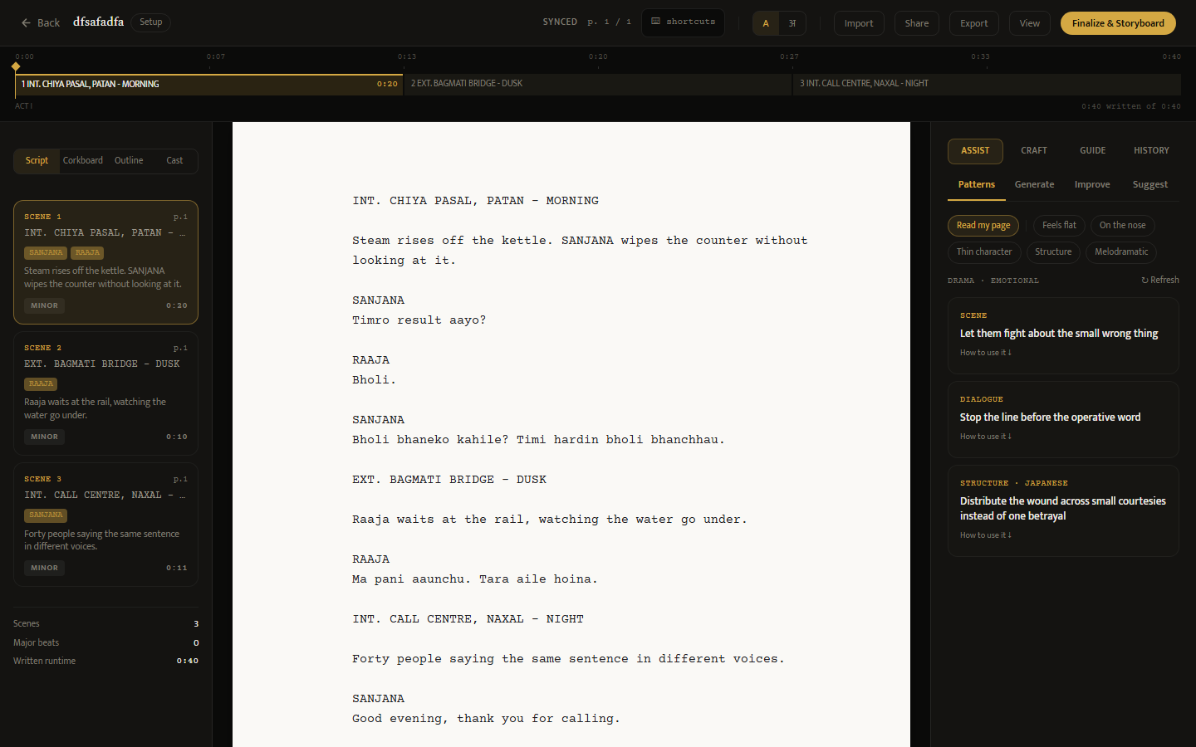
Figure 1. The workspace as it stands at the end of Month 2. Left, the rail carrying the four readings and the index cards, each now showing the page a scene starts on, who is in it and the first thing the camera sees. Centre, the screenplay column. Right, the assist panel with its craft recommendations. Above, the timeline: scene headings are renameable in place and act durations are editable.

Week 5: Coverage of the parts that fail quietly
Three backend modules had no test at all, and the ones without coverage were close to the inverse of where coverage should have been: the Stripe webhook is the only unauthenticated endpoint that grants a paid tier, updates.py is six lines standing between a client dictionary and two write handlers, and rag.py — the differentiator — returns an empty list on every error by design, so it fails silently.
104 backend tests were added across six new files, and all 26 untested frontend components and pages were covered. The suite now stands at 765 backend tests across 42 files and 1,020 frontend tests across 54 files.
Two security defects were found and closed in the process. versions.py ran its access check after its error branches, so any signed-in user could learn whether two arbitrary version identifiers existed and belonged to the same script — every other route in the system returns 404 precisely to prevent that. And the command palette guarded only its render, so pressing Cmd-K while signed out issued an authenticated request, received a 401 and ejected the visitor to the login page.

Week 6: Running outside demo mode
The system had never been executed against a real provider. It was this month, and the run produced more information than a successful one would have.
The first finding was in the test suite rather than the product. conftest.py deliberately forces the mock database and pins payments offline, but had never done the same for the AI keys — which did not matter while those keys were absent. On the day real keys were added the suite began making live, billed API calls, and hung for twenty-six minutes retrying a provider error. The subtlety worth recording is that removing the variables does not fix it: load_dotenv() declines to overwrite a variable that already exists and happily fills in one that does not, so popping the key invites the real one straight back.
The second was the cost model. A storyboard frame was estimated at $0.040 on the assumption of DALL-E 3. Measured against the model the system actually calls, one frame is $0.0033 — a factor of twelve. This inverts the pricing lever: images are roughly 18% of the cost of a script and generation tokens are 82%, so the control that matters is output length, not the frame cap.
Measured | Estimated | Actual
One storyboard frame | $0.040 | $0.0033
24-frame storyboard | $0.96 | $0.08
One script with a board | $1.32 | ~$0.44

Week 7: Measuring retrieval
The retrieval layer is what the product is sold on and nothing had ever measured it. An evaluation harness was built: 34 golden cases mined from the corpus itself rather than invented, scored on precision@1, precision@3 and mean reciprocal rank.
The first result was 82.4% precision@1, which looked like good news and was not. The golden set mixes two populations of very different difficulty, and averaging them buried the one that matters:
REAL QUERIES (what the editor actually sends, n=5)
precision@1 20.0%
precision@3 60.0%

SANITY CHECK (an entry finds itself, n=29)
precision@1 93.1% <- should stay near 100%

Self-retrieval is nearly free — the query is the text that was embedded — so 29 easy cases drowned five real ones. The harness now reports the two apart and leads with the real queries. 20% is the committed baseline, and it agrees with what the corpus loader's own probes had been printing as passes all along: three of its four rank the wrong craft level first.
That result is the most useful thing produced this month. It is also the reason the number is trusted: the measurement caught an error in its own design before it caught one in the system.
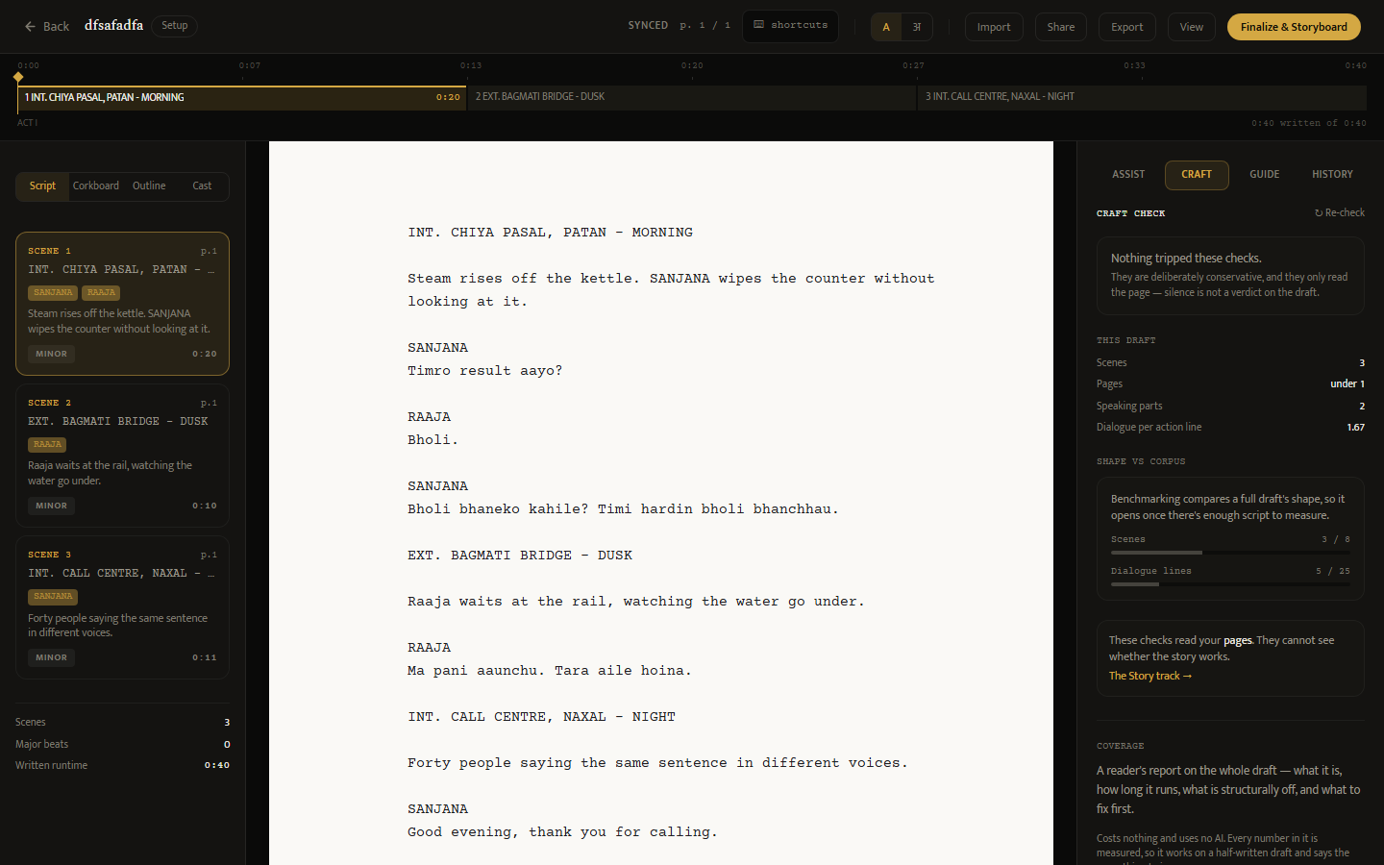
Figure 2. The free tier's measurement surface. The linter reports nothing tripped and says plainly what that does not mean; below it, the draft's own statistics, and beneath those the corpus benchmark holding itself back until there is enough script to compare. Saying when a report will open is more useful than inventing a percentile from three scenes.

Week 8: Craft features and production readiness
Generation now streams. Every AI call blocked until the whole response was composed, so a writer asked for a scene and watched a spinner while two thousand tokens were assembled elsewhere. Server-sent events replace that for scene generation and rewriting, with a provider failure arriving inside the stream — once the first byte is sent the status is already 200, so an error has to be a message the client can read rather than a dropped connection.
Cast was added: the reading the system did not have. The linter reads a page, the benchmark reads a shape, the corkboard reads an order, and none of them answers the question a writer arrives with around page thirty. Reading one character's lines end to end, with three measures chosen to be actionable rather than scored, does. Run against a short film written to test it:
Character | Lines | Words per line | Vocabulary | Asks
AARATI | 30 | 4.1 | 0.65 | 0.17
KANCHHA | 15 | 4.7 | 0.77 | 0.40
BABA | 15 | 6.3 | 0.76 | 0.00

Kanchha asks a question in forty percent of his lines and Baba in none of them. That is characterisation, visible as a number, and it is the fastest way to see two voices collapsing into one. The story bible — which the writer fills in and which had been spent on prompts and shown back to them nowhere — now sits beside it, so the voice they described is next to the voice they wrote.
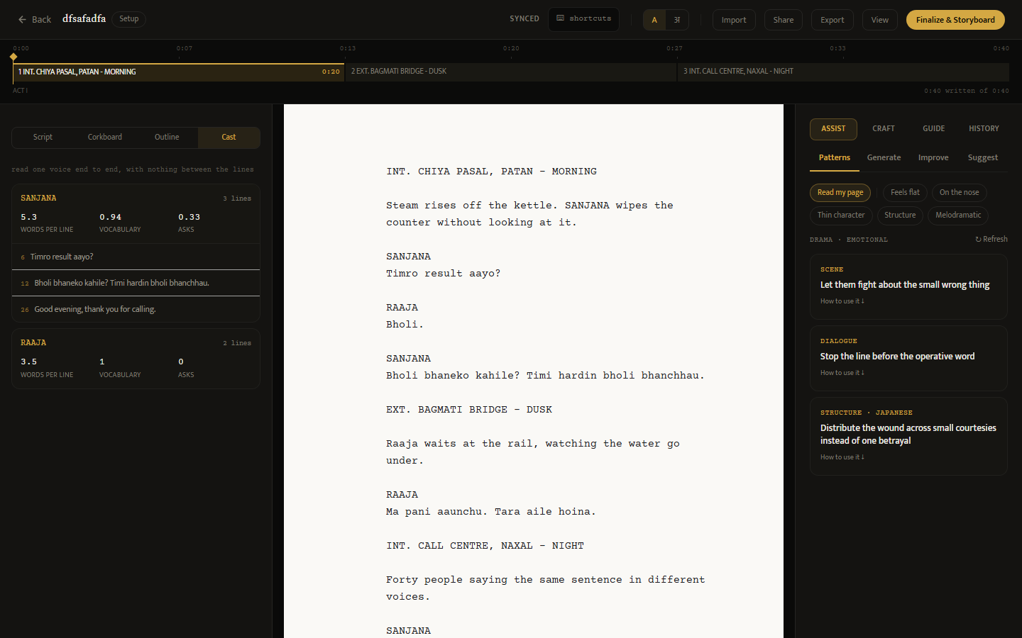
Figure 3. Cast, with one voice opened. Sanjana asks in a third of her lines, Raaja in none of his; her vocabulary is 0.94 against his 1.00 because she repeats herself and he barely speaks. Each line carries its number in the draft, so clicking it puts the caret there. The page stays on screen throughout — the point of moving these readings into the rail.

2. Work beyond Month 2 scope

2.1 Defects found by using the product as a writer would
A full short film was written inside the system and run through its own tools. This found what synthetic fixtures had not: statistics counted FADE IN: as a scene, so a 16-scene script reported 17, a phantom of 0.04 pages led the scene-length curve, and every corpus percentile shown to a writer was computed partly against a scene nobody wrote.
Four further defects were found the same way. The craft panel diagnosed the question a writer clicked rather than their draft, and reported the result as "found in your draft, line 1" — a line of a sentence they had never typed. Renaming a scene heading never reached the scene index, so the timeline kept showing a line no longer in the script. Focus mode drew a 723-pixel page on a 1,274-pixel screen. And the editor's route claimed to carry a project identifier while carrying a script one.

2.2 Interface work
Area | Change
Workspace | Script, Corkboard, Outline and Cast moved into the left rail; the page is never taken away to reorganise it
Page | Card height derived from the pagination rule, so one card is one page; screenplay-standard margins
Timeline | Scene headings renameable in place, act durations editable, labels dropped when blocks are too narrow to read
Writing | Typewriter mode, gold caret, nib and ring pointers, pointer hidden while typing
Import | Word .docx added alongside Final Draft, Fountain, plain text and PDF

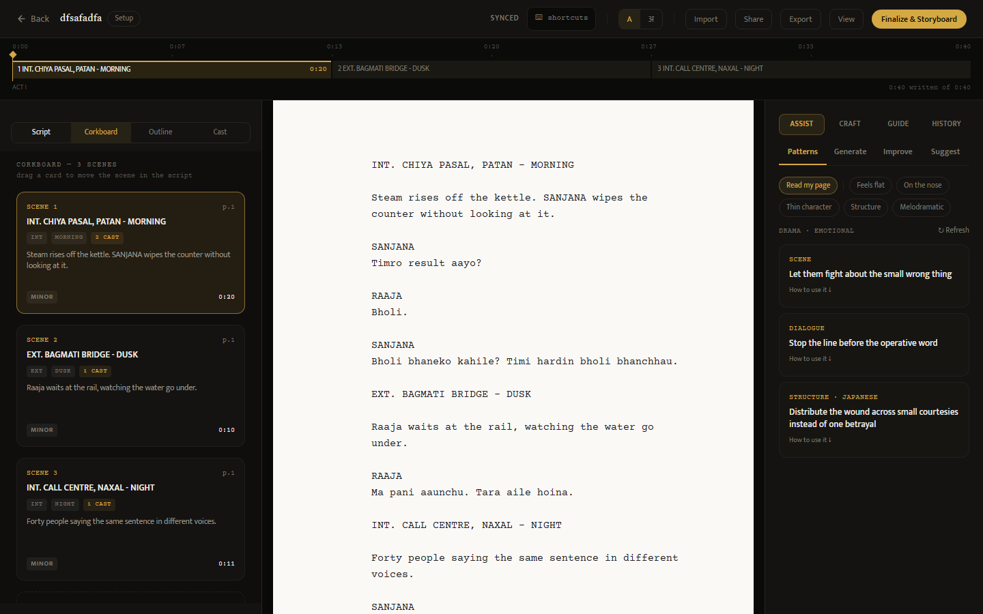
Figure 4. Restructuring beside the writing rather than instead of it. The corkboard used to replace the screenplay, so the reason to move a card — almost always something just read — had to be held in memory while going to move it.

2.3 Documentation and decisions
Three decisions the documents recorded but never settled were closed: live co-editing descoped to asynchronous collaboration, the encryption claim stated truthfully, and tier naming fixed at free / pro / studio. The deploy runbook was corrected — it described three migrations and there are now four. A project skill documented a data schema the code had abandoned, which would have produced entries that half-worked in a way nobody would notice.

3. Verification status
Everything above runs. The AI providers are reachable with live credentials and the OpenAI path has been exercised end to end at real cost; the Anthropic path returns a billing error pending account credit, so streaming and the paid generation routes remain verified against the mock path only.
The system has still never been deployed. It runs on local SQLite because no Supabase project exists yet, which also means the four schema migrations remain unapplied. No money has moved through any payment gateway. Those three — a real database, a live host, and a first real payment — are the work of Month 3, and every remaining estimate depends on them.
Every figure in this report was captured from the running system this month by baakhapaa-frontend/scripts/capture-screenshots.mjs, which signs in, writes a draft, and photographs each surface in turn. The Month 1 report's figures were taken by hand and were still being reused after the screens beneath them had changed; this removes that failure mode for Month 3.

