Next-Gen Functional Testing with Agentic Playwright MCP

Table of Contents
Benefits of using Playwright agentic MCP 1
Best Practices before Getting started 1
How to Get Started: The Step-by-Step Process 3
Well-Written vs. Vague User Stories: How Detail Shapes Test Case Generation 16

Benefits of using Playwright agentic MCP
1. Autonomous Test Generation & Execution
- Agentic systems can interpret user stories or requirements dynamically and generate Playwright test scripts without manual intervention.
- They adapt test flows based on real-time context (e.g., environment, data state), reducing hardcoding and improving flexibility.
2. Context-Aware Testing
- MCP enables structured context sharing between agents and tools, so tests can:
  - Pull latest configurations from CI/CD pipelines.
  - Adjust for feature flags or environment variables automatically.
- This ensures tests remain relevant and accurate even as application states change.
3. Multi-Agent Collaboration
- Different agents can handle specific layers:
  - One agent for UI validation.
  - Another for API checks.
  - A third for data integrity.
- MCP orchestrates these agents, making end-to-end functional testing modular and scalable.
4. Reduced Maintenance Overhead
- Traditional Playwright scripts break when UI changes.
- Agentic approach uses semantic reasoning (e.g., “find login button by intent, not selector”), reducing brittle selectors and lowering maintenance costs.
5. Intelligent Error Recovery
- Instead of failing on minor UI changes, agents can reason about alternatives:
  - “If button X is missing, check for Y.”
- This improves test resilience and reduces false negatives.

6. Integration with DevOps & Observability
- MCP allows bidirectional communication:
  - Tests can feed insights back to ADO or Jira.
  - Agents can query logs, metrics, and telemetry for root cause analysis during failures.
7. Future-Proof for AI-Augmented QA
- Agentic Playwright MCP aligns with AI-driven QA trends:
  - Self-healing tests.
  - Predictive test coverage.
  - Automated documentation and reporting.

Best Practices before Getting started
- Follow the Standard Format
As a [role], I want [goal], so that [reason].
Example:
As a registered user, I want to reset my password so that I can regain access to my account.
- Include Clear Acceptance Criteria
Use Given-When-Then or bullet points.
Example:
Given I am on the login page
When I click "Forgot Password"
Then I should see a password reset form
- Keep It Atomic
One story = one functionality. Avoid bundling multiple features.

How to Get Started: The Step-by-Step Process
Step 1: Install Node.js
- Download and install the latest LTS version of Node.js (version 16 or later).
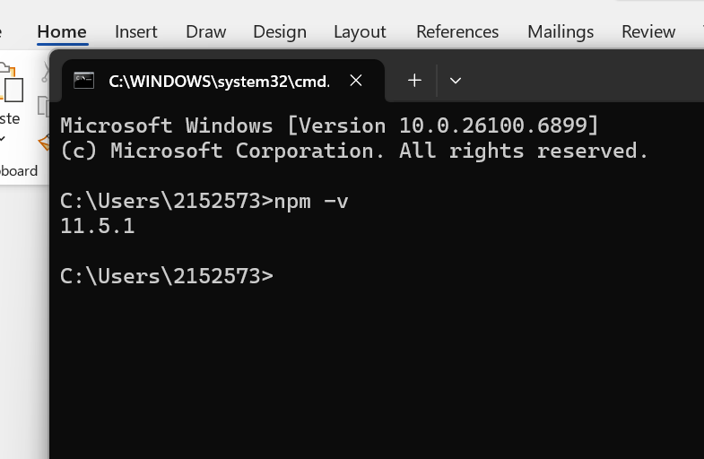
Step 2: Login to your GitHub account.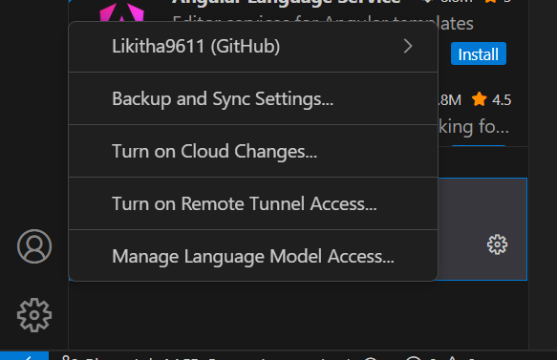
Step 3: Install Required Extensions
- Install Azure CLI Tools
- Install GitHub Copilot and GitHub Copilot Chat in your IDE (likely VS Code).
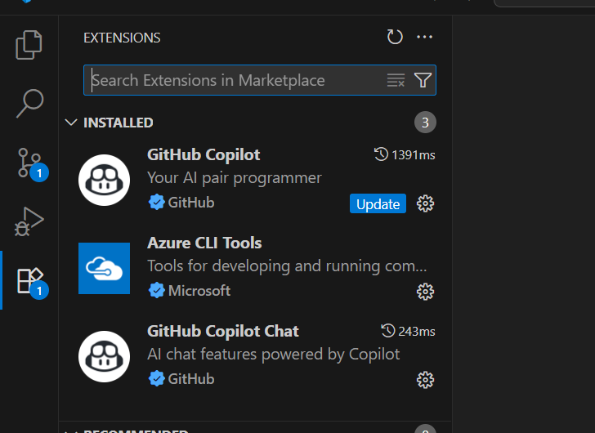
Step 4: MCP Server Installation
Install MCP server (details likely in the repo).
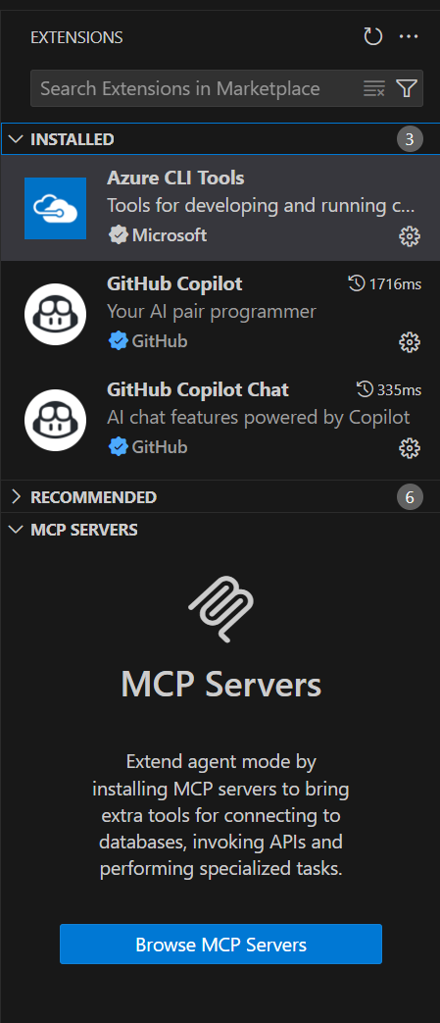
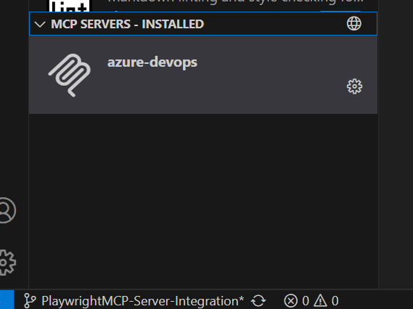
Step 5:Clone the repo: https://github.com/AAInternal/ecs-pwa.git-
Switch branch from main to playwright mcp server
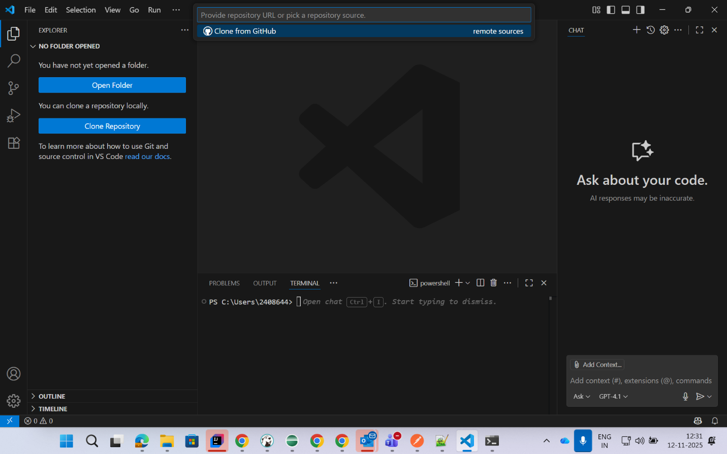
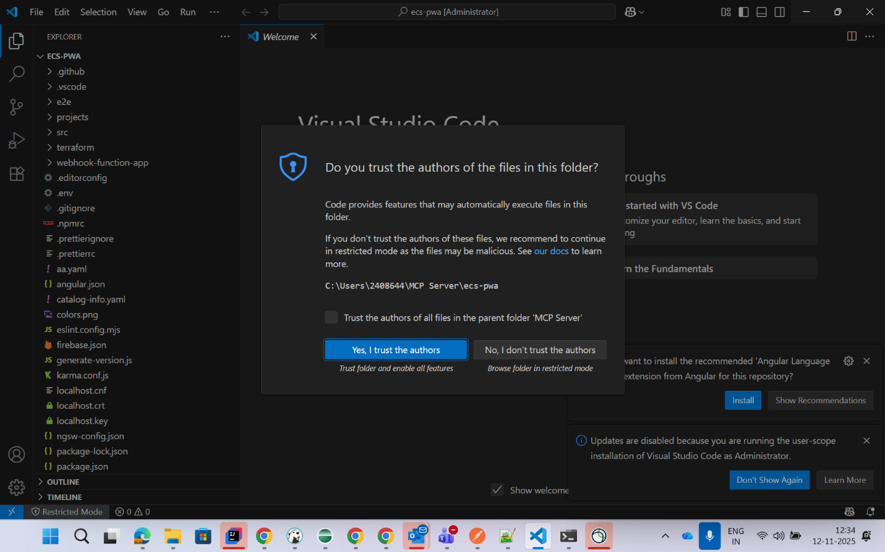
Change the branch from main to playwright MCP server branch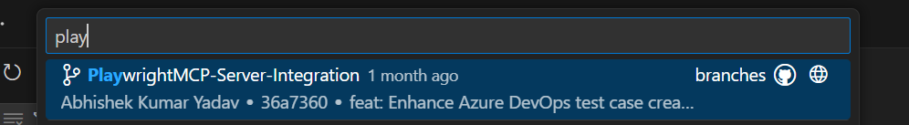
Step 6: Project Structure
- Verify the project structure includes:
  - Prompts folder (as shown in the image).
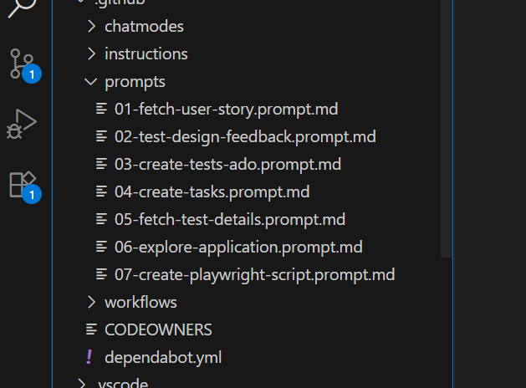
Step 7: Have different agent mode, select the ado- agent mode
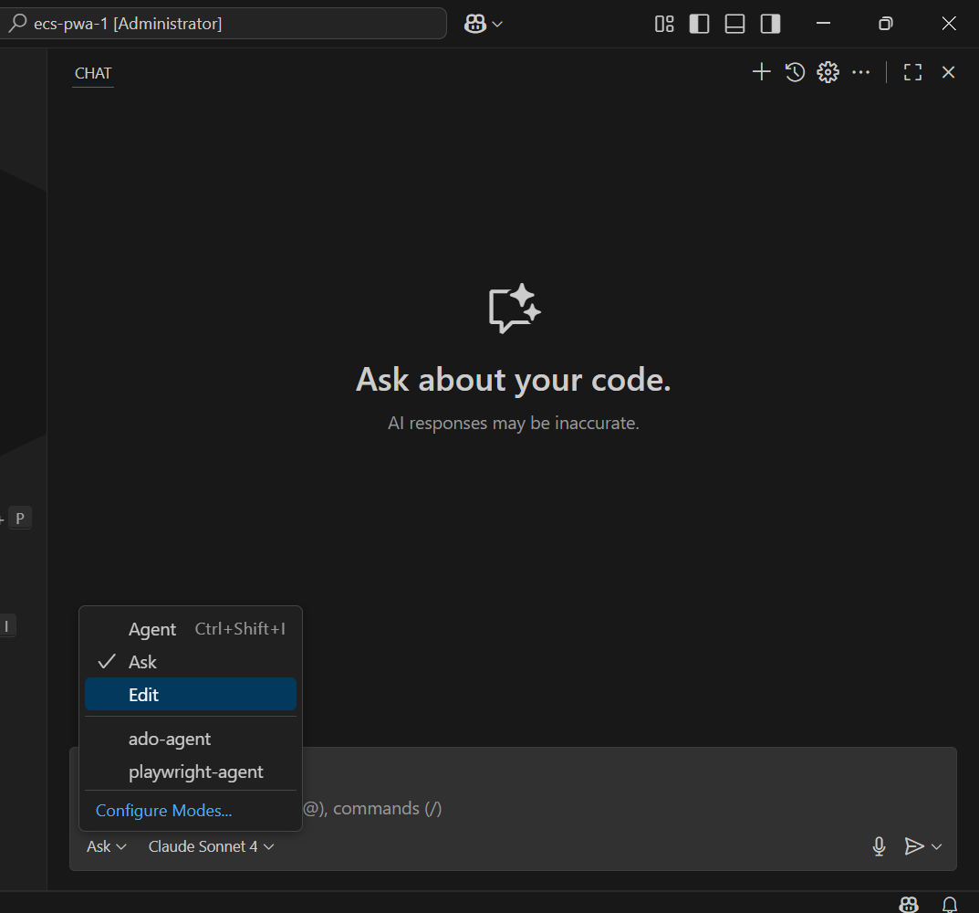
Step 8: Different Prompts and usages
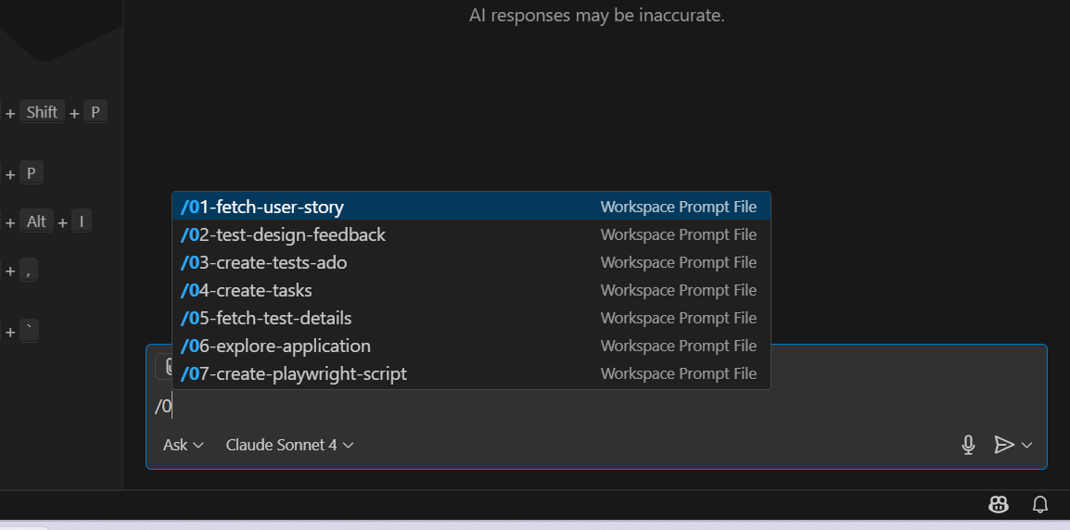
Fetch User Story - Prompt Usage:
- Retrieve specific user stories by ID
- Fetch user stories for a project/sprint
- Get user story details for display
- Load user stories for editing/updating
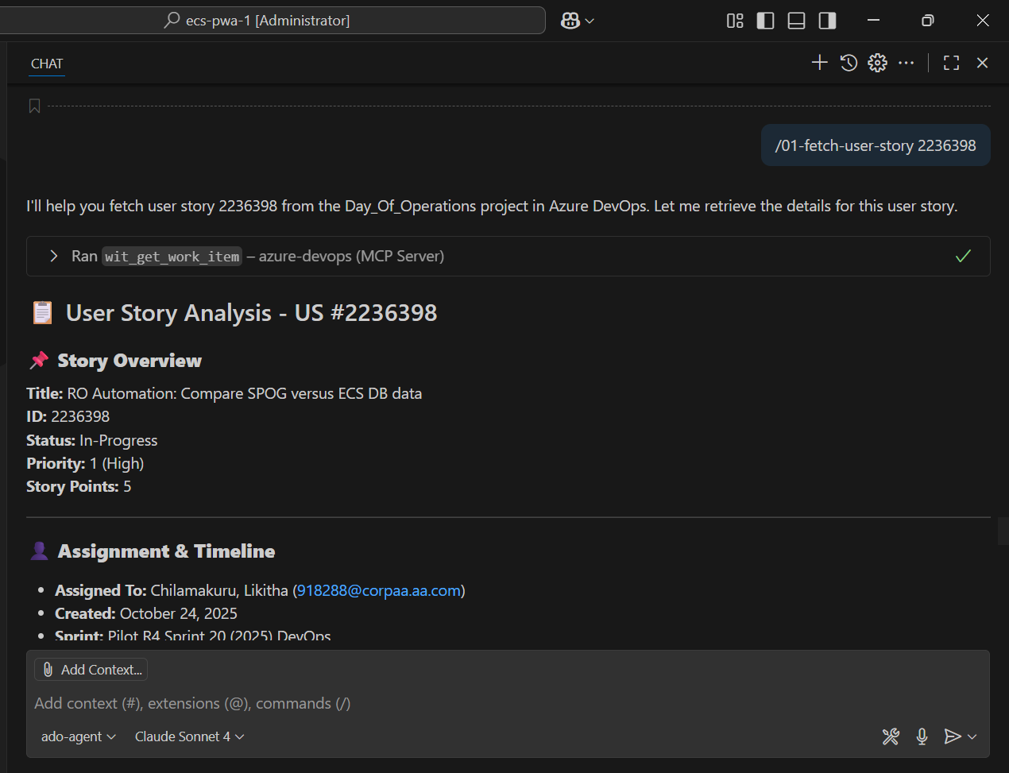

Test Design Feedback - Prompt Usage
- Review test case design quality
- Provide feedback on test coverage
- Suggest improvements to test strategies
- Validate test scenarios against requirements
- Assess test data and environment setup
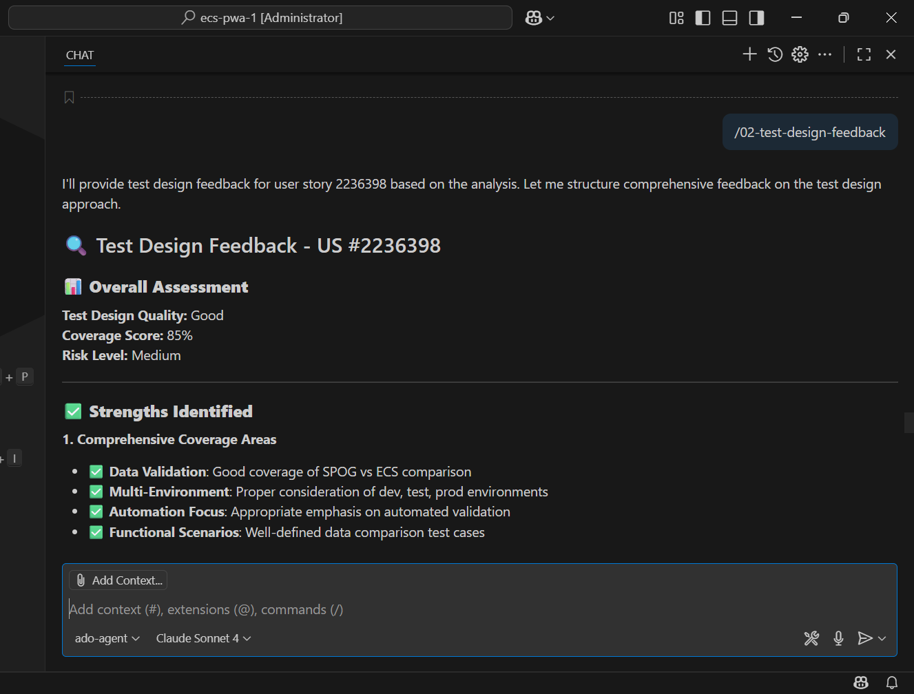

Create Tests-ADO - Prompt Usage
- Generate test cases in Azure DevOps Test Plans
- Create automated tests linked to ADO work items
- Build test suites for ADO pipelines
- Generate ADO-compliant test documentation
- Create test cases with ADO traceability
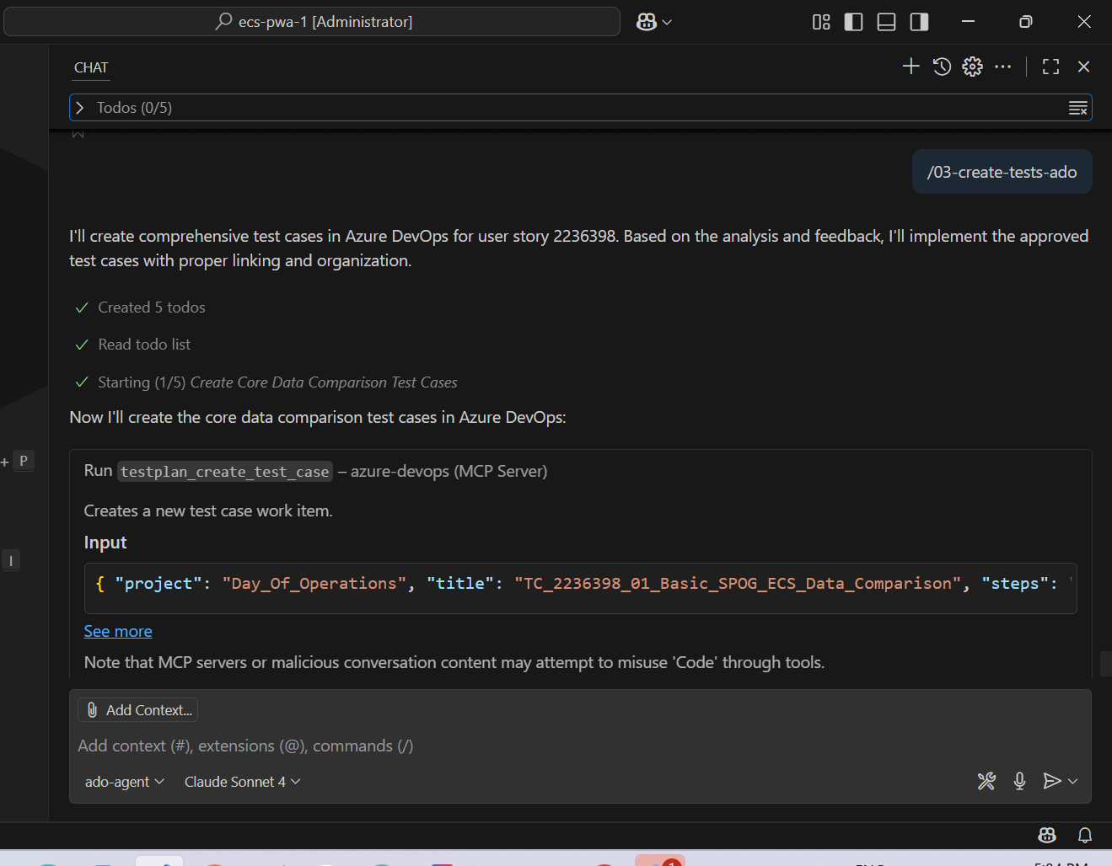

Well-Written vs. Vague User Stories: How Detail Shapes Test Case Generation

Detailed user stories are essential for generating accurate and relevant test cases. When stories lack clarity or specifics, the model tends to make assumptions, which can lead to unnecessary or incorrect test cases. These assumptions, however, can be addressed and refined by providing additional information and real-time feedback during the test case design process.

These are the sample stories used:

User Story 2342167: Sample Story (P): Update Name fields to display Letters only - story with less information in acceptance criteria

User Story 2109500: Sample Story: Update Name fields to display Letters only - story with detailed information in acceptance criteria

TC 1

With Partial information
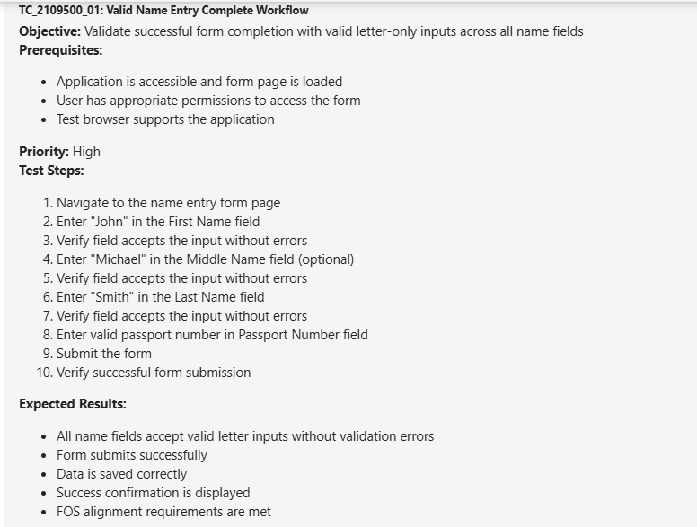

With complete information
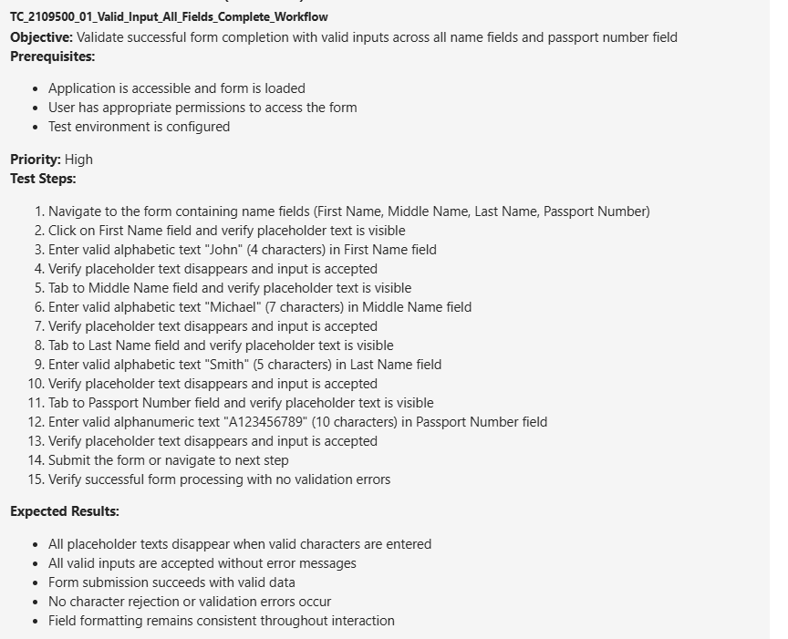

TC 4

With partial information
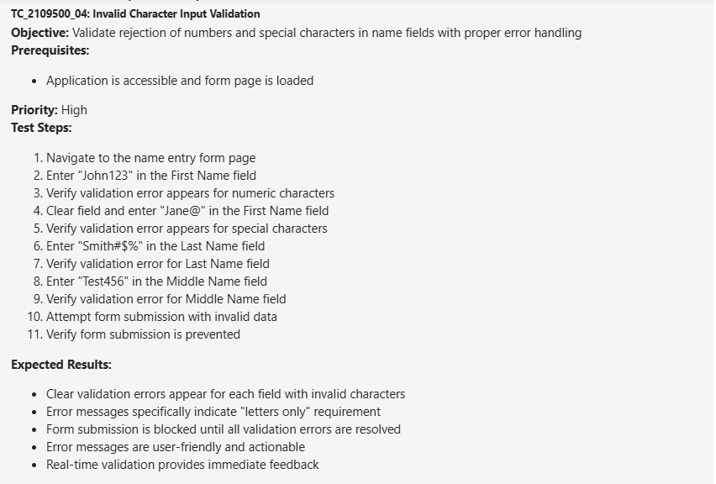

With complete information
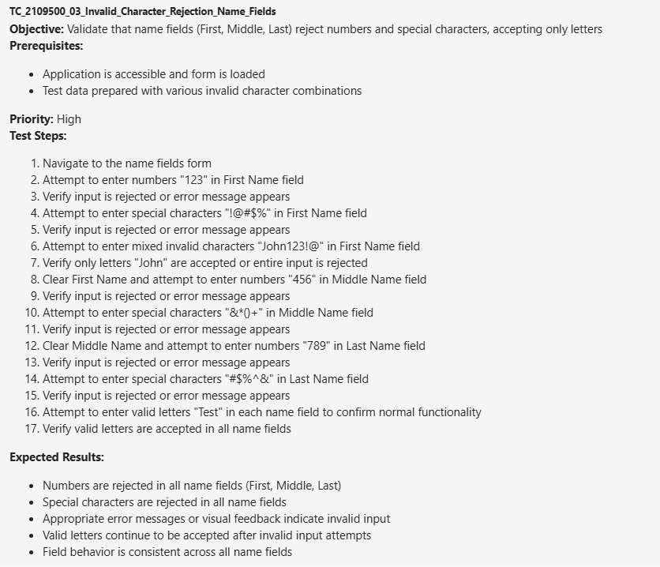

TC 5

With partial information
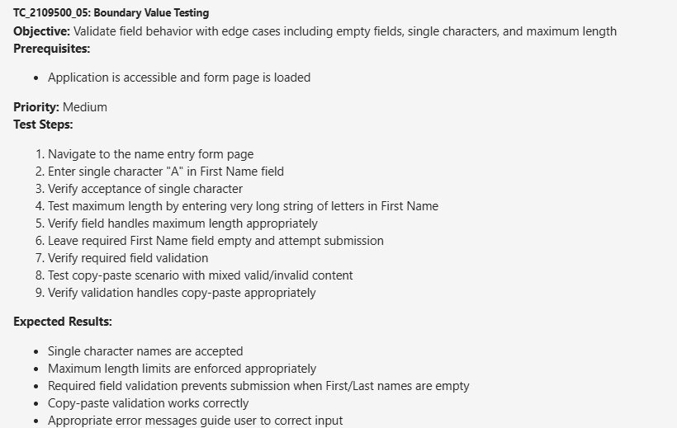

With complete information
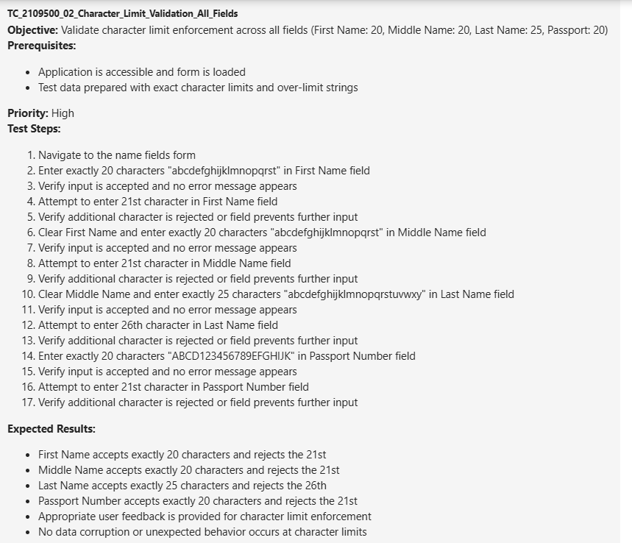

TC 7

With partial information
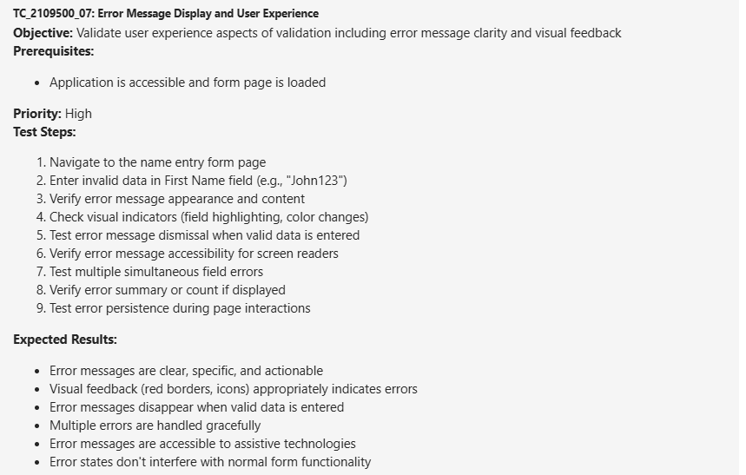

With complete information
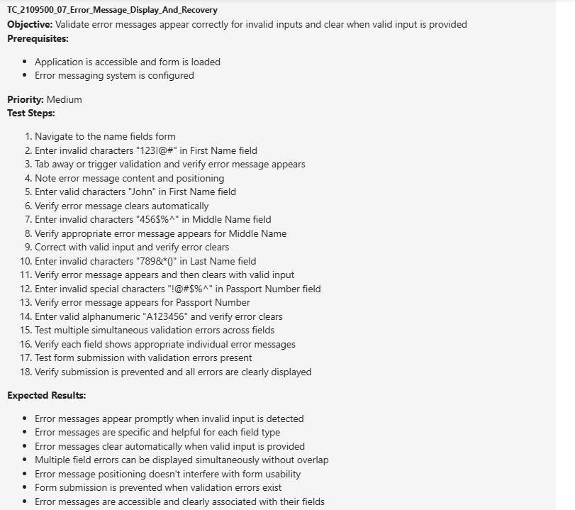

TC 8

With partial information
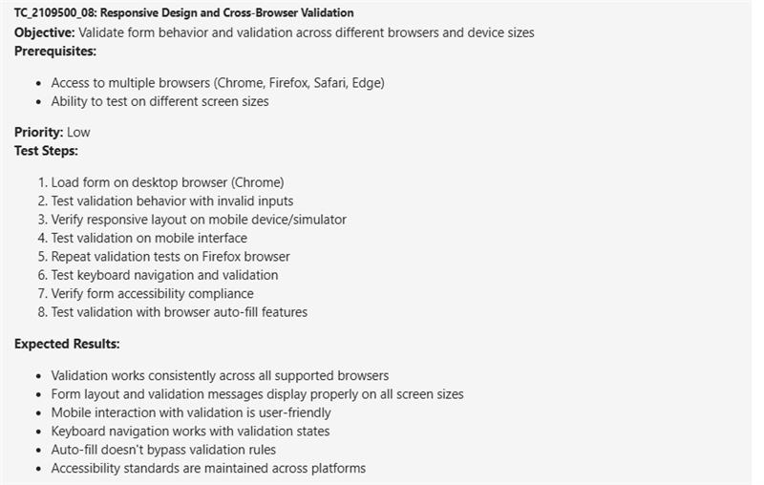

No test case was created for this as nothing was mentioned for Cross browser or responsive design.

Extra TC created with complete Acceptance Criteria:

Password number as alphanumeric validation
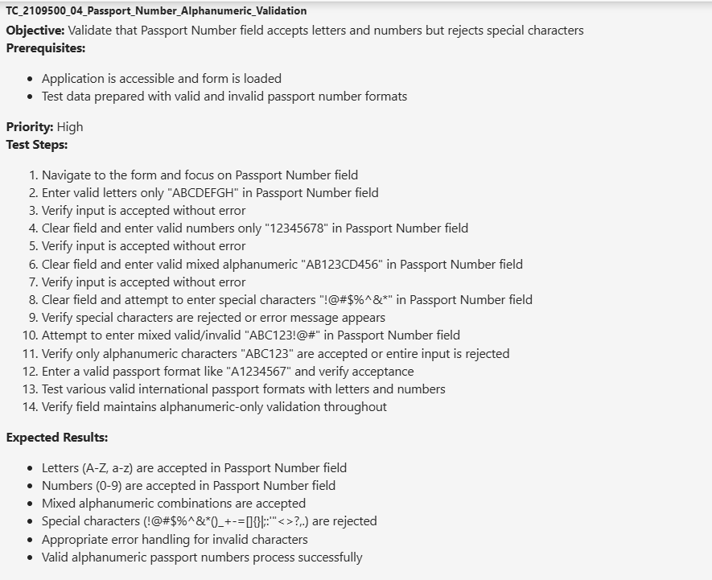

Complete E2E form submission
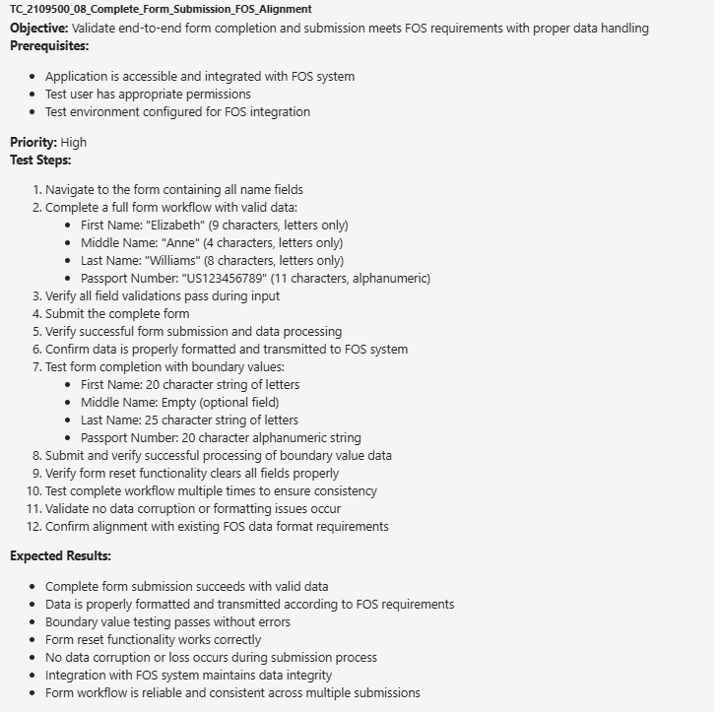

Placeholder Text Behavior All Fields
