Chapter 7 and 8 challenge :

<https://www.screencast.com/t/BBimCayOdUkw>

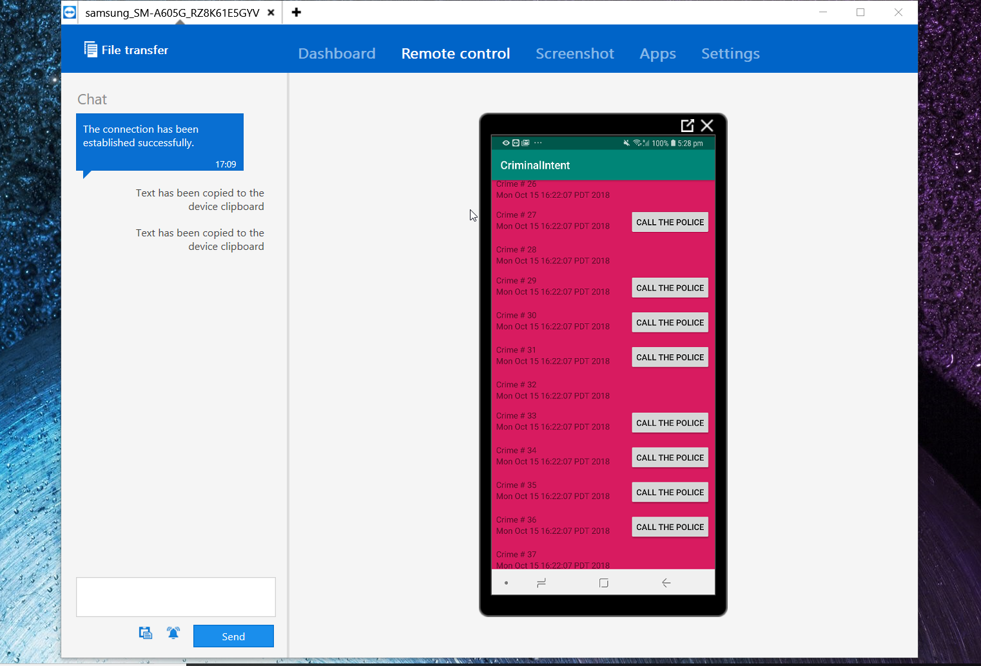

Solution for challenge 8:

Class : Crime

**package** com.bignerdbranch.android.criminalintent;  
  
**import** java.util.Date;  
**import** java.util.Random;  
**import** java.util.UUID;  
  
**public class** Crime {  
  
 **private** UUID **mId**;  
 **private** String **mTitle**;  
 **private** Date **mDate**;  
 **private boolean mSolved**;  
 **private boolean mRequiresPolice**; *// Challenge of Ch8* **public** Crime(){  
 **mId**=UUID.*randomUUID*(); *// provides an easy way to generate universally unique ID* **mDate**=**new** Date();*// intialiazes to default date for a crime  
 // Challenge of Ch8* Random num=**new** Random(); *// geenrates random number between 0 and 2, excluding 2.* **if**(num.nextInt(2)==0){  
 **mRequiresPolice**=**false**;  
 }**else**{  
 **mRequiresPolice**=**true**;  
 }  
 }  
  
 *// Challenge of Ch8* **public boolean** isPoliceRequired(){  
 **return mRequiresPolice**;  
 }  
 **public void** setPoliceRequired(**boolean** policeRequired){  
 **this**.**mRequiresPolice**=policeRequired;  
  
 }  
 **public** UUID getId() {  
 **return mId**;  
 }  
  
 **public** String getTitle() {  
 **return mTitle**;  
 }  
  
 **public void** setTitle(String title) {  
 **mTitle** = title;  
 }  
  
 **public** Date getDate() {  
 **return mDate**;  
 }  
  
 **public void** setDate(Date date) {  
 **mDate** = date;  
 }  
  
 **public boolean** isSolved() {  
 **return mSolved**;  
 }  
  
 **public void** setSolved(**boolean** solved) {  
 **mSolved** = solved;  
 }  
}

**Class : CrimeListFragment**

package com.bignerdbranch.android.criminalintent;

import android.os.Bundle;

import android.support.annotation.NonNull;

import android.support.v4.app.Fragment;

import android.support.v7.widget.LinearLayoutManager;

import android.support.v7.widget.RecyclerView;

import android.view.LayoutInflater;

import android.view.View;

import android.view.ViewGroup;

import android.widget.Button;

import android.widget.TextView;

import android.widget.Toast;

import java.util.List;

public class CrimeListFragment extends Fragment {

// this is the ViewHolder

private RecyclerView mCrimeRecyclerView;

private CrimeAdapter mAdapter;

// CrimeLab crimeLab;

@Override

public View onCreateView(LayoutInflater inflater,ViewGroup container, Bundle savedInstanceState) {

View view=inflater.inflate(R.layout.fragment_crime_list,container,false);

mCrimeRecyclerView=view.findViewById(R.id.crime_recycler_view);

mCrimeRecyclerView.setLayoutManager(new LinearLayoutManager(getActivity()));

updateUI();

return view;

}

private void updateUI() {

CrimeLab crimeLab=CrimeLab.get(getActivity());

List<Crime> crimes=crimeLab.getCrimes();

mAdapter=new CrimeAdapter(crimes);

mCrimeRecyclerView.setAdapter(mAdapter);

}

//CrimeHolder inner class for bindng data

private class CrimeHolder extends RecyclerView.ViewHolder implements View.OnClickListener{

private TextView mTitleTextView;

private TextView mDateTextView;

private Crime mCrime;

public CrimeHolder(View itemView){

super(itemView);

itemView.setOnClickListener(this);

mTitleTextView=itemView.findViewById(R.id.crime_title);

mDateTextView=itemView.findViewById(R.id.crime_date);

}

private void bind(Crime crime){

mCrime=crime;

mTitleTextView.setText(mCrime.getTitle());

mDateTextView.setText(mCrime.getDate().toString());

if(this.getItemViewType()==1){

Button b=itemView.findViewById(R.id.contact_police);

b.setOnClickListener(new View.OnClickListener() {

@Override

public void onClick(View v) {

Toast.makeText(getActivity(),R.string.calling_the_police,Toast.LENGTH_SHORT).show();

}

});

}

}

public CrimeHolder(LayoutInflater inflater, ViewGroup parent){

super(inflater.inflate(R.layout.list_item_crime_police,parent,false));

itemView.setOnClickListener(this);

mTitleTextView=itemView.findViewById(R.id.crime_title);

mDateTextView=itemView.findViewById(R.id.crime_date);

}

@Override

public void onClick(View v) {

Toast.makeText(getActivity(),mCrime.getTitle()+"Clicked ",Toast.LENGTH_SHORT).show();

}

}

private class CrimeAdapter extends RecyclerView.Adapter<CrimeHolder>{

private List<Crime> mCrimes;

public CrimeAdapter(List<Crime> crimes){

mCrimes=crimes;

}

//Challenge ch 8

@Override

public CrimeHolder onCreateViewHolder(ViewGroup parent, int viewType) {

int layout=0;

switch (viewType){

case 0:

layout=R.layout.list_item_crime;

break;

case 1:

layout=R.layout.list_item_crime_police;

break;

}

//LayoutInflater layoutInflater=LayoutInflater.from(getActivity());

//return new CrimeHolder(layoutInflater,parent);

View view=LayoutInflater.from(parent.getContext()).inflate(layout,parent,false);

return new CrimeHolder(view);

}

@Override

public void onBindViewHolder(@NonNull CrimeHolder holder, int position) {

Crime crime=mCrimes.get(position);

holder.bind(crime);

}

@Override

public int getItemCount() {

return mCrimes.size();

}

// implementing the getItemViewType(int) Challenge ch 8

@Override

public int getItemViewType(int position) {

boolean isPoliceNeeded=mCrimes.get(position).isPoliceRequired();

if(isPoliceNeeded){

return 1;

}else{

return 0;

}

//return super.getItemViewType(position);

}

}

}

Layout-> list_item_crime.xml

*<?***xml version="1.0" encoding="utf-8"***?>*<**LinearLayout  
 xmlns:android="http://schemas.android.com/apk/res/android"  
 android:layout_width="match_parent"  
 android:layout_height="wrap_content"  
 android:orientation="vertical"  
 android:padding="8dp"**>  
  
 <**TextView  
 android:id="@+id/crime_title"  
 android:layout_width="match_parent"  
 android:layout_height="wrap_content"  
 android:text="Crime Title"** />  
  
 <**TextView  
 android:id="@+id/crime_date"  
 android:layout_width="match_parent"  
 android:layout_height="wrap_content"  
 android:text="Crime Date"** />  
   
</**LinearLayout**>

**Layout-> list_item_crime_police.xml**

*<?***xml version="1.0" encoding="utf-8"***?>*<**LinearLayout  
 xmlns:android="http://schemas.android.com/apk/res/android"  
 android:layout_width="match_parent"  
 android:layout_height="wrap_content"  
 android:orientation="horizontal"  
 android:padding="8dp"**>  
 <**LinearLayout  
 android:layout_weight="1"  
 android:layout_width="0dp"  
 android:layout_height="wrap_content"  
 android:orientation="vertical"**>  
 <**TextView  
 android:id="@+id/crime_title"  
 android:layout_width="match_parent"  
 android:layout_height="wrap_content"  
 android:text="Crime Title"** />  
  
 <**TextView  
 android:id="@+id/crime_date"  
 android:layout_width="match_parent"  
 android:layout_height="wrap_content"  
 android:text="Crime Date"** />  
 </**LinearLayout**>  
  
 <**Button  
 android:id="@+id/contact_police"  
 android:layout_width="wrap_content"  
 android:layout_height="wrap_content"  
 android:layout_gravity="right"  
 android:text="@string/call_police"** />  
</**LinearLayout**>

Select fields from

Table1 join table 2 on field1=field2 join

Table3 on field(1 or 2)=field3;