exp : spatial fillter

import numpy as np

import cv2

import matplotlib.pyplot as plt

from scipy import ndimage

f_img = cv2.imread("/content/cameraman.tif")

cv2_imshow(f_img)

**output:**

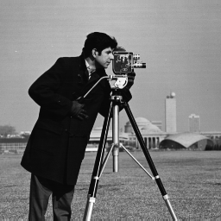

#Convert RGB image to Gray image

gray_img = cv2.cvtColor(f_img, cv2.COLOR_BGR2GRAY)

cv2_imshow(gray_img) #show gray image

**output:**



data_1 = np.array(gray_img, dtype=float)

kernel_1 = np.array([[-1, -1, -1], [-1, 8, -1], [-1, -1, -1]])

highpass_filter = ndimage.convolve(data_1, kernel_1)

cv2_imshow(highpass_filter)

**output:**

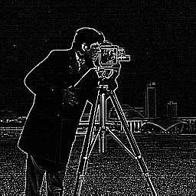

data_2 = np.array(gray_img, dtype=float)

kernel_2 = np.array([[1/9,1/9,1/9], [1/9, 1/9, 1/9], [1/9, 1/9,1/9]])

lowpass_filter = ndimage.convolve(data_2, kernel_2)

cv2_imshow(lowpass_filter)

output:

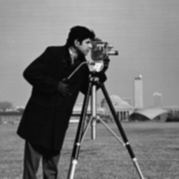

import numpy as np

import cv2

import matplotlib.pyplot as plt

from scipy import ndimage

from scipy.ndimage import gaussian_filter

f_img = cv2.imread("/content/cameraman.tif")

cv2_imshow(f_img)

g = cv2.GaussianBlur(f_img,(3,3),0)

cv2_imshow(g)



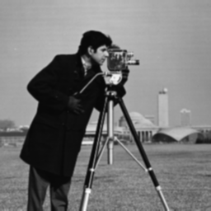

img = cv2.imread('/content/cameraman_salt_and_pepper_noise.tif', cv2.IMREAD_GRAYSCALE)

img_out = img.copy()

height = img.shape[0]

width = img.shape[1]

cv2_imshow(img)

# kernal

for i in np.arange(2, height-3):

for j in np.arange(2, width-3):

neighbors_med = []

neighbors_med.clear()

for k in np.arange(-2, 3):

for l in np.arange(-2, 3):

a = img.item(i+k, j+l)

neighbors_med.append(a)

neighbors_med.sort()

median = neighbors_med[4]

b = median

img_out.itemset((i,j), b)

cv2_imshow(img_out)

output:

