How Fast Do Agents Rot? An Empirical Study of
Long-Horizon Degradation in LLM Agents
Abstract
Agent benchmarks report steadily rising success rates, yet deployed LLM agents remain unreliable on long, multi-step tasks. We argue this tension is largely an artifact of horizon: benchmarks score agents at task lengths where success is still high, while production demands far longer horizons. We measure the effect directly. Across 5,625 controlled agent trajectories spanning five open models (1.2B–671B parameters, three vendor families), three task families, five task horizons ($H​∈​\{2,4,8,16,32\}$ dependent steps), and three context regimes, we characterize the shape of degradation and disentangle its cause. We find that task success follows a geometric law, $P(\text{success})≈a r^{H}$, where $r$ is a model- and task-specific per-step reliability: the best-fitting shape is geometric in $10/15$ model$×$task cells. Per-step reliability rises with model scale (Pearson $r=0.38$ vs. $log$ parameters) but never reaches $1$ on non-trivial tasks, so geometric compounding guarantees collapse at long horizons even for the strongest model. Degradation moreover accelerates: per-step accuracy falls from $0.49$ early in a trajectory to $0.35$ late, a super-geometric tail. Disentangling step-count from context-length, we find the rot is intrinsic to executing many dependent steps, not raw context length: bounding the context window (compressed regime) and collapsing the task to a single long prompt (padded regime) both steepen decay relative to the natural agent loop ($p<0.05$), ruling out “lost-in-the-middle” as the driver and showing that naive context truncation backfires. Projecting measured per-step reliability onto the horizons of popular benchmarks shows the gap concretely: mean projected success falls from $0.31$ at GAIA-length tasks to $0.18$ at SWE-bench-length to $0.10$ at $100$-step production horizons. We release all code, prompts, seeds, and raw trajectories.

Introduction
Large language model (LLM) agents—models that perceive context, plan, call tools, and update state in a loop—now score highly on a fast-growing suite of benchmarks (Jimenez et al. 2024; Yao et al. 2024; Zhou et al. 2023; Mialon et al. 2023). The trajectory of reported numbers is encouraging, and the time horizon of tasks models can complete has been doubling rapidly (Kwa et al. 2025). Yet practitioners who deploy agents report a stubborn gap: agents that pass benchmark tasks remain unreliable on the long, open-ended workflows that production demands.
We take a specific position on why. A benchmark task has a horizon: the number of dependent steps an agent must execute correctly. If each step succeeds independently with probability $r<1$, then a task of horizon $H$ succeeds with probability $≈r^{H}$—a quantity that is close to $r$ for short tasks but collapses geometrically as $H$ grows. Benchmarks predominantly sample short-to-medium horizons; production agents operate at horizons an order of magnitude longer. If degradation is geometric, then benchmarks systematically sample the flat top of the decay curve, and the production gap is not noise but an expected consequence of horizon.
This paper tests that hypothesis empirically. Rather than a single number, we characterize the law—the functional form of success versus horizon—and disentangle its cause, separating the number of sequential steps from the length of accumulated context. We make four contributions:
- A measured law of horizon decay. On controlled, oracle-verifiable agent tasks, success follows a geometric law $P≈a r^{H}$ (best fit in $10/15$ model$×$task cells; §4.1). The single quantity $r$ (per-step reliability) governs everything.
- Degradation accelerates. Per-step accuracy itself declines as a trajectory lengthens ($0.49​→​0.35$ from the first to the last third), producing a super-geometric tail (§4.3).
- Cause: step count, not context length. Using three context regimes that break the natural collinearity of steps and tokens, we show that bounding context and collapsing to a single prompt both worsen decay relative to the natural agent loop. The rot is intrinsic to executing many dependent steps; lost-in-the- middle is not the driver, and naive context truncation backfires (§4.4).
- The benchmark gap, quantified. Projecting measured $r$ onto the horizons of popular agent benchmarks makes the gap concrete: success that looks moderate at benchmark horizons collapses at production horizons (§4.6).
Our study is deliberately reproducible: synthetic tasks with exact oracles (no LLM-judge noise), five public models, recorded seeds, and a released dataset. This paper is the empirical companion to a survey of agent failure modes; where that work argues benchmarks miss long-horizon failure, this work measures it.

Related Work
Agent benchmarks. A large family of benchmarks evaluates agents on software issues (Jimenez et al. 2024), tool-and-user interaction (Yao et al. 2024; Barres et al. 2025), web navigation (Zhou et al. 2023; Deng et al. 2023), general assistance (Mialon et al. 2023), operating-system and app control (Xie et al. 2024; Trivedi et al. 2024), function calling (Patil et al. 2025), multi-environment agent suites (X. Liu et al. 2024), and end-to-end company workflows (Xu et al. 2024). These report aggregate single-attempt success and span short to very long horizons, but rarely report a horizon-resolved decay curve or a reliability metric. Kwa et al. (2025) track the time horizon of completable tasks over model generations; we instead fix the models and resolve success against horizon within a controlled environment.
Evaluation validity and reliability. Kapoor et al. (2024) document cost-blindness and evaluation shortcomings in agent benchmarking, and Zhu et al. (2025) establish best practices for rigorous agentic benchmarks. Both motivate reliability-oriented, horizon-aware measurement. Cemri et al. (2025) build a taxonomy of multi-agent failures. Our compounding result gives a quantitative basis for one of their core observations: local errors cascade.
Long context and compounding. A complementary line studies how models use long contexts: degradation with input position (N. F. Liu et al. 2024), with input length at fixed task (Levy et al. 2024), and on synthetic long-context probes (Hsieh et al. 2024; Modarressi et al. 2025). Dziri et al. (2023) show that transformer accuracy decays rapidly with compositional task complexity, and Laban et al. (2025) show large drops from single- to multi-turn settings. These predict that context length should drive agent degradation. Our disentangling experiment tests this directly and finds the opposite for our tasks: bounding context worsens performance, implicating step count rather than context length.
Agent methods. ReAct-style reasoning-and-acting (Yao et al. 2023) and verbal self-reflection (Shinn et al. 2023) are the dominant agent loops; our harness uses a ReAct-style structured loop. We study the unmodified loop to measure intrinsic degradation rather than the effect of a particular mitigation.

Method

Task families
We use three synthetic task families, each a tool-using agent loop with a ground-truth simulator that verifies success exactly (no LLM judge). All three have a single horizon knob $H$ = the number of dependent operations, and $O(1)$–$O(k)$ per-step state so that step count and context length can be varied independently (§3.2). Each family stresses a distinct capability:
- ledger (arithmetic working memory): maintain three account balances through $H$ deposit/withdraw/transfer operations; report a queried balance.
- refchain (long-range retrieval): track the current value of one announced variable through $H$ assignments interleaved with distractor variables and re-assignments; report its final value.
- cipher (procedural execution): apply $H$ ordered string edits (swap/rotate/replace) to a 5-character string; report the final string.
At each step the agent receives one instruction and must emit a single JSON object carrying its updated running state; no correctness feedback is given, so per-step errors compound and are measured. After $H$ steps the environment poses the final query. The simulator scores each submitted state and the final answer against the oracle, yielding per-trajectory success, per-step accuracy, and the first-error step.

Context regimes: disentangling step count from context length
At a fixed horizon the number of operations is held equal across three regimes, which vary only the two axes of interest:
regime | agent turns | context length
natural | $H$​ | long (full history)
compressed | $H$​ | short (carried state, windowed history)
padded | 1 | long (all $H$ operations in one prompt)
Comparing natural vs. compressed (same turns, different context length) isolates the context-length effect; natural vs. padded (same information, different number of turns) isolates the multi-step-process effect. The same underlying task instance is reused across regimes, making the comparison paired.

Models, design, and metrics
We evaluate five open instruction-tuned models served via OpenRouter, spanning $1.2$B–$671$B parameters and three vendor families: Llama-3.2-1B, Qwen2.5-7B, Llama-3.1-8B, Llama-3.3-70B, and DeepSeek-V3. The full design is $5\text{ models}×3\text{ families}×5\text{ horizons}×3\text{ regimes}×25\text{ trials}=5,625$ trajectories. Generation temperature is fixed at $0.2$; seeds are recorded per trajectory. We report per-cell success with Wilson 95% intervals, fit decay curves and select among geometric/threshold/linear shapes by AIC, estimate per-step reliability $r$ directly as the fraction of individual steps correct, and fit a logistic model $logit P=β_{0}+β_{H}\log_{2}​H⋅C(\text{regime})$ for the disentangling analysis. We pre-registered the hypotheses, design, and analysis plan before the full run; deviations are logged in the released repository.

Results

Degradation follows a geometric law
Figure 1 shows success versus horizon for every model and family. Success declines monotonically with horizon wherever the task is non-trivial for the model. Fitting geometric ($P=a r^{H}$), threshold (logistic-in-$H$), and linear forms and selecting by AIC, the geometric form wins in $10$ of $15$ model$×$family cells; the remaining $5$ are threshold-shaped—visible in Figure 1 as the “cliff” where strong models hold near-perfect accuracy on ledger until $H=32$. The geometric law is therefore the dominant description, and per-step reliability $r$ is the quantity that governs it.
Crucially, the magnitude of decay is governed by $r$, which varies with both model and task difficulty (Table 2). On refchain (variable tracking) the strong models have $r​≈​1$ and show essentially no decay—a ceiling; on cipher (procedural string edits) even DeepSeek-V3 has $r=0.25$ and collapses within a few steps. The same models thus appear robust or fragile depending entirely on per-step reliability, exactly as $P≈r^{H}$ predicts. This is the central point: whether degradation is visible depends on $r$ and the horizon sampled, but $r<1$ on any non-trivial task makes collapse at long horizon inevitable.
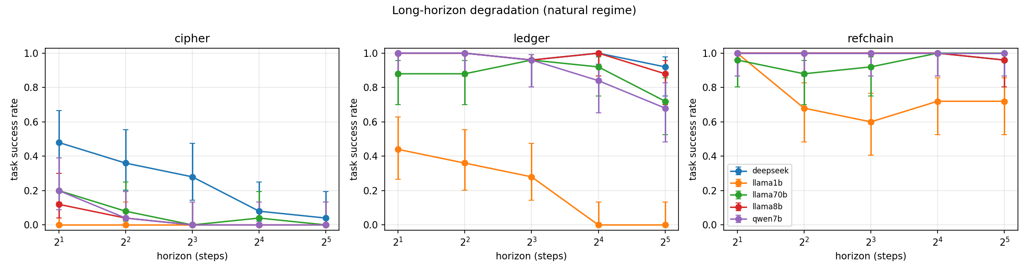
Task success vs. horizon (natural regime), per task family, per model (Wilson 95% intervals; horizon on a $\log_{2}$ axis). Decay is steep where per-step reliability is low (cipher), a long-horizon cliff at medium difficulty (ledger), and a ceiling where reliability is near-perfect (refchain, strong models). All are consistent with $P≈r^{H}$.
Success decays monotonically with horizon for every model. Larger models start higher and decay more gently, but all decay.
 | success rate at horizon $H$ (natural, families pooled)
model ($∼$params) | $H=2$​ | $4$​ | $8$​ | $16$​ | $32$​
Llama-3.2-1B (1.2B) | 0.48 | 0.35 | 0.29 | 0.24 | 0.24
Qwen2.5-7B (7.6B) | 0.73 | 0.68 | 0.65 | 0.61 | 0.56
Llama-3.1-8B (8B) | 0.71 | 0.68 | 0.65 | 0.67 | 0.61
Llama-3.3-70B (70B) | 0.68 | 0.61 | 0.63 | 0.65 | 0.57
DeepSeek-V3 (671B) | 0.83 | 0.79 | 0.75 | 0.69 | 0.64

Per-step reliability spans the full range by task and model. cipher is hard per-step, refchain easy, ledger intermediate—yet the geometric law holds across all. Per-step reliability rises with model scale (Pearson $0.38$ vs. $log$ params).
 | per-step reliability $r$ (natural)
model | cipher | ledger | refchain
Llama-3.2-1B | 0.00 | 0.10 | 0.38
Qwen2.5-7B | 0.06 | 0.74 | 0.99
Llama-3.1-8B | 0.02 | 0.91 | 1.00
Llama-3.3-70B | 0.09 | 0.79 | 0.94
DeepSeek-V3 | 0.25 | 0.94 | 0.98

Per-step reliability rises with scale—but never to 1
Across the $1.2$B–$671$B ladder, per-step reliability rises with model size: the Pearson correlation between $r$ and $\log_{10}$ parameters is $+0.38$, and the within-family Llama trend climbs from $0.16$ (1B) to $0.64$ (8B) before saturating at $0.61$ (70B). DeepSeek-V3 is most reliable at $0.72$. Scale thus buys per-step reliability with diminishing returns, but no model reaches $r=1$ on the non-trivial families. Because success compounds as $r^{H}$, even the best model is guaranteed to fall below any fixed reliability target at a sufficiently long horizon; scale moves the cliff, it does not remove it.

Degradation accelerates within a trajectory
A pure geometric law assumes a constant per-step hazard. We find the hazard instead rises as a trajectory lengthens: pooling long-horizon trajectories, mean per-step accuracy falls from $0.49$ in the first third of a trajectory to $0.35$ in the last third (Figure 2). The first error lands, on average, about a third of the way through; once an agent errs it rarely recovers, consistent with prior reports that models “get lost” after a wrong turn (Laban et al. 2025). Acceleration makes the true decay super-geometric—worse than the constant- hazard model—so geometric fits, if anything, understate long-horizon collapse.
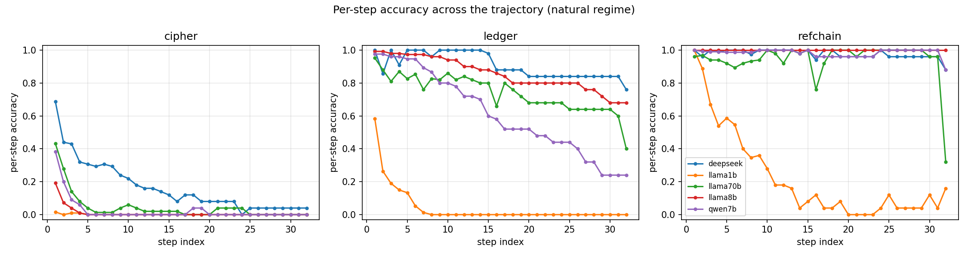
Per-step accuracy vs. step index within a trajectory (natural regime). Accuracy declines as the trajectory progresses: the per-step hazard rises, giving a super-geometric tail rather than constant-hazard geometric decay.

The driver is step count, not context length
Figure 3 contrasts the three context regimes. The natural agent loop—full history, one step per turn—is the best regime at every horizon (pooled success $0.69​→​0.53$ from $H=2$ to $32$). Both interventions are worse: compressed (bounded context, $0.54​→​0.21$) and padded (single long prompt, $0.46​→​0.22$). Fitting $logit P=β_{0}+β_{H}\log_{2}​H⋅C(\text{regime})$, the decay slope per horizon doubling is $−0.37$ (natural), $−0.62$ (compressed, $p=0.0007$ vs. natural), and $−0.53$ (padded, $p=0.023$). Both manipulations steepen decay; neither flattens it.
This is decisive for the cause. If raw context length drove degradation (lost-in-the-middle), bounding the context window would help; instead it hurts—models rely on their accumulated reasoning history, and truncating it removes a scaffold they depend on. If the multi-step process were the problem, collapsing the task into a single prompt would help; instead it also hurts—one-shot execution of $H$ operations forgoes the per-step externalization that the agent loop provides. What remains is that degradation is intrinsic to executing many dependent steps: the number of operations, not how they are packaged, is what compounds. A direct practical corollary: naive context truncation, a common production tactic, backfires on these models.
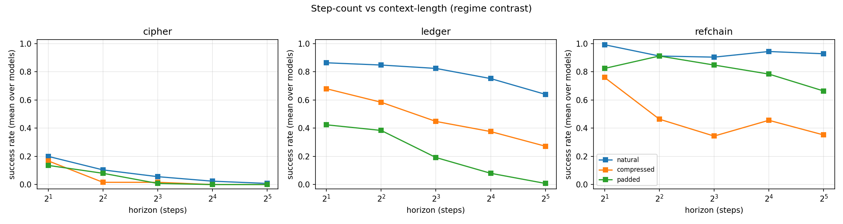
Step-count vs. context-length. At fixed horizon the number of operations is held equal across regimes. The natural loop (full context, step-by-step) is best; bounding context (compressed) and collapsing to one prompt (padded) both steepen decay. Degradation is intrinsic to step count, not context length.

Mechanism
Beyond success, the harness records how trajectories fail. Format and tool-call drift —a turn whose output cannot be parsed as a valid action—rises with horizon and reaches $21\%$ of trajectories overall, an instance of the interface-level failures agents are known to exhibit. The first-error position concentrates around the first third of the trajectory, and per-step accuracy never recovers afterward (§4.3): errors are absorbing. Together these give a mechanistic picture of “rot”: a per-step error rate that is non-zero, rises over time, propagates silently—no oracle interrupts a plausible-but-wrong intermediate state, much as hallucinated content survives without a verifier (Huang et al. 2025)—and compounds into trajectory-level failure.

The benchmark gap, quantified
The practical payoff is to place real benchmarks on the decay curve. Using the mean fitted per-step reliability ($r=0.55$) and the geometric law, we project task success at the representative horizons of popular benchmarks (Table 3). Projected success falls from $0.31$ at GAIA-length tasks ($∼8$ steps) to $0.18$ at SWE-bench-length ($∼30$ steps) to $0.10$ at a $100$-step production horizon. The absolute numbers depend on our task mix, but the shape is the point: an agent that looks moderately reliable at benchmark horizons is far less reliable at the horizons production actually requires. Benchmarks sample the flat top of a curve that collapses out of frame.
Projecting measured per-step reliability ($r=0.55$) onto representative benchmark horizons. Horizons are order-of-magnitude task lengths from the cited benchmark papers; they place each benchmark on the curve rather than asserting its exact score.
benchmark (representative horizon, steps) | projected success
GAIA ($∼$8) | 0.31
WebArena ($∼$15) | 0.24
$τ$-bench ($∼$20) | 0.21
SWE-bench / OSWorld ($∼$30) | 0.18
TheAgentCompany ($∼$100) | 0.10

Discussion and recommendations
Our results recast the agent-reliability gap as a predictable consequence of horizon. Three takeaways follow. For practitioners: estimate per-step reliability $r$ on your own tasks and treat the achievable horizon as $log(\text{target})/logr$; because the hazard accelerates, budget below the geometric estimate. Do not reach for naive context truncation as a reliability fix—in our data it worsens decay; the model relies on its history. For benchmark designers: report success resolved against horizon, not a single aggregate, and include horizons beyond the comfortable regime; a horizon-decay curve is far more predictive of production behavior than a point estimate. For the field: per-step reliability is the right primitive for agent evaluation. It is cheap to measure, composes multiplicatively into task success, and—unlike aggregate pass rates— extrapolates across horizons.

Limitations and threats to validity
Our tasks are synthetic and chosen for exact verifiability and a clean horizon knob; they trade ecological validity for control. We mitigate this by spanning three difficulty regimes and by framing the benchmark projection (§4.6) as a placement on the curve rather than a literal score for any benchmark. We study five open models up to $671$B parameters; the largest proprietary models may have higher $r$, but our scaling analysis indicates this moves the cliff rather than removing it, and $r<1$ on hard tasks suffices for the argument. Per-step reliability for the cipher family is low enough that some cells are near the floor; we report per-step accuracy and Wilson intervals throughout so floor/ceiling effects are visible. Hosted inference carries residual non-determinism despite fixed temperature and seeds; we record seeds and release raw outputs. Three small models (Llama-3.2-3B, Gemma-3-4B, Phi-4-mini) were excluded because their hosted routes did not adhere to the structured protocol (empty tool-call or conversational responses); this is itself a mild instance of interface-level fragility but limits the density of the small-model ladder.

Conclusion
Agents rot geometrically. Task success follows $P≈r^{H}$ in a per-step reliability $r$ that rises with scale but never reaches $1$ on non-trivial tasks, so long horizons guarantee collapse; the decay moreover accelerates within a trajectory. The driver is the number of dependent steps, not context length—bounding context makes things worse, not better. Because benchmarks sample short horizons, they report the flat top of this curve and hide the collapse that defines production behavior. Measuring and reporting per-step reliability against horizon would close much of the gap between what we benchmark and what we deploy.

Reproducibility.
All code, task generators, prompts, seeds, raw trajectories, and analysis scripts are released. Every quantitative claim in this paper traces to the released dataset.
Barres, Victor et al. 2025. “$τ^{2}$-Bench: Evaluating Conversational Agents in a Dual-Control Environment.” arXiv Preprint arXiv:2506.07982.
Cemri, Mert, Melissa Z. Pan, Shuyi Yang, et al. 2025. “Why Do Multi-Agent LLM Systems Fail?” Advances in Neural Information Processing Systems (NeurIPS) Datasets and Benchmarks.
Deng, Xiang, Yu Gu, Boyuan Zheng, et al. 2023. “Mind2Web: Towards a Generalist Agent for the Web.” Advances in Neural Information Processing Systems (NeurIPS).
Dziri, Nouha, Ximing Lu, Melanie Sclar, et al. 2023. “Faith and Fate: Limits of Transformers on Compositionality.” Advances in Neural Information Processing Systems (NeurIPS).
Hsieh, Cheng-Ping, Simeng Sun, Samuel Kriman, et al. 2024. “RULER: What’s the Real Context Size of Your Long-Context Language Models?” Conference on Language Modeling (COLM).
Huang, Lei, Weijiang Yu, et al. 2025. “A Survey on Hallucination in Large Language Models: Principles, Taxonomy, Challenges, and Open Questions.” ACM Transactions on Information Systems (TOIS) 43 (2).
Jimenez, Carlos E., John Yang, Alexander Wettig, et al. 2024. “SWE-Bench: Can Language Models Resolve Real-World GitHub Issues?” International Conference on Learning Representations (ICLR).
Kapoor, Sayash, Benedikt Stroebl, Zachary S. Siegel, Nitya Nadgir, and Arvind Narayanan. 2024. “AI Agents That Matter.” arXiv Preprint arXiv:2407.01502.
Kwa, Thomas, Ben West, et al. 2025. “Measuring AI Ability to Complete Long Tasks.” arXiv Preprint arXiv:2503.14499.
Laban, Philippe, Hiroaki Hayashi, Yingbo Zhou, and Jennifer Neville. 2025. “LLMs Get Lost in Multi-Turn Conversation.” arXiv Preprint arXiv:2505.06120.
Levy, Mosh, Alon Jacoby, and Yoav Goldberg. 2024. “Same Task, More Tokens: The Impact of Input Length on the Reasoning Performance of Large Language Models.” Annual Meeting of the Association for Computational Linguistics (ACL), 15339–53.
Liu, Nelson F., Kevin Lin, John Hewitt, et al. 2024. “Lost in the Middle: How Language Models Use Long Contexts.” Transactions of the Association for Computational Linguistics (TACL) 12: 157–73.
Liu, Xiao, Hao Yu, et al. 2024. “AgentBench: Evaluating LLMs as Agents.” International Conference on Learning Representations (ICLR).
Mialon, Grégoire, Clémentine Fourrier, Craig Swift, Thomas Wolf, Yann LeCun, and Thomas Scialom. 2023. “GAIA: A Benchmark for General AI Assistants.” arXiv Preprint arXiv:2311.12983.
Modarressi, Ali, Hanieh Deilamsalehy, Franck Dernoncourt, et al. 2025. “NoLiMa: Long-Context Evaluation Beyond Literal Matching.” International Conference on Machine Learning (ICML).
Patil, Shishir G., Huanzhi Mao, et al. 2025. “The Berkeley Function Calling Leaderboard (BFCL): From Tool Use to Agentic Evaluation.” International Conference on Machine Learning (ICML).
Shinn, Noah, Federico Cassano, Edward Berman, Ashwin Gopinath, Karthik Narasimhan, and Shunyu Yao. 2023. “Reflexion: Language Agents with Verbal Reinforcement Learning.” Advances in Neural Information Processing Systems (NeurIPS).
Trivedi, Harsh, Tushar Khot, et al. 2024. “AppWorld: A Controllable World of Apps and People for Benchmarking Interactive Coding Agents.” Annual Meeting of the Association for Computational Linguistics (ACL).
Xie, Tianbao, Danyang Zhang, Jixuan Chen, et al. 2024. “OSWorld: Benchmarking Multimodal Agents for Open-Ended Tasks in Real Computer Environments.” Advances in Neural Information Processing Systems (NeurIPS) Datasets and Benchmarks.
Xu, Frank F., Yufan Wang, et al. 2024. “TheAgentCompany: Benchmarking LLM Agents on Consequential Real World Tasks.” arXiv Preprint arXiv:2412.14161.
Yao, Shunyu, Noah Shinn, Pedram Razavi, and Karthik Narasimhan. 2024. “$τ$-Bench: A Benchmark for Tool-Agent-User Interaction in Real-World Domains.” arXiv Preprint arXiv:2406.12045.
Yao, Shunyu, Jeffrey Zhao, Dian Yu, et al. 2023. “ReAct: Synergizing Reasoning and Acting in Language Models.” International Conference on Learning Representations (ICLR).
Zhou, Shuyan, Frank F. Xu, Hao Zhu, et al. 2023. “WebArena: A Realistic Web Environment for Building Autonomous Agents.” Advances in Neural Information Processing Systems (NeurIPS).
Zhu, Yuxuan et al. 2025. “Establishing Best Practices for Building Rigorous Agentic Benchmarks.” Advances in Neural Information Processing Systems (NeurIPS) Datasets and Benchmarks.

