Linux :

https://phoenixnap.com/kb/install-vscode-ubuntu

Installation steps for VS Code in Windows:

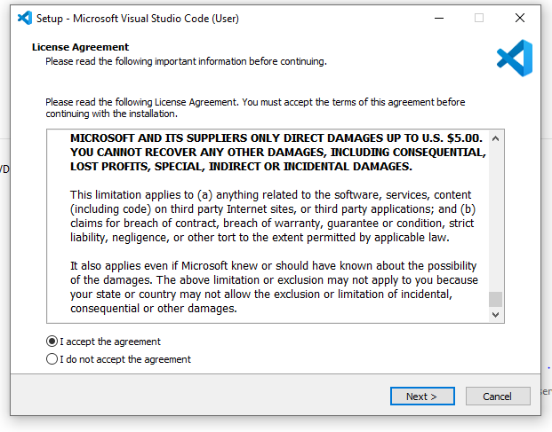

* Click next until you reach to below snapshot

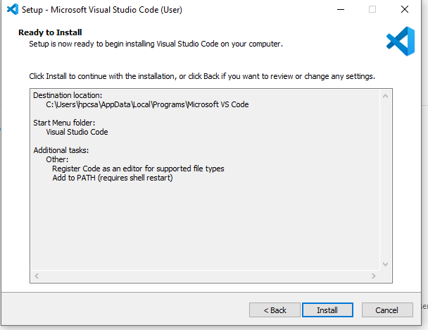

This should start your installation like below fig.

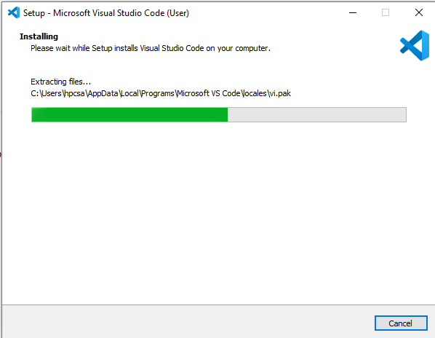

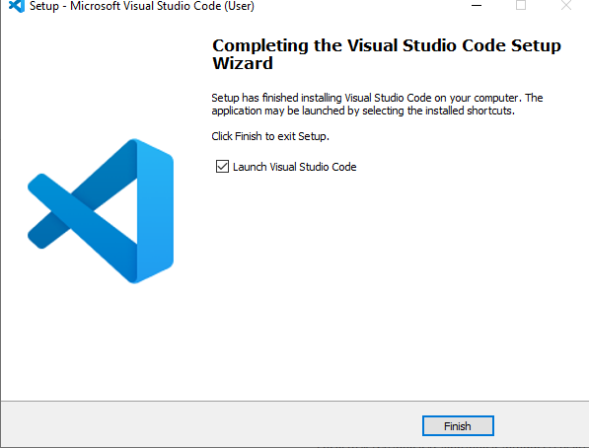

* After installation, launch visual studio code and click on extension tab like below. And install **Python Extension Pack** (highlighted below).

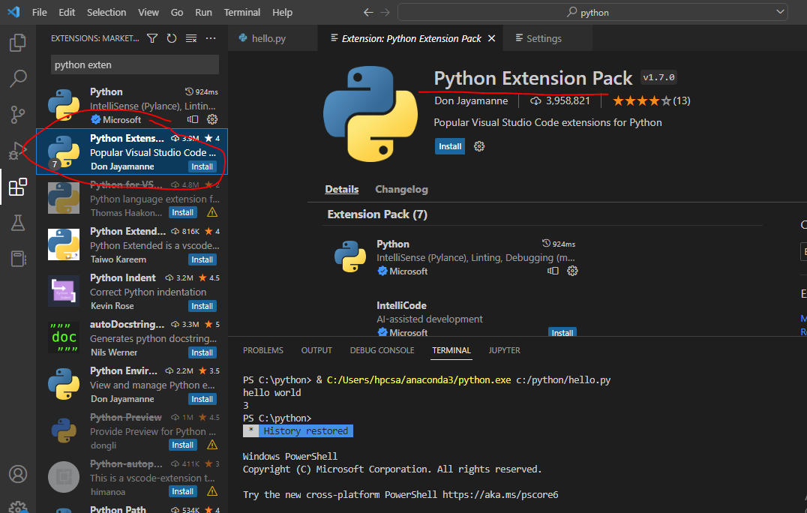

Anaconda installation-

For windows installation go with with all default options and install directly.

|  |
| --- |
| -- conda installation |
|  |

|  |
| --- |
| https://conda.io/projects/conda/en/latest/user-guide/install/windows.html |
|  |

|  |
| --- |
| https://conda.io/projects/conda/en/latest/user-guide/install/linux.html |
|  |