***Deploy OS in Vmware machine:***

* Vmware Workstation Pro 🡪 File 🡪 New Virtual machine
  + Click on custom(advanced) 🡪 Next 🡪 Next

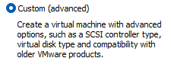

* + I will install the Operating system later. 🡪 Next

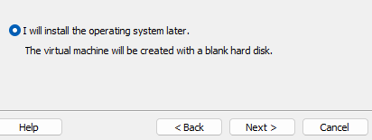

* + Select Operating system: Linux and, Version: CentOS 7 64-bit 🡪 Next

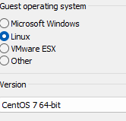

* + Give Virtual machine name: “CentOS 7 64-bit” and, Location: Make separate folder in D drive or in C 🡪 Next

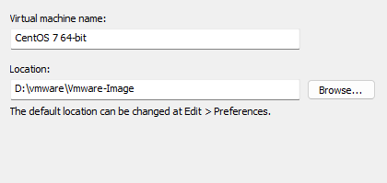

* + Select Number of processors and Core per processor 🡪 Next

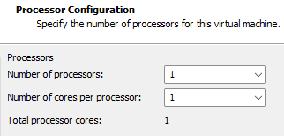

* + Select Memory: 7 GB 🡪 Next

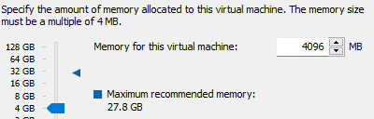

* + Select Network Type: NAT 🡪 Next

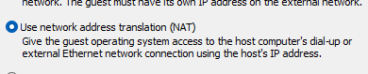

* + Select I/O controller types: Leave Default (LSI Logic) 🡪 Next

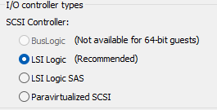

* + Select a Disk Type: leave Default (SCSI) 🡪 Next

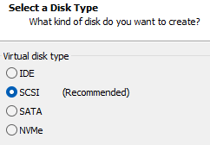

* + Select a Disk: leave Default (Create a new virtual disk) 🡪 Next

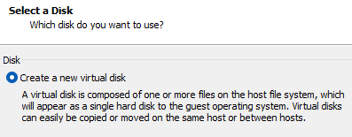

* + Maximum disk size: as per requirements, click on “Store virtual diak as a single file” 🡪 Next

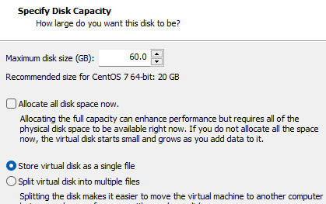

* + Leave Default page 🡪 Next

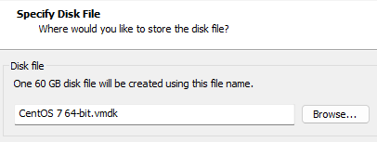

* + Click on “Customize hardware” then finish

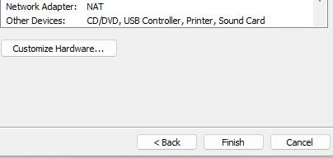

* + Click Auto detect for CD/DVD (IDE) then,

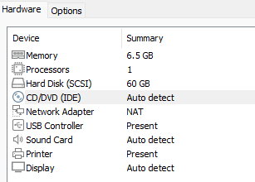

* + Click on “Use ISO image file” and the select the location of iso image. 🡪 OK

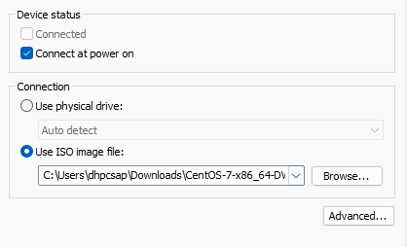

Then, Click on Power on this Virtual machine.

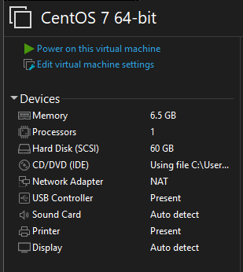

* + Click on Install CentOS 7

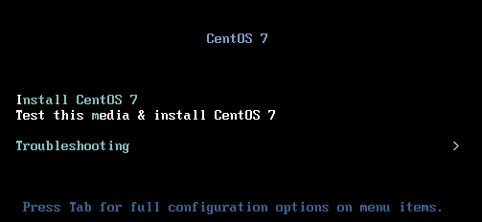

* + Select English and, English (India) 🡪 continue



* + Select Date & Time: Asia & kolkata timezone, Software Selection: Server with GUI (For GUI and, for CLI select “minimal installation”), Installation Pratition: Automatic partitioning selected and Network & Hostname: Wired(ens33) selected 🡪 Being Installat

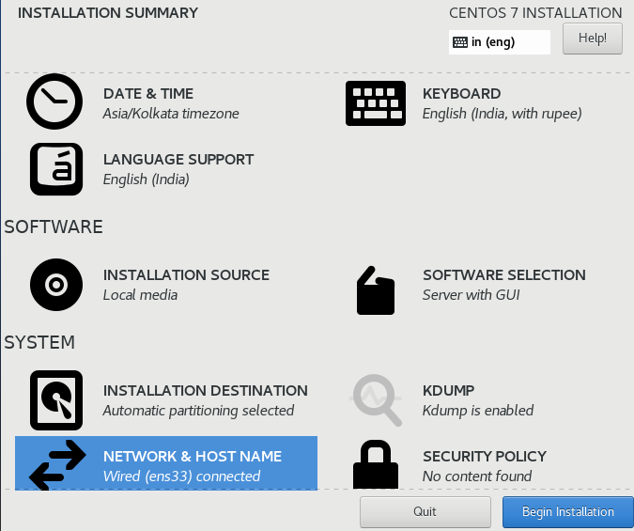

* + Set Root Password: “hpcsa” and, create user: hpcsa 