Hostname

Vi /etc/hosts

Firewalld stop

Selinux disable

Passwordless ssh

* vi /etc/chrony.conf (in master and nodes)

master-

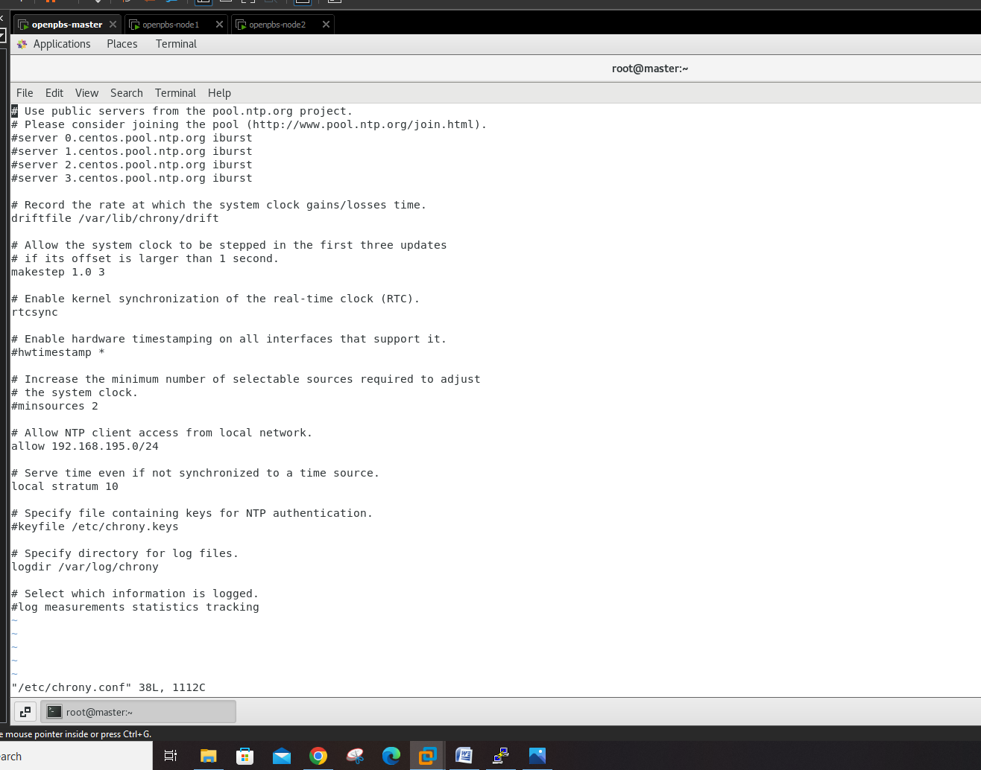

On nodes-

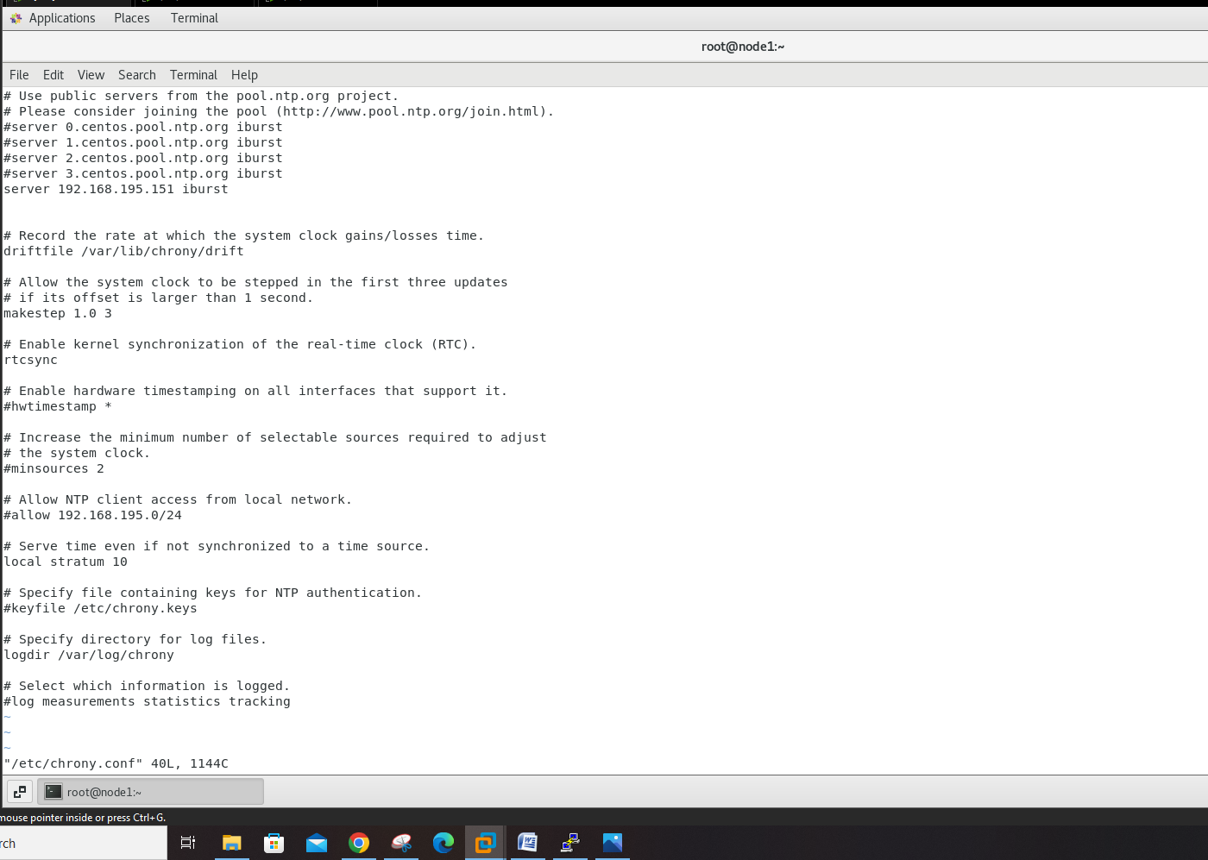

Chrony.conf -🡪 for syncing time🡪 after editing the conf files restart chrony service

On node🡪 ntpdate -u master (if the timezomes are not set set it by 🡪 timedatectl set-timezone Asia/Kolkata)

<https://github.com/openpbs/openpbs/blob/master/INSTALL>

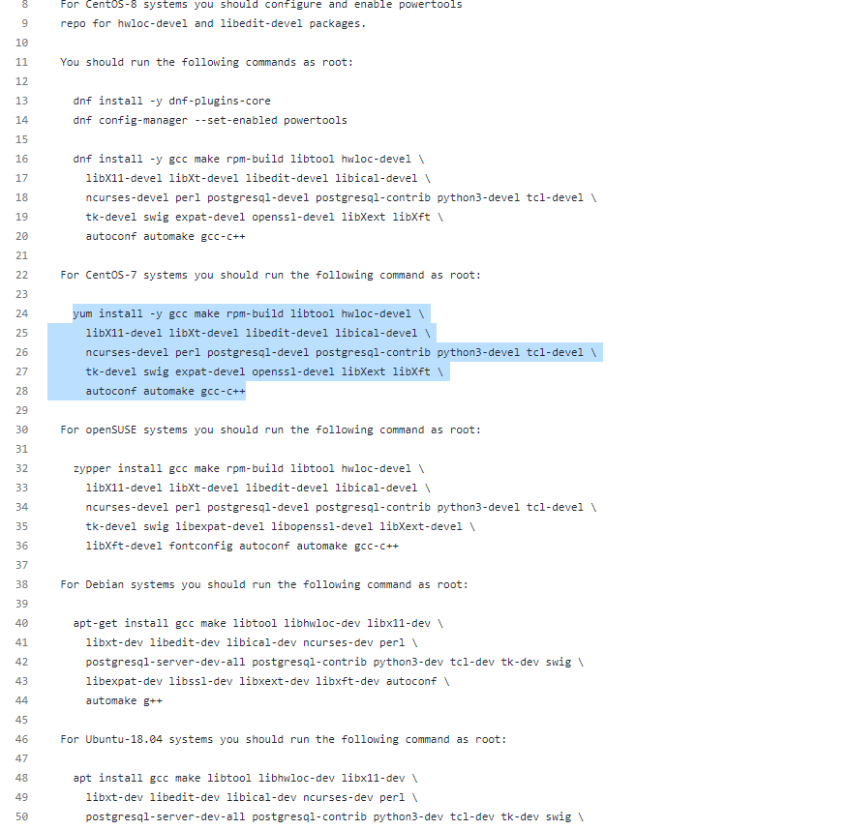

**Run this on master**

Line 🡪 66

Now go tho this link🡪

<https://github.com/openpbs/openpbs/releases/tag/v20.0.1>

wget <https://github.com/openpbs/openpbs/archive/refs/tags/v20.0.1.tar.gz>

* yum install -y expat libedit postgresql-server postgresql-contrib python3 sendmail sudo tcl tk libical
* wget <https://github.com/openpbs/openpbs/archive/refs/tags/v20.0.1.tar.gz>
* ls
* mv v20.0.1.tar.gz openpbs-20.0.1.tar.gz
* rpmbuild -ta openpbs-20.0.0.tar.gz
* ls
* yum install libtool-ltdl-devel
* rpmbuild -ta openpbs-20.0.1.tar.gz
* cd /root/rpmbuild/RPMS/x86_64/
* rpm -ivh openpbs-server-20.0.1-0.x86_64.rpm
* vi /etc/pbs.conf

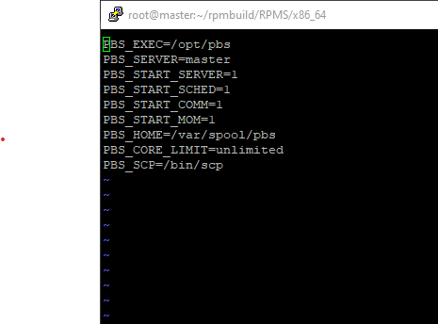

* systemctl start pbs or 🡪 /etc/init.d/pbs start
* systemctl status pbs
* . /etc/profile.d/pbs.sh
* su - username
* qsub -I
* qstat

**Adding node to the pbs-**

On master-

* cd openpbs-20.0.1/ RPMS/ x86_64/
* ls
* scp openpbs-execution-20.0.1-0.x86_64.rpm root@node1:/etc
* scp openpbs-execution-20.0.1-0.x86_64.rpm root@node1
* ssh node1

on node1-

* cd /etc/
* ls
* rpm -ivh openpbs-execution-20.0.1-0.x86_64.rpm
* yum install libICE.so* libSM.so* hwloc-libs* libX11.so* libhwloc.so* libpython3.6m.so* libtcl8.5.so* libtk8.5.so* python3*
* rpm -ivh openpbs-execution-20.0.1-0.x86_64.rpm
* cd
* vi /var/spool/pbs/mom_priv/config

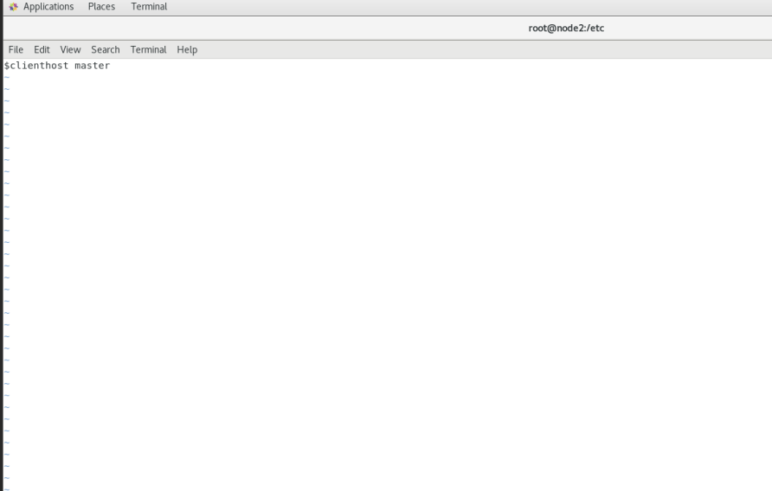

* vi /etc/pbs.conf

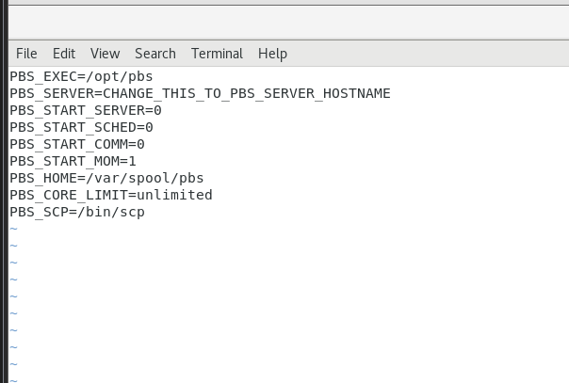

On master-

* vi /var/spool/pbs/server_priv/nodes

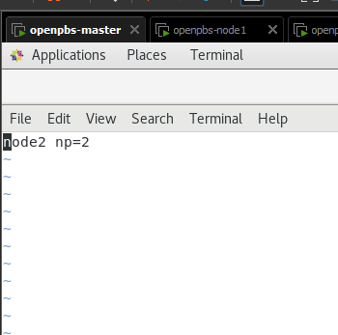

* qmgr -c "create node node1”
* . /etc/profile.d/pbs.sh
* pbsnodes -a