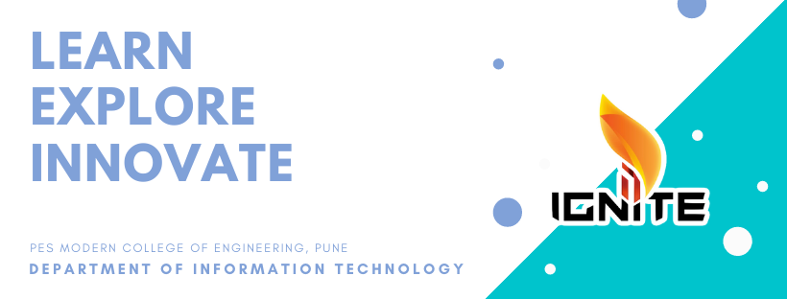

LEARN EXPLORE INNOVATE

**IGNITE**

PES MODERN COLLEGE OF ENGINEERING, PUNE DEPARTMENT OF INFORMATION TECHNOLOGY