Enterprise DevOps AI Copilot
Demo Documentation
Hybrid RAG + Agentic AI

1. Solution Overview
This demo showcases an Enterprise DevOps AI Copilot that answers operational questions using enterprise documentation. The application combines metadata-aware retrieval with a grounded LLM to provide structured, explainable responses sourced from internal knowledge.

2. System Architecture
+------------------+
| User UI |
| (Streamlit) |
+--------+---------+
|
v
+------------------+
| FastAPI Backend |
+--------+---------+
|
v
+-------------------------------+
| Intent Classification Agent |
+---------------+---------------+
|
v
Metadata Filter + Semantic Search
|
v
+-------------------------------+
| ChromaDB Vector Store |
+---------------+---------------+
|
v
Context Builder & Response Formatter
|
v
Google Gemini 2.5 Flash Lite
|
v
Structured Enterprise Answer

3. Technology Stack
Layer | Technology
Frontend | Streamlit
Backend | FastAPI
LLM | Google Gemini 2.5 Flash Lite
Framework | LangChain
Embeddings | BAAI/bge-base-en-v1.5
Vector Database | ChromaDB
Logging | Loguru

4. Demo Walkthrough
- Launch FastAPI backend and Streamlit application.
- Ask a DevOps question (for example: 'Why did the Payment API fail yesterday?').
- Intent Classification Agent identifies the document category.
- Retriever performs metadata-filtered semantic search in ChromaDB.
- Gemini generates a grounded response using retrieved context.
- UI displays the answer and the source document(s).

5. Expected Demo Output
Input Query:
Why did the Payment API fail yesterday?
Expected Result:
• Intent detected: RCA
• Relevant RCA document retrieved
• Structured response containing Issue Summary, Root Cause, Business Impact, Resolution, and Preventive Actions
• Source document displayed: RCA-001_Payment_API_Timeout_Due_to_Database_Connection_Pool_Exhaustion.pdf

6. Screenshots
Screenshot 1 - Streamlit Home Screen
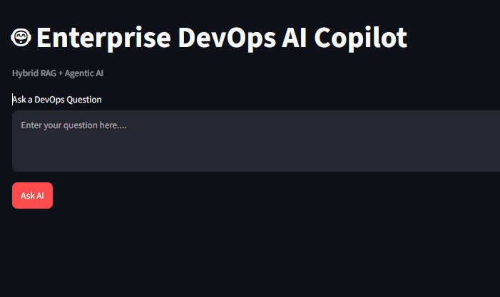

________________________________________________________________________________
Screenshot 2 - Query Submitted
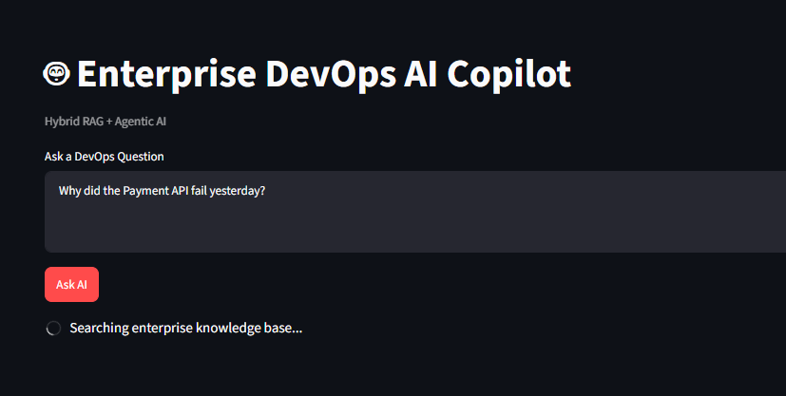 ________________________________________________________________________________
Screenshot 3 - AI Response
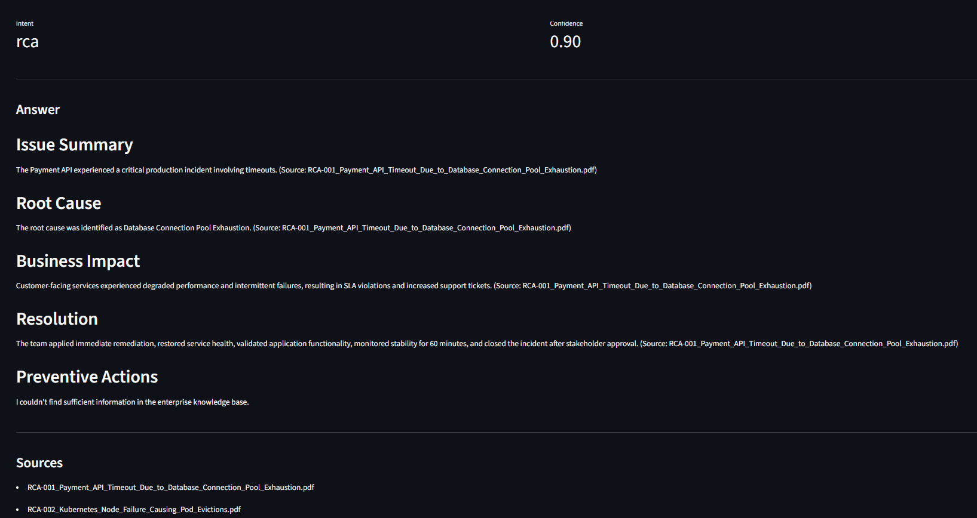

7. Business Value
• Faster access to operational knowledge
• Reduced mean time to resolution (MTTR)
• Consistent responses grounded in enterprise documentation
• Modular architecture suitable for future enterprise-scale enhancements

