**Disclaimer**

*This document provides general information about heart disease for educational purposes only. It is not a substitute for professional medical advice, diagnosis, or treatment. Always seek the advice of your physician or other qualified health provider with any questions you may have regarding a medical condition. Never disregard professional medical advice or delay in seeking it because of something you have read here.*

**Understanding Heart Disease: A Comprehensive Guide**

Heart disease, also known as cardiovascular disease (CVD), is a broad term that refers to a range of conditions that affect the heart and blood vessels. It remains a leading cause of death worldwide, but understanding its causes, symptoms, and prevention strategies can empower individuals to take control of their cardiovascular health. This guide provides a comprehensive overview of heart disease, from its fundamental types to practical advice for prevention and management.

**What Is Heart Disease?**

Heart disease encompasses a variety of problems, many of which are related to **atherosclerosis**. Atherosclerosis is a condition where plaque—made of fat, cholesterol, calcium, and other substances—builds up inside the arteries, which are the blood vessels that carry oxygen-rich blood from the heart to the rest of the body. This plaque buildup hardens and narrows the arteries, restricting blood flow and potentially leading to serious complications.

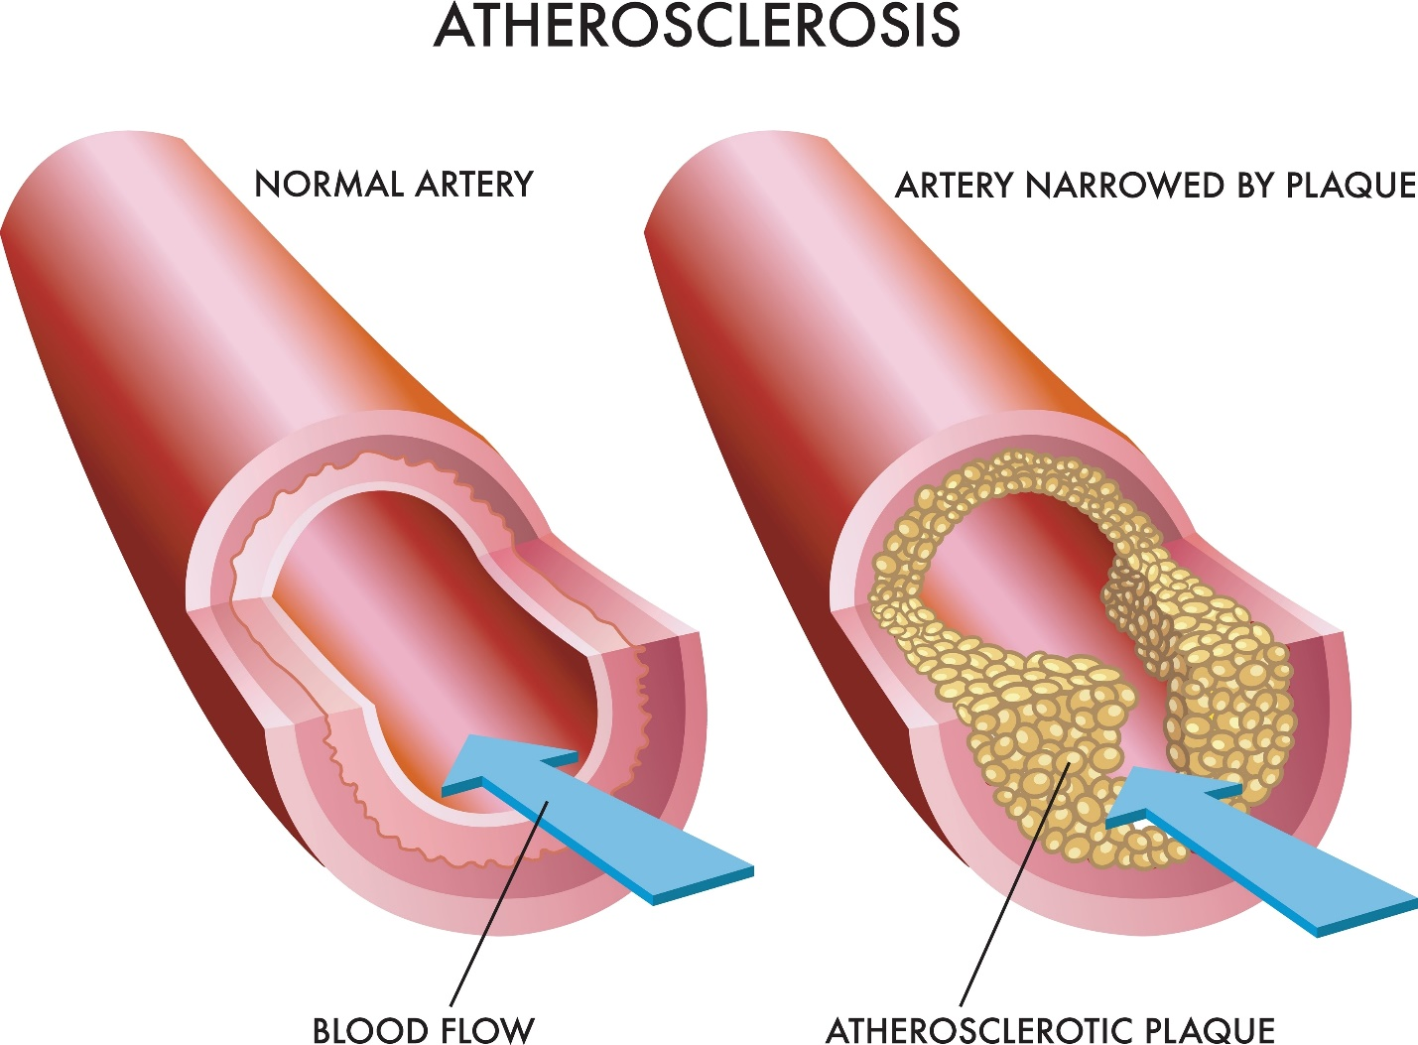

**Major types of heart disease include:**

* **Coronary Artery Disease (CAD):** This is the most common type of heart disease. It occurs when plaque builds up in the coronary arteries, which supply blood to the heart muscle itself. If the blood flow is partially or completely blocked, it can cause chest pain (angina) or a heart attack.
* **Heart Failure:** Also known as congestive heart failure, this condition does not mean the heart has stopped working. Instead, it means the heart muscle has become too weak or stiff to pump blood as efficiently as it should. This can lead to fluid buildup in the lungs and other parts of the body.
* **Arrhythmia:** This is an irregular heartbeat. It happens when the electrical impulses that coordinate the heart's rhythm don't work properly, causing the heart to beat too fast (tachycardia), too slow (bradycardia), or irregularly.
* **Heart Valve Disease:** The heart has four valves that keep blood flowing in the correct direction. Valve disease occurs when one or more of these valves don't open or close properly. This can be due to stenosis (narrowing of the valve) or regurgitation (leaking of the valve).
* **Hypertension (High Blood Pressure):** While often a risk factor, chronic high blood pressure is also a type of cardiovascular disease. It forces the heart to work harder to pump blood, which can cause the heart muscle to thicken and stiffen over time, increasing the risk of heart attack, stroke, and heart failure.
* **Stroke:** An ischemic stroke, the most common type, occurs when a blood vessel supplying the brain becomes blocked, often by a clot that has traveled from another part of the body (like the heart) or formed due to atherosclerosis in the brain's arteries.

**Key Risk Factors for Heart Disease**

Understanding risk factors is the first step toward prevention. They can be divided into two categories: non-modifiable (things you cannot change) and modifiable (things you can change).

**Non-Modifiable Risk Factors:**

* **Age:** The risk of heart disease increases significantly after the age of 65.
* **Gender:** Men are generally at a higher risk of heart disease earlier in life. However, women's risk increases significantly after menopause.
* **Family History:** A strong family history of early-onset heart disease (a father or brother diagnosed before age 55, or a mother or sister diagnosed before age 65) increases your own risk.
* **Ethnicity:** Certain ethnic groups, such as South Asians, have a higher predisposition to heart disease.

**Modifiable Risk Factors:**

* **High Blood Pressure (Hypertension):** The "silent killer," as it often has no symptoms. It damages arteries over time, making them more susceptible to plaque buildup.
* **High Cholesterol (Hyperlipidemia):** High levels of "bad" LDL cholesterol contribute directly to plaque formation in the arteries. Low levels of "good" HDL cholesterol are also a concern.
* **Diabetes:** People with diabetes have a much higher risk of developing heart disease. High blood sugar levels can damage blood vessels and the nerves that control the heart.
* **Smoking:** Smoking is one of the most significant risk factors. The chemicals in tobacco smoke damage blood cells, increase plaque formation, and harm the function of the heart and blood vessels.
* **Obesity:** Excess body weight, particularly around the abdomen, is linked to high blood pressure, high cholesterol, and diabetes.
* **Physical Inactivity:** A sedentary lifestyle contributes to obesity and other risk factors. Regular exercise strengthens the heart and improves circulation.
* **Unhealthy Diet:** A diet high in saturated fats, trans fats, sodium, and added sugar can directly contribute to high cholesterol, high blood pressure, and obesity.
* **Stress:** Chronic stress can lead to high blood pressure and may encourage unhealthy coping mechanisms like smoking, overeating, or drinking alcohol.

**Recognizing the Symptoms**

Symptoms of heart disease can vary depending on the specific condition. It's crucial to know the warning signs, as early action can save lives.

**Common Symptoms of a Heart Attack:**

* **Chest Discomfort:** This is the most common sign. It can feel like pressure, squeezing, fullness, or pain in the center of the chest that lasts for more than a few minutes or goes away and comes back.
* **Pain in Other Areas:** Discomfort can spread to one or both arms, the back, neck, jaw, or stomach.
* **Shortness of Breath:** This can occur with or without chest discomfort.
* **Other Signs:** Breaking out in a cold sweat, nausea, or lightheadedness.

It's important to note that **women may experience different symptoms** than men. While chest pain is still common, women are more likely to experience shortness of breath, nausea/vomiting, and back or jaw pain. They may also describe the chest pain as pressure or tightness rather than a sharp pain.

**Symptoms of Other Heart Conditions:**

* **Heart Failure:** Shortness of breath (especially when lying down), fatigue, weakness, and swelling (edema) in the legs, ankles, and feet.
* **Arrhythmia:** A fluttering feeling in the chest (palpitations), a racing heartbeat, a slow heartbeat, dizziness, or fainting.
* **Heart Valve Disease:** Shortness of breath, fatigue, chest pain, and an irregular heartbeat or heart murmur.

**The Pillars of Prevention**

Up to 80% of premature heart disease and stroke can be prevented through healthy lifestyle choices. The key is to manage your modifiable risk factors.

**1. Adopt a Heart-Healthy Diet:** The food you eat has a direct impact on your heart. Focus on a diet rich in whole foods.

* **Eat More:** Fruits, vegetables, whole grains, lean proteins (fish, chicken), nuts, and seeds.
* **Limit:** Processed foods, red meat, sugary drinks, and refined carbohydrates (white bread, pastries).
* **Healthy Fats:** Choose unsaturated fats found in olive oil, avocados, and nuts over saturated and trans fats found in fried foods and baked goods.
* **Reduce Sodium:** Excess sodium contributes to high blood pressure. Aim for less than 2,300 milligrams per day.

**2. Engage in Regular Physical Activity:** Exercise helps you maintain a healthy weight, lower blood pressure and cholesterol, and strengthen your heart muscle.

* **Aim for at least 150 minutes of moderate-intensity aerobic exercise** (like brisk walking, swimming, or cycling) or **75 minutes of vigorous-intensity aerobic exercise** (like running or jogging) each week.
* **Include muscle-strengthening activities** (like lifting weights or using resistance bands) at least two days a week.

**3. Maintain a Healthy Weight:** Losing even a small amount of weight (5-10% of your body weight) can significantly reduce your risk by lowering blood pressure and improving cholesterol levels.

**4. Quit Smoking:** This is the single best thing you can do for your heart health. Your risk of a heart attack drops significantly within just one year of quitting.

**5. Manage Stress:** Find healthy ways to cope with stress, such as exercise, meditation, yoga, spending time in nature, or connecting with friends and family. Chronic stress can take a toll on your heart.

**Diagnosis and Screening**

If you have symptoms or risk factors, your doctor may recommend several tests to diagnose heart disease:

* **Blood Tests:** To check levels of cholesterol, triglycerides, and other markers that can indicate heart problems.
* **Electrocardiogram (ECG or EKG):** Records the electrical activity of the heart and can detect irregular rhythms and signs of a past or current heart attack.
* **Echocardiogram:** An ultrasound of the heart that shows how the heart's chambers and valves are pumping blood.
* **Stress Test:** Monitors your heart while you walk on a treadmill or ride a stationary bike to see how it performs under stress.
* **Coronary Angiogram:** A special X-ray using dye to visualize the inside of your coronary arteries to check for blockages.

**Common Treatment Approaches**

Treatment for heart disease depends on the type and severity of the condition. It usually involves a combination of lifestyle changes, medications, and sometimes medical procedures.

* **Lifestyle Changes:** The prevention strategies listed above are also crucial components of treatment.
* **Medications:**
  + **Statins:** To lower LDL ("bad") cholesterol.
  + **Beta-Blockers:** To lower blood pressure and slow the heart rate.
  + **ACE Inhibitors:** To relax blood vessels and lower blood pressure.
  + **Aspirin or other Blood Thinners:** To prevent blood clots.
  + **Diuretics:** To help the body get rid of excess fluid and sodium, often used for heart failure.
* **Medical Procedures and Surgery:**
  + **Angioplasty and Stenting:** A procedure to open blocked arteries. A tiny balloon is used to widen the artery, and a small mesh tube (stent) is often left in place to keep it open.
  + **Coronary Artery Bypass Surgery (CABG):** A surgery where a healthy blood vessel from another part of the body is used to create a new path for blood to flow around a blocked artery.
  + **Pacemaker Implantation:** A small device placed under the skin to help control abnormal heart rhythms.

**Living a Full Life with Heart Disease**

A diagnosis of heart disease is a life-changing event, but it doesn't have to be a life-ending one. Many people live long, active lives after a diagnosis by actively managing their condition.

* **Adhere to Your Treatment Plan:** Take medications as prescribed and follow your doctor's recommendations.
* **Cardiac Rehabilitation:** This is a medically supervised program designed to improve your cardiovascular health after a heart event. It includes exercise training, education on heart-healthy living, and counseling.
* **Monitor Your Health:** Regularly check your blood pressure and be aware of any new or worsening symptoms.
* **Build a Support System:** Lean on family, friends, and support groups. Talking about your experience can be very helpful for your mental and emotional well-being.

**Frequently Asked Questions (FAQ)**

* **Q: Can I reverse heart disease?**
  + **A:** While you cannot completely "cure" atherosclerosis, intensive lifestyle changes (a very healthy diet, regular exercise, stress management) and medication can stabilize or even partially reverse plaque buildup in the arteries.
* **Q: Is red wine good for my heart?**
  + **A:** Some studies suggest that moderate alcohol consumption (especially red wine) may have some heart benefits. However, the benefits are not significant enough to recommend that non-drinkers start drinking. If you do drink, do so in moderation.
* **Q: Does stress cause heart attacks?**
  + **A:** While the direct link is complex, chronic stress can contribute to risk factors like high blood pressure. Sudden, extreme stress can also trigger a heart attack in people who are already at risk.