A Project Based Learning Report on
CANCER DETECTION SYSTEM
In partial fulfilment of the requirement For Project Based Learning of BACHELOR OF TECHNOLOGY
In

COMPUTER ENGINEERING

For

Data Warehousing & Mining


BHARATI VIDYAPEETH (DEEMED TO BE UNIVERSITY) COLLEGE OF ENGINEERING, PUNE-43
DEPARTMENT OF COMPUTER ENGINEERING
2026-27

SUBMITTED TO:

Dr. Rohini Khalkar

SUBMITTED BY: | PRN
Shubham Maurya (48)  Kiran Salunkhe (53) | 2414110245  2414110252
Siddhant Nayak (54) | 2414110254
Pranjal Pallav (57) | 2414110257

BHARATI VIDYAPEETH (DEEMED TO BE UNIVERSITY) COLLEGE OF ENGINEERING, PUNE-43 DEPARTMENT OF COMPUTER ENGINEERING

CERTIFICATE

This is to certify that the Project Based Learning report titled “Cancer Detection System”, submitted by Shubham Maurya (48), Kiran Salunkhe (53), Siddhant Nayak (54), Pranjal Pallav (57), to the Bharati Vidyapeeth (Deemed to be University), College of Engineering, Pune-43 for the award of the degree of BACHELOR OF TECHNOLOGY in Computer Engineering is a Bonafide record of the PBL work done by them under my supervision.

Place: Pune Dr. Rohini Khalkar
Date:

Acknowledgement

To begin with, we would like to thank our Course Coordinator for providing us this golden opportunity. We are very grateful to our Course Coordinator, Dr. Rohini Khalkar for her valuable support and guidance.
We are also very grateful to all those who helped us in our entire project. We would like to thank Dr. Rohini Khalkar, our Course Coordinator and our HOD Dr. S.B. Vanjale sir for their support and guidance in completing our project-based learning on the topic “Cancer Detection System”. It was a great learning experience.
I would like to take this opportunity to express my gratitude to all the group members Shubham, Kiran, Siddhant, Pranjal. The project-based learning would not have been successful without their cooperation and inputs. At last, but not the least, we are thankful to our parents and families who encourage us to study and who support us financially and who gave us the opportunity to spend our golden time in learning.
Thanks again to all who helped us.

Index

S.NO | TITLE | PAGE NO.
1 | Introduction | 1
2 | Objectives | 3
3 | System Architecture | 4
4 | System Requirements | 7
5 | Implementation | 8
6 | Output | 16
7 | Challenges | 19
8 | Future Scope and Enhancements | 20
9 | Conclusion | 21
10 | References | 22

1. Introduction
Cancer is one of the leading causes of death worldwide, and detecting it early greatly improves the chances of successful treatment. In recent years, machine learning has become a valuable tool in healthcare because it can learn patterns from large collections of past patient records, such as risk factors, symptoms and clinical measurements, and use those patterns to estimate how likely it is that a new patient has the disease. Such estimates can help to prioritise screening and support medical professionals, but they can never replace a clinician's judgement.
The Cancer Detection System is a full-stack web application that demonstrates the complete life cycle of such a model. It lets a user explore a dataset, train and compare several classification algorithms, obtain a risk estimate for a new set of patient values, and watch the models keep learning as new patient records arrive. The machine-learning part is written in Python using pandas and scikit-learn, the model-serving part uses the FastAPI framework, and the user interface is built with Next.js (React and TypeScript). The system currently supports two datasets, lung cancer risk and breast cancer (Wisconsin Diagnostic), and a drop-down list in the page header switches the whole application between them.
As a project for the course Data Warehousing and Mining, the system follows the main stages of the knowledge discovery process: selecting and cleaning data, transforming it into a form suitable for mining, applying classification algorithms, evaluating the discovered models on unseen data, and presenting the knowledge to the user in a clear visual form.

1.1 Background
Most machine-learning demonstrations train a model once and then freeze it. In a real healthcare setting, however, new patients and confirmed outcomes keep arriving, and a model that cannot take advantage of them slowly becomes outdated. Some algorithms, such as stochastic gradient descent classifiers, Naive Bayes and small neural networks, can update themselves from small batches of new data using an operation called partial fitting. This is known as online learning. Other algorithms, such as Random Forest and kernel Support Vector Machines, must discard what they have learnt and be retrained on the complete data. This is known as batch learning. Understanding this difference is central to this project.

1.2 Problem Statement
Existing classroom demonstrations are usually written for one fixed dataset, compare algorithms inconsistently and do not show how a model behaves over time. There is a need for a single system that (a) works for any yes/no cancer dataset with no changes to the interface code, (b) compares several algorithms fairly on the same unseen test data, and (c) shows honestly which algorithms can learn continuously and which cannot.

1.3 Scope and Disclaimer
The system is an educational demonstration. It is not a diagnostic tool, it has not been clinically validated, and its output must never be used to make medical decisions. It handles one yes/no target column per dataset, runs on a single machine, and has no user accounts or database in this version. The patients that “arrive” during the online-learning demonstration are existing dataset records whose answers are already known, replayed in chunks to imitate new data. They are not live clinical data.

2. Objectives
The main aim of the project is to build an easy-to-use web application that trains, compares and demonstrates cancer-risk classification models, including their ability to learn continuously. The specific objectives are:
1. To load a tabular cancer dataset and present a clear summary of it: the number of rows and columns, the class balance and the distribution of each column.
2. To train several classification algorithms with identical pre-processing and an identical data split, so that their results can be compared fairly.
3. To evaluate every model on a frozen test set that is never used for training, using recall, precision, F1-score, ROC-AUC and accuracy. Recall is treated as the most important measure, because a missed cancer case is more harmful than a false alarm.
4. To let a user enter patient values in an automatically generated form and receive a risk probability, a risk band (low, moderate or high) and a medical disclaimer.
5. To demonstrate online learning by streaming held-back patient records in chunks and plotting model quality against the number of patients learnt.
6. To show clearly that batch-only algorithms (Random Forest and Support Vector Machine) cannot update incrementally, and to display their retrain-from-scratch results alongside.
7. To keep the interface independent of the data, so that a new dataset is added through one configuration entry and one training command, with no chart or form code.
8. To follow good engineering practice: a clean separation between machine learning, API and interface, a uniform error format, automated tests and clear run instructions.

On completion, the user should be able to switch datasets, see how each algorithm performs, obtain a risk estimate and understand, through the live chart, the practical difference between online and batch learning.

3. System Architecture
This section gives a visual overview of the Cancer Detection System before its implementation is described in detail. Section 3.1 shows how the parts fit together, and Sections 3.2 and 3.3 show, as flowcharts, the algorithm that trains the models and the steps followed while the application runs.

3.1 System Architecture
The system is organised into four layers, as shown in Figure 3.1. Training is done once, offline, and its results are saved as files. The API and the web interface only read those files while the application runs, so no database is needed in this version.
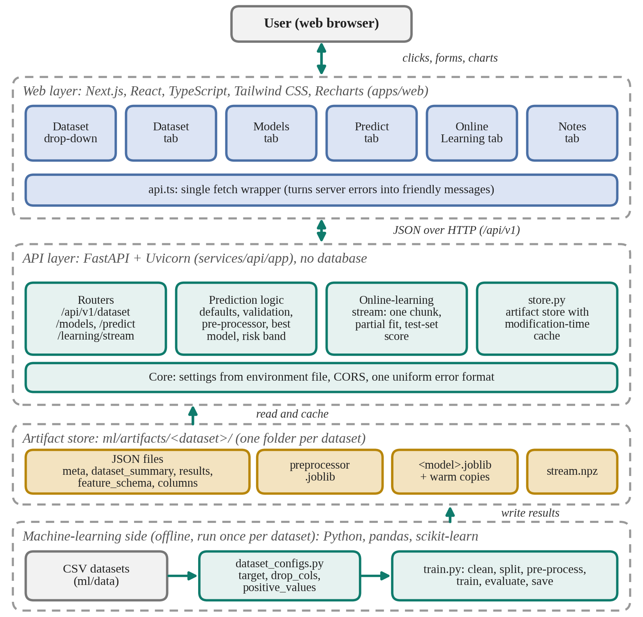
Figure 1: Layered architecture of the Cancer Detection System
The machine-learning side reads the CSV datasets and, guided by dataset_configs.py, writes every result into one artifact folder per dataset. The API layer loads and caches these artifacts and serves them under /api/v1, and the web layer draws the tabs, forms and charts from the API responses. Because the interface is generated from the saved files, it contains no reference to a particular column or dataset. A simpler three-part view of the same design is given in Section

3.2 Algorithm Flowchart: Model Training
Figure 3.2 shows the algorithm followed by the training script train.py. It is run once for each dataset, for example with the command python ml/train.py lung.
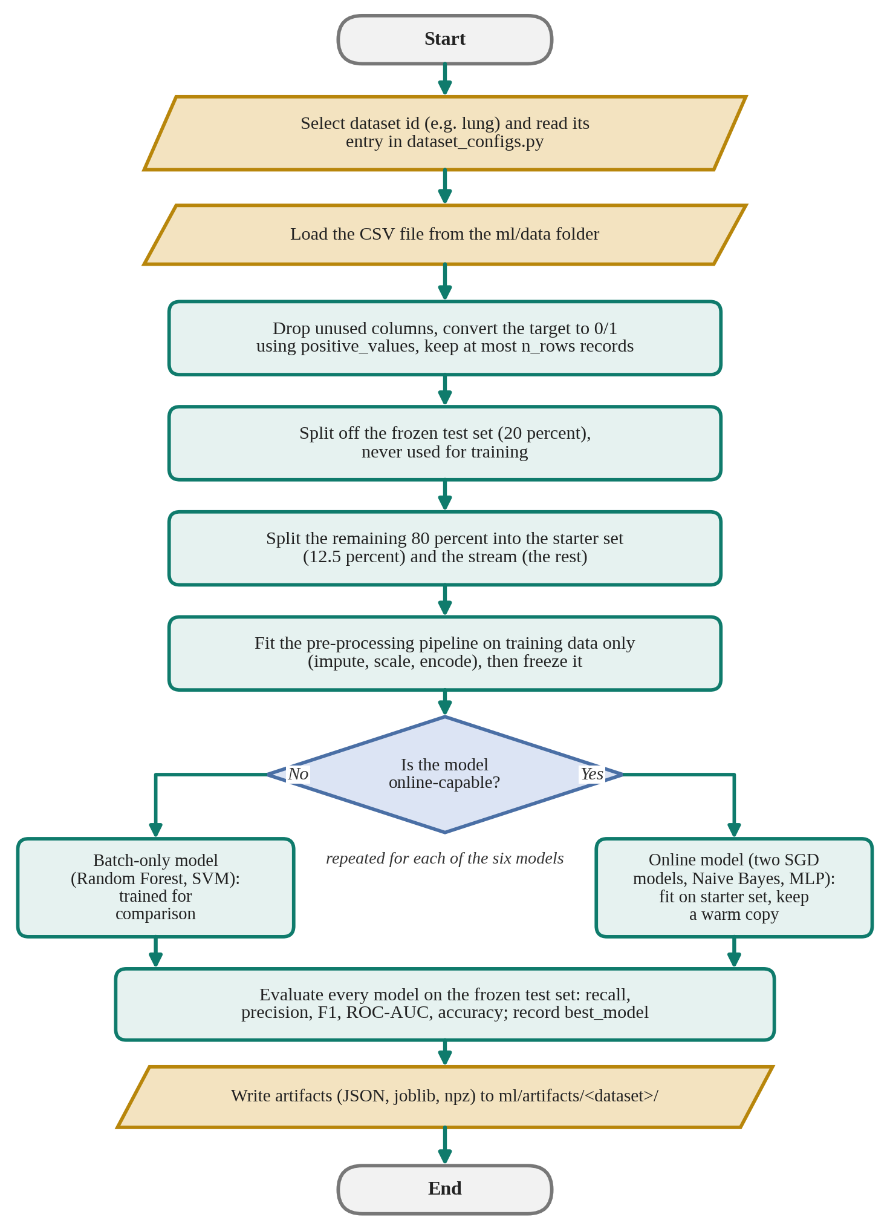
Figure 2: Flowchart of the training algorithm (train.py)
The frozen test set is separated first so that no model ever learns from it, and the pre-processing pipeline is fitted on training data only and then frozen. The decision step separates the four online-capable models, which are fitted on the small starter set and saved as warm copies, from the batch-only models (Random Forest and Support Vector Machine), which are trained for comparison. All six models are scored on the same frozen test set and the best model is recorded for the Predict tab.

3.3 Algorithm Flowchart: Prediction and Online Learning
Figure 3.3 shows what happens while the application is running. After a dataset is chosen, the path depends on the tab that the user opens. The Dataset and Models tabs only read saved summaries, the Predict tab turns the entered values into a risk estimate, and the Online Learning tab replays the held-back stream chunk by chunk.
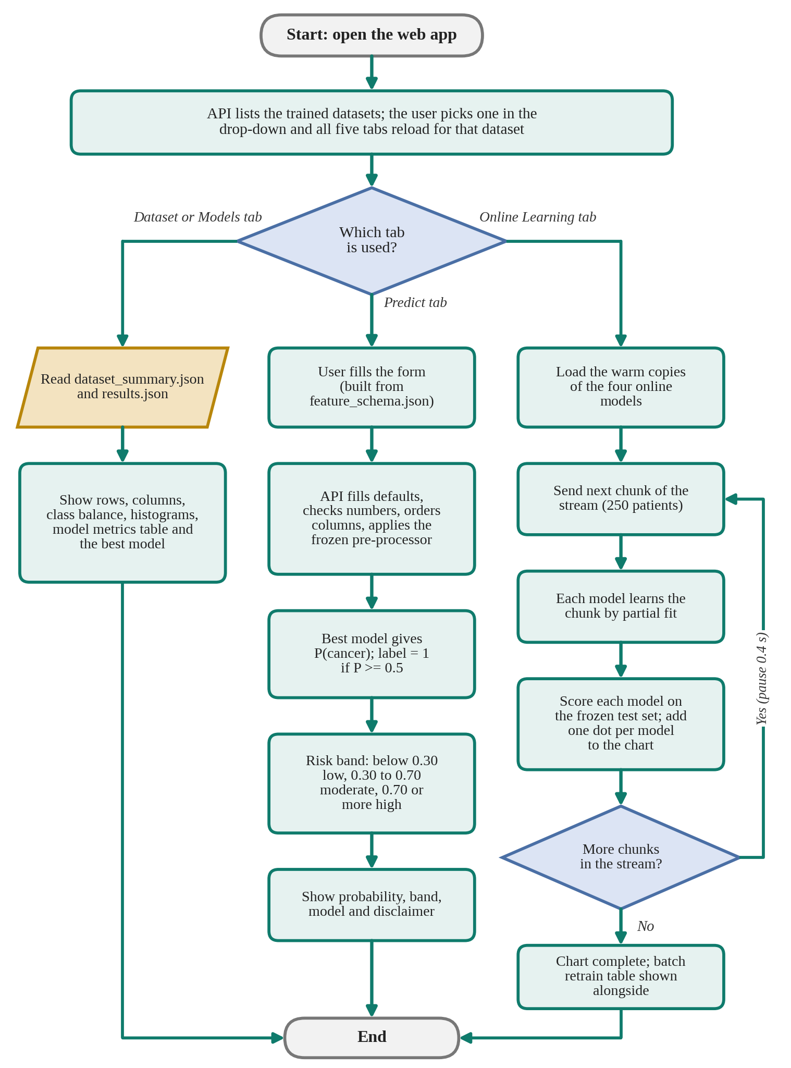
Figure 3: Flowchart of prediction and online learning at run time
In the prediction path the label is 1 when the probability is at least 0.5, and the probability is also mapped to a risk band. In the online-learning path the loop of sending a chunk, updating the models and scoring them on the frozen test set repeats until the stream is used up.

4. System Requirements
To set up and run the Cancer Detection System (model training, API and web interface) on one computer, the following requirements are necessary.

4.1 Hardware Requirements
- Processor: Intel Core i3 or higher (Intel i5 or better recommended)
- RAM: minimum 4 GB (8 GB recommended)
- Storage: minimum 2 GB of free disk space (environments, datasets, models)

4.2 Software Requirements
- Operating system: Windows 10/11 (used for development), Linux or macOS
- Python: version 3.10 or higher (3.12 used) with a virtual environment
- Node.js: current LTS version with the pnpm package manager
- Browser and tools: a recent Chrome, Edge or Firefox; Git and a code editor such as VS Code
Python libraries (back end and machine learning):
- pandas and numpy: loading, cleaning and transforming tabular data
- scikit-learn and joblib: pipelines, models, metrics and saving trained models
- FastAPI, Uvicorn and pydantic-settings: web service, server and configuration
- pytest and httpx: automated tests of the API
JavaScript libraries (front end):
- Next.js (App Router), React and TypeScript: the web application
- Tailwind CSS and Recharts: styling, histograms and the live online-learning chart

4.3 Other Requirements
- Dataset files in the ml/data folder: lung_cancer_risk.csv and the breast cancer CSV generated from scikit-learn
- Internet connection for the first installation of libraries (the application itself runs locally)
- Free local ports 8000 (API) and 3000 (web) and permission to install packages

5. Implementation

5.1 Overall Architecture
The system has three parts that communicate through files and HTTP requests, as shown in Figure 5.1.
- Machine-learning side (offline). The script train.py reads a CSV file, prepares the data, trains and evaluates the models and writes every result the application needs into a folder named after the dataset.
- API side (FastAPI). A Python web service reads those files and exposes them over HTTP under the path /api/v1. It also makes predictions and runs the online-learning stream. It uses no database in this version.
- Web side (Next.js). The browser application calls the API and draws the tabs, forms and charts.
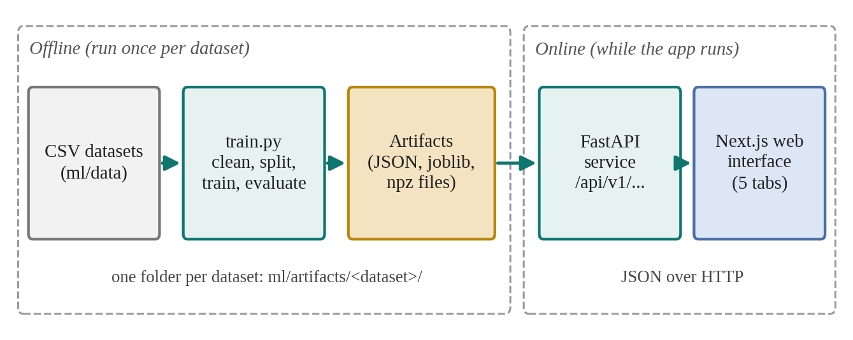
Figure 4: Architecture of the Cancer Detection System
This separation means that slow work, such as training, is done once outside the server, while the server only loads finished files and therefore responds quickly. Because the interface is built from the files that training writes, nothing in the interface code mentions a specific column or dataset. The project folders are organised as follows.
Table 1: Contents in each folder.
Folder | Contents
ml/ | train.py, dataset_configs.py, inspect_data.py and the data folder
ml/artifacts/<dataset>/ | Everything written by training for one dataset
services/api/app/ | FastAPI application: core settings and errors, routers, store.py
services/api/tests/ | Automated tests run with pytest
apps/web/src/ | Next.js pages, tab components and the API client

5.2 Technology Stack
Table 2: Technology used in each layer.
Layer | Technology | Purpose
Machine learning | Python, pandas, numpy, scikit-learn, joblib | Data handling, models, saving results
API | FastAPI, Uvicorn, pydantic-settings | Web service, server, configuration
Web | Next.js, React, TypeScript, Tailwind CSS, Recharts | Interface, styling, charts
Testing | pytest, httpx | Automated API tests
Tools | Git, pip, pnpm, VS Code | Version control, packages, editing

5.3 Datasets
Each dataset is described by one entry in the file ml/dataset_configs.py. The entry tells the training script where the CSV file is, which column is the target and which raw value means “has cancer”. The settings are listed below.
Table 3: Meanings of each dataset variables.
Setting | Meaning
label | Name shown in the dataset drop-down
csv | File name inside the ml/data folder
target | The yes/no column to be predicted
drop_cols | Columns to ignore, such as identifiers
positive_values | Raw values of the target that mean “has cancer”
n_rows | Maximum number of rows used for training

Lung cancer risk. The file lung_cancer_risk.csv contains about 30,000 patient records with a mix of numeric and categorical risk-factor columns and the yes/no target column lung_cancer.
patient_id,age,gender,pack_years,radon_exposure,asbestos_exposure,secondhand_smoke_exposure,copd_diagnosis,alcohol_consumption,family_history,lung_cancer
100000,69,Male,66.02524418183087,High,No,No,Yes,Moderate,No,No
100001,32,Female,12.78080001832259,High,No,Yes,Yes,Moderate,Yes,Yes
100002,89,Female,0.4082780991943702,Medium,Yes,Yes,Yes,None,No,Yes
100003,78,Female,44.06523180717622,Low,No,Yes,No,Moderate,No,Yes
100004,38,Female,44.43244048453104,Medium,Yes,No,Yes,None,Yes,Yes

Breast cancer (Wisconsin Diagnostic). This dataset is included with scikit-learn. It has 569 records, each described by 30 numeric measurements computed from images of cell nuclei, such as radius, texture, area and smoothness. In scikit-learn's copy the value 0 means malignant, so the configuration lists 0 as the positive value; this keeps “1 means cancer” consistent across datasets. Because it has only 569 rows, it serves as a small second demonstration dataset.
Limits. The target must be a single yes/no column (several classes, such as cancer stage, need extra code), and a dataset with 40 or more columns produces 40 or more histograms.

5.4 Machine-Learning Pipeline
The script train.py is run once per dataset with a command such as python ml/train.py lung. It performs the following stages.
Data preparation. Columns listed in drop_cols are removed, the target column is converted to 0 and 1 using positive_values, and the data is limited to n_rows records.
Splitting the data. The data is divided into three parts, as shown in Figure 5.2. For the 30,000-row lung dataset, 20 percent (about 6,000 records) forms the frozen test set, which is used only for scoring and never for training. The remaining 80 percent (about 24,000 records) is split further into a starter set of 12.5 percent of it (about 3,000 records), on which the models are first trained, and a stream of about 21,000 records that is held back to imitate new patients arriving later. Keeping the test set frozen guarantees that every score, before and after learning, is measured on data that no model has learnt from.
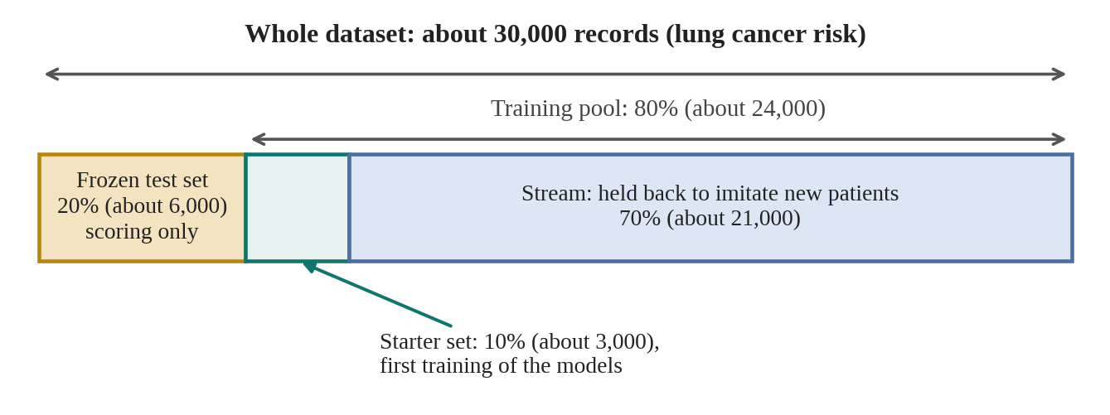
Figure 5: Splitting of the dataset into test, starter and stream parts
Pre-processing. A scikit-learn ColumnTransformer pipeline handles numeric and categorical columns separately. Missing values are filled with a SimpleImputer, numeric columns are scaled and categorical columns are converted to numbers. The pipeline is fitted only on training data and then frozen, so that the same transformation is applied to the stream, the test set and every user input. It is saved as preprocessor.joblib.
Models. Two groups of algorithms are trained. The online-capable models (four algorithms that support partial fitting in scikit-learn) are first fitted on the starter set and can later be updated chunk by chunk. A saved “warm” copy of each is kept so that every demonstration run starts from exactly the same small base. The batch-only models, Random Forest and Support Vector Machine, are trained for comparison. They cannot be updated incrementally.
Evaluation. Every model is scored on the frozen test set. Recall (sensitivity) is the share of real cancer cases that the model catches. Precision is the share of positive predictions that are correct. The F1-score combines the two, ROC-AUC measures how well the model separates the classes at all thresholds, and accuracy is the share of all correct predictions. Recall is the primary measure. The best-performing model is recorded in results.json as best_model and is used by the Predict tab.
Saved artifacts. At the end, training writes the files listed below into ml/artifacts/<dataset>/.
Table 4: Use of each json file.
File | Used for
meta.json | Dataset id, label and target; fills the drop-down
dataset_summary.json | Dataset tab (sizes, class balance, distributions)
results.json | Models tab and online-learning set-up: models, metrics, best model, mode and file names
feature_schema.json | Predict form: name, kind (number or category), choices and default of each column
columns.json | Exact column order expected by the model
preprocessor.joblib | The frozen pre-processing pipeline
<model>.joblib and warm copies | The trained models
stream.npz | Held-back records used for the online-learning replay

5.5 Back End (FastAPI)
The API is built with FastAPI and served by Uvicorn. All routes start with /api/v1, and every data route takes a dataset parameter, for example /api/v1/models/results?dataset=lung. The routes are summarised below.
Table 5: Different Methods used in backend and their tasks.
Method | Path | Purpose
GET | /health | Liveness check; returns {"status": "ok"}
GET | /dataset | Lists the trained datasets (fills the drop-down)
GET | /dataset/summary | Summary shown in the Dataset tab
GET | /models/results | Models, metrics and the best model
GET | /predict/schema | Definition of the prediction form
POST | /predict | Returns probability, label, risk band, model name and disclaimer
GET | /learning/stream | Streams the online-learning replay (chunk and delay parameters)

Prediction logic. When the Predict tab submits values, the API fills any missing field with the default from the feature schema, converts numeric fields to numbers (returning a clear error if a value is not a number), arranges the columns in the exact order used in training, applies the saved pre-processor and asks the best model for the probability of cancer. The label is 1 when the probability is at least 0.5. The probability is also converted into a risk band: below 0.30 is low, from 0.30 up to 0.70 is moderate, and 0.70 or above is high. Every response carries the disclaimer that the result is an estimate for education only and not a medical diagnosis.
Artifact store. The module services/store.py finds the trained datasets by scanning the artifacts folder, and loads and caches the files it needs. The cache is keyed by each file's modification time, so retraining a dataset refreshes the data automatically and the API never needs a restart. The warm models are loaded fresh on every online-learning run so that each run begins from the same state.
Errors and configuration. All errors, including validation errors and unexpected failures, are returned in one shape: a code, a message and optional details (for example UNKNOWN_DATASET or INVALID_VALUE). Settings such as the allowed web origin are read from an environment file, and CORS permits requests from the web interface.

5.6 Front End (Next.js)
The page component holds two pieces of state: the active tab and the chosen dataset. At start-up it asks the API which datasets have been trained, selects the first one and fills the drop-down. Every tab is rendered with a key made from the dataset and the tab name, so choosing another dataset remounts the tabs and resets their charts and forms. Inactive tabs are hidden rather than destroyed, so the online-learning chart keeps its state when the user visits another tab. The five tabs are described below.
Table 6: Working of each tab in our website.
Tab | What it shows
Dataset | Number of rows and columns, target, class balance and a histogram or statistics for each column
Models | Table and charts comparing all trained models, their learning mode (online or batch) and the best model
Predict | A form generated from the feature schema; shows probability, label, risk band and disclaimer
Online Learning | Start button, chunk size and delay controls, the live chart and the batch-model comparison table
Notes | Static explanations of the method

A single fetch wrapper (api.ts) sends every request, converts server errors into one error type and shows friendly messages, such as “We can't reach the server. Is the API running?”. Styling uses Tailwind CSS and the charts use Recharts.

5.7 Online Learning Mechanism
The idea can be compared to a student who studied from a small set of notes and then receives a few new pages at a time, updating what they know after each batch. The process, shown in Figure 5.3, has five steps.
1. Before the Start button is pressed, the four online models know only the starter set of about 3,000 patients.
2. About 21,000 other patients are held back as the stream.
3. At each step the server sends one chunk (250 patients by default). Each model learns only from that chunk by partial fitting, adjusting its internal numbers slightly without re-reading old data.
4. Straight after learning, each model is scored on the frozen test set, which it has never learnt from, and the scores are sent to the browser.
5. One dot per model is added to the chart. After a short pause (0.4 seconds by default, only so that the user can watch), the next chunk is sent.

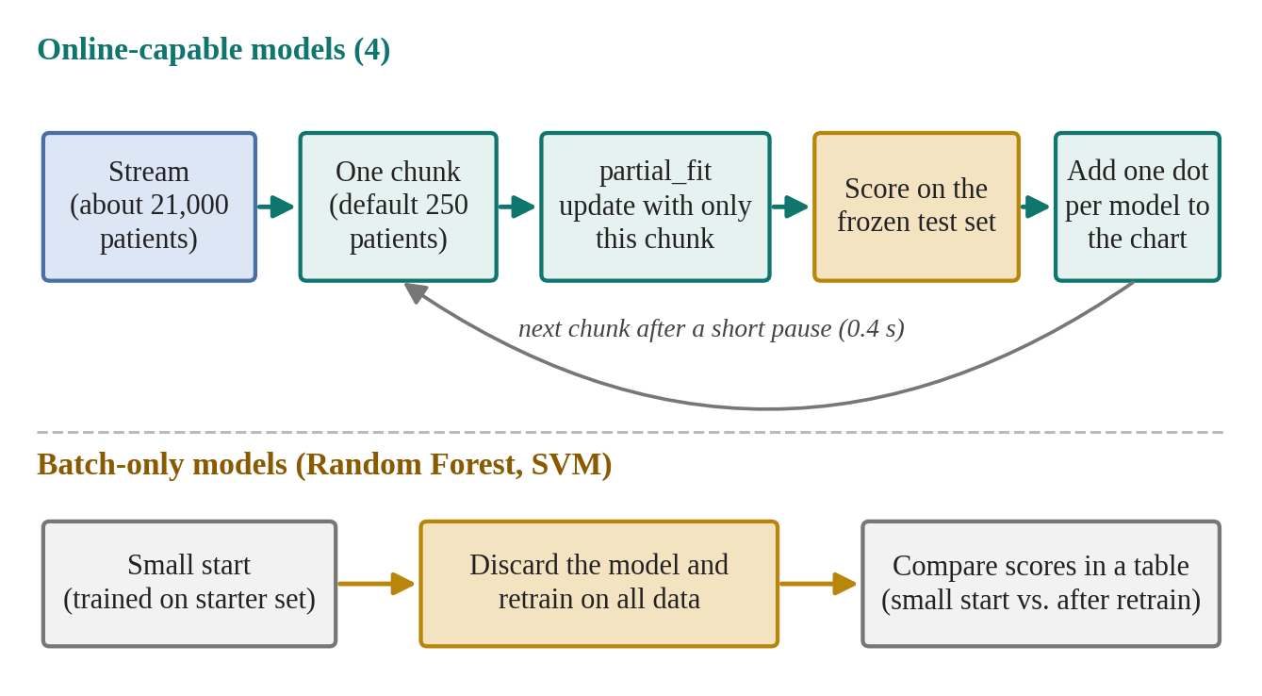
Figure 6: Online learning loop and batch retraining
On the chart, the horizontal axis is the number of patients learnt so far and the vertical axis is the score on the test set. A rising line means that the model improves as it sees more data, a flat line means that there is nothing more to gain, and small wiggles are normal because some chunks help and some hurt. The final value should be close to that model's score in the Models tab, which shows that online learning reaches similar quality without ever retraining from scratch.
Batch-only models. Random Forest and the Support Vector Machine cannot learn in this way. To make use of new patients they must discard everything and retrain on all the data. The table under the chart therefore shows two scores for them, “small start” and “after batch retrain”, and the interface states clearly that online update is not supported for these algorithms.
Honesty note. This is a replay: the arriving patients are dataset rows whose answers are already known. In a real system, outcomes would arrive only when they are confirmed. If the lines are flat from the start, the starter set was already large enough or the data has weak signal; reducing train_size in train.py from 0.125 to 0.03 (about 750 starting patients) makes learning more visible.

5.8 Adding a New Dataset
Because the interface is generated from the training output, adding a dataset needs no interface code. The steps are:
1. Place the CSV file in the ml/data folder.
2. Run python ml/inspect_data.py with the file name to see the columns, the target column and the value that means “has cancer”.
3. Add one entry to ml/dataset_configs.py with the label, file name, target, columns to drop and positive values.
4. Run python ml/train.py followed by the dataset id.
5. Refresh the browser. The new dataset appears in the drop-down, with no restart and no code changes.

5.9 Running and Testing
To run the project, the Python environment is created and activated in services/api and the requirements are installed. From the project root, with the same environment active, each dataset is trained (for example python ml/train.py lung and python ml/train.py breast). The API is then started from services/api with the command uvicorn app.main:app --reload --port 8000, and the web interface is started from apps/web with pnpm dev and opened at http://localhost:3000.
The automated tests in services/api/tests use pytest with httpx to call the API and check, for example, that the health route returns status ok. Manual checks cover the health URL, the dataset list and then each tab for each dataset.

6. Output
This section presents the working application. Each figure shows one screen of the running system, followed by a short explanation of what it demonstrates.

6.1 Dataset Selection and Dataset Tab
The header contains the dataset drop-down. After a dataset is chosen, the Dataset tab shows its size, the target column, the balance between cancer and non-cancer records and the distribution of every column. Changing the drop-down reloads all five tabs for the new dataset.
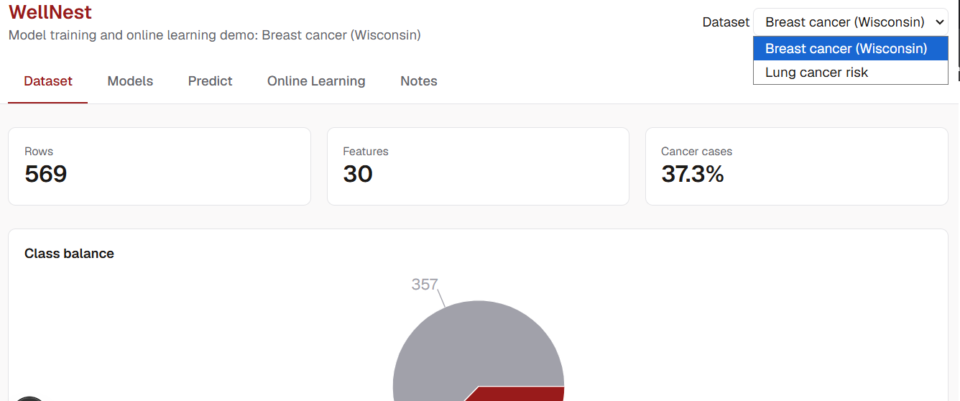
Figure 7: Dataset tab showing the details of chosen database

6.2 Model Comparison
The Models tab lists every trained model with its learning mode and its scores on the frozen test set. Table 6.1 summarises the results.
Table 1: Model comparison of all the models used.
Model | Mode | Acc. | Prec. | Recall | F1 | AUC | Fit Time
SGD Logistic Regression | Online | 0.623 | 0.826 | 0.571 | 0.675 | 0.724 | 0.2s
SGD Linear SVM | Online | 0.670 | 0.783 | 0.719 | 0.750 | 0.712 | 0.3s
Gaussian Naive Bayes | Online | 0.713 | 0.766 | 0.839 | 0.801 | 0.724 | 0s
Neural Network (MLP) | Online | 0.736 | 0.754 | 0.913 | 0.826 | 0.752 | 10.7s
Random Forest | Batch | 0.673 | 0.796 | 0.704 | 0.784 | 0.732 | 1.6s
Support Vector Machine | Batch | 0.6667 | 0.826 | 0.652 | 0.729 | 0.738 | 39.6s
Guessing "no cancer" every time would already score 68.7% accuracy, so recall and F1 matter as much as accuracy. ★ = best F1 among models that give probabilities (used in Predict).
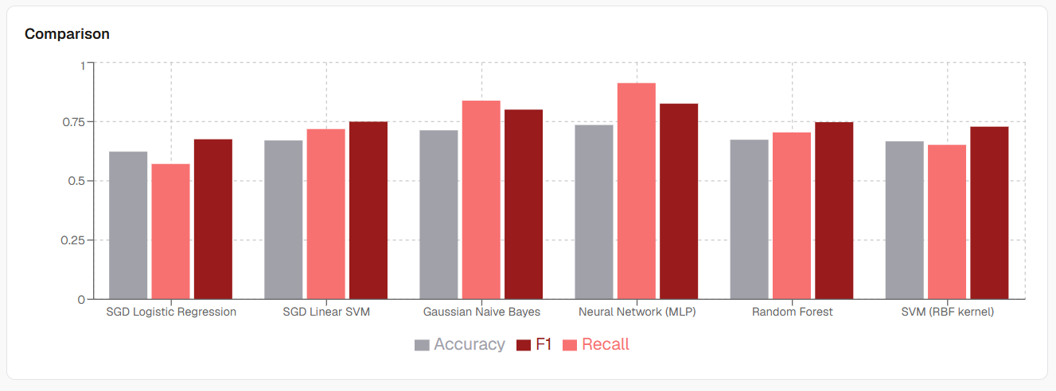
Figure 8: Graphical representation of each model’s accuracy.

6.3 Risk Prediction
In the Predict tab the form is generated from the feature schema. After the user enters values and submits, the page displays the probability of cancer, the label, the risk band (low, moderate or high), the name of the model that produced the estimate and the disclaimer. Invalid input, such as text in a numeric field, is rejected with a clear message.
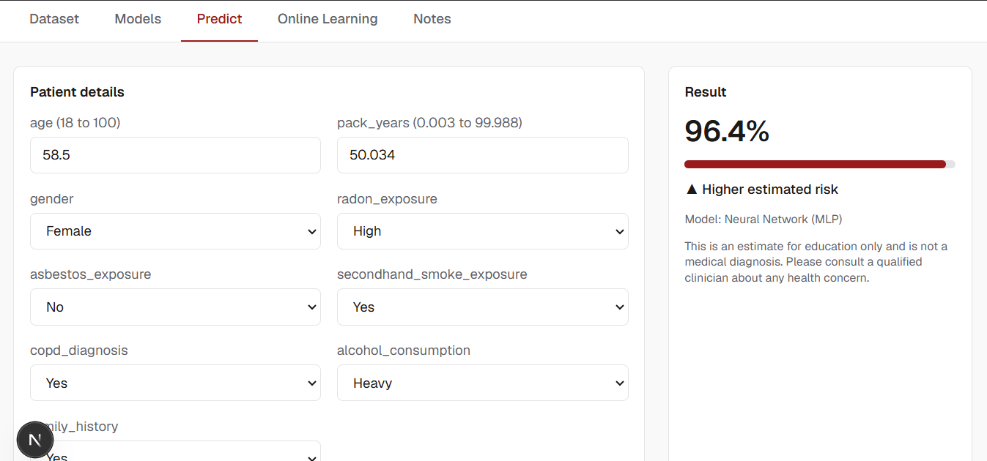
Figure 9: User tab of predicting their risk of cancer by given data

6.4 Online Learning Chart
After Start is pressed, the chart grows one dot per model for every chunk of patients. The online models are updated at each step, and their test-set scores are plotted against the number of patients learnt.
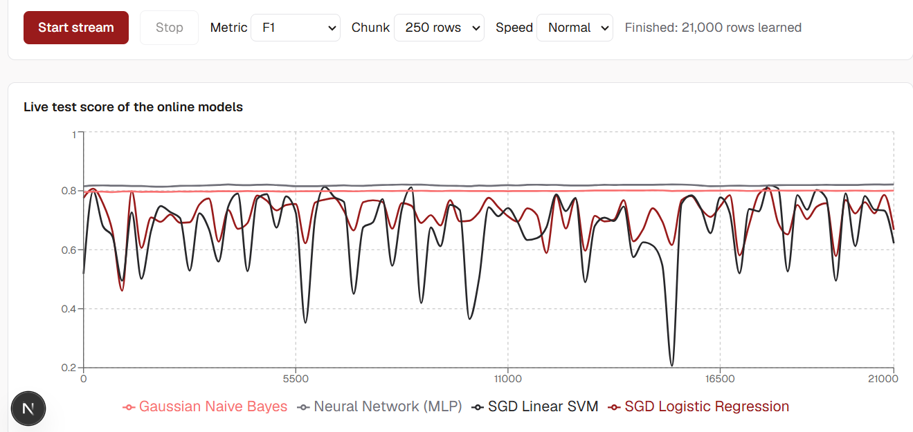
Figure 10: Online Learning through saved dataset of new upcoming users
- Waiting room: about 21,000 other patients are held back. This is the "stream", standing in for new patients arriving later.
- Each step: the server sends one chunk, say 250 patients. Each model learns from only those 250 rows. It adjusts its numbers slightly, without re-reading anything old (partial fit in the code).

6.5 Batch Models and API Documentation
The table below the chart compares Random Forest and the Support Vector Machine before and after a full retrain, which is the only way these algorithms can use new patients. Table 6.2 records those scores.
Table 7: Batch only models after retraining.
Model | Small start | After batch retrain
Random Forest | 0.753 | 0.748
Support Vector Machine | 0.722 | 0.729

FastAPI also generates an interactive documentation page at http://localhost:8000/docs, where every route listed in Section 5.5 can be tried directly.
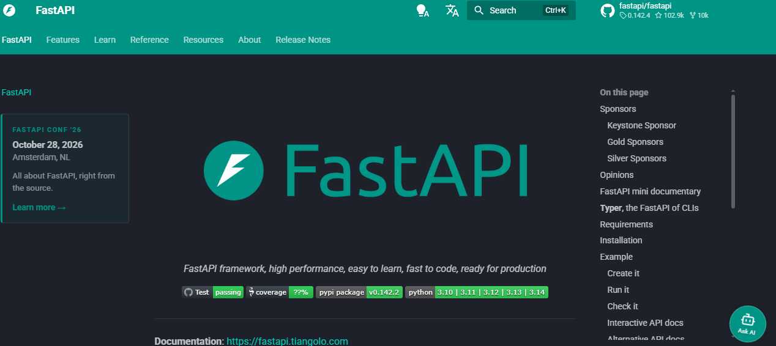
Figure 11: Automatic API documentation

7. Challenges
Several problems were met while building and testing the system. They are described below together with their causes and solutions.
Keeping the interface independent of the dataset. At first, the titles, form fields and charts were tied to one dataset. Training now writes a feature schema, a results file and a summary file for each dataset, and the tabs are built from those files.
Fair evaluation and visible online learning. To avoid data leakage, the frozen test set is set aside first and never trained on, and pre-processing is fitted only on training data. To make online learning visible, the starting set had to be small enough that the models could still improve, which led to the separate starter set and stream.
Library version mismatch of saved models. The Predict tab failed with the error that SimpleImputer has no attribute _fill_dtype. The cause was that the models had been saved by a different scikit-learn version than the one used by the API, because training had run outside the project's virtual environment. Saved model files are tied to the library version, so the solution was to retrain inside the environment that serves the API and to pin the versions.
Wrong folder when starting the server. Starting Uvicorn from the project root produced “No module named app”, because the app package lives in services/api. The server must be started from the folder that contains the package, while training is run from the project root.
Browser CORS errors that hid server crashes. The browser reported that the Access-Control-Allow-Origin header was missing, which suggested a CORS problem. The real cause was server errors (HTTP 500). Responses from the catch-all error handler are produced outside the CORS middleware and carry no CORS header. Reading the server log first revealed the true errors.
Changing function signatures during the multi-dataset change. After the store functions were changed to take a dataset argument, one router still used the old call and failed with a missing-argument error. The fix was to search the code for every call of the changed functions, and the lesson was to do this whenever a signature changes.
Charts inside hidden tabs. Recharts reported a width and height of zero because charts were mounted inside tabs hidden with display: none. A minimum size on each chart container solves it.

8. Future Scope and Enhancements
The current version concentrates on the machine-learning story. The following enhancements would move it towards a complete product.
- User accounts and consent. Registration, login, recorded consent for the use of data and a database that stores each user's predictions.
- Clinician verification. Replacing the replayed labels with outcomes confirmed by a doctor, which then feed a training pool of verified records.
- Safe online updates. A guard that accepts an updated model only if recall does not drop, with snapshots before every update and a one-click rollback.
- Explanations. Showing which input values pushed a prediction up or down, for example with feature contributions or SHAP values.
- Calibration review. Checking that predicted probabilities match real frequencies and tuning the cut-offs of the risk bands accordingly.
- More data and targets. Additional datasets, clinically measured lung data and multi-class targets such as cancer stage.
- Image-based detection. Models that read medical images, such as scans or histology slides, in addition to tabular data.
- Deployment. Hosting on a server with a background worker for training, so that training does not block the API.

9. Conclusion
The Cancer Detection System shows, in one application, how a cancer-risk model is prepared, trained, compared, used and kept up to date. It applies the main stages of data mining: cleaning and transforming the data, classifying with several algorithms, evaluating them honestly on a frozen test set and presenting the findings visually. Its central demonstration is the difference between online learning, where models improve chunk by chunk, and batch learning, where a model must be retrained from scratch.
The design keeps machine learning, API and interface separate, and generates the interface from the training output, so a new yes/no dataset can be added with one configuration entry and one command. Problems such as version mismatches, server errors hidden behind CORS messages and hidden charts were identified and solved, and are documented for future work.

9.1 Advantages
- Works for any yes/no dataset without changing interface code
- Fair comparison of several algorithms on the same unseen test data
- Shows honestly which algorithms can and cannot learn online
- Fast responses, because training is done offline and the API only loads finished files

9.2 Limitations
- An educational demonstration only; it is not clinically validated and must not be used for diagnosis
- The online-learning stream is a replay of known labels, not live clinical data
- Supports one yes/no target per dataset, with no user accounts or database yet

10. References
[1] scikit-learn documentation: https://scikit-learn.org/stable/
[2] scikit-learn, Strategies to scale computationally (incremental learning with partial_fit): https://scikit-learn.org/stable/computing/scaling_strategies.html
[3] scikit-learn, Column transformer and pipelines: https://scikit-learn.org/stable/modules/compose.html
[4] Breast Cancer Wisconsin (Diagnostic) dataset, UCI Machine Learning Repository: https://archive.ics.uci.edu/dataset/17/breast+cancer+wisconsin+diagnostic
[5] Lung cancer risk dataset (lung_cancer_risk.csv): https://www.kaggle.com/datasets/mikeytracegod/lung-cancer-risk-dataset
[6] pandas documentation: https://pandas.pydata.org/docs/
[7] FastAPI documentation: https://fastapi.tiangolo.com/
[8] Uvicorn documentation: https://www.uvicorn.org/
[9] Pydantic Settings documentation: https://docs.pydantic.dev/latest/concepts/pydantic_settings/
[10] Next.js documentation: https://nextjs.org/docs
[11] Recharts documentation: https://recharts.org/
[12] Tailwind CSS documentation: https://tailwindcss.com/docs
[13] pytest documentation: https://docs.pytest.org/

