Cancer Detection System: A Full-Stack Machine-Learning Framework
for Cancer-Risk Classification and Incremental Learning
Shubham Maurya, Kiran Salunkhe, Siddhant Nayak, and Pranjal Pallav
Department of Computer Engineering, Bharati Vidyapeeth (Deemed to be University), College of Engineering, Pune, India
Abstract — In this paper we describe a web-based education application implementing cancer risk-data exploration, comparison of classifiers, prediction and incremental learning illustration. The Python pipeline works on two datasets; the first one is the lung-cancer risk dataset with roughly 30,000 entries and the second one is Wisconsin Diagnostic breast cancer dataset containing 569 entries with 30 numerical attributes. In this experiment we use six classifiers with the same preprocessing process and the held out test data. Four classifiers out of the six described above are able to operate incrementally in our web-application. Random Forest and SVM are included for batch re-training experiments. On the lung-dataset split provided by this project, MLP had a recall of 0.913, f1 of 0.826 with accuracy of 0.736. This information is relevant to our particular experiment and not for any clinical performance purposes. The online-learning section is re-playing the rows already included in the available dataset. There is no online clinical information flow. No metrics on the breast-dataset nor its clinical evaluation results. For this reason the proposed system can be viewed as a demo engineering project and data mining exercise.
Index Terms—cancer-risk classification, breast cancer, lung cancer risk, machine learning, online learning, batch learning, FastAPI, model evaluation, full-stack application.

I. INTRODUCTION
Machine learning may be used to detect patterns from tabular data. However, the classifier developed for the purposes of a classroom assignment is not a clinical tool that is clinically validated. This assignment combines various steps into one local web application including analysis of datasets, development and comparison of different models, prediction of one record, and incremental learning. The application allows for classification only on two datasets and is limited to binary classification. It is not meant for diagnosing or treating patients..
he software makes use of the WDBC data set having 569 instances with 30 numeric attributes extracted from the digitized fine needle aspirate images, and a lung cancer risk CSV file having about 30,000 entries with numeric as well as categorical risk factor attributes [2], [3]. These data sets can be used for testing the software; however, their use does not indicate their representation of any clinical population.

Where a single training process is used by the demonstration, there may be problems distinguishing between the behaviors of various algorithms and machine learning strategies. In order to facilitate this analysis, scoring is performed on the unseen test data as well as illustrating the reactions of the supported estimators when rows of data that have been labeled are replayed in batches. The stream consists of past data with predetermined labels.

II. RESEARCH OBJECTIVES

Summarize datasets, show balance of classes, and plot distributions for features with the help of dataset-agnostic interface.

•Train and compare six binary classifiers using common preprocessing and frozen test set.

•Calculate accuracy, precision, recall, F1-score, and ROC-AUC; recall is stressed as one of important measures of evaluation.

•Make prediction form for each dataset based on its schema of features and produce probability, label, risk band, and disclaimer about prediction.

•Implement incremental learning algorithm for replay of withheld labeled examples in batches and plotting scores on test set.

III.LITERATURE REVIEW AND TECHNICAL BACKGROUND
The WDBC dataset is commonly used for binary-classification experiments. It contains 569 samples, 30 continuous features, and a diagnosis label [2]. Its well-defined structure makes it suitable for demonstrating preprocessing and classification. Still, a result on this benchmark alone does not show that a model would be useful in clinical practice. The second dataset used in the project is the lung-cancer-risk CSV, which the PBL report identifies as a Kaggle dataset [3]. The report does not provide evidence that this dataset has been independently validated for clinical use.

Incremental learning involves updating the model when new samples or mini-batches are introduced rather than training it on all historical data at once. An example of such models is estimators utilizing stochastic gradient techniques [4]. The ability to use incremental learning within scikit-learn framework is possible with specific estimators, provided they implement `partial_fit`; not all classifiers can be incrementally trained [5]. This project leverages this functionality with four different estimators and includes Random Forest and Support Vector Machine as batch-only baselines.

Several metrics are included in the evaluations since they describe distinct characteristics of performance of the model. Accuracy is the ratio of correct predictions, while precision is the ratio of the correct predictions to the total positive predictions. Recall is the ratio of correctly identified positive cases; F1-score is the harmonic mean of precision and recall. ROC-AUC describes ranking power of the model regardless of the threshold [6]. These metrics characterize performance of the model on selected test sets. By themselves, they do not imply clinical utility or safety.

IV. RESEARCH GAP

What makes this project unique is that the problem addressed by it is one of the shortcomings of a lot of classroom demonstrations – dataset inspection, comparison of models, prediction, and learning modes comparison are often presented as different activities. In this application, they are unified and are applied to configured classifiers using a unified preprocessing pipeline and frozen test set. Additionally, the difference between incremental training and complete retraining is highlighted rather than all models being treated equally in terms of how they learn.

V. PROPOSED METHODOLOGY
A. Data Set Acquisition and Description
In this study, the data set of lungs is configured as a two-class problem, consisting of 30,000 entries. It consists of age, sex, smoking history, radon/asbestos exposure, second-hand smoking, COPD, alcohol use, family history, and binary classification of lung cancer. The patient id is not included in the model features. The WDBC data set has 569 instances and 30 numerical values of the cell nuclei. The coding of the target value is mapped such that the internal positive class of the project corresponds to the positive cancer class [2], [3].

B. Preprocessing and Transformation

Configuration parameters specific to datasets include the file name, the target column, the columns to drop, the values of positive target class, and any row limits. In the training script, we start by dropping identifier columns, converting the target to binary labels and apply a preprocessing pipeline constructed using scikit-learn. For both numerical and categorical columns, we use a ColumnTransformer which performs imputation, normalization of numerical variables, and encoding of categorical variables. The preprocessing pipeline is fitted on the training dataset and used again for test data, streaming records, and prediction inputs to avoid contamination of information from the hold-out records [5].

C. Starter, Stream, and Test Split

For the reported 30,000-row lung dataset, 20% (around 6,000 data points) is held out as the frozen test set. The rest 80% is used as the training pool, where 12.5% of that training pool (around 3,000 data points) will be the starter set, and the rest will be the replay stream. The incremental learners train using the starter set at the beginning. The stream data points are for updates, but the test data points are never seen by fitting processes and used for evaluating models before and after updates. This is not mentioned in the PBL report regarding the 569-row breast dataset.

D. Classification Algorithms

The six classifier configurations are as follows: SGD Logistic Regression, SGD Linear SVM, Gaussian Naive Bayes, Neural Network (MLP), Random Forest, and Support Vector Machine. The first four classifiers are configured as incrementally updatable in the application itself. Random Forest and Support Vector Machine are regarded as batch classifiers and are evaluated before and after retraining them completely. There are no other estimators or any parameter optimization specified in the report, and hence we will not consider it in this paper.

E. Training and Evaluation

The dataset is trained before the web application begins using its trained models. This involves saving summaries of the datasets, schema metadata about the features, the pre-processing pipeline, models, and evaluations as artifacts related to the dataset. Then the web application utilizes these saved artifacts in its Dataset, Models, Predict, and Online Learning modules. All classifiers are tested on the same frozen test set based on accuracy, precision, recall, F1 score, and ROC-AUC. Recall in particular is of significance due to the cost of missed positives in this application. However, no threshold or operating point was validated.

F. Online Learning and Risk Bands
As the online learning replay happens, an API passes a block of retained labeled instances to each of the four incremental learners by using the `partial_fit` method. The learner is scored on the same test set as it gets updated, and the score obtained is plotted against the number of processed instances. The block size is 250 instances by default. Neither Random Forest nor the Support Vector Machine can use this update approach in this implementation; rather, they show their scores before and after batch retraining.
In case of prediction, the back-end checks the submitted values, organizes them according to the required feature order, uses the preprocessor stored in the system and gets a probability using the chosen model. The result of the prediction is positive if the probability is 0.5 or greater. The user interface transforms probabilities smaller than 0.30 into low risk, between 0.30 and 0.70 into moderate risk, and greater than 0.70 into high risk.

VI. PROPOSED SYSTEM ARCHITECTURE
The system architecture consists of four modules: training offline, stored models, the API, and the browser-based user interface. The training script loads the data and the configuration, generates the features, runs training and evaluation on the classifiers, and stores the output for each of the datasets. FastAPI loads the stored models and exposes the endpoints to list all datasets and return summaries about them, the results of the model runs, prediction schemas, predictions, and learning replay. Next.js frontend queries the HTTP/JSON endpoint and displays the data as forms, tables, and graphs. Training happens separately from the serving of requests, and currently there is no database involved.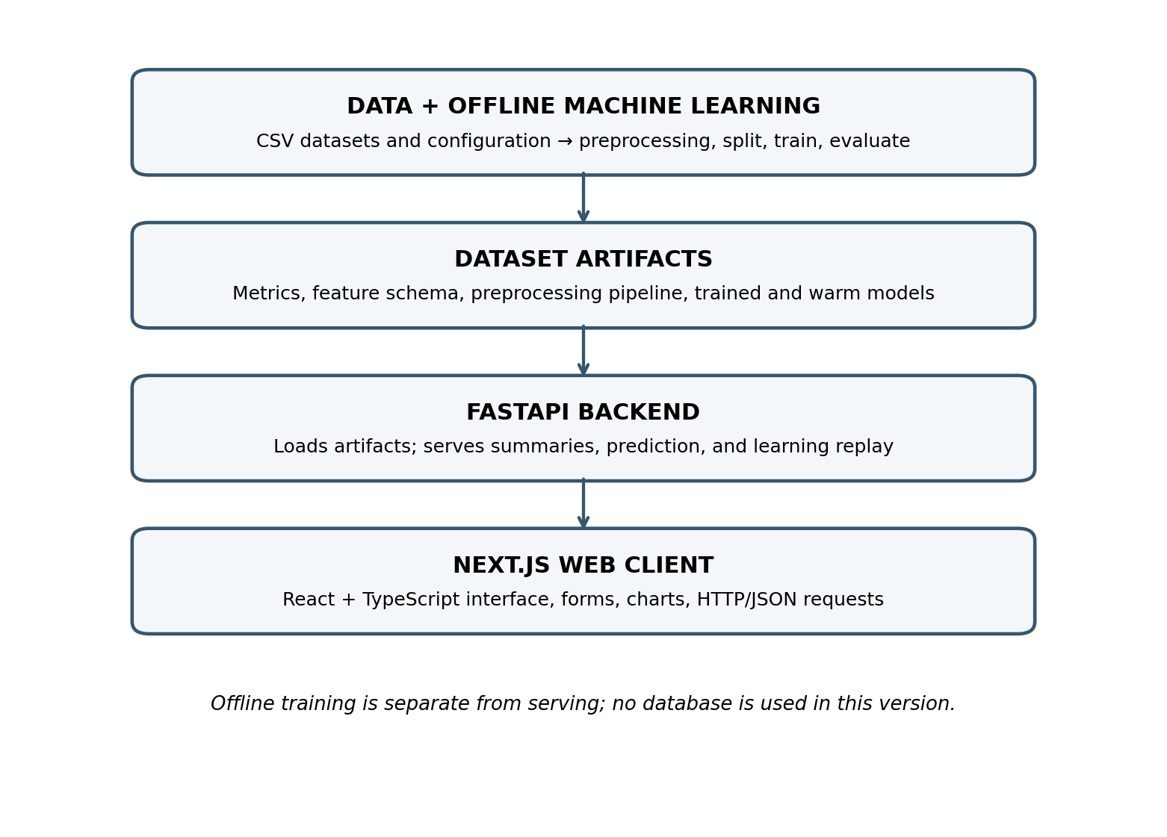
Fig. 1. Layered architecture of the Cancer Detection System.

VII. SYSTEM MODULES AND IMPLEMENTATION
Python, pandas, NumPy, scikit-learn, and joblib are used for data preprocessing, training, testing, and exporting models. FastAPI and Uvicorn are responsible for service functionality. The front-end application is based on Next.js, React, TypeScript, Tailwind CSS, and Recharts libraries. API tests are performed using pytest and httpx [5], [7]–[10].
Module | Responsibility | Output / interface
Dataset exploration | Summarizes target distribution, feature balance, and dataset information. | Dataset View and Settings
Offline training | Preprocesses data, divides data points, trains six classifiers, and computes metrics. | Model Files and Output
Artifact store | Retrieves stored schemas, pre-processing objects, and model artifacts. | Dataset Info and Model Cache
FastAPI routes | Provides summary, model output, prediction schemas, predictions, and replay updates. | HTTP / JSON Endpoints
Prediction view | Generates form based on feature schema and shows probability, label, band, and disclaimer. | Educational Estimate
Online Learning view | Replays stream segments for incremental models and shows batch comparisons only. | Score Curves and Comparison Table
Table I. Implemented modules and their responsibilities.
Training artifacts consist of metadata, data set summaries, model outputs, feature schema, expected column order, fitted pre-processing pipeline, trained models, incremental models in warm form, and the reserved stream. Invalid values and unknown data sets give structured error through the API. The front-end is created based on saved schema data rather than coding individual feature names.

VIII. EXPERIMENTAL SETUP AND EVALUATION
Numeric values are available in the PBL report for lung cancer risk dataset only. All the six classifiers have been tested with respect to the same held out test set using the mentioned criteria. The values have been taken from the provided project report.
Model | Mode | Acc. | Prec. | Recall | F1 | ROC-AUC
SGD Logistic Regression | Online | 0.623 | 0.826 | 0.571 | 0.675 | 0.724
SGD Linear SVM | Online | 0.670 | 0.783 | 0.719 | 0.750 | 0.712
Gaussian Naive Bayes | Online | 0.713 | 0.766 | 0.839 | 0.801 | 0.724
Neural Network (MLP) | Online | 0.736 | 0.754 | 0.913 | 0.826 | 0.752
Random Forest | Batch | 0.673 | 0.796 | 0.704 | 0.784 | 0.732
Support Vector Machine | Batch | 0.667 | 0.826 | 0.652 | 0.729 | 0.738
Table II. Reported lung-dataset test metrics, transcribed from the PBL report.
In terms of the described split, MLP has the highest recall (0.913) and F1-score (0.826) out of all six mentioned models. MLP’s accuracy is 0.736. Additionally, the report mentions that the accuracy of a majority-negative baseline would be around 0.687. Thus, accuracy is not sufficient to describe the behavior of the model in relation to the positive class.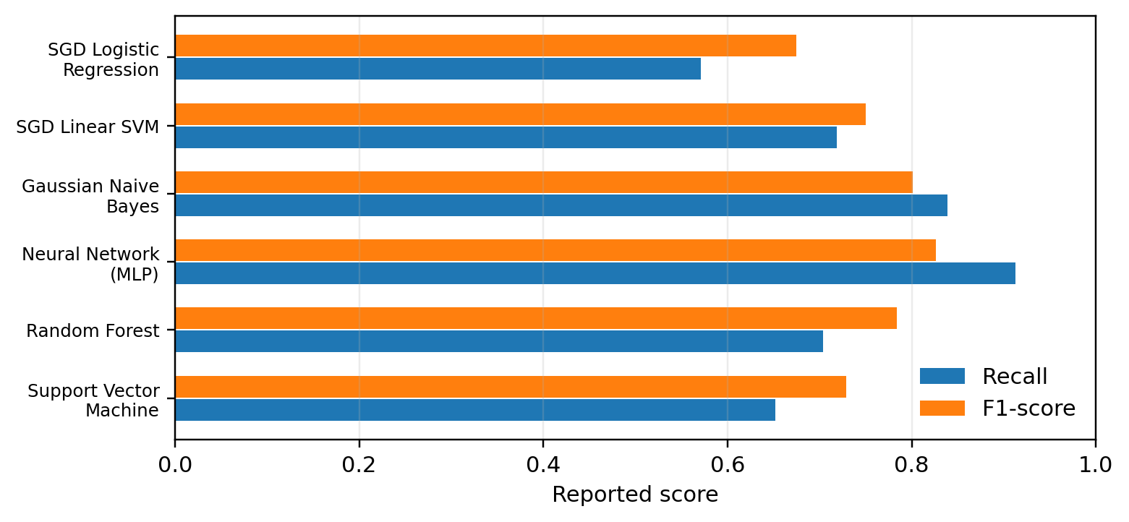
Fig. 2. Reported recall and F1-score for the six lung-dataset classifiers.
The reported fit times of the PBL are 0.2 s, 0.3 s, about 0 s, 10.7 s, 1.6 s, and 39.6 s for the six models in Table II. These times are environment-specific and cannot be used to create a general benchmark. In case of batch only models, the report shows Random Forest score of 0.753 for small start and 0.748 after batch retraining, and Support Vector Machine score of 0.722 and 0.729, respectively. The two figures above are provided by the application as a retraining comparison and not an incremental learning one.
A breast-dataset metric table, confidence intervals, repeated split results, and any form of clinical validation proof are not provided in the source report. The paper therefore provides no such figures. A better future evaluation should show the random seed used, class-wise confusion matrices, repeated stratified splits, calibration, and even external validation where applicable.
IX. RESULTS AND OUTPUT ANALYSIS
The application offers the data set summary, model score table, auto-generated form for predictions, and online learning diagram. Values from the lung-dataset indicate that there is a compromise between the classifiers under analysis since MLP has the largest reported recall and F1-score, and Gaussian Naive Bayes has high recall (0.839), but a lower reported fitting time. This does not confirm the applicability of any classifier to practice. The chart represents the reported recall and F1 values; it is a visualization of the table.
The diagram of the online-learning process shows how well the incremental estimators perform after each chunk in terms of their score against the number of the processed rows. Batch-only comparison shows the initial and retrained scores of Random Forest and Support Vector Machine. The report provided describes this process but does not offer curve coordinates, uncertainty in repeated runs, and values from breast-dataset. Thus, no numerical improvement of the entire replay process can be stated.

X. DISCUSSION

This is the key innovation here – data preparation, model comparison, predictions, and visualization of learning modes are all available in one software. Since offline training and API serving are decoupled, this software loads pre-trained models rather than trains them per request. Finally, the schema-based UI allows changing datasets without coding forms and charts specific to those datasets.

The test dataset that does not change provides the basis for comparing models, and the replay reveals the estimator-specific update mechanism. On the other hand, the experiment is limited by the data it uses and the way it is split and presented as one run. The predicted probabilities and risk intervals are just application outputs; without proper calibration and clinical validation, they cannot be regarded as such.

XI. LIMITATIONS AND FUTURE SCOPE
It is an educational prototype and has not been clinically validated. The clinical representativeness of the lung dataset is not validated in the given report. This replay makes use of already stored data sets with labels known beforehand and not on real-time or delayed data with confirmation from the clinicians. The present prototype is executed locally, works with one binary target at a time for each data set, and lacks any feature of users' account or database.
The possible future work could include making use of datasets that are clinically characterized better, multiclass targets support, external data test, probability calibration check, explanation of which features affect the predictions. A more realistic learning system would include ingestion of outcomes after verification and model snapshots, model monitoring, and rollback in case of underperformance. Secure data storage, consent management, and deployment architecture including background training would be necessary before considering any real-world application.

XII. CONCLUSION

This paper has proposed a full-stack education application for studying two table datasets, analyzing six classifiers, computing risk assessments, and presenting the concept of incremental learning along with batch retraining. This project has divided its architecture into offline machine learning pipeline, artifacts, FastAPI service, and Next.js. For the provided dataset, the MLP classifier obtained a recall score of 0.913 and F1 score of 0.826 on the particular partition but this information relates only to the experiment provided and does not prove any clinical effectiveness. The online learning option uses previous labeled data and thus it does not represent a real-life clinical learning algorithm.

REFERENCES
[1] UCI Machine Learning Repository, “Breast Cancer Wisconsin (Diagnostic) Data Set.” [Online]. Available: https://archive.ics.uci.edu/dataset/17/breast+cancer+wisconsin+diagnostic
[2] MikeyTraceGod, “Lung Cancer Risk Dataset,” Kaggle. [Online]. Available: https://www.kaggle.com/datasets/mikeytracegod/lung-cancer-risk-dataset
[3] L. Bottou, “Large-Scale Machine Learning with Stochastic Gradient Descent,” in Proc. 19th International Conference on Computational Statistics (COMPSTAT), 2010, pp. 177–186.
[4] scikit-learn Developers, “Strategies to scale computationally: bigger data,” scikit-learn User Guide. [Online]. Available: https://scikit-learn.org/stable/computing/scaling_strategies.html
[5] T. Fawcett, “An introduction to ROC analysis,” Pattern Recognition Letters, vol. 27, no. 8, pp. 861–874, 2006, doi: 10.1016/j.patrec.2005.10.010.
[6] scikit-learn Developers, “ColumnTransformer and pipelines,” scikit-learn documentation. [Online]. Available: https://scikit-learn.org/stable/modules/compose.html
[7] FastAPI, “FastAPI Documentation.” [Online]. Available: https://fastapi.tiangolo.com/
[8] Vercel, “Next.js Documentation.” [Online]. Available: https://nextjs.org/docs
[9] Recharts, “Recharts Documentation.” [Online]. Available: https://recharts.org/

