本次实验选择编程类工具Echarts。

在WebStorm中新建nodejs项目，并引入echarts，echarts-gl等必要包。

创建index.html，写入以下内容，作为本次实验样式文件。

<!DOCTYPE html>

<html lang="en">

<head>

<meta charset="UTF-8">

<title>数据可视化实验三</title>

</head>

<body>

<div id="main" style="width: 1000px;height:1000px;"></div>

</body>

<script type="text/javascript" src='bundle.js/main.js'></script>

</html>

**一、螺旋曲线（半径为5，每旋转一周z坐标增加π）**

新建app.js文件。

在app.js文件中引入echarts，echarts-gl等包并编写逻辑代码，代码如下

const echarts = require('echarts');

const echartsGL = require('echarts-gl');

const myChart = echarts.init(document.getElementById('main'));

function spiral(r, k, w) {

return [r * Math.cos(k * w), r * Math.sin(k * w), k * w]

}

const data = [];

for (let w = 0; w < 30 * Math.PI; w += 0.1)

data.push(spiral(5, 0.5, w));

option = {

grid3D: {},

xAxis3D: {},

yAxis3D: {},

zAxis3D: {max: 60},

series: [{

type: 'line3D',

data: data,

}]

}

myChart.setOption(option);

执行webpack，然后在浏览器中打开index.html文件，结果如下

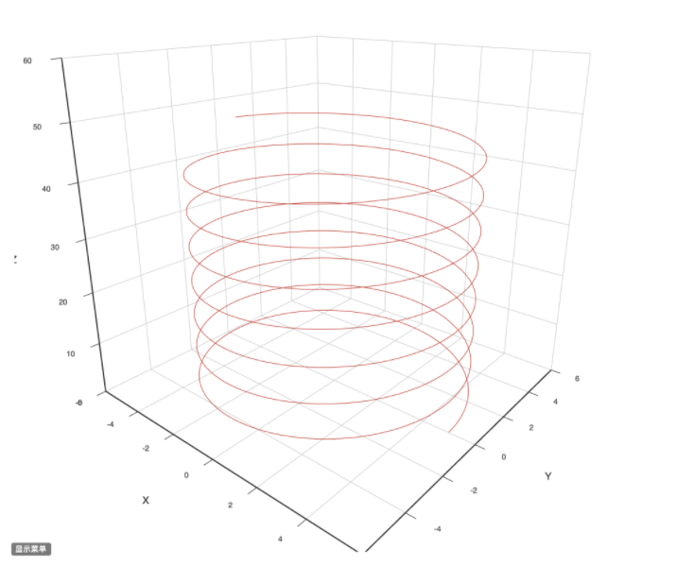

**二、二元正态分布曲面**

在app.js文件中引入echarts，echarts-gl等包并编写逻辑代码，代码如下

const echarts = require('echarts');

const echartsGL = require('echarts-gl');

const myChart = echarts.init(document.getElementById('main'));

function makeGaussian(amplitude, x0, y0, sigmaX, sigmaY) {

return function (amplitude, x0, y0, sigmaX, sigmaY, x, y) {

const exponent = -(

(Math.pow(x - x0, 2) / (2 * Math.pow(sigmaX, 2)))

+ (Math.pow(y - y0, 2) / (2 * Math.pow(sigmaY, 2)))

);

return amplitude * Math.pow(Math.E, exponent);

}.bind(null, amplitude, x0, y0, sigmaX, sigmaY);

}

const gaussian = makeGaussian(50, 0, 0, 20, 20);

const data = [];

for (let y = -50; y <= 50; y++) {

for (let x = -50; x <= 50; x++) {

const z = gaussian(x, y);

data.push([x, y, z]);

}

}

option = {

grid3D: {},

xAxis3D: {},

yAxis3D: {},

zAxis3D: {max: 60},

series: [{

type: 'surface',

data: data

}]

}

myChart.setOption(option);

执行webpack，然后在浏览器中打开index.html文件，结果如下

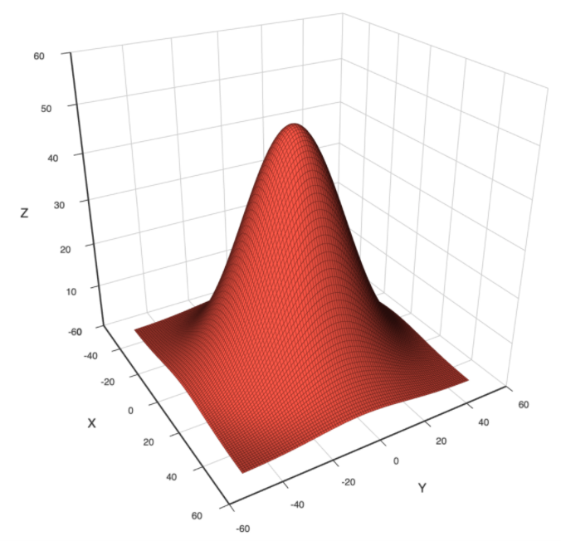

**三、球面（半径为5）**

在app.js文件中引入echarts，echarts-gl等包并编写逻辑代码，代码如下

const echarts = require('echarts');

const echartsGL = require('echarts-gl');

const myChart = echarts.init(document.getElementById('main'));

option = {

tooltip: {},

visualMap: {

show: false,

dimension: 2,

min: -1,

max: 1,

inRange: {

color: ['#313695', '#4575b4', '#74add1', '#abd9e9', '#e0f3f8', '#ffffbf', '#fee090', '#fdae61', '#f46d43', '#d73027', '#a50026']

}

},

xAxis3D: {},

yAxis3D: {},

zAxis3D: {},

grid3D: {},

series: [{

type: 'surface',

parametric: true,

parametricEquation: {

u: {

min: -Math.PI,

max: Math.PI,

step: Math.PI / 20

},

v: {

min: 0,

max: Math.PI,

step: Math.PI / 20

},

x: function (u, v) {

return 5 * Math.sin(v) * Math.sin(u);

},

y: function (u, v) {

return 5 * Math.sin(v) * Math.cos(u);

},

z: function (u, v) {

return 5 * Math.cos(v);

}

}

}]

};

myChart.setOption(option);

执行webpack，然后在浏览器中打开index.html文件，结果如下

