Java2 Lab 10
(JavaFx2)

[Experimental Objective]
In-depth understanding of JavaFx charts, 2d and 3d image creation

[Charts in JavaFx]
There are many charts in JavaFx:
Such as pieChart, lineChart, barChart, scatterChart, etc.

[Case 1 - Line Chart]

We can use JAVAFx to draw a line chart that depicts the fluctuations in stock prices. First build the x-axis and y-axis, add them to the line chart, and then fill in the chart data and bind it to the line chart.

public void start(Stage primaryStage) {
primaryStage.setTitle("line Chart");
NumberAxis xAxis = new NumberAxis();
NumberAxis yAxis = new NumberAxis();
xAxis.setLabel("number of month");
LineChart<Number, Number> lineChart = new LineChart<Number,Number>(xAxis, yAxis);
lineChart.setTitle("stock monitor,2018");
XYChart.Series series =new XYChart.Series();
series.setName("my portfolio");
series.getData().add(new XYChart.Data(1, 23));
series.getData().add(new XYChart.Data(2, 14));
series.getData().add(new XYChart.Data(3, 15));
series.getData().add(new XYChart.Data(4, 24));
series.getData().add(new XYChart.Data(5, 34));
series.getData().add(new XYChart.Data(6, 36));
series.getData().add(new XYChart.Data(7, 22));

lineChart.getData().add(series);
Scene scene = new Scene(lineChart,800,600);
primaryStage.setScene(scene);
primaryStage.show();
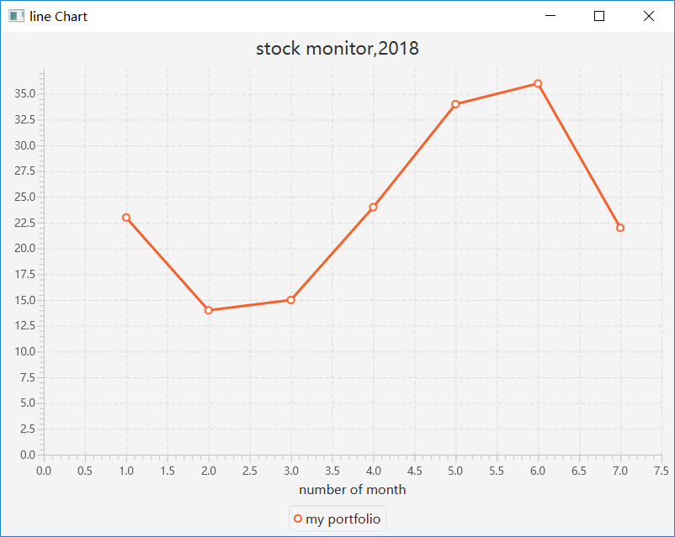
}

[Exercise 1 - Line Chart]
On the basis of Case 1, draw three broken lines to represent the trend of three different investment portfolios. The sample image is as follows, and the data can be drawn up.
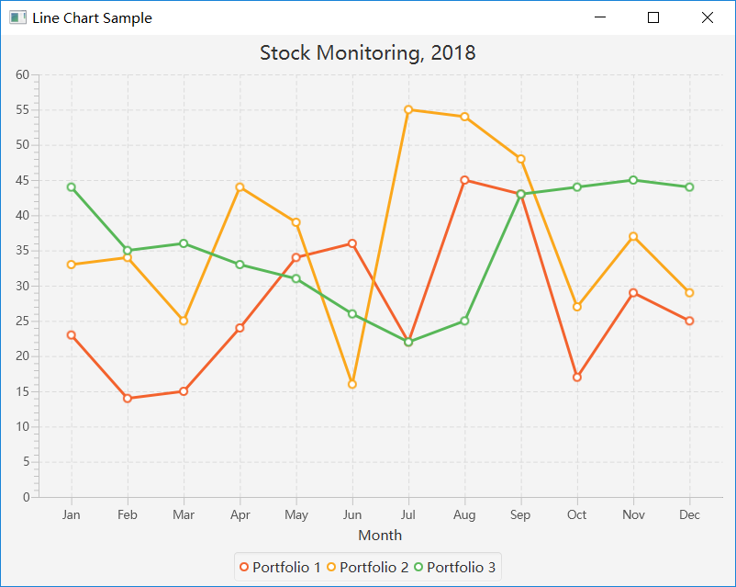

[Case 2-2d image]
We can draw a 2D picture with JAVAFx. Some commonly used class libraries are in the javafx.scene.shape package. Here we can simply draw a 2D rectangle, then add the rectangle to the pane, then add it to the stage:
public class twod1 extends Application {
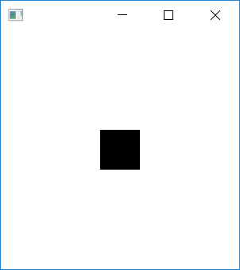
@Override
public void start(Stage stage) {

Rectangle rect = new Rectangle(100,100,50,50);

StackPane pane = new StackPane();
pane.getChildren().add(rect);
Scene scene = new Scene(pane, 300, 300);
stage.setScene(scene);
stage.show();
}
public static void main(String[] args) {
launch(args);
}
}

[Exercise 2-2d image]
Based on Case 2, we can draw a circle and connect it. Of course, you can also create some complex patterns by combining several other graphics.
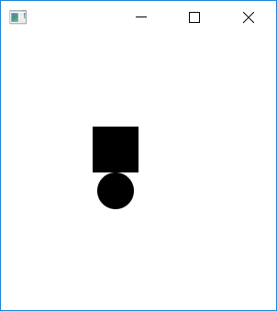

[Case 3-3d image]
We can draw a 3D picture with JAVAFx. Here we simply draw a 3D box:
Set the size of the Box, the line type, and then set the camera angle. Rotate an angle to see the entire box. Then bind the camera and Box to the scene and the stage.
public Parent createContent() throws Exception {
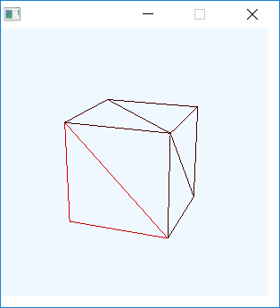
// Box
Box testBox = new Box(3, 3, 3);
testBox.setMaterial(new PhongMaterial(Color.RED));
testBox.setDrawMode(DrawMode.LINE);
// Create and position camera
PerspectiveCamera camera = new PerspectiveCamera(true);
camera.getTransforms().addAll (
new Rotate(-20, Rotate.Y_AXIS),
new Rotate(-20, Rotate.X_AXIS),
new Translate(0, 0, -15));

// Build the Scene Graph
Group root = new Group();
root.getChildren().add(camera);
root.getChildren().add(testBox);

// Use a SubScene
SubScene subScene = new SubScene(root, 300,300);
subScene.setFill(Color.ALICEBLUE);
subScene.setCamera(camera);
Group group = new Group();
group.getChildren().add(subScene);
return group;
}
@Override
public void start(Stage primaryStage) throws Exception {
Scene scene = new Scene(createContent());
primaryStage.setScene(scene);
primaryStage.show();
}

[Exercise 3-3d graphics]
On the basis of Case 3, draw a small box and place it on top of the big box. The effect is as follows:

