Java2 Lab 12
(Java I/o)

[Experimental Objective]
1. Learn to understand Java's Io operations
2. Master JAVA serialization and deserialization methods by writing and debugging programs

[Java I/O]
Java's input/output streams are mainly classified into two categories according to their data types: Character Stream and Bite Stream.
(1) character stream
The input/output data of the character stream is a character code, that is, a Unicode character. There are two basic classes for character streams: the Reader class and the Writer class.
Reader: An abstract class that cannot be used directly, and gets characters from a file through its subclass, FileReader.
Writer: An abstract class that cannot be used directly, writes characters to a file through its subclass, FileWriter.
(2) byte stream
The byte stream is read/write binary data in bytes. There are two basic classes for byte streams: the InputStream class and the OutputStream class.
InputStream: An abstract class that cannot be used directly, and gets its bytes from a file through its subclass FileInputStream.
OutputStream: An abstract class that cannot be used directly, and writes bytes to the file through its subclass FileOutputStream.
[Case 1 character stream]

Use character stream, mainly use FileReader, read the information in the file, you can get a character, and the value is ASCII code type (int), and need to be converted to become char type. Examples are as follows:•
• public class Read1 {
• public static void main(String[] args) {
• try {
• FileReader fr = new FileReader("File.txt");
• System.out.print("文件内容：\n");
• int s = fr.read(); //读取到的字符的ASCII值，返回值是int
• //ASCII值转成字符
• char ss = (char)s;
• System.out.print(ss);
• fr.close();
• } catch (IOException e) {
• System.out.println(e);
• }
• }
• }
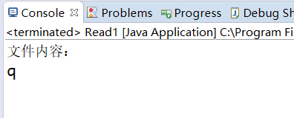

[Exercise 1 character stream]
Although the character stream can only be processed character by character, we can write a loop to improve it. Please use the character stream (ie using FileReader) to read the contents of the first line of the document in batches.
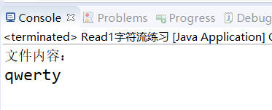

[Case 2 byte stream]
The byte stream is read/write binary data in bytes. The following example reads the first line of the file (ie the first 6 characters). You will find that the is.read(buffer, 0, 6) changes 6 to Both 7 and 8 show the first line of data, because the 7th character is '\n' and the 8th is '\r'.
- public class Read2 {

- public static void main(String[] args) {
- try {
- FileInputStream fis = new FileInputStream("File.txt");
- System.out.println("文档内容：");
- byte[] buffer = new byte[1024];
- fis.read(buffer, 0, 6);
- System.out.println(new String(buffer));
- fis.close();
- System.out.println("reading finished");
- } catch (IOException e) {
- System.out.println(e);
- }
- }
- }
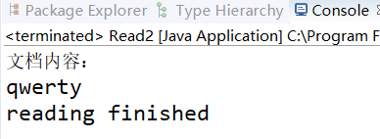

[Exercise 2 byte stream]

Please follow the case 2, using the byte stream method (that is, using FileOutputStream), batch write a string into the file.
effect:
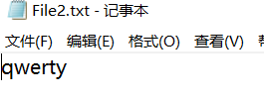

[Case 3 Bufferstream]
The Java filter stream itself does not have IO functionality, but filters are added to other streams to improve efficiency, such as loading a package for other streams. Filtered streams are divided into byte and character filter streams
The byte filter stream is:
BufferedInputStream—字节输入过滤流
BufferedOutputStream—字节输出过滤流
Character filter stream is：
BufferedReader—字符输入过滤流
BufferedWriter—字符输出过滤流

If you copy a file, do not use the filter stream as follows:
- public class FileCopy {
- public static void main(String[] args) {
- try (FileInputStream in = new FileInputStream("./TestDir/src.zip");
- FileOutputStream out = new FileOutputStream("./TestDir/subDir/src.zip")) {
- //开始时间，当前系统纳秒时间
- long startTime = System.nanoTime();
- // 准备一个缓冲区
- byte[] buffer = new byte[1024];
- // 首先读取一次
- int len = in.read(buffer);
- while (len != -1) {
- // 开始写入数据
- out.write(buffer, 0, len);
- // 再读取一次
- len = in.read(buffer);
- }
- //结束时间，当前系统纳秒时间
- long elapsedTime = System.nanoTime() - startTime;
- System.out.println("耗时：" + (elapsedTime / 1000000.0) + " 毫秒");
- } catch (FileNotFoundException e) {
- e.printStackTrace();
- } catch (IOException e) {
- e.printStackTrace();
- }
- }
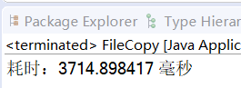
- }

Use the filtered stream as follows:
- public class FileCopyWithBuffer {
- public static void main(String[] args) {
- try (FileInputStream fis = new FileInputStream("./TestDir/src.zip");
- BufferedInputStream bis = new BufferedInputStream(fis);
- FileOutputStream fos = new FileOutputStream("./TestDir/subDir/src.zip");
- BufferedOutputStream bos = new BufferedOutputStream(fos)) {
- //开始时间
- long startTime = System.nanoTime();
- // 准备一个缓冲区
- byte[] buffer = new byte[1024];
- // 首先读取一次
- int len = bis.read(buffer);
- while (len != -1) {
- // 开始写入数据
- bos.write(buffer, 0, len);
- // 再读取一次
- len = bis.read(buffer);
- }
- //结束时间
- long elapsedTime = System.nanoTime() - startTime;
- System.out.println("耗时：" + (elapsedTime / 1000000.0) + " 毫秒");
- } catch (FileNotFoundException e) {
- e.printStackTrace();
- } catch (IOException e) {
- e.printStackTrace();
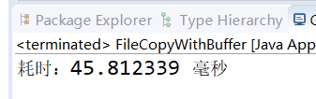
- }
- }
- }

It can be seen that the use of filtered streams significantly increases the speed of replication.

[Exercise 3 Bufferstream]
Please use the Bufferstream to read the entire contents of a txt file.
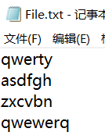
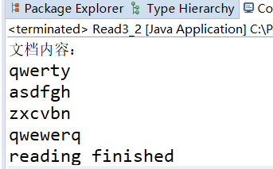

【Serialization and deserialization in java】
Serialization: The process of converting a Java object into a sequence of bytes is called serialization of the object.
Deserialization: The process of restoring a sequence of bytes to a Java object is called deserialization of the object.
There are two main uses for serialization of objects:
1) Permanently save the byte sequence of the object to the hard disk, usually in a file;
2) Transfer the byte sequence of the object over the network.
Object serialization includes the following steps:
1) Create an object output stream that wraps a different type of target output stream, such as a file output stream;
2) Write the object through the writeObject() method of the object output stream.

[Case 4 Serialization]
First create a student class as follows, remember to define it as a class that can be serialized. Its members include name, age, student number, and test scores.
- class Student implements Serializable {
- String name;
- int age;
- String num;
- double score;
- public Student() {
- }
- public Student(String name, int age, String num, double score) {
- this.name = name;
- this.age = age;
- this.num = num;
- this.score = score;
- }
- public String toString() {
- return name + "\t" + age + "\t" + num + "\t" + score;
- }
- }

Then create two instances with the student class and write to the txt file:
- import java.io.File;
- import java.io.FileOutputStream;
- import java.io.IOException;
- import java.io.ObjectOutputStream;
- public class SerializableTest {
- public static void main(String[] args) {
- Student stu_1 = new Student("wjl", 25, "47843847", 89);
- Student stu_2 = new Student("yxm", 23, "47856547", 99);
- File f = new File("serializable.txt");
- try {
- FileOutputStream fos = new FileOutputStream(f);
- ObjectOutputStream oos = new ObjectOutputStream(fos);
- System.out.println("没有被序列化时的对象如下：");
- System.out.println(stu_1);
- System.out.println(stu_2);
- oos.writeObject(stu_1);
- oos.writeObject(stu_2);
- System.out.println("序列化成功！！");
- oos.flush();
- fos.close();
- oos.close();
- } catch (IOException e) {
- e.printStackTrace();
- }
- }
- }
You can see that the output after serialization is as follows:
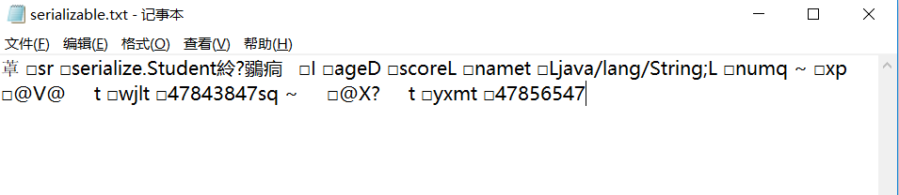

对应在显示台上是：
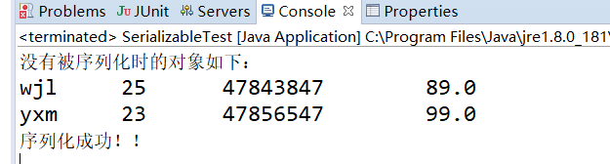

[Exercise 4 Deserialization]

In Case 4, we learned how to serialize objects. In this exercise, you need to read the txt file generated by Case 4 as an object instance and output the details to the console.
The effect is as follows:
