Java2 Lab 13
(JDBC)

[Experimental Objective]
Learn and understand jdbc,

[环境安装]
Mysql install：
https://www.jb51.net/article/148764.htm

sqlyog install（option）
http://www.onlinedown.net/soft/24926.htm

jdbc download：
http://static.runoob.com/download/mysql-connector-java-5.1.39-bin.jar

【Main step of JDBC】
1. Register driver
Class.forName("com.mysql.jdbc.Driver");
DriverManager.registerDriver(new com.mysql.jdbc.Driver());

2. establish connection
conn = DriverManager.getConnection(DB_URL,USER,PASS);
3. create statement
stmt = conn.createStatement();

4 run sql ，and obtain ResultSet

String sql; sql = "SELECT id, name, url FROM websites";
ResultSet rs = stmt.executeQuery(sql);
5. Query data
int id = rs.getInt("id");
String name = rs.getString("name");
String url = rs.getString("url");

6. Release resources

rs.close();
stmt.close();
conn.close();

[Case]
Create a websites database in mysql, you can also use the graphical management tools to create, create the following statement:
CREATE TABLE `websites` (
`id` int(11) NOT NULL AUTO_INCREMENT,
`name` char(20) NOT NULL DEFAULT '' COMMENT '站点名称',
`url` varchar(255) NOT NULL DEFAULT '', `alexa` int(11) NOT NULL DEFAULT '0' COMMENT 'Alexa 排名',
`country` char(10) NOT NULL DEFAULT '' COMMENT '国家', PRIMARY KEY (`id`)
) ENGINE=InnoDB AUTO_INCREMENT=10 DEFAULT CHARSET=utf8;
Then insert some data:
INSERT INTO `websites` VALUES ('1', 'Google', 'https://www.google.cm/', '1', 'USA'), ('2', '淘宝', 'https://www.taobao.com/', '13', 'CN'), ('3', '菜鸟教程', 'http://www.runoob.com', '5892', ''), ('4', '微博', 'http://weibo.com/', '20', 'CN'), ('5', 'Facebook', 'https://www.facebook.com/', '3', 'USA');

The contents of the database table: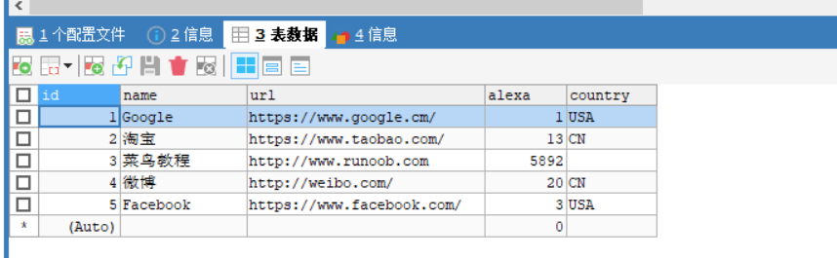
Link database:
Need to add jdbc to the project, then build path jdbc to make it start. Then corresponding to the url, username and password written to the database, write the query statement, you can get the query result:
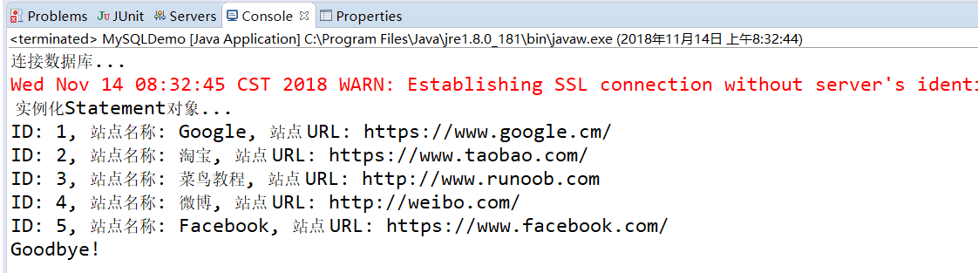

[Exercise]
exercise1：
(1) On the basis of Case 1, add a record in the JAVA program, such as: ID: 6, site name: Baidu, site URL: https://www.baidu.com/
Note: Do not add directly in the database!
The effect is as follows, you can see one more record: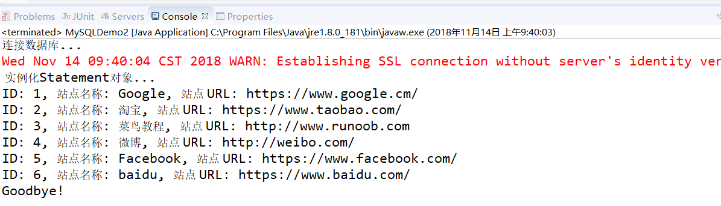
(2) In the JAVA program, delete the newly added records in the database.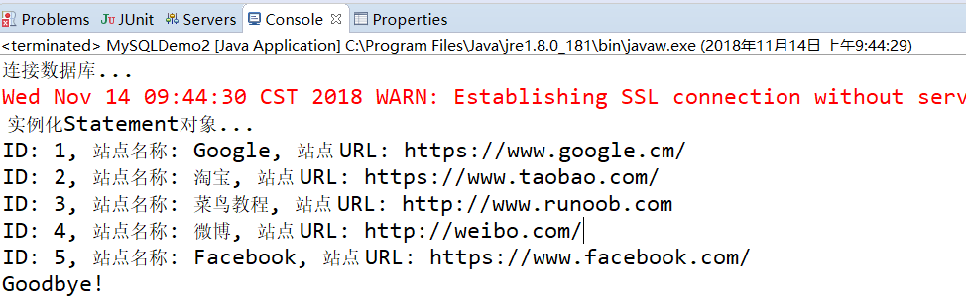
(3) On the basis of Case 1, change the site with id=5 to Baidu, url: https://www.baidu.com
The effect is as follows: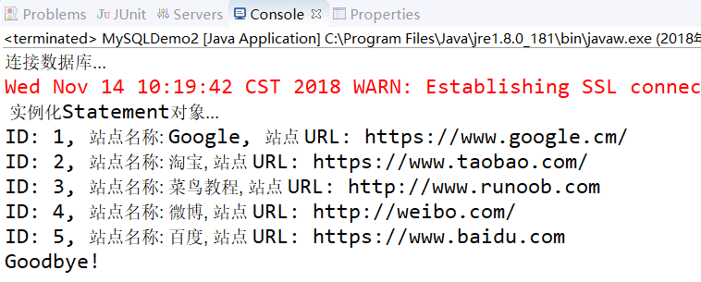

Exercise 2:
Referring to the case, build a user to log in to the database, and write a JAVA program to implement the addition, deletion, and change of the user. User information includes id, username, password, and so on.

