Java2 Lab 14
(TCP/UDP)

[Experimental Objective]
Master the basic methods of TCP and UDP network programming

【UDP】
DatagramPacket:
The data sent and received by UDP communication needs to use the DatagramPacket class. The instance object of this class is equivalent to a container for encapsulating data sent or received in UDP communication.Api:
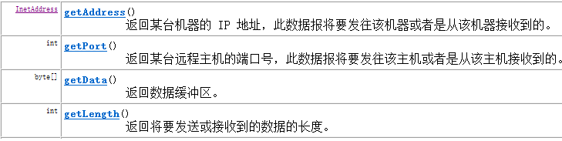
DatagramSocket
The DatagramSocket class acts like a dock, and can send and receive DatagramPacket packets using instance objects of this class.

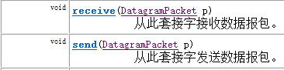
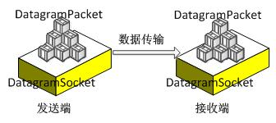

[案例1 UDP]
UDP uses DatagramSocket for simple data transfer.
Write the sender and receiver programs locally to implement string transmission.
Sending end:
The steps are: Create a sender Socket object
Create data and package
send data
Release resources
- public class udpSendDemo {
- public static void main(String[] args) throws IOException {
- DatagramSocket ds = new DatagramSocket();
- String s = "hello udp,I'm comming!";
- byte[] bys = s.getBytes();
- int length = bys.length;
- InetAddress address = InetAddress.getLocalHost();
- int port = 8888;
- DatagramPacket dp = new DatagramPacket(bys,length,address,port);
- ds.send(dp);
- ds.close();
- }
- }
Receiving end:：
The steps are as follows: Create a Receive Socket object
Receive data
Analytical data
Output Data
Release resources
- public class udpReceiveDemo {
- public static void main（String [] args） throws IOException {

- DatagramSocket ds = new DatagramSocket（8888 ）;

- byte [] bys = new byte [ 1024 ];
- DatagramPacket dp = new DatagramPacket（bys，bys.length）;

- ds.receive（DP）;
- System.out.println（“接收成功” ）;

- InetAddress address = dp.getAddress（）;
- byte [] data = dp.getData（）;
- int length = dp.getLength（）;

- System.out.println（“sender --->” + address.getHostAddress（））;
- System.out.println（new String（bys，0 ，length））;

- ds.close（）;

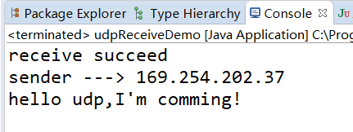
- }

[练习1 UDP]
请在案例一的基础上，结合之前学过的I/O流，使用UDP协议，在发送端上传一个txt文档（message.txt），在接收端将文档内容读出。
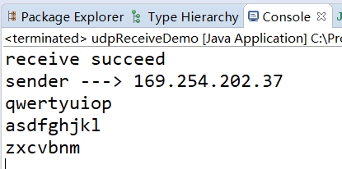

【TCP】
UDP only has a sender and a receiver. It does not distinguish between the client and the server. The computer can send data arbitrarily.
TCP communication strictly distinguishes between client and server. In communication, the client must connect to the server to communicate. The server cannot actively connect to the client, and the server program needs to be started before waiting for the client to connect. .
Two classes are provided in the JDK for implementing TCP programs. One is the ServerSocket class, which is used to represent the server side, and the other is the Socket class, which is used to represent the client.ServerSocket:
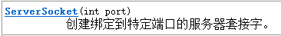
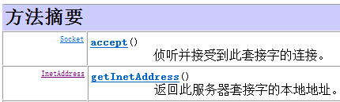

Socket:
方法声明 | 功能描述
int getPort() | 该方法返回一个int类型对象，该对象是Socket对象与服务器端连接的端口号
InetAddress getLocalAddress() | 该方法用于获取Socket对象绑定的本地IP地址，并将IP地址封装成InetAddress类型的对象返回
void close() | 该方法用于关闭Socket连接，结束本次通信。在关闭socket之前，应将与socket相关的所有的输入/输出流全部关闭，这是因为一个良好的程序应该在执行完毕时释放所有的资源
InputStream getInputStream() | 该方法返回一个InputStream类型的输入流对象，如果该对象是由服务器端的Socket返回，就用于读取客户端发送的数据，反之，用于读取服务器端发送的数据
OutputStream getOutputStream() | 该方法返回一个OutputStream类型的输出流对象，如果该对象是由服务器端的Socket返回，就用于向客户端发送数据，反之，用于向服务器端发送数据

[Case2 TCP]
Using the TCP protocol, a string is sent on the client, and the server receives and displays
Server:
Steps: Receive data using the TCP protocol
Create a Receive Socket object
Monitor (block)
Get the input stream object
retrieve data
Output Data
Release resources
- public class TcpServerDemo {
- public static void main(String[] args) throws IOException {

- ServerSocket ss = new ServerSocket(10086);
- Socket s = ss.accept();
- InputStream is = s.getInputStream();

- byte[] bys = new byte[1024];
- int len;
- len = is.read(bys);

- InetAddress address = s.getInetAddress();
- System.out.println("client ---> " + address.getHostAddress());
- System.out.println(new String(bys, 0, len));

- s.close();
- // ss.close(); //服务端实际一般不关
- }
- }
client：
Steps: Send data using TCP protocol
Create a sender Socket object (create a connection)
Get the output stream object
send data
Release resources

- public class TcpClientDemo {
- public static void main(String[] args) throws IOException {
- Socket s = new Socket(InetAddress.getLocalHost(),10086);
- OutputStream os = s.getOutputStream();
- String str = "hello tcp,im comming!!!";
- os.write(str.getBytes());
- //释放资源
- //os.close();
- s.close();
- }
- }

result：
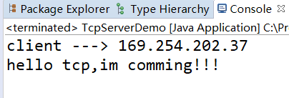

[Exercise2 TCP]
Please simulate the user login process on the basis of Case 2.

Encapsulate the username and password into a User class, providing the corresponding constructor and getter/setter methods
Create a new UserDB class to define a collection, add the following User object to the collection:
new User("zhangsan","123456");
new User("lisi","654321");

Feature Tip:
Client:
1. Prompt the user to enter the user name and password, and send the user name and password entered by the user to the server.
2. Receive the result of the server verifying the username and password.

Server:
The server encapsulates the username and password sent by the client into a User object.
If the User object is included in the collection, write "Login Successful" to the client.
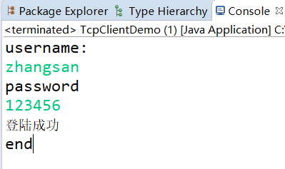
Otherwise write "login failed" to the client.
