Java2 Lab 15
(Socket+JDBC+Junit)

[Experimental Objective]
1. Review the previously learned JDBC and Socket through a comprehensive project
2. Learn to deploy projects with Maven and test with JUnit units.

【project】
In lab13, we learned the operation of JDBC and practiced writing a login database containing Username and password.
In lab14, we learned to use sockets for network programming, and practiced simulating the operation of the server and client that the user logged into.
In this project, please combine the knowledge learned in the previous two experiments, and integrate the database and network programming related parts. After the user logs in on the client, the server calls the information in the database for verification, and the result is transmitted. Back to the client display.
Due to the larger scale of the project, we will use maven for project management and unit testing with JUnit.

【Junit】
Maven install:
https://www.cnblogs.com/eagle6688/p/7838224.html

in pom.xml，Write the following statement, it will automatically add Junita to come in
- <dependencies>
- <dependency>
- <groupId>junit</groupId>
- <artifactId>junit</artifactId>
- <version>3.8.1</version>
- <scope>test</scope>
- </dependency>

- </dependencies>

Junit The order of execution of the annotations is@BeforeClass -> @Before -> @Test -> @After -> @Before -> @Test -> @After -> @AfterClass。@Ignore会被忽略。

@BeforeClass will only be executed once, and it will be the first one.
@Before runs before the test method runs
@Test test method
@After allows after the test method is run
@AfterClass will only be executed once, and it will be the last one.
@Ignore ignores this method
Using method：
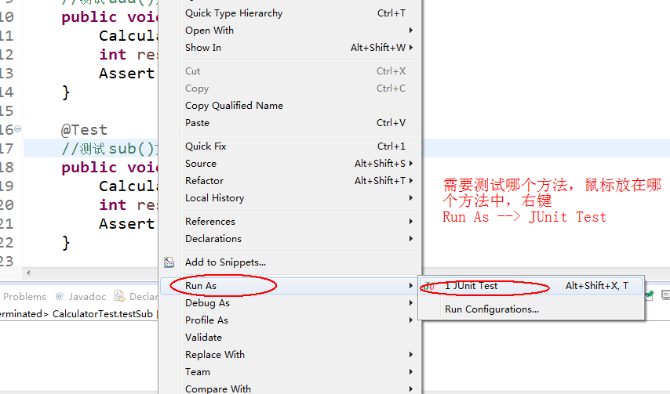

[exercise]
Requirement 1: Projects to be deployed with maven, unit testing with JUnit
Requirement 2: Create a database, the table includes the user id, username, password, add some members such as "zhangsan", "123456", etc., read the database content in the class
Requirement 3: Establish Socket communication
Feature Tip:
Client:
1. Prompt the user to enter the user name and password, and send the user name and password entered by the user to the server.
2. Receive the result of the server verifying the username and password.
Server:
The server encapsulates the username and password sent by the client into a User object.
If the User object is included in the collection read from the database, write "Login Successful" to the client.
Otherwise write "login failed" to the client.
