Java2 Lab 8
(Swing)
[Experimental Objective]
1. Learn to understand Swing
2. Master the basic method of JAVA graphical interface design by writing and debugging programs

[Swing component]

​​JFrame – java GUI program is based on JFrame, which is the object of the window on the screen, which can be maximized, minimized and closed.
JPanel – Java graphical user interface (GUI) toolkit The panel container class in swing, included in the javax.swing package, can be nested. The function is to combine components with the same logic function in the form, which is a kind of light. A volume container that can be added to a JFrame form. .
JLabel – JLabel objects can display text, images, or both. You can specify where the label content in the label display area is aligned by setting the vertical and horizontal alignment. By default, labels are vertically centered in their display area. By default, only the labels that display the text are aligned at the beginning; the labels that only display the image are centered horizontally.
JTextField – A lightweight component that allows editing of a single line of text.
JPasswordField – allows us to enter a line of words like input box, but hide the asterisk (*) or point to create a password (password)
JButton – An instance of the JButton class. Used to create a button like "Login" in an instance
[Exercise]

Exercise 1: Write the helloworld program, showing the window and content as helloworld, the effect is as shown.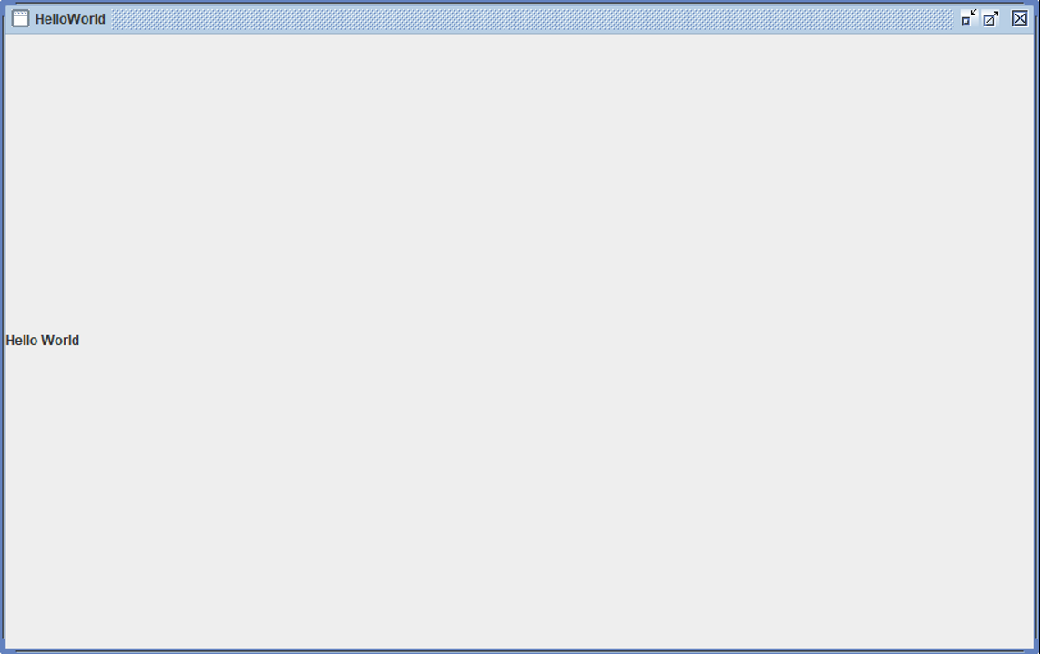

Tip: First create a GUI display class, set windows, labels, containers, resize, etc.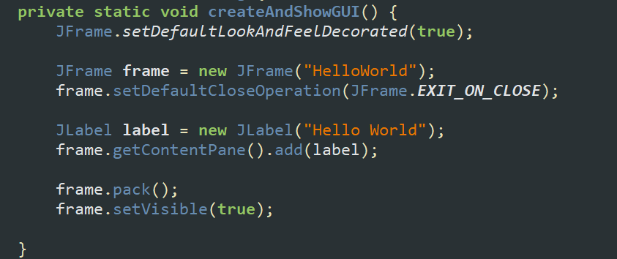
Then rewrite the run method and execute the GUI

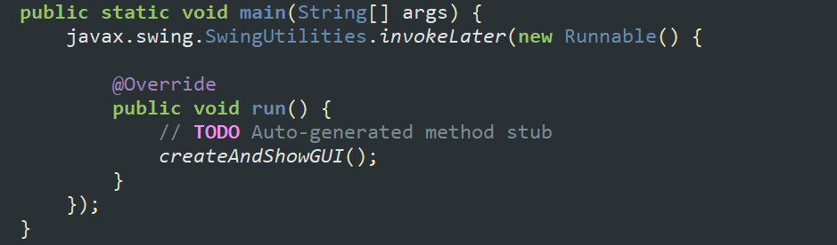

Exercise 2:
Based on Exercise 1, write a window to the login screen. Requirement: The user name is displayed in plain text, the password is displayed in cipher text, and the login button can be used to log in. The effect achieved is as follows: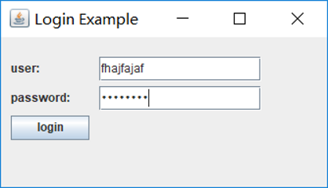
Tip: first create a window, load the panel, set the interface visibility
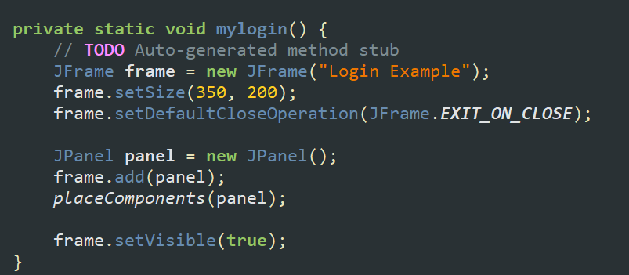
Then implement the method of adding components to the panel:
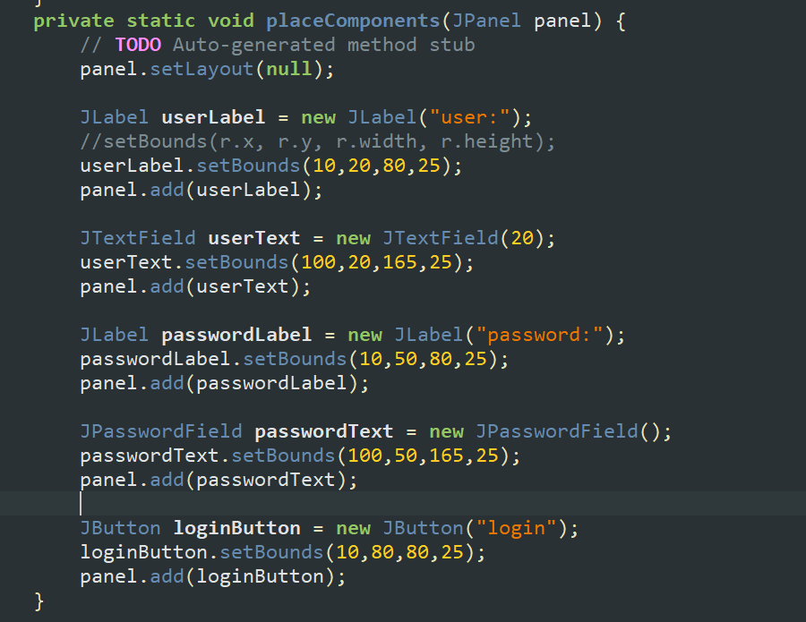
Finally rewrite the run method, execute
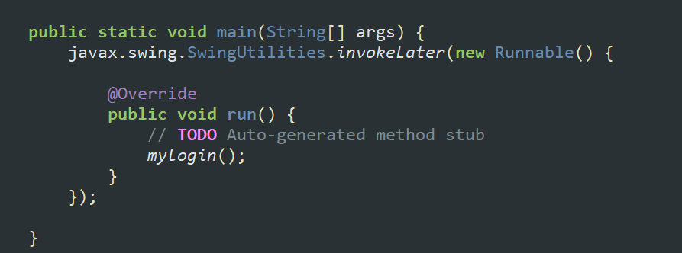

Exercise 3 (optional):
Install the windowbuilder in eclipse，The installation tutorial is as follows: https://blog.csdn.net/jason0539/article/details/21219043?utm_source=blogxgwz8
Implement the exercises 2 in a graphical programming way, talking about the advantages and disadvantages of graphical programming and writing code.

